This document provides an approved procedure for the analysis of DO for compliance monitoring per 15A NCAC 02H .0805 (a) (7) and (g) (4).

Holding Time:

- Samples must be analyzed within 15 minutes of collection (40 CFR Part 136 Table II); however, in situ or immediate analysis is recommended due to the unstable nature of dissolved oxygen in samples.

General Information:

- Certification for this method is determined by the type of probe used by the laboratory:

  - Dissolved Oxygen Membrane Electrode
    - Standard Methods 4500 O G-2021
    - ASTM D888-18 (B)
  - Luminescence Dissolved Oxygen (LDO) Sensor
    - Standard Methods 4500 O H-2021
    - ASTM D888-18 (C)
    - Hach 10360, Rev 1.2, September 2011
    - In-Situ Method 1002–8–2009

- Instrument Warm-up Times: Membrane electrodes can have either galvanic or polarographic sensors. Galvanic sensors require no warm-up time. Polarographic sensors require a 15-minute warm-up time. LDO probes all have optical sensors and require no warm-up time.

- For membrane electrodes, movement of water across the membrane is required for accurate readings. If measurements are not made directly in flowing water, they must be made by using an in-probe stirring mechanism, a stir bar or by swirling the probe in the sample. Do not put the probe on the sides or the bottom of the sample container.

- Movement across the sensor is not required for all LDO probes. Follow manufacturer’s instructions.

- Follow the manufacturer’s instructions for probe storage and maintenance.

- Sample duplicates are not a required quality control element for Field parameters.

Meter Calibration:

- Instruments are to be calibrated according to the manufacturer’s calibration procedure prior to analysis of samples each day compliance monitoring is performed.

- The laboratory must use water-saturated air for the air calibration. This is accomplished by calibrating the electrode in an environment with a high relative humidity. Using dry air for the calibration can result in errant readings.

- The laboratory must document each time that a calibration is performed. Calibration documentation must include the instrument identification as well as the temperature, the elevation or barometric pressure (in mmHg), and the salinity* of the compliance sample(s) to be analyzed. After calibration, record the final DO reading in mg/L or % saturation.

* Per NC WW/GW LC Branch policy, facilities may use the Salinity default value of zero when calibrating the DO meter unless it is known or suspected that the Salinity value of the samples being analyzed is > 9 ppt. In those situations, actual Salinity values must be used. Regardless of which value is used, it must be documented.

NOTE: Meters that measure Conductivity and convert that reading to Salinity to use in the DO calibration and analysis must be calibrated for Conductivity before being calibrated for DO. If Salinity is manually entered by the user during calibration and samples of differing Salinity concentrations are analyzed, the meter must be recalibrated using the Salinity of each new sample.

- For meters that require manual entry of the barometric pressure, the true pressure (i.e., not corrected to pressure at sea level) must be used.

If using a laboratory barometer, it is important to determine from the manufacturer’s instructions what type of pressure (i.e., true or corrected) the laboratory barometer is displaying.

If a laboratory barometer is not available, care must be taken when obtaining the current barometric pressure from other sources. Most sources report the pressure corrected to sea level, which is not the true pressure and is not to be used for calibration without being converted. The following formula must be used to convert corrected pressure to the true pressure:

True BP = [Corrected BP] – [2.5 * (Local Altitude in ft. above sea level/100)]

The following website can be used to access many weather stations throughout North Carolina that report the current pressure: https://products.climate.ncsu.edu/cardinal/scout/
In all cases where an outside source is used for pressure, the weather station must be located nearby and at a similar elevation to the site where the meter is being calibrated. An appropriate weather station may not be available in all locations.

- For LDO sensors that cannot be calibrated by the user, the internal calibration must be verified each day of use. This can be performed by back calculating the theoretical DO for the current air calibration conditions (e.g., temperature, elevation, barometric pressure, etc.). The calculated DO value must verify the meter reading within ±0.5 mg/L. Refer to the Dissolved Oxygen Meter Calibration Verification handout at the end of this document. If the meter verification does not read within ±0.5 mg/L of the theoretical DO, corrective action must be taken.

- A post-analysis calibration verification must be performed at the end of the run any time the meter is transported by vehicle to another location after calibration. The calculated theoretical DO value must verify the meter reading within ±0.5 mg/L. If the meter verification does not read within ±0.5 mg/L of the theoretical DO, corrective action must be taken. If the meter is not calibrated at each sample site, it is recommended that a mid-day calibration be performed when samples are analyzed over an extended period of time.

Documentation:

The following must be documented in indelible ink whenever sample analysis is performed:

- Date and time of sample collection
- Date and time of sample analysis to verify the 15-minute holding time is met. Alternatively, one time may be documented for collection and analysis with the notation that samples are measured in situ or immediately at the sample site
- Permitted facility name or permit number, and sample site (ID or location)
- Collector’s/analyst’s name or initials
- Conductivity calibration standard and check standard values and check standard evaluation (only required when using a Conductivity meter to determine the Salinity for calibration)
- Calibration variables (temperature, elevation or barometric pressure [in mmHg], and salinity)
- Meter calibration and/or verification date and time(s)
- Calibration information (DO reading in mg/L or % saturation)
- Theoretical value and DO meter reading for the calibration verification(s), where applicable
- Quality control assessments
- Final value to be reported
- Units of measure
- Unique instrument identification (serial number preferred)
- Parameter analyzed
- Method reference
- Data qualifier(s), when applicable

Ref: Standard Methods 4500 O G-2021and Standard Methods 4500 O H-2021
Hach Method 10360, Rev. 1.2, September 2011
In Situ Method 1002-8-2009
ASTM Method D888-18 (B) and ASTM Method D888-18 (C)

Refer to the NC DEQ WW/GW LCB website for additional resources.

Dissolved Oxygen Meter Calibration Verification When Salinity is Zero

DO meters/probes must be calibrated each day of use prior to sample analysis. If the meter cannot be calibrated, the calibration must be verified each day of use. Additionally, when transporting the DO meter by vehicle, a post analysis calibration verification must be analyzed at the end of the run for all types of DO probes, unless the meter is recalibrated at each sample site. Below is a procedure for verifying the calibration of a DO probe.

- Follow the manufacturer’s instructions for meter operation.
- Place probe in a plastic bag, the probe storage cup, the storage well of the meter (each containing a wet sponge), or a BOD bottle partially filled with water. Allow appropriate instrument warm up time.
- Read DO and temperature.
- Check the temperature vs. DO mg/L table below and apply appropriate atmospheric (barometric) pressure or altitude correction factor.
- Calculated (theoretical) DO value must verify within ± 0.5 mg/L of meter reading.

Atmospheric Pressure mm Hg | Equivalent Altitude Ft. | Correction Factor
760 | 0 | 1.00
752 | 278 | .99
745 | 558 | .98
737 | 841 | .97
730 | 1126 | .96
722 | 1413 | .95
714 | 1703 | .94
707 | 1995 | .93
699 | 2290 | .92
692 | 2587 | .91
684 | 2887 | .90
676 | 3190 | .89
669 | 3496 | .88
661 | 3804 | .87
654 | 4115 | .86
646 | 4430 | .85
638 | 4747 | .84
631 | 5067 | .83
623 | 5391 | .82
616 | 5717 | .81
608 | 6047 | .80
600 | 6381 | .79
593 | 6717 | .78

Temp. °C | DO mg/L | Temp. °C | DO mg/L
4.0 | 13.11 | 19.5 | 9.18
4.5 | 12.94 | 20.0 | 9.09
5.0 | 12.77 | 20.5 | 9.00
5.5 | 12.61 | 21.0 | 8.92
6.0 | 12.45 | 21.5 | 8.83
6.5 | 12.30 | 22.0 | 8.74
7.0 | 12.14 | 22.5 | 8.66
7.5 | 11.99 | 23.0 | 8.58
8.0 | 11.84 | 23.5 | 8.50
8.5 | 11.70 | 24.0 | 8.42
9.0 | 11.56 | 24.5 | 8.34
9.5 | 11.42 | 25.0 | 8.26
10.0 | 11.29 | 25.5 | 8.18
10.5 | 11.16 | 26.0 | 8.11
11.0 | 11.03 | 26.5 | 8.04
11.5 | 10.90 | 27.0 | 7.97
12.0 | 10.78 | 27.5 | 7.90
12.5 | 10.66 | 28.0 | 7.83
13.0 | 10.54 | 28.5 | 7.76
13.5 | 10.42 | 29.0 | 7.69
14.0 | 10.31 | 29.5 | 7.62
14.5 | 10.20 | 30.0 | 7.56
15.0 | 10.08 | 30.5 | 7.50
15.5 | 9.98 | 31.0 | 7.43
16.0 | 9.87 | 31.5 | 7.37
16.5 | 9.77 | 32.0 | 7.31
17.0 | 9.67 | 32.5 | 7.24
17.5 | 9.57 | 33.0 | 7.18
18.0 | 9.47 | 33.5 | 7.12
18.5 | 9.38 | 34.0 | 7.07
19.0 | 9.28 | 34.5 | 7.01
Ref: YSI Model 5000/5100 DO Meter Manual. Slight variations in DO, pressure, and/or altitude may be found in other manuals.

Example: If ambient temperature is 21°C and elevation is approximately 1126 ft, the theoretical DO would be:
8.92 X 0.96 = 8.56 mg/L

or, if ambient temperature is 21°C and the atmospheric (barometric) pressure is 745 mm Hg, the theoretical DO would be:

8.92 X 0.98 = 8.74 mg/L
Dissolved Oxygen Meter Calibration Verification When Salinity is Greater Than Zero
If calibrated at a salinity greater than zero, use the following table and column with applicable salinity:

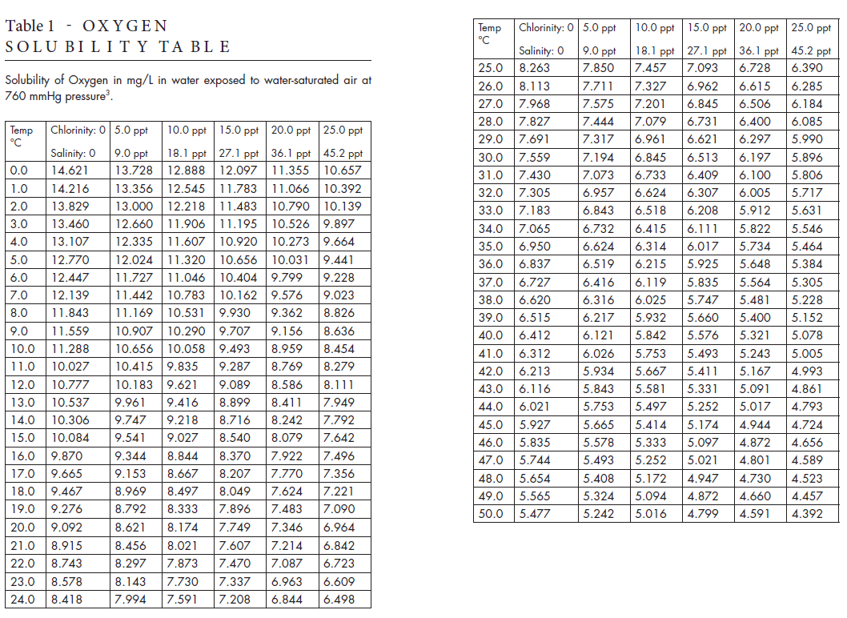
Reference: The Dissolved Oxygen Handbook. YSI, Incorporated, September 2009.

