LABORATORY NAME: |  |  | CERT #:
PRIMARY ANALYST: |  |  | DATE:
NAME OF PERSON COMPLETING CHECKLIST (PRINT):
SIGNATURE OF PERSON COMPLETING CHECKLIST:

Parameter: Chlorophyll a (Fluorometric)
Method: Standard Methods 10150 C-2022

Equipment & Reagents:
 | Tissue Grinder - Preferably use round-bottom grinding tubes with a matching pestle having grooves in the TFE tip. |  | Filters, glass fiber or membrane  (0.45-um porosity, 47-mm diameter) |  | Centrifuge tubes, 15-mL graduated, screw-cap.
 | Clinical or benchtop centrifuge (5000 to 7500 rpm)  [g = (0.00001118r) (rpm),  where r = centrifuge’s radius]. |  | vacuum pump |  | Hydrochloric acid, HCl, 0.1 N.
 | Cuvettes, with 1-cm path length. |  | Pipets, various volumes. |  | Solvent-resistant filter assembly (e.g., an all-glass filter-support apparatus that can be cleaned with water and organic solvents),
 | Aqueous acetone solution: Mix 90 parts acetone (reagent grade BP 56 °C) with 10 parts saturated magnesium carbonate solution.* |  | *Saturated magnesium carbonate solution: Add 1.0 g finely powdered MgCO₃ to 100 mL distilled water. |  | Fluorometer, [Model 10-005, Turner Designs, or equivalent] equipped with a high-intensity F4T.5 blue lamp; photomultiplier tube R-446 (red-sensitive); sliding window orifices 1×, 3×, 10×, and 30×; and filters for light emission (CS-2-64) and excitation (CS-5-60)

PLEASE COMPLETE CHECKLIST IN INDELIBLE INK
Please mark Y, N or NA in the column labeled LAB to indicate the common lab practice
and in the column labeled SOP to indicate whether it is addressed in the SOP.
 | GENERAL | LAB | SOP | EXPLANATION
- 1 | What is the most recent review/revision date of the SOP? [15A NCAC 02H .0805 (a) (7)]  Date: |  |  | Verify proper method reference. During review notate deviations from the approved method and SOP. Recommend an annual review. Update SOPs any time changes are made to procedure and make a list or highlight any changes that were made to methodology.
- 2 | Are all revision dates and procedural edits tracked and documented? [15A NCAC 02H .0805 (a) (7)] |  |  | Each laboratory shall have a formal process to track and document review dates and any revisions made in all quality assurance, quality control and SOP documents.
- 3 | Is there North Carolina data available for review? |  |  | If not, review round robin data
 | PRESERVATION and STORAGE | LAB | SOP | EXPLANATION
- 4 | What type of bottle is used for sample collection? [SM 10150 A-2022 (2) (b) (1)] [WW/GW LCB Chlorophyll Sample Collection, Preservation and Holding Time Policy]  Answer: |  |  | SM: Use opaque containers because even brief exposure to light during storage alters chlorophyll values or wrap with aluminum foil.  Policy: Chlorophyll samples must be collected in bottles that protect the sample from light (e.g., brown, opaque or foil wrapped) and maintained at ≤ 6 °C, without freezing, until filtration.  Brown, wide-mouth bottles are recommended. No less than 250 mL is recommended to obtain a representative sample. Bottles should be clean and acid-free.
- 5 | Are samples protected from light and iced to above freezing but ≤ 6 ºC during transport and storage? [WW/GW LCB Chlorophyll Sample Collection, Preservation and Holding Time Policy] |  |  | Chlorophyll samples must be collected in bottles that protect the sample from light (e.g., brown, opaque or foil wrapped) and maintained at ≤ 6 °C, without freezing, until filtration. Filtration must begin as soon as possible but not to exceed 48 hours from the time of collection. Samples with a pH < 6 S.U. must be extracted immediately after filtration. For samples with a pH ≥ 6 S.U., filters may be wrapped in foil, placed in an air-tight bag and frozen between -20 °C and -70 °C for up to 24 days.
- 6 | Are samples filtered within 48 hours of collection? [WW/GW LCB Chlorophyll Sample Collection, Preservation and Holding Time Policy] |  |  | Filtration must begin as soon as possible but not to exceed 48 hours from the time of collection.
 | If sample pH ≥ 6 S.U., are filtered samples wrapped in foil, placed in airtight plastic bags, and stored frozen for no more than 24 days and the process documented? [NC WW/GW LCB Chlorophyll Sample Collection, Preservation and Holding Time Policy]  Storage temperature: |  |  | For samples with a pH ≥ 6 S.U., filters may be wrapped in foil, placed in an air-tight bag and frozen between -20 °C and -70 °C for up to 24 days.
 | If sample pH < 6 S.U., are filtered samples extracted as soon as possible after filtration? [SM 10150 A-2022 (2)] [NC WW/GW LCB Chlorophyll Sample Collection, Preservation and Holding Time Policy] |  |  | Method: Process samples from naturally acidic water with pH <6 promptly after filtration to prevent possible chlorophyll degradation from residual acidic water on the filter. (Naturally acidic water has a pH <6 S.U. due to humic acid or the contents of senescent cells, not preservatives.)  Policy: Samples with a pH < 6 S.U. must be extracted immediately after filtration.
 | PROCEDURE – Filtration and Extraction | LAB | SOP | EXPLANATION
 | What type of filter is used? [SM 10150 A-2022 (2) and (2) (a) (4)]  Answer: |  |  | Preferably, use glass fiber filters to remove algae from water. The glass fibers help break the cells during grinding, larger volumes of water can be filtered, and no precipitate forms after acidification. Inert membrane filters, such as polyester filters, may be used when these factors are irrelevant.  Filtration equipment, filters, glass fiber (Whatman GF/F (0.7 gm), GFB (1.0 gm), Gelman AE (1 gm), or equivalent) or membrane (0.45-μm porosity, 47-mm diameter)  Note: A filter fluorescence blank is a good idea when membrane filters are used.
 | What volume of sample is filtered?  Answer: |  |  | Standard Methods does not specify a volume
 | Is approximately 2 mL of MgCO₃ solution added to the sample just before filtering process is completed? [SM 10150 A-2022 (2) (b) (1)] |  |  | Add approximately 2 mL of MgCO₃ solution added to the sample just before filtering process is completed. MgCO₃ solution acts as a pH buffer to keep chlorophyll from degrading.
 | Are samples filtered, extracted and analyzed under subdued lighting? [SM 10150 A-2022 (2)]  Describe lighting: |  |  | Conduct this procedure with chlorophyll extracts in subdued or green light to avoid degradation.  The DWR laboratory uses a dark room with green lighting.
 | Is acetone used as the extraction solvent? [SM 10150 A-2022 (2) (b) (2)]  Answer: |  |  | Place the sample in a tissue grinder, cover with 2 to 3 mL  90% aqueous acetone solution, and macerate at 500 rpm for 1 min. Use a PTFE-glass grinder for a glass-fiber filter and glass grinder for a membrane filter.
 | Are filters mechanically ground? [SM 10150 A-2022 (2) (b) (2)]  Length of time:  Grinding RPM: |  |  | See above.
 | Describe grinding apparatus. [SM 10150 A-2022 (2) (b) (2)]  Answer: |  |  | Use PTFE-glass grinder for a glass-fiber filter and glass-glass grinder for a membrane filter.
 | What is the final volume of the extracted sample? [SM 10150 A-2022 (2) (b) (3)]  Answer: |  |  | Transfer sample to a screw-cap centrifuge tube, rinse grinder with a few milliliters 90% aqueous acetone, and add the rinse to the extraction slurry. Adjust total volume to 10 mL, with 90% aqueous acetone.
 | How long are samples allowed to steep? [SM 10150 A-2022 (2) (b) (3)]  Answer: |  |  | Steep samples at least 2 h at 4°C in the dark. Note: Some literature suggests that longer steeping times improve recovery. The DWR lab steeps overnight, not to exceed 24 hours.
 | Are samples steeped in the dark above freezing and at ≤ 4ºC? [SM 10150 A-2022 (2) (b) (3)] |  |  | Steep samples at least 2 h at 4°C in the dark.
 | After steeping, are samples filtered or centrifuged? [SM 10150 A-2022 (2) (b) (4)]  Filter type (if applicable):  Centrifuge time and speed (if applicable): |  |  | Clarify by filtering through a solvent-resistant disposable filter [e.g., a 0.45 µm PTFE 13 mm syringe filter (to minimize retention of extract in filter and filter holder, force 1 to 2 mL air through filter after extract)] or by centrifuging in closed tubes for 20 min at 500 g or 3000 rpm.
 | Is the clarified extract decanted into a clean, calibrated, 15-mL, screw-cap centrifuge tube and the total volume measured? [SM 10150 A-2022 (2) (b) (4)] |  |  | Decant clarified extract into a clean, calibrated, 15-mL, screw-cap centrifuge tube and measure total volume.
 | PROCEDURE – Instrument Calibration | LAB | SOP | EXPLANATION
 | Are chlorophyll-a standards prepared and analyzed first on a spectrophotometer? [SM 10150 C-2022 (2) (b)] |  |  | To achieve acceptable results, calibrate the fluorometer spectrophotometrically with a sample from the same source. Optimum sensitivity for chlorophyll-a extract measurements is obtained at an excitation wavelength of 430 nm and an emission wavelength of 663 nm.
 | What are the concentrations of the calibration standards? [SM 10150 C-2022 (2) (b)]  Standard type/source:  List Concentrations: |  |  | Calibrate the fluorometer with a known concentration of chlorophyll solution as follows. Prepare chlorophyll extract and analyze spectrophotometrically. Prepare serial dilutions of the extract to provide concentrations of approximately 2, 6, 20, and 60 μg chlorophyll-a per liter.
 | Are fluorometric readings made for each solution at each sensitivity setting? [SM 10150 C-2022 (2) (b)] |  |  | Make fluorometric readings for each solution at each sensitivity setting (sliding window orifice): 1x, 3x, 10x, and 30x.
 | Are the values obtained used to derive calibration factors to convert fluorometric readings in each sensitivity level  to concentrations of chlorophyll-a? [SM 10150 C-2022 (2) (b)] |  |  | Using the values obtained, derive calibration factors to convert fluorometric readings in each sensitivity level to concentrations of chlorophyll-a, as follows:  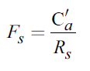  where:  F_{s} = calibration factor for sensitivity setting S  C'_{a} = concentration of chlorophyll-a determined spectrophotometrically (µg/L)  R_{s} = fluorometer reading for sensitivity setting S  Measure sample fluorescence at sensitivity settings that provide a midscale reading. (Avoid using the 1× window because of quenching effects.) Convert fluorescence readings to concentrations of chlorophyll-a by multiplying the readings by the appropriate calibration factor.
 | PROCEDURE – Sample Analysis | LAB | SOP | EXPLANATION
 | Is the extract fluorescence at each sensitivity setting determined before and after acidification? [SM 10150 C-2022 (3) (b)]
 | Are calibration factors calculated before and after acidification? [SM 10150 C-2022 (3) (b)] |  |  | Calculate calibration factors (Fs) and before and after  acidification fluorescence ratio by dividing the fluorescence  reading obtained before acidification by the one obtained after acidification. Avoid readings on the 1× scale and those outside the range of 20 to 80 fluorometric units.
 | How is the chlorophyll-a concentration calculated? [SM 10150 C-2022 (2) (c)]  Show Calculation: |  |  | 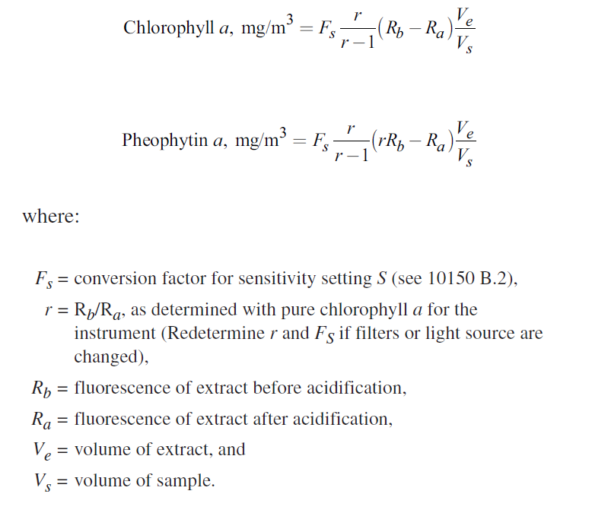
 | QUALITY ASSURANCE | LAB | SOP | EXPLANATION
 | Does the laboratory analyze duplicate samples at a rate of 5% or greater? [15A NCAC 02H .0805 (a) (7)] |  |  | Except where otherwise specified in an analytical method, laboratories shall analyze five percent of all samples in duplicate to document precision. Laboratories analyzing fewer than 20 samples per month shall analyze one duplicate during each month that samples are analyzed.
 | What is the acceptance criterion sample duplicates? [15A NCAC 02H .0805 (a) (7) (A)]  Answer: |  |  | Establish laboratory control limits.  Unless specified by the method or this Rule, each laboratory shall establish performance acceptance criteria for all quality control analyses.
 | What corrective action does the laboratory take if the duplicate samples results are outside of established control limits or method precision limits? [15A NCAC 02H .0805 (a) (7) (B)]  Answer: |  |  | If quality control results fall outside established limits or show an analytical problem, the laboratory shall identify the Root Cause of the failure. The problem shall be resolved through corrective action, the corrective action process documented, and any samples involved shall be reanalyzed, if possible. If the sample cannot be reanalyzed, or if the quality control results continue to fall outside established limits or show an analytical problem, the results shall be qualified as such.
[Recommended] Is a reference standard analyzed to test wavelength accuracy?

State standard type and frequency:

 | [If applicable] What is the acceptance criterion for the reference standard? [15A NCAC 02H .0805 (a) (7) (A)]  Answer: |  |  | Establish laboratory control limits.  Unless specified by the method or this Rule, each laboratory shall establish performance acceptance criteria for all quality control analyses.

 | [If applicable] What corrective action is taken when the reference standard recovery exceeds the acceptance criterion? [15A NCAC 02H .0805 (a) (7) (B)]  Answer: |  |  | If quality control results fall outside established limits or show an analytical problem, the laboratory shall identify the Root Cause of the failure. The problem shall be resolved through corrective action, the corrective action process documented, and any samples involved shall be reanalyzed, if possible. If the sample cannot be reanalyzed, or if the quality control results continue to fall outside established limits or show an analytical problem, the results shall be qualified as such.
 | Are results qualified to indicate quality control failures or sample anomalies when reporting results? [15A NCAC 02H .0805 (e) (5)] |  |  | Reported data associated with Quality Control failures, improper sample collection, holding time exceedances, or improper preservation shall be qualified as such.
Additional Comments:
______________________________________________________________________________________________________________
______________________________________________________________________________________________________________
______________________________________________________________________________________________________________
______________________________________________________________________________________________________________
______________________________________________________________________________________________________________
______________________________________________________________________________________________________________
______________________________________________________________________________________________________________
______________________________________________________________________________________________________________
______________________________________________________________________________________________________________
______________________________________________________________________________________________________________
______________________________________________________________________________________________________________
______________________________________________________________________________________________________________
______________________________________________________________________________________________________________
______________________________________________________________________________________________________________
______________________________________________________________________________________________________________
______________________________________________________________________________________________________________
______________________________________________________________________________________________________________
______________________________________________________________________________________________________________
______________________________________________________________________________________________________________
______________________________________________________________________________________________________________
______________________________________________________________________________________________________________
______________________________________________________________________________________________________________
______________________________________________________________________________________________________________
______________________________________________________________________________________________________________
______________________________________________________________________________________________________________
______________________________________________________________________________________________________________
______________________________________________________________________________________________________________
______________________________________________________________________________________________________________
______________________________________________________________________________________________________________
______________________________________________________________________________________________________________
______________________________________________________________________________________________________________
______________________________________________________________________________________________________________
______________________________________________________________________________________________________________
______________________________________________________________________________________________________________
______________________________________________________________________________________________________________
______________________________________________________________________________________________________________

Inspector: ______________________________________________________Date:____________________________________________

