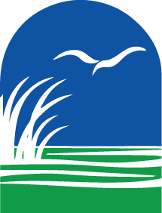

The North Carolina Coastal Reserve and National Estuarine Research Reserve’s

Research at the Reserve Symposium
Wednesday & Thursday, May 8-9, 2024
Beaufort, NC

Workshop Objectives – Participants will:
- Share and learn about research at the Reserve
- Learn more about the NC Reserve system, available data streams, and funding opportunities
- Provide thoughts on future research avenues and Reserve management priorities
- Network with researchers and coastal managers throughout the NC coast
Agenda

Wednesday, May 8
1:50pm Optional: Rachel Carson Reserve Field Trip (Island Ferry Adventures, 610 Front St, Beaufort)
5:30pm Optional: Reception with Posters (NC Maritime Museum, 315 Front St, Beaufort)
Thursday, May 9 (NOAA Beaufort Lab, 101 Pivers Island Rd)
8:30am Check-In
9:00am Introduction
9:15am Reserve Overview
9:45am The What and How of Collaborative Science
10:00am Break
10:15am Collaborative Science Discussion
10:45am Research Presentations: Water Quality
11:10am Breakout: Water Quality Discussion
11:50am Lunch
12:35pm Research Presentations: Coastal and Estuarine Ecosystem Protection
1:25pm Breakout: Coastal and Estuarine Ecosystem Protection Discussion
2:05pm Break
2:20pm Research Presentations: Coastal Hazards Resilience
3:10pm Breakout: Coastal Hazards Resilience Discussion
3:50pm Break
4:05pm Reserve Research Priorities and Interests
4:20pm Next Steps & Wrap Up
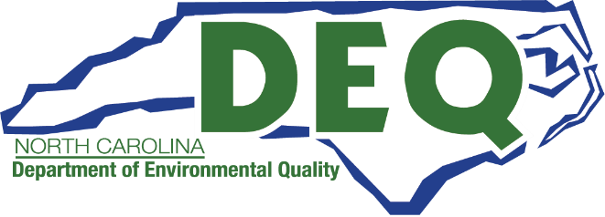
4:30pm Adjourn

