Effects of Hard Structures on Sandy, Open-Ocean Coastlines

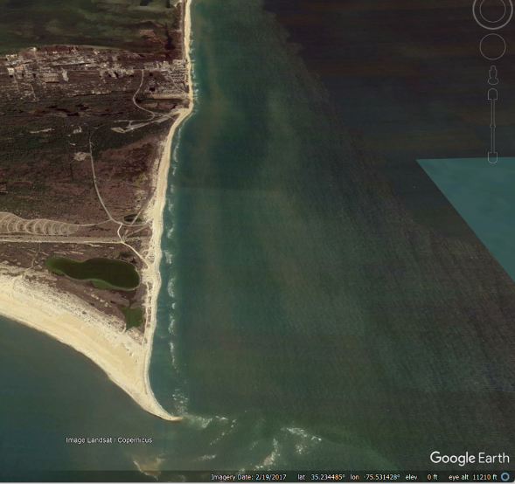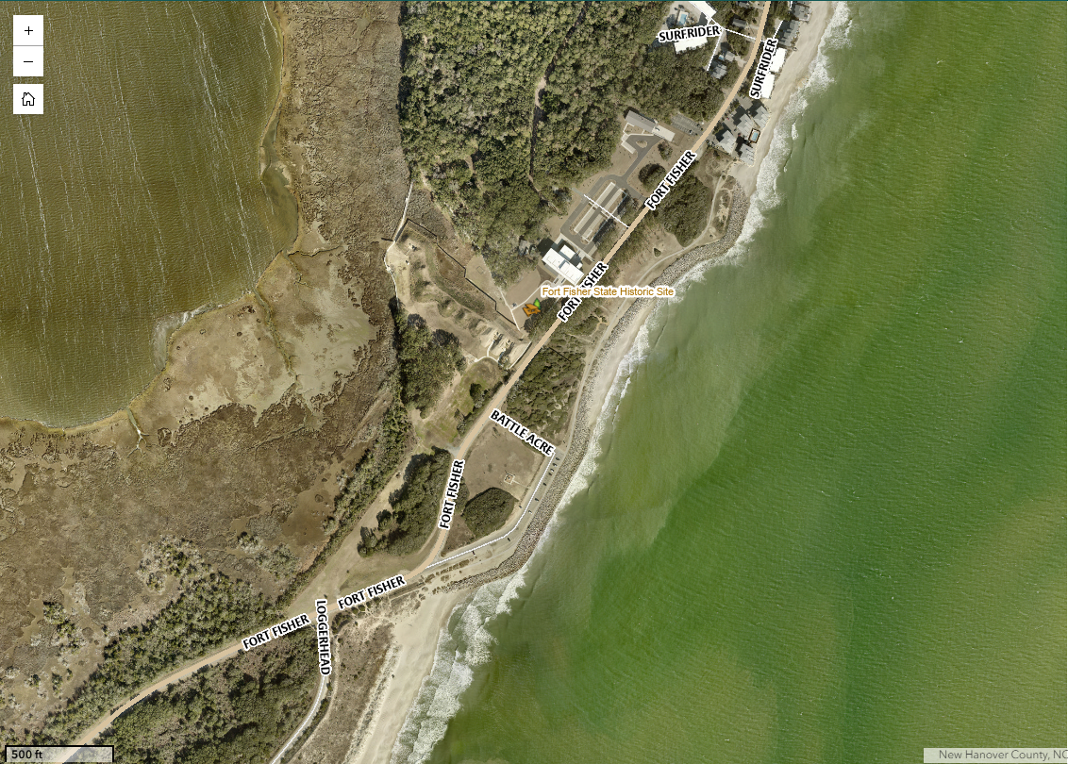

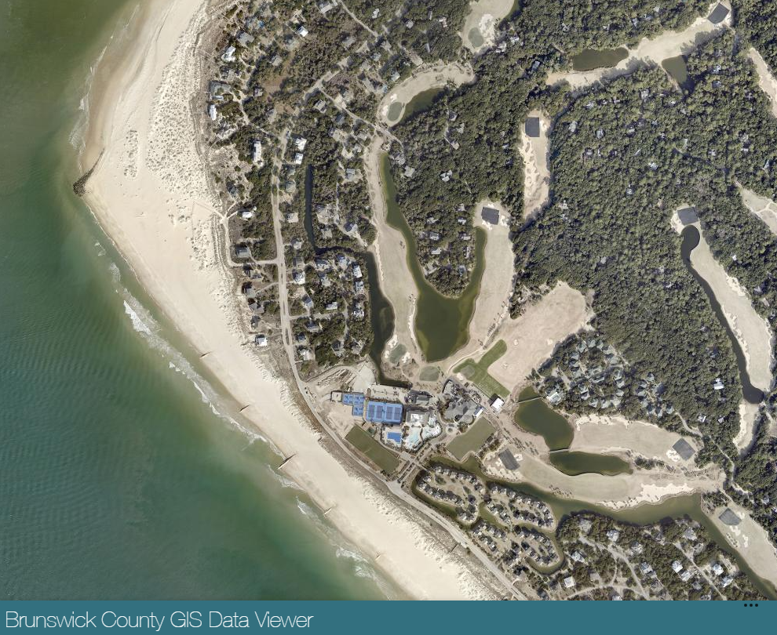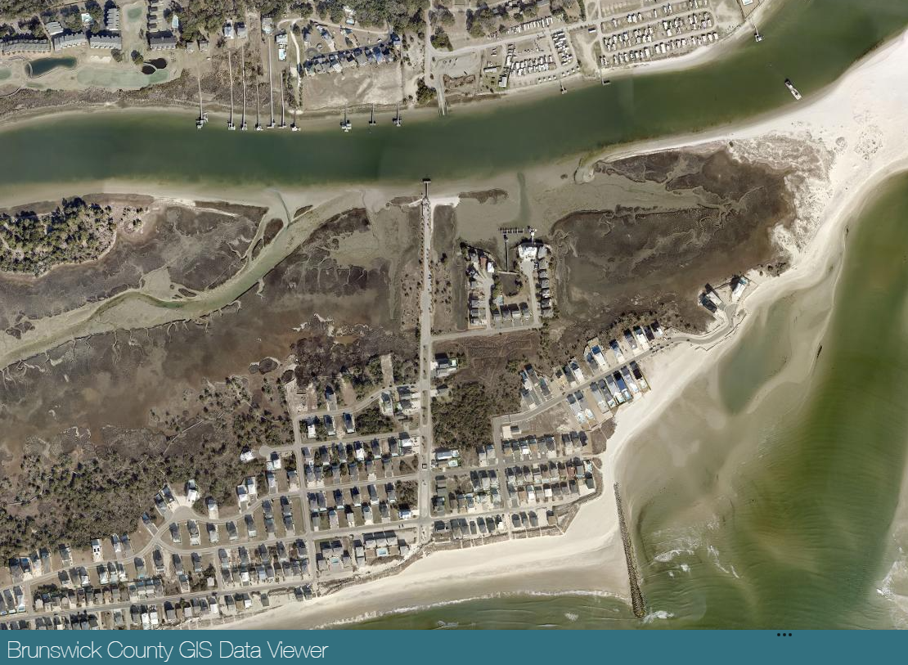

FINAL Report to the North Carolina Coastal Resources Commission

August 2026

Prepared by the N.C. Coastal Resources Commission Science Panel

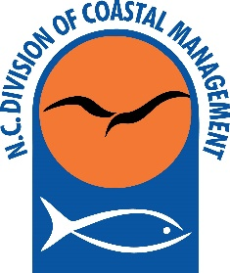

This work was supported by the N.C. Department of Environmental Quality, Division of Coastal Management.

Disclaimer: This report was prepared by the N.C. Coastal Resources Commission’s Science Panel, acting entirely in a voluntary capacity on behalf of the Coastal Resources Commission. The information contained herein is not intended to represent the views of the organizations with which the authors are otherwise affiliated. The Science Panel reserves the right to revise this draft report.

Cover Images (clockwise from top right)
1. Cape Hatteras National Seashore in Dare County, looking North towards Buxton
2. Revetment at Fort Fisher in New Hanover County
3. Terminal groin at Ocean Isle Beach in Brunswick County, completed in 2022
4. Terminal groin on Bald Head Island in Brunswick County, completed in 2015, along with geotextile tube groin field along South Beach
Members of the N.C. Coastal Resources Commission Science Panel

The Science Panel consists of the following individuals, who serve voluntarily and at the pleasure of the N.C. Coastal Resources Commission.

Dr. Laura Moore, Chair
Professor, UNC-Chapel Hill, Department of Earth, Marine and Environmental Sciences

Dr. Reide Corbett
Executive Director of Coastal Studies Institute, Dean of Integrated Coastal Programs, East Carolina University

Dr. Andrea Hawkes
Associate Professor of Geology, University of North Carolina Wilmington

Dr. Joseph W. Long
Director Coastal Engineering Program, Department of Physics & Physical Oceanography, University of North Carolina Wilmington

Dr. A. Brad Murray
Professor, Nicholas School of the Environment, Division of Earth and Ocean Science, Duke University

Dr. Martin Posey
Professor, Department of Biology and Marine Biology, University of North Carolina Wilmington

Mr. Spencer Rogers
North Carolina Sea Grant (retired), Wilmington

Mr. Greg “Rudi” Rudolph
Maritime Program Director, Woolpert

Dr. Greg Williams, P.E.
Assistant Professor of Practice in Coastal Engineering, Department of Civil Engineering, University of North Carolina Wilmington

Contributing Guest Author:

Dr. Craig Landry
Professor, Department of Agricultural & Applied Economics, University of Georgia
N.C. Coastal Resources Commission Charge to the Science Panel

This report has been written by the members of the Science Panel as a public service in response to a charge from the Coastal Resources Commission (CRC):

2026 Charge to the Science Panel

In response to increasing concerns about beach erosion in Dare and Currituck Counties, the Coastal Resources Commission (CRC) established the Outer Banks Erosion Task Force in 1984. The 16-member task force included representatives from the CRC, the Coastal Resources Advisory Council (CRAC), municipal and county governments, the U.S. Army Corps of Engineers (USACE), and coastal erosion specialists. The group was supported by an additional 13 technical and policy advisors.

The Task Force recommended a balanced approach to managing oceanfront erosion that protects both public beach access and private property rights while minimizing public costs and future erosion risks. It strongly opposed permanent shoreline stabilization structures, such as seawalls, that impair public trust rights, while supporting temporary and innovative erosion-control measures that avoid adverse impacts to neighboring properties and public beach use. Although some recommendations were adopted through subsequent CRC rulemaking efforts, to include NC’s regulatory restrictions on hard structures, others were acknowledged as valuable guidance but did not result in regulatory or legislative action.

Recent erosion impacts in several North Carolina oceanfront communities have brought shoreline management issues back to the forefront, prompting questions about whether alternatives to beach nourishment should be considered to address chronic erosion. These concerns are underscored by the loss of 32 oceanfront homes to erosion in Dare County (Rodanthe and Buxton) since 2020.

Reflecting these growing concerns, the CRC requested its Science Panel prepare a report on the effects of hard structures along sandy, open-ocean shorelines. The CRC approved the Science Panel’s draft report outline at their February 2026 meeting. The report is intended to be a high-level review of various types of structures, their advantages and disadvantages, lessons learned from existing projects in North Carolina and other coastal states, cost-benefit considerations, tradeoffs, and potential alternatives to hard structures, including approaches currently in use.

Executive Summary

In response to a request from the Coastal Resources Commission (CRC), the volunteer CRC Science Panel provides this overview of the benefits and adverse effects of hard structures on open-ocean coastlines, including representative citations from the large body of literature on this topic. On open-ocean, sandy, barrier coastlines, large quantities of sand move both in the alongshore direction and the cross-shore direction. Long-term, chronic shoreline erosion results when a stretch of shoreline progressively loses sand because the net alongshore transport of sand leaving one end of the stretch is greater than the net sand transport entering at the other end. Cross-shore sand transport can also contribute to chronic erosion when storms are strong enough to overtop or erode away dunes, and move sand from the shallow seabed, beach and dunes to the interior of a barrier island (or barrier spit). While these ‘overwash’ events constitute hazards for humans and coastal development, they are also the way barriers are created, and the way these landscapes are maintained above water level as sea level rises, which it has for millennia.
As the rate of sea-level rise continues to increase into the future (Sweet et al., 2022; IPCC 2023; N.C. Coastal Resource Commission Science Panel on Coastal Hazards, 2024) along with the frequency of major hurricanes in the Atlantic basin (Kossin et al., 2022), erosion rates and the frequency of overwash events will also increase, making it even more challenging, and more expensive to mitigate erosion and reduce risk to infrastructure.
We distinguish between the category of structures intended to mitigate erosion, which includes a wide range of ways to trap sand moving alongshore, and the category of structures intended to directly reduce risk for coastal development (e.g., homes and commercial buildings, etc.) and infrastructure (e.g., roads, utilities, parking lots, etc.) by hardening the shoreline, which includes seawalls, revetments and a range of analogous approaches.
All structural approaches emplaced with the intention of mitigating erosion by trapping sand, whether in an obvious way through the use of groins or through the use of less visible underwater features, lead to the same inevitable impact: an increase in shoreline erosion ‘downdrift’ (e.g., Davis and FitzGerald, 2009). The increase in erosion downdrift occurs because sand that would have been deposited downdrift is captured updrift, remaining there instead of passing alongshore. Because sand is neither created nor destroyed in these cases (following the principle of mass conservation), increases in downdrift erosion tend to equal decreases in erosion in the updrift project area arising from the sand trapping effect. This process leads to the tendency for the installation of a single groin or structure that traps sand to prompt, or require, the installation of additional similar structures downdrift over time to mitigate increasing erosion of neighboring beaches (e.g., Davis and FitzGerald, 2009; Komar, 1998).
Compared with other sand-trapping approaches, groins tend to produce downdrift erosion that is more immediately adjacent to the structure, more spatially concentrated, visually apparent, and relatively straightforward to document. However, the conservation of mass dictates that reductions in erosion that are achieved by reducing the net alongshore movement of sand will always be equaled by increases in erosion downdrift, even if those increases are distributed along broader lengths of coastline (for example in the case of a permeable groin, or a breakwater). In addition, the longer a sand-trapping structure is in place on an eroding shoreline, the farther the effects will extend (e.g., Fredsoe and Deigaard, 1992).
All approaches to protecting infrastructure that involve hardening the shoreline tend to produce the same adverse physical effects. First, beaches and dunes tend to shift landward as shorelines erode, and creating a fixed, hardened location landward of an eroding shoreline prevents the natural landward shift of the dune and beach zone. This means that the dune and beach zone will become narrower (e.g., Dugan et al., 2008; Griggs, 2005) and will ultimately disappear over time (e.g., Pilkey and Wright, 1988; Hall and Pilkey, 1991; Komar, 1998). If erosion continues in front of a shoreline hardening structure, the sand comprising the beach and nearshore seabed will continue to be progressively lost, eventually leaving sub-tidal seabed in front of the hardened structure instead of a beach (Hall and Pilkey, 1991). Additional adverse physical/geomorphological effects of shoreline hardening are described in Section 2b.
In addition to physical/geomorphological effects of hard structures, high-energy open-ocean coastlines are important habitats for commercially and recreationally important species, including juvenile habitat, migration routes, and foraging locations (Able et al. 2013; Layman 2000; Ross and Lancaster 2002). Other species utilizing these habitats may include sea turtles, various shorebirds, and periodic use by other animals of interest (Shamblott et al. 2021; Zeigler et al, 2021). Approaches designed to mitigate erosion or reduce risk may also have significant impacts on the ecological services of these areas (e.g., Airoldi et al. 2005, Gittman et al., 2016), with the type and degree of impact varying among approaches.
Similarly, North Carolina beaches support a variety of recreational activities that are of significant economic value and require consideration in discussions of approaches to mitigate erosion and reduce risk. At the project scale, determining whether installing a structure (to mitigate erosion or reduce risk to infrastructure) makes economic sense requires accounting for the present value of dynamic paths of benefits and costs over time and comparing them to a counterfactual scenario (typically current conditions projected into the future) and other alternatives. Physical/geomorphological, ecological, and risk exposure changes and adverse effects arising from the implementation of hard structures affect the flow of net benefits across multiple economic sectors, including housing, recreation, tourism and ecosystem services. Identified geomorphological, ecological, and risk exposure changes and adverse effects over space and time likely to occur as a result of a proposed project, as well as the counterfactual and control interventions, can be translated into benefits and costs, which can be projected into the future to calculate the present value of net benefits over time (which may be positive or negative). However, not all tradeoffs can be easily monetized or fully captured through economic analysis alone. Benefits and costs may be distributed unevenly among private property owners, local governments, state agencies, recreational users, adjacent communities and future taxpayers.
The Science Panel’s recommendations, presented in the last section of this report, are predicated on the well-accepted scientific and engineering understanding that sand-trapping and shoreline-hardening approaches on sandy, open-ocean coastlines involve adverse effects as well as potential localized benefits. The Panel therefore recommends that North Carolina maintain a cautious approach to any expansion of the use of hardened structures and that any major reconsideration of the State’s oceanfront management policies include a broad and comprehensive assessment of the physical, ecological, recreational, and economic consequences of expanded use, including consideration of who will likely benefit and who will likely suffer adverse effects, prior to policy modification.
We recommend that if policy changes create new opportunities for specific projects, those projects should be thoroughly evaluated for intended benefits, the likelihood of achieving benefits, the myriad adverse effects described in detail in this report, net benefits (positive or negative), and ongoing long-term maintenance needs, which can be considerable. We further recommend that project evaluations also include assessment of a comprehensive, required monitoring and mitigation plan, and receive impartial scientific and engineering review supported by appropriate third-party and state technical capacity. We recommend avoiding authorization of projects for which evaluations reveal that adverse effects cannot be mitigated sufficiently to make the tradeoffs acceptable.

- Introduction

The North Carolina Coastal Resources Commission requested that the Science Panel provide a report addressing the effects of hard structures on open-ocean coastlines. This report focuses on open-ocean shorelines (and therefore excludes estuarine shorelines), and primarily addresses structures intended either to mitigate erosion or to reduce the risk of storm impacts (rather than those intended for other purposes, such as jetties, which are related to navigation).
This section briefly reviews the physical processes relevant on open-ocean North Carolina coastlines, and describes potential approaches to managing coastal-development challenges in North Carolina. In Section two, we discuss the types of hardened structures used to mitigate erosion, and those used to reduce risk to houses, roads, or any infrastructure landward of the beach/dune zone (hereafter collectively termed ‘infrastructure’), as well as the common physical adverse effects associated with these categories of structures. That section also summarizes recreational, ecological, and economic considerations related to these types of hard structures. Section three presents case studies exemplifying the tradeoffs between intended benefits and adverse impacts associated with the use of hard structures and Section four provides a high-level overview of how other states approach the use of structures to mitigate erosion and reduce risk to infrastructure. We close with some general recommendations from the Science Panel based on the scientific literature and current understanding of how coastal systems function.

a. Overview of shoreline change on barrier island landscapes
On sandy, open-ocean shorelines waves and currents move sand from one place to another, shaping the coastal landscape. Sand moves both perpendicular to the shore (‘cross-shore’) and parallel to the shore (‘alongshore’). Both cross-shore and alongshore sand transport can cause ongoing changes in the position and shape of coastal landscapes, including beach and shoreline erosion (or seaward growth of the beach/‘accretion’, in some places), and the landward and upward migration of barrier islands over timescales of decades and longer.
During moderate storms, when sand dunes remain intact, sand moves offshore from the beach and nearshore seabed, causing short-term storm erosion (e.g., Sallenger 2000). However, over the days and months after a moderate storm, eroded sand tends to move back to the nearshore seabed and onshore to the beach, reversing the temporary erosion that occurs during a storm (e.g., List and Ferris, 1999; List et al., 2006). In contrast, during more severe storms, when sand dunes are eroded away or inundated by high water levels, sand can also move landward of the beach, through a process called ‘overwash’ that leads to deposition of sand called “washover.” In the natural state, sand that is transported landward of the beach does not return to the beach or nearshore seabed, and in this way, the removal of sand from the beach by overwash via emplacement on barrier island interiors contributes to lasting, chronic shoreline erosion.
On the other hand, on a low-lying coastline like the North Carolina coast, the transport of sand landward of the beach during overwash events is what created barrier islands and barrier spits (hereafter referred to as ‘barriers’; e.g., Moore and Murray, 2018). And, as sea level continually rises (as it has in recent millennia), repeated washover deposits tend to maintain barrier width and elevation above sea level, enabling continued existence of the barrier landscape (e.g., Leatherman, 1976; Moore et al., 2010; Moore and Murray, 2018; Anarde et al., 2024a,b).
In addition to the cross-shore processes described above, alongshore sand transport strongly influences shoreline position and beach width. Alongshore sand transport arises because waves approach the coast at an angle. When waves break, they create a current in the direction of the breaking waves (Komar, 1998). The alongshore current is relatively slow. However, the turbulence of the breaking waves suspends sand in the water column allowing large volumes of sand to be transported alongshore (e.g., Fredsoe and Deigaard, 1992).
On some days, the alongshore current moves sand to the left (looking offshore) and on others days it moves sand to the right, but over time these movements of sand amount to a unidirectional net movement (transport) of sand along a shoreline. Ongoing, chronic shoreline erosion results primarily from variations in the amount of net alongshore sand transport along the coast: If the net amount of sand transported into a section of shoreline, say over a year or longer, is smaller than the net amount of sand transported out of that section, the ongoing loss of sand results in chronic shoreline erosion. In contrast, if the ongoing contribution of sand to a section of shoreline, say over a year or longer, is greater than the amount of sand lost, this leads to shoreline accretion.
The chronic shoreline erosion experienced in recent decades along barrier coastlines results primarily from these alongshore variations in net sand transport. However, the contributions to chronic shoreline erosion from overwash deposition are likely to become more impactful as sea-level-rise rates increase (Sweet et al., 2022). Shoreline erosion rates are expected to increase in coming decades, with continued increases in sea-level rise rate (Sweet et al., 2022; IPCC, 2023; N.C. Coastal Resource Commission Science Panel, 2024) in combination with an expected increase in the frequency of the strongest hurricanes (e.g., Kossin et al., 2020; Vecchi et al., 2021; IPCC 2023), and with likely changes in distributions of wave directions and consequent effects on alongshore sand transport (e.g., Slott et al., 2006; Moore et al., 2013; Antolinez et al., 2018). By 2050 sea level on the North Carolina coast is projected to be a foot higher than it was in the year 2000 (Sweet et al., 2022). By the end of the century, sea level is expected to rise at rates higher than any in recent millennia (since the rapid sea-level rise following the end of the last glacial period; IPCC 2023), and barrier environments are likely to be even more dynamic than they have been in recent centuries (e.g., Moore and Murray, 2018; Anarde et al, 2025; Franklin et al., 2026).

b. Processes specific to the North Carolina coastline
Along the NC open-ocean coastline, which is largely made up of barriers, relatively high-energy waves play a stronger role in shaping and shifting the landscape than do tidal currents, leading to long stretches of continuous alongshore sand transport, interrupted by relatively widely spaced tidal inlets. In addition to the cross-shore and alongshore processes described above in Section 1a, the tidal inlets and associated shoals in NC tend to act as “sand sinks,” meaning they are depositional environments where sand collects and is therefore effectively removed from the beach/dune system (Fitzgerald, 1988). The three NC capes (Cape Hatteras, Cape Lookout and Cape Fear) and their associated shoals also act as sand sinks, places where sand is naturally transported by currents and effectively removed from the beach and nearshore system (McNinch and Wells, 1999). Although inlet dredging is sometimes associated with return of sand from inlets to the beach/dune system, the loss of sand to tidal inlets and cape-associated shoals contributes to the prevalence of coastal erosion along the NC coast.
According to the latest erosion rate study completed by the NC Division of Coastal Management (NC DCM, 2025a), the open-ocean NC coastline is eroding at an average rate of 1.9 ft/year. The report found that ~140 miles of open-ocean coast is eroding more than 2 ft/year while ~135 miles of coast is eroding less than 2 ft/year and ~100 miles of coastline is accreting (NC DCM, 2025a). In many locations, frequent and sustained beach nourishment has successfully masked naturally higher rates of background erosion and this effect has become more pronounced (except in the state’s erosion hot spots) as nourishment has become more widely and frequently used (Hapke et al., 2010; Hapke et al., 2013; Johnson et al., 20214).
The current NC coastal erosion hot spots arise primarily where there are large differences in net alongshore sand transport from one end of a section of shoreline to the other (e.g., Lazarus and Murray, 2011). Volumes vary and in the vicinity of Kill Devil Hills and Nags Head, for example, net alongshore transport ranges from 100,000 cubic yards/year to 260,000 cubic yards/year, equivalent to 27 to 71 dump trucks of sand per day (Kaczkowski & Kana, 2012). These differences in net alongshore sand transport can be caused by shoreline shape (e.g., Ashton et al., 2001; Ashton and Murray, 2006; Lazarus and Murray, 2011; Moore et al., 2013), by inlets (CRC Science Panel, 2025), or by nearshore or offshore features on the seabed that affect how wave energy is distributed along the coastline (e.g., Limber et al., 2017). Currently, the most concerning open-ocean erosion hot spots are located in Dare and Hyde County (Figure 1).
The hot spot at Rodanthe straddles a convex-seaward bend in the coastline, which tends to cause erosion (Lauzon et al, 2019). The coastline in the vicinity of Buxton has tended to erode at high rates from prehistoric times to the present, as patterns of net alongshore sand transport have led to the alongshore migration of Cape Hatteras (e.g., Figure 5; Pilkey et al., 1998, p. 15; Ashton et al., 2001; Antolinez et al., 2018). Prior to installation of groins and repeated beach nourishment in this area, chronic erosion was occurring at a rate of greater than 20 ft/year (National Research Council, 1988). In areas of high long-term erosion rates, natural shoreline erosion has led to the unfortunate intersection of homes and infrastructure with the shoreline and beach-dune profile. This occurrence is a product of natural processes and a setback policy that typically requires homes to be constructed a distance of at least 30 times the average long-term erosion rate landward of the vegetation line (with some exceptions). Many of the homes lost had been present since the 1990s and 1980s, having been constructed well over 30 years ago.
Prior to the construction of dunes along the NC Coast by the Civilian Conservation Corps in the 1930s, the NC barriers, especially within the Cape Hatteras National Seashore were dominated for at least a few decades by overwash processes; they were essentially washover plains (Stick, 2015). At that time, washover likely contributed significantly to landward shoreline migration. Where dunes are currently present, differences in net alongshore sand transport remains the primary driver of shoreline erosion.
Repeated overwash deposition concentrated along a section of shoreline can create or accentuate erosion hot spots (Anarde et al., 2024a, b). For example, on Ocracoke Island, patterns of net alongshore transport related to a tidal delta have created an erosion hot spot that narrowed the island locally and concentrated washover, which enhances erosion due to differences in net alongshore transport alone (Franklin et al., 2026). Importantly, although dunes limit overwash event frequency and the degree to which overwash contributes to shoreline erosion, dunes also prevent the accumulation of washover behind the beach and therefore prevent increases in elevation that washover deposition provides. This leaves the landscape vulnerable to soundside inundation during storms and rising sea level (Maggliocca et al., 2011; Rogers et al., 2015; Anarde et al., 2024a, b; Eisemann et al., 2025; Franklin et al., 2026).
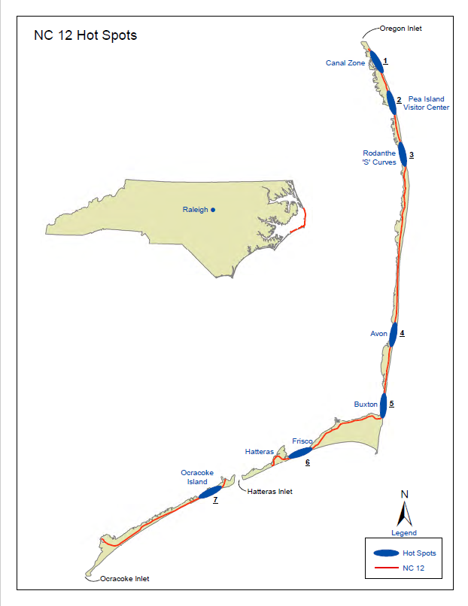
Figure 1. Map of erosion hot spots in Dare and Hyde Counties, NC (From NCDOT, 2021)
c. Categories of management approaches for sandy, open-ocean coastlines
Management alternatives that mitigate erosion and/or reduce infrastructure risk on open-ocean coastlines can be divided into five main categories, including strategic relocation; planting vegetation and building dunes; adding sand; trapping sand; or hardening the shoreline (e.g., Griggs & Reguero, 2021). The latter two categories are the focus of the report as per our charge from the CRC and are the focus of Section 2. Below, we briefly introduce the other three alternatives. While there are different management alternatives often applied to estuarine barrier island shorelines, such as living shorelines (e.g., Gittman et al., 2015; Gittman et al., 2021; Smith et al., 2018), low sills or reefs intended to create habitat (e.g., Scyphers et al., 2015) or bulkheads that function as retaining walls in estuarine environments (e.g., Burdick et al., 2025, Gittman et al., 2016), these are not suitable for open-ocean higher wave energy environments and for this reason are not discussed in this report.

Plan, strategically relocate or realign
The challenges associated with erosion can potentially be avoided by advanced planning, such as the development and implementation of land-use plans and building setbacks, which identify the various erosion threats and require construction some distance from the shoreline with the intent of preventing erosion from impacting a structure during the lifetime of the building. Areas of high chronic erosion, or where shoreline change patterns are variable over time (for example, inlet hazard areas; see the 2025 Inlet Hazard Area Update, Division of Coastal Management, 2025), may require more restrictive policies to avoid threats to infrastructure from erosion. In the case of erosion associated with movement of inlets that are not stabilized, relocation of the inlet throat and routine maintenance may provide a viable alternative to structures, as in the case of Mason Inlet, NC and Bogue Inlet, NC.
Once buildings and roads become threatened, damage may be avoided by moving existing infrastructure farther from the shoreline. This can be done strategically by monitoring the position of the shoreline relative to infrastructure over time and either relocating or removing threatened infrastructure or adjusting land use so that it is better aligned with the changing landscape. This requires sufficient land to move development a safe distance from the eroding shoreline and so works best in low-erosion-rate areas, but it can be used in high-erosion-rate areas where beach nourishment and other erosion mitigation options are not cost-effective. Adaptation approaches of this sort may take place at the individual or community scale, with the latter often referred to as “managed retreat” (e.g., Hino et al., 2017; Siders, 2019; Siders et al., 2019; Lester et al., 2022) and include incentives to relocate or remove infrastructure provided through private or public funding. This approach is also sometimes referred to as “managed realignment” (Griggs and Reguero, 2021), however this term is also often applied broadly in Europe to refer to the removal or alteration (usually notching) of structures such as estuarine sills, ocean-front seawalls and dunes to restore natural processes after realizing that preventing them through erosion mitigation and risk reduction measures has caused more harm than benefit (e.g., Esteves, 2014).

Plant vegetation and build dunes
Storm protection for infrastructure landward of the dune line may be enhanced by trapping wind-blown sand and using other methods to build dunes or increase their height and/or width (USACE 2013). Planting beach and dune grasses (Elko et al., 2016), installing sand fences (e.g., Nordstrom et al., 2012; Miller et al., 2001; Anthony et al., 2007; Jackson and Nordstrom, 2018; Charbonneau and Wnek, 2016) or using other methods to increase the volume of sand in the dune seaward of the infrastructure (Elko et al., 2016) to be protected can increase dune height and width. How much reduction in risk during storms–and for which types and characteristics of storms–depends on the dune height and width achieved through the use of these approaches (Itzkin et al., 2021). This low-cost solution does not mitigate chronic long-term erosion and over time may increase vulnerability to sound-side inundation by preventing increases in island interior elevation gained by overwash (Anarde et al., 2024a, b; Eisemann et al., 2025).

Nourish beaches
Beach nourishment is the placement of sand of similar grain size and quality onto an eroding beach to mitigate erosion (e.g., Dean 2003, Elko et al., 2021). Ideally, sand is sourced from a location—such as an offshore shoal, inlet, or navigation dredging area—where it can be extracted without causing adverse impacts to the borrow site or the beach and nearshore system (Finkl et al., 1997, Benedet et al., 2008). Adding sand to the beach system can mitigate, or offset, natural long-term erosion losses. Because long-term erosion continues after placement, sand must be added at a sufficient frequency and in sufficient quantities to continue mitigating erosion. The frequency and rate of sand placement required depends on the natural erosion rates (National Research Council, 1995), and requires the continued availability of compatible sand sources, which may be limited (UNEP, 2026) especially in Onslow, Pender, New Hanover and Brunswick Counties (USACE, 2021).
The addition of sand to the beach and nearshore also replenishes adjacent beaches, both updrift and downdrift, as sand is naturally redistributed by alongshore sand transport. Beach nourishment projects that also include dune construction can reduce risk to infrastructure behind the dunes as discussed above. In areas with high erosion rates, beach nourishment may be cost prohibitive. This alternative must be completed at a community scale and is not an option for individual homeowners. It can also impact recreation, groundwater processes, and have adverse impacts to habitat (e.g., de Schipper et al., 2020).

d. Approaches currently allowed and implemented on the NC oceanfront
North Carolina’s Coastal Area Management Act (CAMA) and implementing rules in 15A NCAC Chapter 7 establish a clear policy preference against the use of hard structures along the oceanfront. Hard structures intended to mitigate erosion within a project area (such as groins and breakwaters) and structures intended to reduce risk to infrastructure (such as seawalls, bulkheads and revetments) are generally prohibited along the open-ocean coastline due to the potential for adverse effects on public access, public trust beaches, adjacent properties, and natural beach dynamics. Instead, the State relies primarily on beach nourishment as the preferred method for mitigating erosion and reducing risk to infrastructure on the open-ocean coastline. Limited exceptions exist for temporary structures intended to reduce risk, such as sandbags, which may be authorized to provide some measure of protection for imminently threatened structures. These exceptions are subject to strict siting, design, and time limitations and are not intended as permanent measures. Sandbags are limited in size to six feet high and 20 feet wide with a time limit; emplacement is limited to no more than eight years. Previous analysis by the Science Panel on Coastal Hazards advised that the size limit on sandbag revetments was more important than the time limit in minimizing the impact of temporary protection on the seaward beach and adjacent properties.

In 2002 the General Assembly enacted legislation that codified the State’s existing oceanfront erosion-control rules in law as G.S. 113A-115.1. The General Assembly later authorized a limited number of terminal groins as experimental projects, creating a narrow exception to the broader prohibition on permanent erosion-control structures. Outside of these specific exceptions and other limited circumstances allowed under current law and rules, new oceanfront structures intended to mitigate erosion or and reduce risk to infrastructure remain prohibited.

Prior to North Carolina’s modern oceanfront regulatory framework, a number of hardened structures were constructed along the coast. Many have since deteriorated, failed, or been removed, but some remain as legacy structures. These structures generally may be maintained or repaired, rather than treated as new construction, if more than 50% of the original structure remains.

- Structures that Trap Sand or Harden the Shoreline: Benefits, Adverse Effects and Tradeoffs

Coastal areas through North Carolina exhibit key differences in physical characteristics (e.g., wave climate, sediment characteristics, shoreface slope and substrate) that can make a relatively successful management approach or combination of approaches in one location ungeneralizable and unsuitable for use in other areas. Each management approach also involves physical, ecological, recreational, and economic considerations within and beyond the project area. There are hundreds of proposed structural approaches intended to mitigate erosion and/or reduce risk to infrastructure; a few have been widely used. While many new variations continue to be developed, most are untested or have not been in place long enough to determine overall efficacy. Regardless, all structural approaches used on open-ocean coastlines fall into one of two general categories: Structures intended to 1) mitigate erosion in the project area by trapping sand or 2) reduce risk to infrastructure by hardening the shoreline. In the two sub-sections that follow we summarize the function and benefits versus adverse effects (tradeoffs) associated with the most well-known and best-understood approaches within these two categories.

- Structures that trap sand - Function and benefits vs adverse effects (tradeoffs)
Sand-trapping structures intended to mitigate erosion on sandy, open-ocean coastlines can be emplaced either parallel to shore or perpendicular to shore. In both cases, the primary function is to reduce beach erosion by interrupting or decreasing net alongshore transport of sand.
Shore-parallel structures like nearshore breakwaters on open-ocean coastlines are “detached structures that reduce the amount of wave energy reaching the shore” (USACE, 2008, Part V). The effectiveness and impacts of the structure depend on the distance from shore, total length, breakwater structure (e.g., open or closed structure), elevation of the breakwater relative to water level, etc. The reduction in wave energy locally reduces the net alongshore sand transport resulting in deposition of sand and a shoreline bulge directly in front of the structure (USACE, 2008, Part V). Typically, nearshore breakwaters are constructed of rubble mound rock or concrete armor units piled on the seafloor and extend to an elevation above sea level or remain submerged. Nearshore breakwaters in the U.S. tend to be used on sediment-starved shores with fetch-limited (low energy) wave climates on the Great Lakes, Chesapeake Bay and Gulf of Mexico (Pope and Dean, 1986).
Submerged breakwaters (also sometimes called low-crested breakwaters or reef breakwaters) are shore-parallel structures built with the intention of reducing wave action on the beach by causing waves to break on the submerged structure. Traditionally, submerged breakwaters are built of large stone or concrete armor units. In addition to causing wave breaking over the crest, submerged breakwaters can affect wave action by diffraction and refraction. The amount of wave transmission and sand trapping capacity is related to the design height of the breakwater relative to sea level. It is important to keep in mind the high energy of the NC Atlantic-facing coastline and what is required, from an engineering standpoint, to provide an effective wave break. For example, submerged, open-form breakwaters are likely to be ineffective in an environment such as the open-ocean NC coastline and at this time, we have not seen examples of successful use of such structures in comparable environments. Because they are submerged and not visible at the surface, submerged breakwaters are also a hazard to participants in nearshore water sports and navigation such as boating, kayaking, and swimming (USACE, 2008, Part VI).
While rubble-mound submerged breakwaters have been studied to quantify wave reduction (e.g., Van der Meer and Daemen 1994), new types of materials and shapes have been developed for the construction of modular and porous submerged breakwaters. Examples include various 3D printed concrete units, reef-style modules, oyster bags, geotextiles, and other engineered forms. Many of these forms have been applied primarily in estuarine environments where wave energy is low compared to the open-ocean coast. There are also examples in other parts of the world (e.g., Australia, Arabian Gulf) where modular reef units or geotextiles have been deployed for habitat creation, erosion mitigation, or both (Coastal Engineering Research: International Coastal Management). Many units, however, have only been tested in controlled flume experiments (Lamsal et al., 2026) without large-scale field applications in high-energy wave environments. As a result, their stability, anchoring requirements, durability, sediment-transport effects, and performance under storm conditions remain untested and uncertain for open-ocean settings such as the North Carolina coast
Shore-perpendicular structures, such as groins, extend offshore, but are relatively short when compared to navigation jetties (USACE, 2008). Groins can be constructed as rubble-mound structures or sheet-piles made of steel, concrete or wood. A groin acts “as a partial dam” that intercepts a portion of the sand transported alongshore (Galgano, 2004). Groins can be designed with variable permeability. Permeable groins allow some amount of sand to pass through or over the structure, while impermeable groins are “sand tight” and do not allow sand to pass through (USACE 1992). Recent research addresses ways to increase groin permeability, and to combine this approach with beach nourishment to increase sand bypassing (USACE, 2008 Part V). To allow permeability, groins are sometimes designed to have a “low-profile” and to closely follow the slope of the nearshore (Basco and Pope, 2004). Attempts to increase permeability of existing groins has involved “notching” whereby part of the groin near the swash zone is removed to allow sand to migrate alongshore (Donohue et al., 2004; Rankin et al., 2004; Wang and Kraus, 2004).
A terminal groin is a groin that is emplaced at the end of a barrier island or peninsula. Terminal groins function in much the same way as described above and are emplaced with the intention of holding sand in place on the beach rather than losing it to a sand sink (Griggs et al., 2020), such as an inlet at the island terminus. Terminal groins (and groins in general) should not be confused with jetties, which have a primary purpose of stabilizing inlets, preventing sand from entering into navigation channels and reducing wave energy for navigation (USACE, 2008). Jetties are typically five to 10 times longer than groins and extend into much deeper water. Like groins, jetties function as sand traps; the larger and longer the structure the greater the potential sand trapping capacity. For more information on the complexity of inlets and related shoreline features see: Inlet Hazard Area Boundaries, 2025 Update: Recommendations to the NC Coastal Resources Commission (N.C. Coastal Resource Commission Science Panel, 2025).
Any structure that reduces shoreline erosion in one area by reducing the net alongshore transport of sand out of that area, including, but not limited to, breakwaters and groins, will increase erosion downdrift. Increases in downdrift erosion are most obvious in the case of groins (and jetties), but any structure designed to reduce the net alongshore transport of sand to mitigate erosion will necessarily reduce the net transport of sand into downdrift areas (e.g., Davis and Fitzgerald, 2009). The longer a sand-trapping structure remains in place, the farther alongshore the impacts will extend (e.g., Fredsoe and Deigaard, 1992). As a result of downdrift impacts, emplacing a single groin often necessitates the need to later emplace additional groins, leading to compounding costs and translation of downdrift erosion farther downdrift. For this reason, multiple groins are sometimes arrayed alongshore, emplaced as a ‘groin field’ to mitigate increased erosion of downdrift beaches (e.g., Davis and FitzGerald, 2009; Komar, 1998). In such cases, the impacts on beaches downdrift of the last groin will be amplified. Therefore, any evaluation of a sand-trapping structure should explicitly consider the tradeoff between reducing erosion in the targeted area and increasing erosion, sediment deficits, and management costs downdrift.

- Structures that harden the shoreline - Function and benefits vs adverse effects (tradeoffs)
The U.S. Army Corps of Engineers (USACE) Coastal Engineering Manual (USACE, 2008) defines coastal armoring structures as structures that armor, or harden, the shoreline, with the intention of holding it in place to prevent or reduce damage to what is behind (landward) of the beach. The intent is for these structures, which on the open-ocean are typically seawalls or revetments, to serve as a barrier to block erosion, ocean inundation, and wave attack.
These structures have a variety of configurations and construction materials. Vertical structures often made from concrete or metal sheet piles that reflect incoming waves are known as seawalls. Seawalls typically serve as a massive barrier installed with the intention to “prevent inland flooding from major storm events accompanied by large, powerful waves.” (USACE, 2008 Part V). These vertical, non-absorbing structures block wave energy and re-direct it back toward the ocean. While similar to bulkheads placed in estuarine environments, seawalls require much stronger materials and sturdier construction to withstand much larger amounts of wave energy. Re-curved seawalls (e.g., Galveston, TX and Ocean Beach in San Francisco, CA) include a curved, rather than purely vertical face, and are designed to more efficiently re-direct wave energy and uprush back toward the sea instead of upwards which can reduce overtopping, but the general impacts to the beach are the same
Armoring structures with a sloping front face are called revetments and are intended to ‘absorb’ some of the incoming wave energy. These essentially function in the same way as a seawall, armoring the shoreline and installed with the intention of preventing or reducing damage to landward infrastructure. Revetments are typically made of rip-rap (stone) and laid on the natural slope of the backshore. Sandbags and geotextile tubes, although made of sand and fabric, are also seawalls, functioning in the same manner as vertical, re-curved or rock seawalls. Although they may not last as long as the concrete and stone versions, they have the same adverse effects.
Any structure that hardens the shoreline will, in addition to providing some protection of landward structures and infrastructure, have four types of adverse physical effects in the project area and three types of physical adverse effects on downdrift beaches. Adverse physical effects within the project area include: loss of beach width due to seawall emplacement (e.g., Hall and Pilkey, 1991); loss of beach width due to continued erosion (e.g.; Komar, 1998); prevention of seabed-profile adjustments during storms (Kriebel, 1987; Barnett & Wang, 1988; Jones & Basco, 1996); and prevention of washover deposition, which lowers the area behind the wall relative to sea level (e.g., Maggliocca et al., 2011; Miselis and Lorenzo-Trueba, 2017; Anarde et al., 2024a,b). Adverse physical effects occurring downdrift of the project area include: loss of the seawalled back-beach and dune as a sand source for downdrift beaches (e.g., Komar, 1998); accelerated erosion of adjacent dune areas during storm events on both sides of the structure (Walton, 1985; McDougal, 1987); and eventual sand trapping and alongshore sand transport reduction as updrift beaches erode and the seawalled section begins to present as a a bulge in shoreline, acting as a groin (e.g., Balaji et al., 2017).
The primary adverse effect of shoreline hardening is that placing a fixed structure landward of an eroding shoreline will inevitably cause a progressive loss of the beach seaward of the structure (e.g., Pilkey and Wright, 1988; Komar, 1998). A chronically eroding shoreline indicates an ongoing loss of sand, most commonly because net alongshore transport of sand out of a section of shoreline is greater than then net transport into it. A shoreline-hardening structure does not stop this ongoing sand loss, so that over time, the beach in front of the structure will narrow and ultimately disappear. As the beach and nearshore profile lower or retreat, the structure becomes more exposed to wave attack, scour, overtopping, and potential undermining, increasing the likelihood of damage and the need for repair. The only way to maintain a beach seaward of a shoreline-hardening structure is to add or retain sufficient sand through beach nourishment and/or a sand-trapping structure, compounding adverse effects and long-term maintenance obligations.
A potentially important long-term impact arises from the reduction or prevention of storm overwash. One of the intended functions of many shoreline hardening structures is to prevent or reduce storm wave impacts to landward infrastructure. Preventing or reducing wave impacts also prevents or reduces sand transport onto the interior of a barrier (Rogers et al., 2015; Eisemann et al., 2025). Without the intermittent elevation gains these storm overwash events provide, barriers tend to drown as sea level rises (e.g., Maggliocca et al., 2011; Miselis and Lorenzo-Trueba, 2017; Anarde et al., 2024a, b). Therefore, a shoreline-hardening structure involves tradeoffs between 1) preventing or reducing storm damage and loss of infrastructure, and 2) the long-term maintenance of the coastal landform.
The presence of a hardened structure landward of the dune and/or beach zone also reduces offshore transport from the now-truncated beach and dune zone, potentially preventing beneficial adjustments in the offshore profile under incoming storm surge and wave conditions (Kriebel, 1987; Barnett & Wang, 1988; Jones & Basco, 1996).
Shoreline hardening also prevents the back-beach and dune profile from serving as a sand source for downdrift beaches (e.g., Komar, 1998). When a coastline is erosional, especially under conditions of rising sea level, the beach and nearshore-seabed profile shifts landward. The sand eroded as the profile moves landward is distributed to other parts of the shoreline (e.g., Moore and Murray, 2018). The loss of this sand source from hardened shorelines, combined with the groin-like effect of a shoreline-hardening structure that protrudes onto the beach because of ongoing erosion, leads to increased erosion rates in both updrift and downdrift areas (e.g., Komar, 1992; Beuzen et al., 2018).

c. Ecological Considerations
In addition to physical considerations, high-energy open-ocean coastlines are ecologically important as migration routes and foraging locations for recreationally and commercially important species. Direct fishery use of these areas can range from surf fishing to nearshore commercial activities. However, much of the fisheries value is related to juvenile use, migratory passage, and prey species abundance (Able et al. 2013; Layman 2000; Ross and Lancaster 2002). Although specific species will vary among locations, examples of fish utilizing these habitats, at least periodically, include red and black drum, speckled trout, striped bass, bluefish, and Spanish mackerel (Chapoton and Sykes 1961; Hackney et al. 1996). Inlet areas bisecting these beaches are important spawning sites for blue crabs and migratory passes for juveniles of a variety of species such as white, pink, and brown shrimp, flounder, drum, and seatrout among others (e.g., Eggleston et al. 2009).

As many as 84 fish species have been reported utilizing the surf zone in a North Carolina beach, with some bait fish spending much of their lives in the habitat (Arb 2018, Layman 2000). Other species of interest periodically utilizing these habitats include sea turtles as nesting sites on beaches, as well as offshore pre-nesting congregation areas, and various shorebirds including species of state and federal interest such as the Piping Plover (Shamblott et al. 2021, Zeigler et al, 2021). Utilization of this habitat can be significantly affected by actions that affect nearshore sediment grain size, slope of the beach front, slope and depth gradient of the adjacent subtidal regions, and the intertidal/upland interface (Boreland et al. 2017; Hackney et al. 1996; Manning et al. 2013). Factors affecting turbidity, alongshore flow, or that may interfere with nearshore fish movement also may have impacts for resident, periodic, or migratory utilization of these habitats. Since certain migratory species utilize shallower water pathways parallel to the beach, structures affecting this passage may have significant impacts. The specific impacts will vary among approaches designed to mitigate erosion by trapping sand and approaches designed to protect infrastructure by hardening the shoreline.

Depending on the regional landscape, various approaches may also have broader ecosystem impacts. These may include introduction of hard substrate organisms into an area where they were previously uncommon, enhancing the potential spread of invasive species, changes in adjacent soft substrate (sands and finer sediments), and possible changes in local productivity (Airoldi et al. 2005). The nature of these changes and their potential local and regional impacts (positive or negative) will vary with the extent of structures in a region, the type of structure, and the regional habitats. For example, the impacts may not be as strong in a region with rocky outcrops but may be more apparent in a region such as the high energy beaches of North Carolina where naturally occurring intertidal hard substrates are not common (Airoldi et al. 2005).

d. Recreational Considerations
Ocean beaches are important centers for recreational activities that may be of significant local, regional and statewide economic value (described below). These include valuable recreational fisheries ranging from fishing piers and surf fishing to nearshore recreational boat fishing. Although only a portion of ocean beach recreational fishing activities, a 2012 report estimated that fishing piers had an economic impact of $152 million annually (Hadley 2012). As indicated in the preceding section on ecological considerations, recreationally important fish may be adversely affected by some approaches designed for erosion mitigation, with adverse effects on recreational fishing.
Among other recreation-related and economically important activities are tourism, both from NC state residents and tourists from other states and countries, vacation homes, and recreational use by residents. North Carolina periodically ranks among the top five tourist destination states in the U.S., with a significant proportion of tourists coming to visit the ocean beaches, likely influenced in part by their overall positive reputation (e.g., Houston 2023). Depending on the circumstances, the benefits and adverse effects on tourism of erosion mitigation structures and shoreline hardening approaches are important to consider in cost/benefit analyses regarding approaches to erosion mitigation and risk reduction (see section below for more details). Such considerations may involve both direct and indirect (e.g., reputational) effects. In addition, hard structures may result in reduced beach access and they generate a visual impact (Griggs, 2005), which may contribute to less recreational use of beaches with hard structures than beaches where erosion is mitigated with nourishment or relocation/removal of threatened structures (Landry and Smith, 2026).
e. Economic Considerations
Developing an economic analysis to determine whether installing a structure (to mitigate erosion or reduce risk to infrastructure) makes economic sense requires accounting for the present value of dynamic paths of benefits and costs over time and comparing them to a counterfactual scenario (typically current conditions projected into the future). To truly optimize management of a coastal system from an economic standpoint, however, requires specification of an optimal control problem that includes all possible erosion mitigation and adaptation measures (e.g., beach replenishment, shoreline armoring, managed retreat) as potential controls and finding the path that maximizes the present value of net benefits over time. Given the complexity of coastal systems, however, this can be a daunting challenge. A properly specified model must: (i) account for dynamic geomorphological, ecological, and risk exposure changes associated with control interventions across space and time (including spatial spillovers, such as adverse effects downdrift); (ii) be spatially explicit in representing flows of net benefits across distinct economic sectors (e.g., housing, tourism, ecological services); (iii) integrate complex socio-economic institutions and responses (e.g., general equilibrium responses); and (iv) assess the impact of dynamically evolving environmental forcings (rising sea levels, intensifying coastal storms) with stochastic elements.

Geomorphological, ecological, and risk exposure changes and adverse effects arising from the implementation of hard structures, as described in Section 2, affect the flow of net benefits across multiple economic sectors. Identified geomorphological, ecological, and risk exposure changes and adverse effects over space and time likely to occur as a result of a proposed project, as well as the counterfactual and control interventions, can be translated into benefits and costs. These, in turn, can be projected into the future and combined with best estimates for discount rates to calculate the present value of net benefits over time. Estimates of erosion rate reduction, risk reduction, project performance, and design life are inherently uncertain and may prove more optimistic than what is realized, particularly when project appraisal does not fully account for risk, uncertainty, and long-term maintenance needs (National Research Council, 1995; Flyvbjerg and Bester, 2021). Additionally, there is always the potential for a major storm or hurricane to impact a project sooner or in a more extreme way than anticipated, leading to loss or the unexpected need for repairs (increasing maintenance costs). For these reasons, it is beneficial to include an uncertainty range when estimating the geomorphic changes, and downstream net benefits, associated with a project and its counterfactual and control interventions.

The peer-reviewed literature in economics provides empirical bases to account for how geomorphic changes affect net benefit streams. For example, the effects of geomorphological changes on home value (e.g., Gopalakrishnan et al., 2011; Landry et al., 2022), shore fishing (e.g., Whitehead et al., 2009), tourism (e.g., Silberman and Klock, 1988; Whitehead et al., 2009; Landry and Smith, 2026), and non-use ecosystem service values (Landry et.al, 2020) have been quantified. Direct effects of impacts on ecosystem services on net benefit stream have also been quantified (Fishbach et al., 2023). In addition to the economic effects of geomorphological and risk exposure changes, the choice of management strategy itself can also impact the net benefits stream. For example, the value of shoreline hardening was found to be 13-22% of the land value for property behind the structure, while adjacent unhardened properties experienced a reduction in value of 8% because of spillover effects including increased wave energy and erosion (Dundas and Lewis, 2020). In addition, an analysis of survey data demonstrates the effect of different management approaches on recreational trips to the beach with households reporting a weighted average of 3.41 trips where the beach was nourished, 2.85 trips to beaches with hard structures and 4.22 trips to beaches where the management approach is “retreat” or relocation (Landry and Smith, 2026). Additive to the net benefits stream calculations are project costs including those associated with project development and engineering; construction and permitting; ongoing maintenance; regulatory compliance; and future lawsuit exposure (e.g., arising from opposition to implementation, and anticipated or actual damage due to adverse effects or personal injury (Banks v. United States, 78 Fed. Cl. 603 (2007), vacated in part, 721 F. App'x 928 (Fed. Cir. 2017); Cangemi v. United States, 13 F.4th 115 (2d Cit. 2021); Golden v. Town Bd. of Town of Oyster Bay, 246 A.D.3d 732 (N.Y. App. Div. 2026); Peterman v. Michigan Dep’t of Nat. Res., 521 N.W.2d 499 (Mich. 1994); Sand Key Assocs., Ltd v. Bd. of Trs. of Internal Improvement Tr. Fund of Fla.¸458 So. 2d 369 (Fla. Dist. Ct. App. 1984)).

Accounting for socio-economic institutions requires a stylized model that addresses primary interfaces between environmental management and public/ private sector drivers and responses. For example, a hedonic property sorting model can be used to predict how location decisions are influenced by changes in risk and management. Agent-based modeling frameworks can be employed to simulate complex human-environmental interactions, including voting for beach replenishment, investment decisions, and migration patterns (Smith, et al. 2024).

Finding a path that maximizes net benefit over time also requires accounting for changing conditions, their stochastic nature and their effect on the net benefits stream. For example, rising sea level (Sweet et al., 2022; IPCC 2023) and an increasing frequency of major hurricanes in the Atlantic basin (Kossin et al., 2022) will make mitigating erosion and maintaining structures that harden the shoreline even more expensive in the future. Designing structures for future conditions adds additional costs now; redesigning or repairing structures that no longer function in future conditions adds considerable cost in the future, with impacts on the net benefit stream. In addition, the success of many projects involving the emplacement of hard structures relies on inclusion of beach nourishment conducted at regular intervals. Beyond inflation, the increased demand for beach-compatible sand in concert with its dwindling availability (e.g., Gopalakrishnan et al., 2011; Landry et al., 2022; UNEP, 2025) must also be accounted for.

Calculating the net benefits stream for a project, counterfactuals and control interventions is commonly done for a period of 30 years to match the lifetime of a typical home mortgage. However, few homes last only 30 years, and once erosion mitigation or risk-reduction measures are in place, their continued maintenance tends to be expected indefinitely. Considering the net stream of benefits across longer time periods may provide a more holistic assessment of whether or not a particular management approach makes sense from an economic perspective (Smith, et al. 2024). To be credible an analysis such as the one described in this section needs to be carried out at the project scale, based on the best available guidance from the economic and coastal literature, conducted by a resource economist well versed in coastal resource economics, and ideally undergo an independent third-party review.

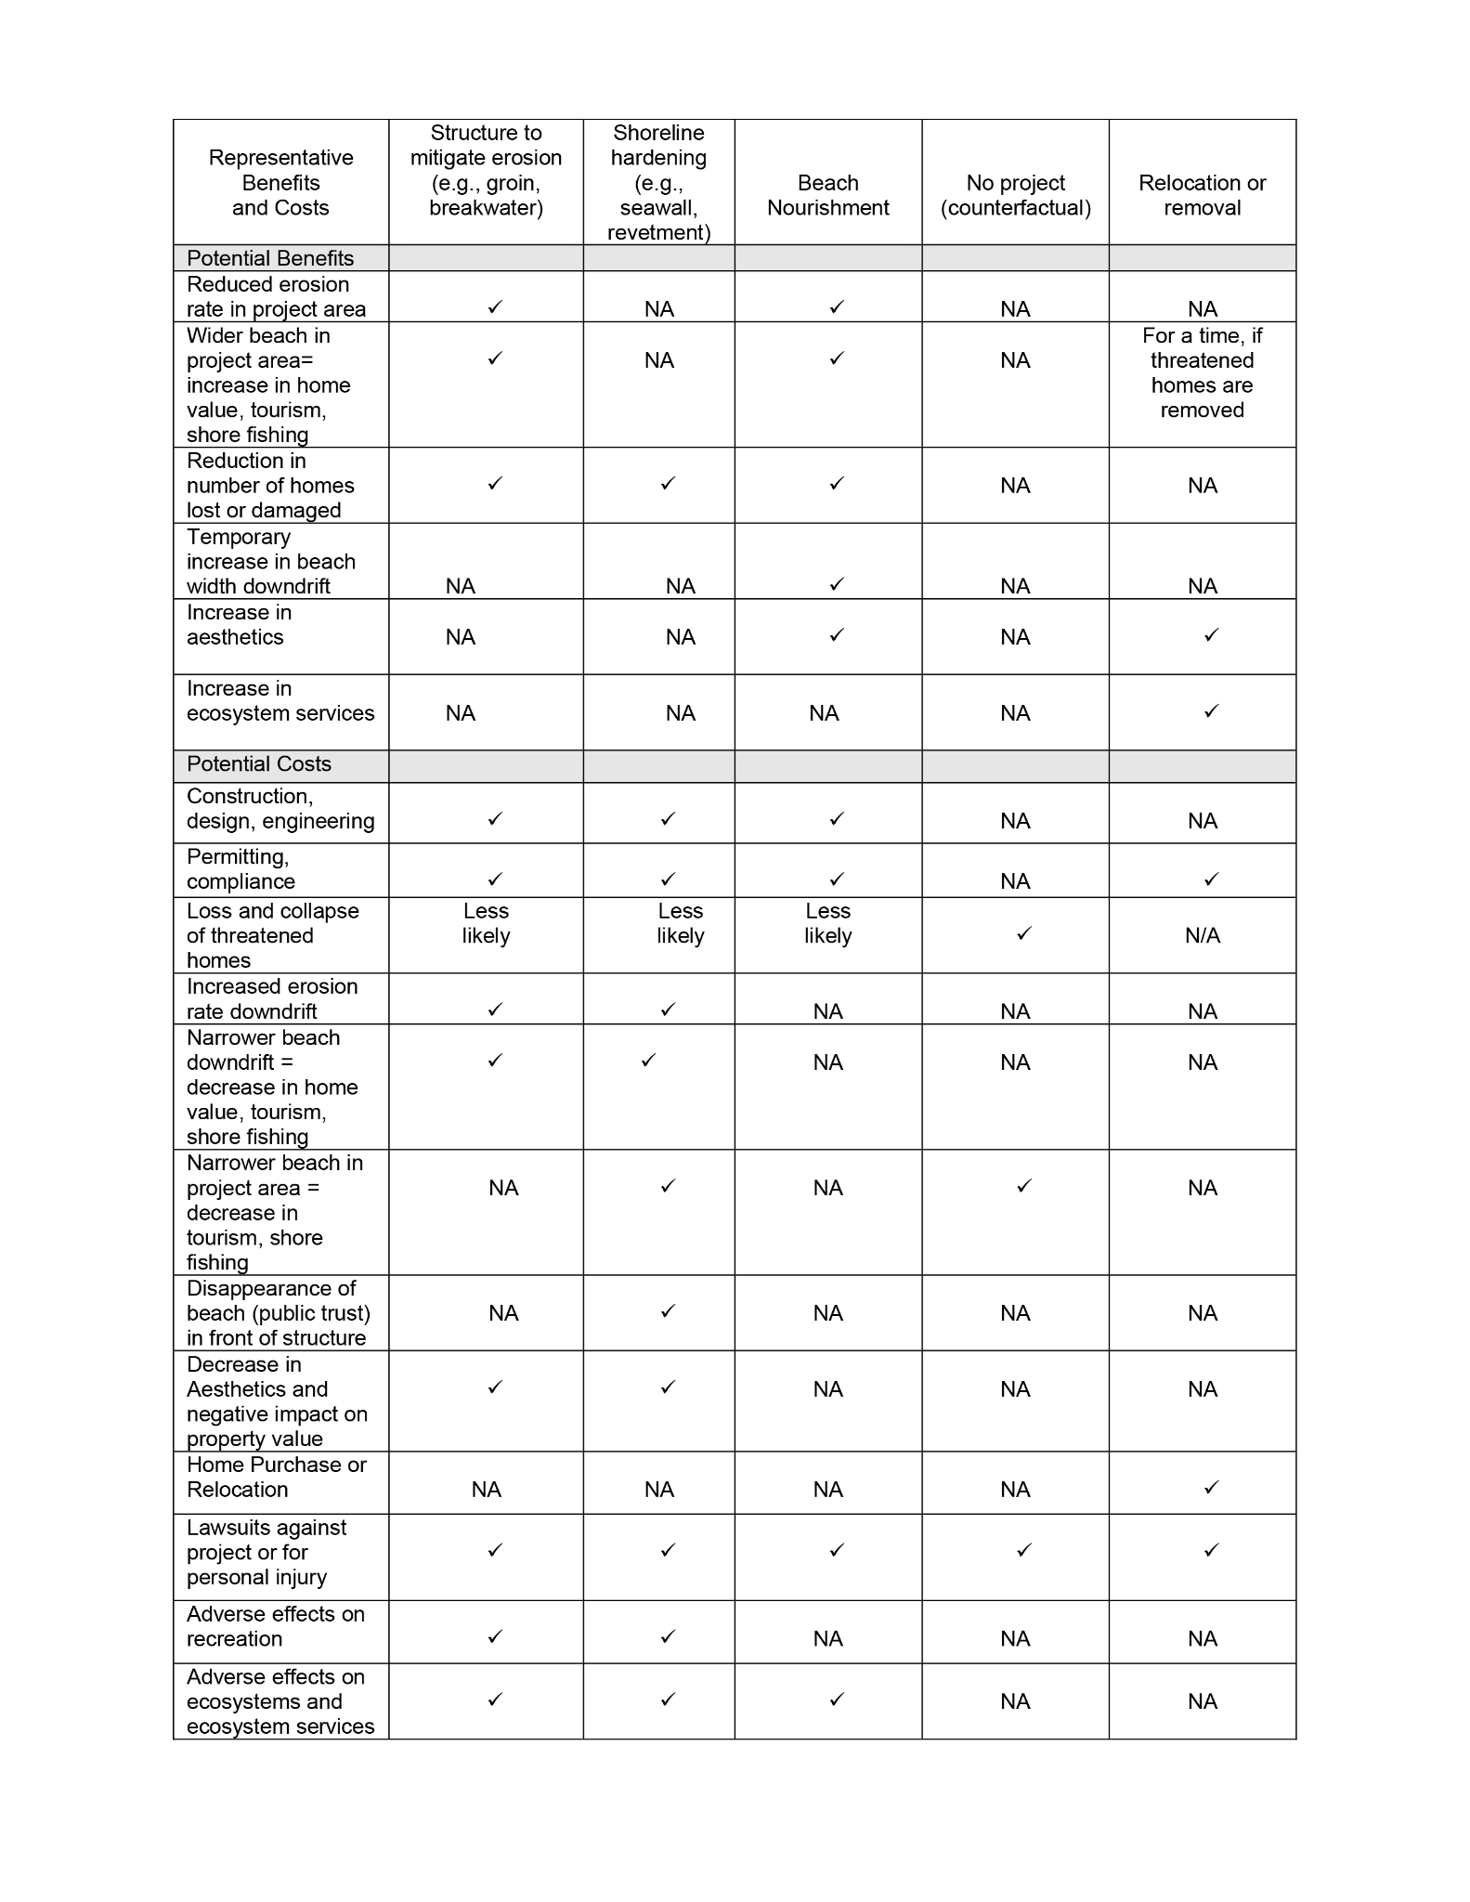 3. Key Lessons Learned – Case Studies
Table 1. A summary of the types of benefits and costs associated with the emplacement of erosion-mitigation or risk-reduction structures, a no project counterfactual and control options. NA = not applicable; a checkmark indicates likely occurrence.
The following case studies provide examples of shoreline management actions implemented in response to chronic erosion, infrastructure vulnerability, and with the intent of protecting public or historic resources. Collectively, they illustrate that structural and sediment-management approaches can produce localized shoreline responses, but their performance depends on site-specific geomorphic setting, sand supply, maintenance commitments, and interactions with adjacent shorelines. These examples are intended to highlight key lessons learned regarding project context, management objectives, observed outcomes, tradeoffs, and the long-term needs required to maintain intended benefits and mitigate adverse effects.
a. Shoreline hardening: Overview of Fort Fisher State Historic Site
Fort Fisher, a Confederate earthwork fort, was constructed during the Civil War to assist blockade runners delivering supplies through New Inlet to the Port of Wilmington, avoiding the Federal blockade and the deeper water access at the entrance to the Cape Fear River. The fort was constructed just south of the only natural rock outcrops on a beach in NC (Figure 2), adjacent to New Inlet which was relatively stable in location at that time. After the Civil War the USACE constructed a tidal barrier to reduce shoaling problems in the primary navigation channel from the Cape Fear River entrance to the Port of Wilmington, which isolated New Inlet’s tidal basin. As a result, New Inlet began to migrate rapidly, at times, exceeding 1000 feet per year. Over time, multiple new storm-induced inlets opened followed by closure of the original inlet.

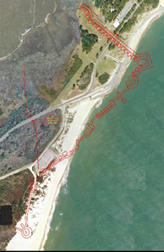
Figure 2. Image showing original Fort Fisher fortifications and the southern limit of the rock outcrop on the shoreline to the north (top of the photo).

The rock outcrops stabilized the shoreline farther north in Kure Beach but resulted in accelerated erosion of the earthwork fort to the south. From 1933 to 1997 the shoreline in Kure Beach, north of the rock outcrops, showed little net change. South of the outcrops and of the shoreline hardening at the fort the erosion rate was more than 10 feet/year. Plans intended to protect the remains of the fort began in the 1930s. A southern section of the shoreline was armored with concrete and masonry construction debris after WWII. In the 1960s, the shoreline farther north was armored with a light-weight limestone revetment. Within a decade, the revetment began to progressively collapse. After multiple studies the USACE produced a final granite revetment design which was completed in 1995, replacing or burying the previous structures (USACE, 1993).

CAMA rules then and now prohibit such shoreline-hardening structures, but the project was reviewed under an exception in the rules that allows threatened, registered historic sites to use otherwise prohibited structures in an effort to protect the site where relocation and beach nourishment are impractical. An earthwork fort cannot be relocated without losing the historical context. The high erosion rate south of the rock outcrops made beach nourishment impractical. The USACE predicted the beach seaward of the planned revetment would disappear and that erosion on the rapidly eroding shoreline south of the revetment would increase by an additional 1.6 feet/year. The NC Division of Cultural Resources was faced with a choice of losing the beach or losing the fort. They chose to protect the remaining fort and agreed to conduct mitigation on the accelerated erosion south of the revetment, if needed. A major factor in their decision was that the shoreline is undeveloped for over five miles downdrift of the revetment (the state-owned Fort Fisher State Recreation Area), reducing concerns about increased downdrift erosion that could result from shoreline hardening.

In 1997, two years after completion of the revetment, the USACE extended the Carolina Beach storm damage risk-reduction project to the south resulting in the addition of sand along most of Kure Beach. This resulted in significantly increased alongshore transport into the areas with the outcrops and the revetment, and beyond. Since the sand addition, although a low tide beach remains absent at each end of the revetment (Figure 3, 4), a pocket beach formed in the central cove in the structure and has remained a persistent feature (Figure 3). In addition, likely because of the increased alongshore sand transport into the revetment area and downdrift as a result of nourishment, the high erosion area south of the revetment, predicted to erode at an increased rate due to the revetment, began to progressively accrete for at least a decade. Due to repeated updrift nourishments, no mitigation has been needed.

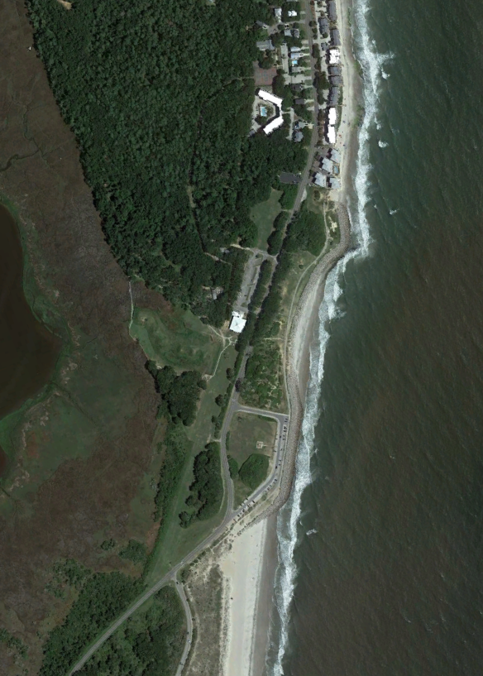
Figure 3. Fort Fisher, fronted by a revetment that now extends seaward past the position of the beach to the south, without a beach in front. A pocket beach in the cove between the revetment and the rocky headland to the north formed after a Kure Beach nourishment project.

The revetment was impacted by landfalling Hurricanes Bertha and Fran (1996); Bonnie (1998) and Floyd (1999). Fran was a design-level storm for the revetment. Some backfill was lost due to overtopping but the structure remained stable and the fort’s preservation areas were protected.

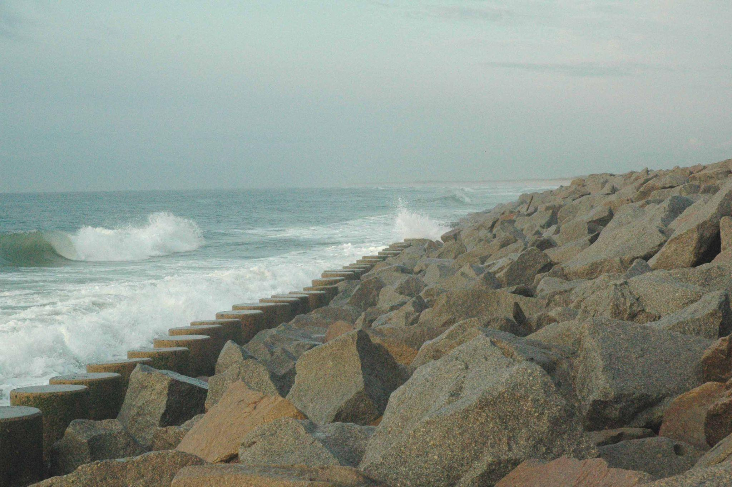
Figure 4. South end of the Fort Fisher revetment.

b. Sand trapping: Overview of Buxton groins
Buxton is located along a highly dynamic beach system near Cape Hatteras, where shoreline change is driven by strong wave energy, storm impacts, alongshore sand transport gradients, and the complex geometry of the cape itself. This reach has experienced some of the highest long-term erosion rates along the Atlantic Coast (as illustrated in Figure 5). These naturally high erosion rates, which were greater than 20 ft/year prior to erosion mitigation (National Research Council, 1988), have created persistent threats to federal facilities, the Cape Hatteras Lighthouse, and later, to oceanfront development. Over the past 60 years, erosion mitigation and risk reduction measures have included dune building, sandbags, repeated beach nourishment, artificial seaweed, and groin construction and repair (National Research Council, 1988). Among these, beach nourishment and the groin field have had the greatest influence on shoreline change in northern Buxton.

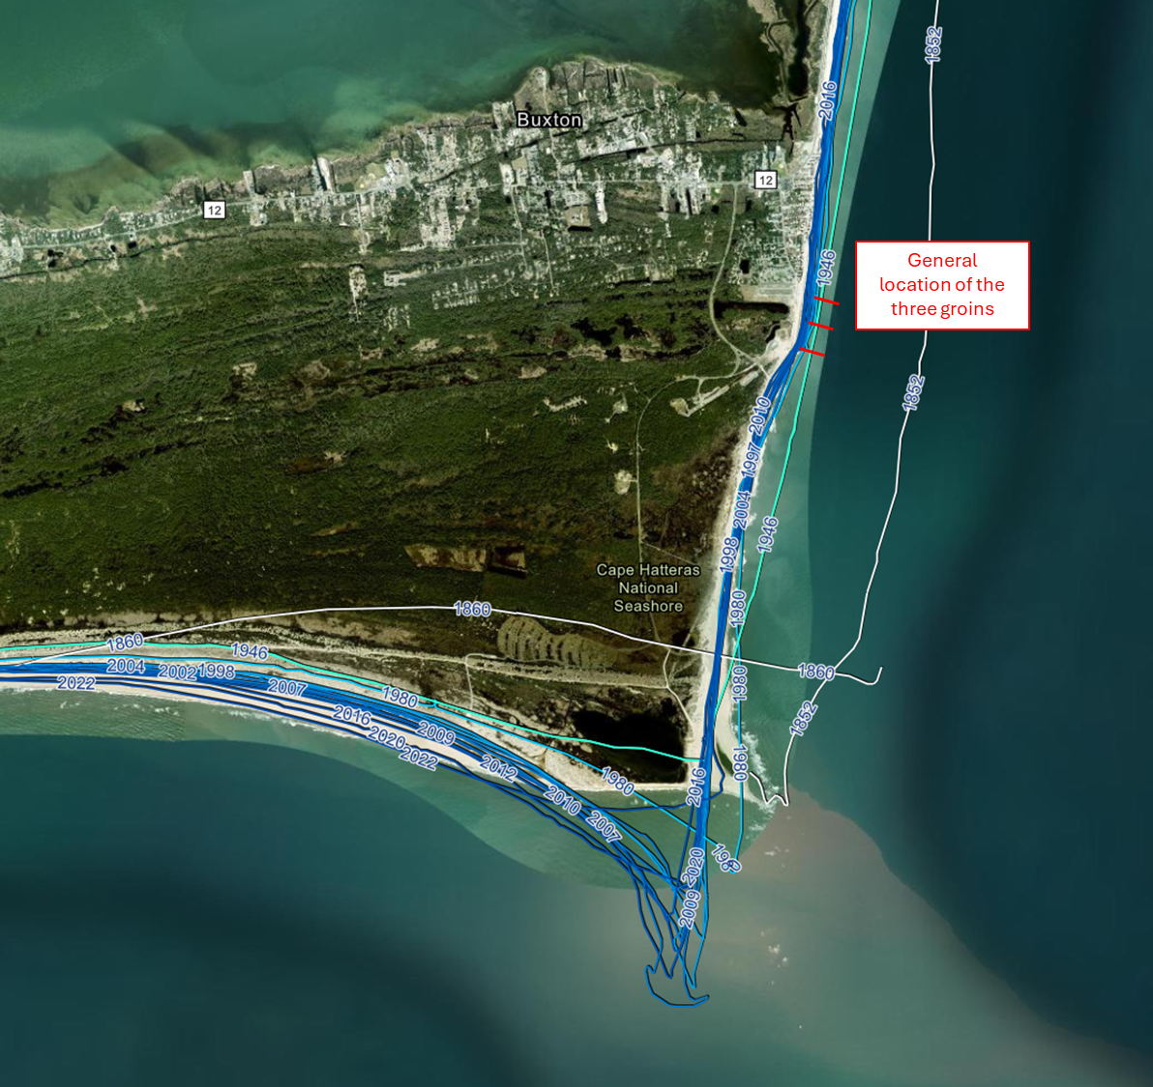

Figure 5. Generalized location of three shore-perpendicular rock and steel groins constructed by the U.S. Navy between 1969 and 1970 to protect former military infrastructure near the Cape Hatteras Lighthouse, NC. Shoreline positions from the NCDCM database are overlaid on 2024 aerial imagery. The groins are not depicted to scale and are commonly referred to as the 1st, 2nd, and 3rd “jetty,” progressing from south to north.

The primary management goal has been to reduce erosion and maintain a protective beach in front of important infrastructure and developed areas. Early actions focused on the Naval Facility Cape Hatteras and, indirectly, the Cape Hatteras Lighthouse. More recent nourishment projects have focused on maintaining beach width, reducing exposure of oceanfront development, supporting public access, and sustaining the recreational and tourism value of the beach.

The National Park Service conducted beach nourishment in 1966, 1971, and 1973. In 1969, the Navy constructed three concrete sheet-pile groins, commonly locally referred to as “the jetties,” spaced approximately 650 feet apart, ending directly seaward of the Cape Hatteras Lighthouse. These groins are relatively short, which allows some alongshore sand transport to bypass, especially in conjunction with the beach nourishment. The structures were damaged soon after construction, requiring repairs and additional sheet piling in 1974. Emergency protection was added near the lighthouse in 1980, including more steel sheet piling around the lighthouse foundation, asphalt rubble, large sandbags, a groin extension, and a rubble scour apron. Hurricane Gloria damaged part of the apron in 1983 (National Research Council, 1988), and in 1999 in response to the persistent erosion hazard the Cape Hatteras Lighthouse was moved landward. Figure 6 shows that within, and updrift, of the groins the shoreline moved landward less far than in other areas. Figure 6 also shows the downdrift offset farther south to Cape Point, resulting from the alongshore-transport deficit caused by the sand trapped in the groin field. More recently, the groins have structurally deteriorated, significantly reducing their sand trapping capacity. Dare County nourished Buxton in 2018 and 2022, with another project scheduled for 2026 involving approximately 2 million cubic yards of sand over about 15,500 feet of shoreline (ASBPA, 2025; Dare County, 2026).

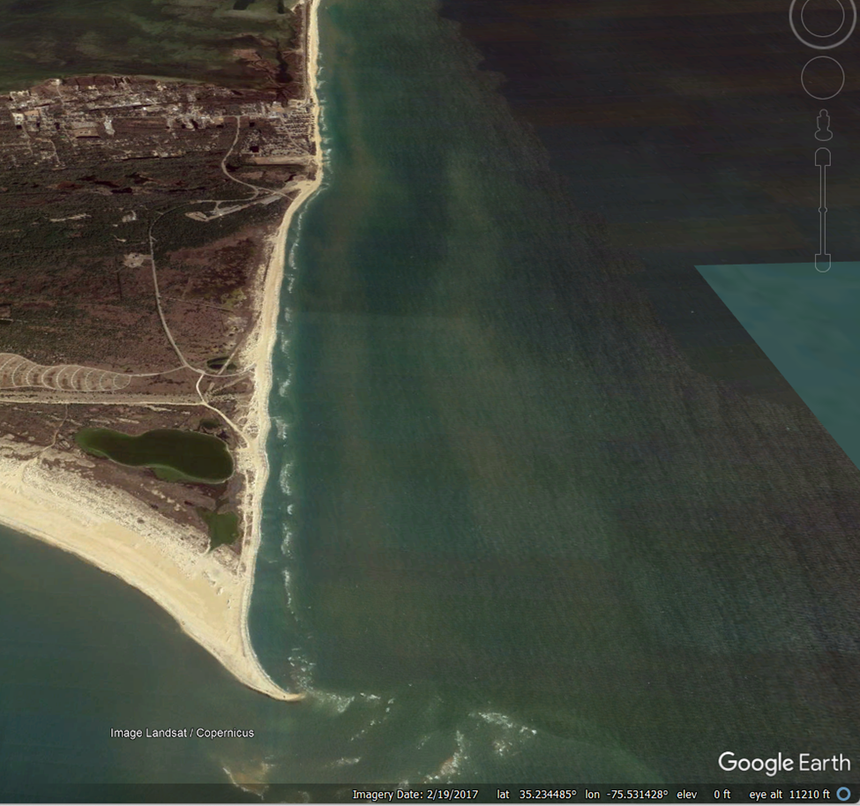
Figure 6. Oblique view of Buxton groins looking north from Cape Hatteras in 2017. When functional the groins have slowed the rate of erosion farther north with the tradeoff of creating a sand deficit farther south.

Collectively, these modifications likely slowed or reduced the naturally high erosion rate within portions of the groin-influenced shoreline (as suggested by the bulge in the shoreline in Figure 6) and helped maintain a wider beach for periods of time. Recent nourishment also temporarily reduced risk to infrastructure while supporting public access and tourism. However, neither the groins nor nourishment stopped the underlying erosion processes. Instead, the groins altered sediment transport patterns, contributing to a landward offset of the shoreline downdrift of the structures. As the groins have deteriorated, their influence on shoreline position has likely diminished, allowing erosion rates in the previously modified area to likely shift closer to the naturally high rate for this reach (although repeated nourishment can mask or partly mask background erosion rates; e.g., Hapke et al., 2010; Hapke et al., 2013; Johnson et al., 2014). While downdrift impacts south of the groin field are evident, they have not been characterized with the same level of analysis as the conditions within the groin field itself.

The Buxton case study illustrates that groins can temporarily change where erosion occurs, but they do not eliminate the underlying erosional processes. Further, attempting to maintain an intended shoreline position requires regular nourishment and hardened structures deteriorate over time and can be damaged during storms, necessitating repeated structural repair and emergency measures.

c. Sand trapping: Overview of terminal groin in Fort Macon
The Fort Macon shoreline represents one of the longest-standing and most intensively managed coastal protection systems in NC, with a history of structural intervention dating to the early 1800s. Over time, multiple generations of groins and erosion mitigation measures have been implemented with the intention of countering chronic erosion associated with the Beaufort Inlet system (Walker, 2010).
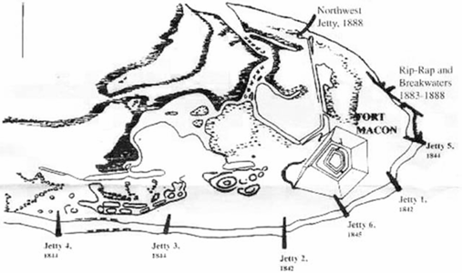
Figure 7. Map depicting groin placements from 1842 to 1888, under direction of Robert E. Lee (From Branch, 2005)
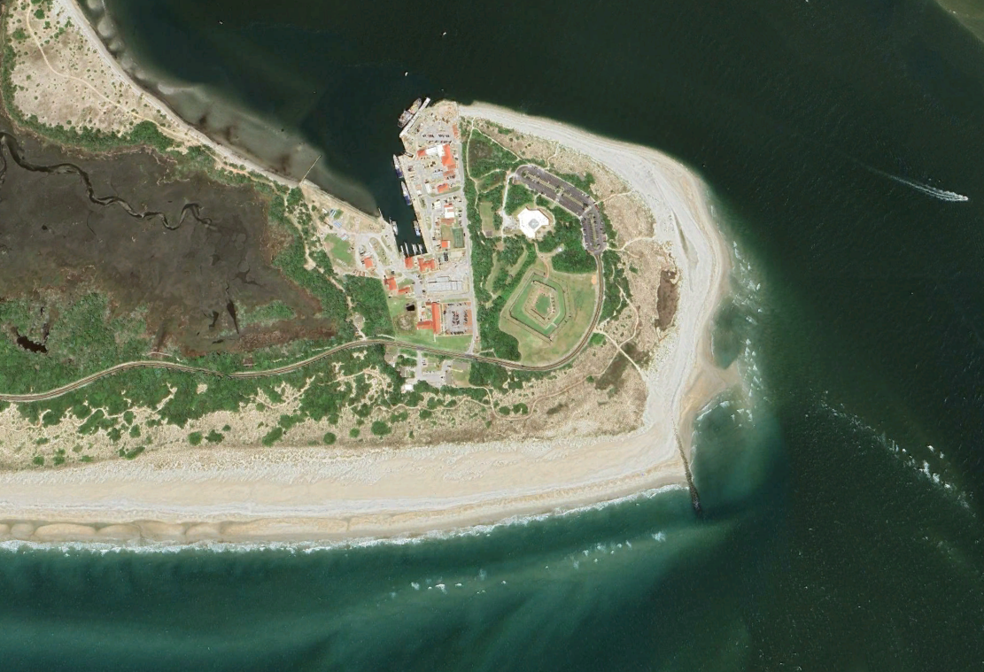
Figure 8. The terminal groin at the East end of Bogue Banks, and Fort Macon, NC in 2023.
The modern coastal environment at Fort Macon is strongly influenced by the Morehead City Harbor Federal Navigation Project. Channel deepening and maintenance activities have stabilized the inlet position while substantially altering the regional sediment budget. In particular, large-scale dredging has contributed to long-term depletion and redistribution of the ebb tidal delta, fundamentally changing sediment transport pathways and shoreline response along both Bogue Banks (Fort Macon/Atlantic Beach) and Shackleford Banks. A beach nourishment program has been instituted at the Harbor resulting in periodic placement of sand along the beaches of Ft. Macon and Atlantic Beach to offset adverse effects on shoreline position.
Construction of the terminal groin between 1961 and 1969 fixed the eastern terminus of Bogue Banks (Figure 8). However, the overall success of this feature is closely linked to decades of sustained nourishment, with approximately 10–12 million cubic yards of dredged material placed along eastern Bogue Banks since the late 1970s. This continued sediment input has enabled shoreline progradation and maintenance of a stable beach system adjacent to the groin.
The groin itself functions as a semi-permeable structure due to its relatively low crest elevation and the use of porous construction materials. This design allows for sand bypassing through overtopping, transmission, and transport around the structure, supplying sand to the inlet-facing shoreline.
Overall, the stability of the Fort Macon shoreline is governed by the interaction of three key factors: (1) a fixed inlet channel position resulting from federal navigation improvements, (2) sustained sediment supply through long-term dredged material placement (sand), and (3) a permeable groin structure that enables continued sand bypassing. The effectiveness of the system is dependent on the continued presence of all three elements; removal or degradation of any one component would likely result in a materially different and less stable shoreline position.

d. Sand Trapping: Overview of Bald Head Island terminal groin and groins
Bald Head Island has three water-front shorelines: West Beach (adjacent to the Cape Fear River), South Beach (Atlantic Ocean shoreline facing south), and East Beach (Atlantic Ocean shoreline facing east). The dynamics of South Beach are highly influenced by the adjacent Cape Fear River. There have been continued changes to the adjacent Wilmington Harbor Navigation Channel over the past few decades including deepening and widening through Bald Head Shoals. Westward directed alongshore transport of sand along South Beach enters the navigation channel and is removed from the natural coastal sand transport system. This sand has been routinely removed during maintenance of the navigation channel and modern placement of that sand occurs on Bald Head Island (twice per six-year cycle) and Oak Island (once per six-year cycle).

South Beach has had a long history of shoreline erosion that has been partially mitigated by USACE beneficial placement of dredged sand. Even with this sand placement, erosion rates remained high especially at the highly curved west end of South Beach (Figure 9). In 1995, to help slow the westward transport of sand, the Village of Bald Head Island installed 16 shore-perpendicular geotextile tube groins along a 5300-foot-long segment of South Beach. This groin field, which was replaced in 2005 and 2010, slowed, but did not eliminate the erosion on South Beach.

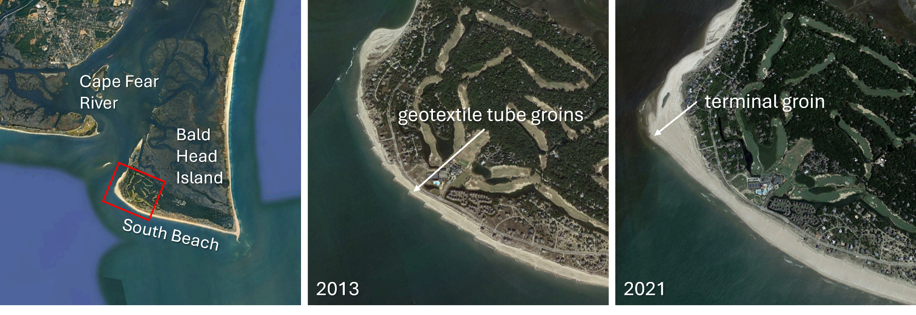
Figure 9. Location of South Beach on Bald Head Island adjacent to the Cape Fear River (left). The red box indicates the area where aerial images from 2013 (pre-terminal groin) and 2021 (post-terminal groin) are shown in the middle and right, respectively.

A terminal groin was installed on Bald Head Island in 2015 at the western tip of South Beach where the island meets the Cape Fear River. The USACE permit also approved an initial placement of sand and periodic future beach nourishment on South Beach. The terminal groin was permitted to reduce risk to infrastructure that was at increasing risk from erosion despite decades of implementing different management strategies. Figure 9 shows South Beach before and after construction of the terminal groin.

The terminal groin at Bald Head Island has helped to mitigate erosion on South Beach by trapping westward-moving sand that would enter the Cape Fear River navigation channel. It is important to note, however, that the terminal groin is only one part of an on-going, comprehensive strategy that includes the geotextile tube groin field that remained in place after construction of the terminal groin and recurring sand placement both from the navigation channel and offshore sources. However, maintenance of the groin field continues to be a challenge and it is due for replacement. In 2024, legislation was passed to authorize a permit from DCM to replace the sand tubes with rock with the hope of decreasing the frequency of maintenance going forward.

e. Sand Trapping: Presque Isle, PA nearshore breakwaters

Although located in Lake Erie, which experiences a much milder wave climate and thus smaller volumes of alongshore transport (Guy and Moore, 2010) and no tidal influences, Presque Isle provides a useful example of a location where breakwaters were installed with the intention of mitigating chronic erosion. Presque Isle is a curved spit immediately offshore of Erie, Pennsylvania. The spit is a little over six miles long with a lake-side perimeter of nine miles. The root of the peninsula is only about 800 feet wide, but increases to over one mile wide farther to the east. Presque Isle is critical to maintaining the function of Erie Harbor as the peninsula actually forms and protects the harbor (Figure 10) (Mohr, 1994).

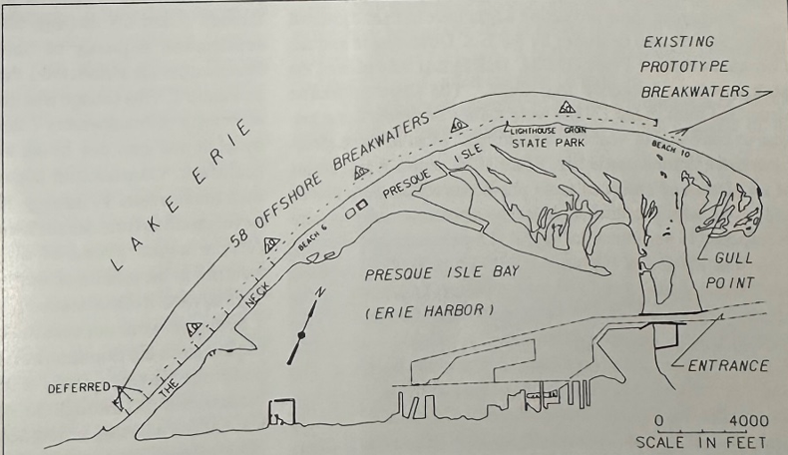
Figure 10. Presque Isle and Erie Harbor (from Mohr, 1994)

Since the early 1800s, lake storms had caused erosion and actually breached the location where the peninsula attaches four times. The U.S. Government tried unsuccessfully to reduce erosion rates using beach nourishment, but as of 1960 they had determined that nourishment by itself was inadequate to sufficiently reduce erosion rates. The Water Resources Development Act of 1986 authorized a project that involved installing 58 offshore segmented breakwaters in conjunction with placement of about 373,000 cubic yards of sand. At the time of construction, it was anticipated that approximately 38,000 cubic yards of sand would need to be placed each year for maintenance (Mohr, 1994).

Nearly 20 years later, by 2006, the downdrift shoreline (at Gull Point, the eastern end of the peninsula) had eroded by about 500 ft leaving trees and shrubs on the beach and in the nearshore (Pilkey 2012). Erosion continued over the following 20 years and continues today, eroding another approximately 500 feet over the subsequent two decades (2006 - 2025; Figure 11).
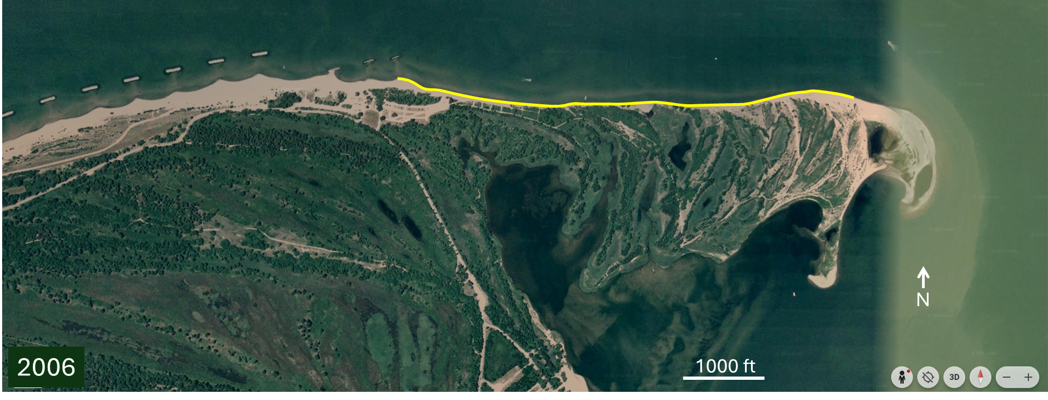

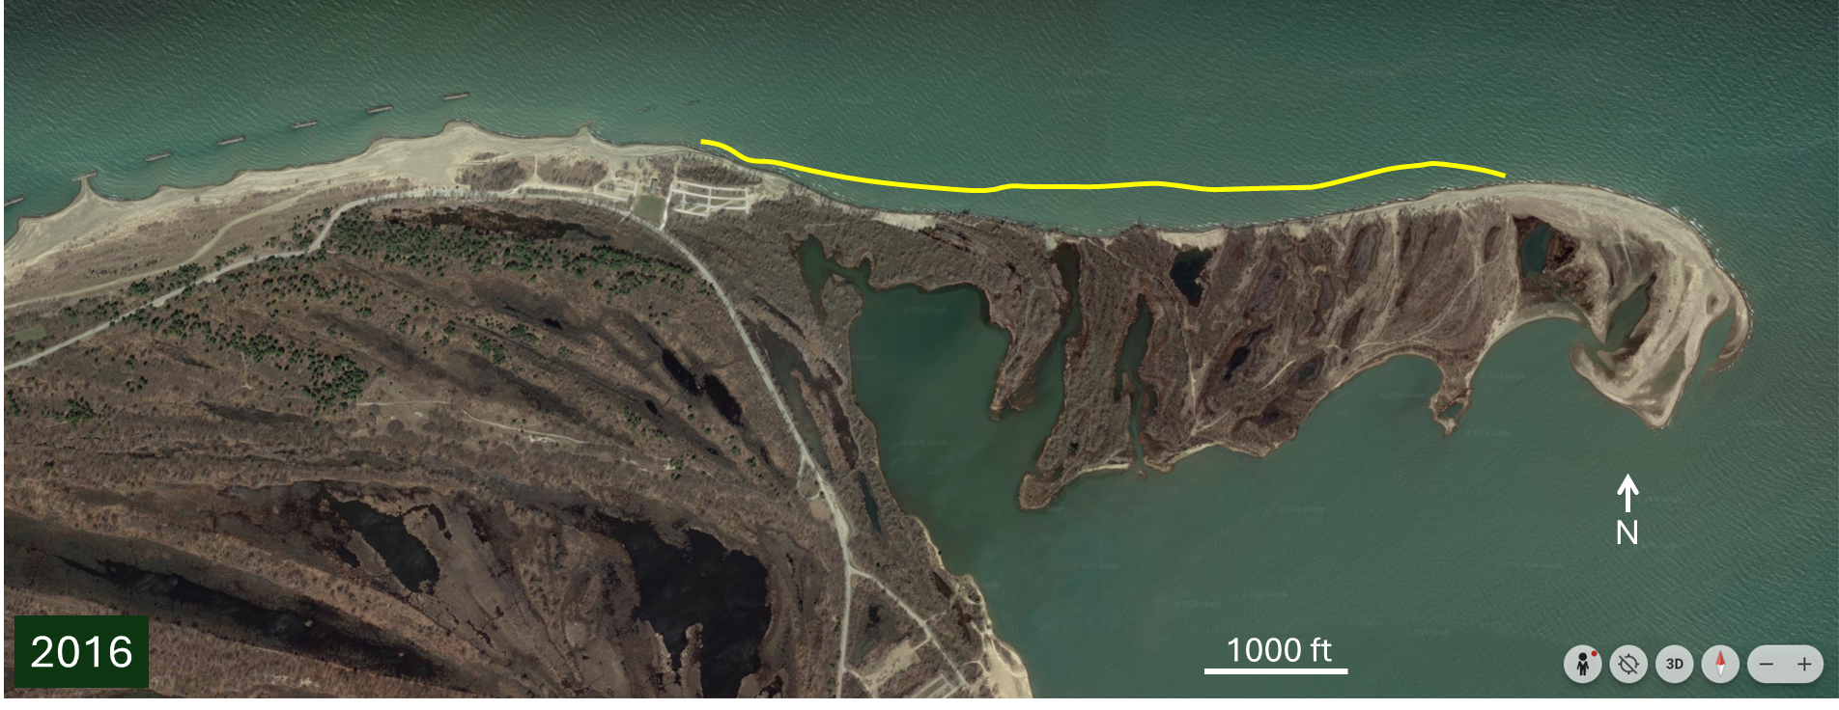

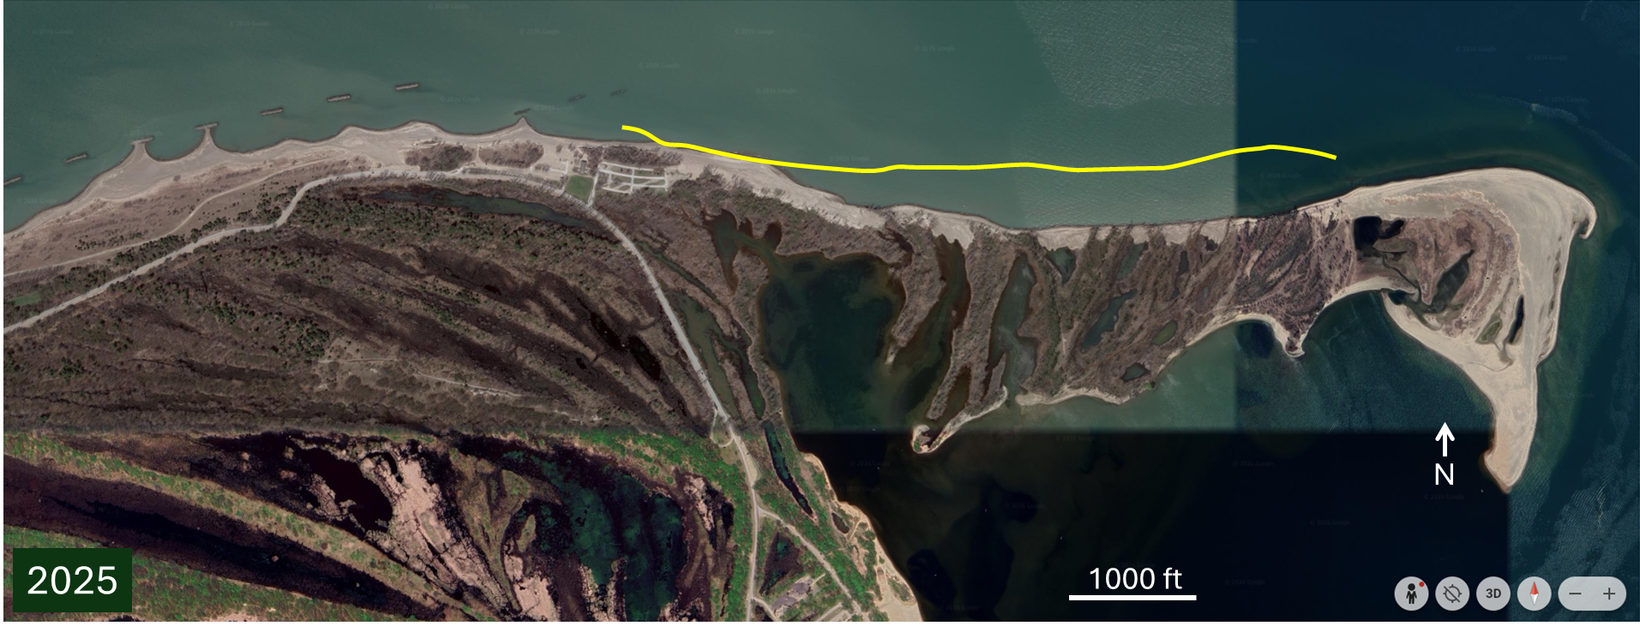
Figure 11. Presque Isle in 2006, 2016 and 2025 (top to bottom), showing continued, progressive erosion along the eastern end of the peninsula, downdrift of the field of breakwaters (Google Earth). The yellow curve in each image shows the shoreline position in 2006.

f. Sand trapping and shoreline hardening: The northern New Jersey coast

Shoreline erosion along the northern New Jersey coast, where alongshore sand transport is to the north, has been observed since the early 1900s with the first groins built in 1915 (Donohue, et al., 2004). Between 1915 and 1960 over 100 primarily stone groins, with lengths of 200 - 400 feet, had been constructed between Sea Bright and Loch Arbor (Figure 12). By 1958 most of the shorefront property in Sea Bright and Monmouth Beach was without a dry beach (Donohue et al., 2004). The Sandy Hook to Manasquan Inlet Beach Erosion Control Project, authorized in 1958, attempted to address erosion along the 21-mile stretch from Manasquan to Sandy Hook. The timing and location of the multitude of structures emplaced by municipalities, the state, and the U.S. Government is too complex to summarize here, but a 1987 USACE inspection revealed another 82 groins constructed at undocumented times between Asbury Park and Manasquan, ranging in length from 50 to 650 feet. At that time, many timber and steel bulkheads, and lengths of rock revetments and seawalls were also reported along the coast between Seabright and Manasquan (Donohue, et al., 2004).

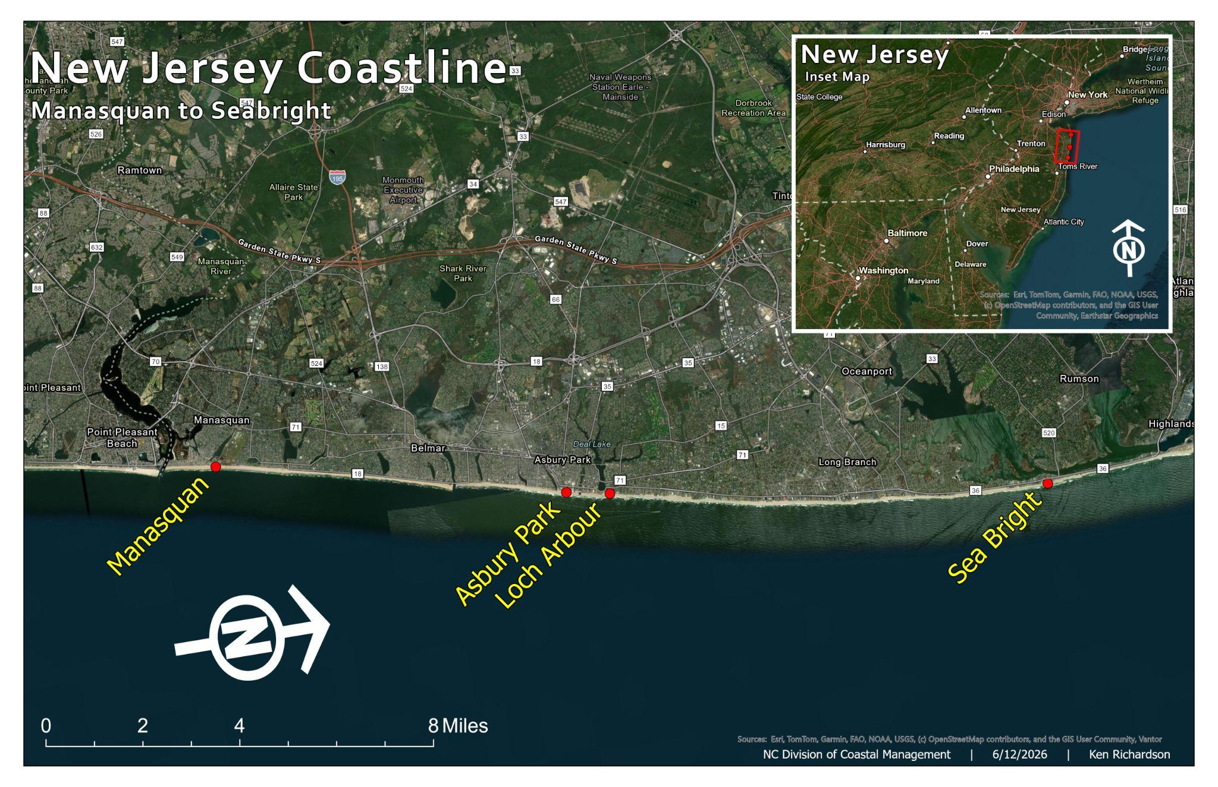
Figure 12. Northern New Jersey location map indicating location of communities referenced above.

Donohue, et al. (2004) noted that in the early 2000s the entire coastal zone in the area between Seabright and Manasquan is extensively developed for residential and commercial uses, and in most places, development was encroaching on the landward side of the beach such that dunes were rarely present. A combination of shore-perpendicular structures, storms and hardening of the upland portions of the beach profile caused the beaches to be severely sand-starved.

In 1989, numerical modeling indicated that the longevity of nourishments, planned to offset erosion, would be extended if groins longer than 400 feet were removed. The cost to remove these structures was prohibitive, and local fishermen and environmental advocates opposed removal due to the hard-structure habitat they provided. Instead, groin notching was identified as an alternative to provide a straighter beach and decrease erosion losses from the variations in alongshore sand transport caused by the groins (Donohue, et al., 2004).

Between 1994 and 1999, 28 groins were notched with notch widths of 100 ft. Notching, in combination with beach fill, had the intended effect early on and was studied in some detail (Donohue, et al., 2004, Rankin et al., 2004). Since 1991 when the post-notching nourishment program began, the State of NJ has emplaced a conservatively estimated 44 million cubic yards of sand at a nominal cost of $528 million (equivalent to over $880 million in today’s dollars) to offset erosion along this 21-mile-long stretch between Manasquan and Sandy Hook (PSDS, 2026). Currently, the groins aren’t visible in recent aerial images, suggesting recent nourishments in the area, given that the durability of nourishments has decreased over time with beaches often disappearing before the next nourishment cycle (PSDS, 2026).

This case study illustrates the challenges associated with reversing the unintended, but predictable, adverse effects of groins on downdrift beaches, the compounding effects of shoreline hardening, and the high cost of maintaining beaches among groins with nourishment.

g. Shoreline hardening: Galveston Seawall, Galveston, Texas
In 1900 a hurricane made landfall on Galveston Island causing the loss of over 6000 lives. It remains the deadliest natural disaster in U.S. history. Up to 300 feet of shoreline retreat was reported as a result of the storm (USACE, 1981). In response, the City of Galveston constructed a freestanding concrete seawall with stone scour protection along three miles of shoreline, completed in 1904. Its purpose was to protect the community from future hurricanes. Shoreline erosion was not a primary issue in the design. Local and Federal funding extended the seawall approximately three miles to the west through multiple efforts between 1904 and 1963.

The seawall was also extended east for approximately three miles to attach to the Galveston Bay Entrance jetty in several segments completed between 1921 and 1927. The eastern extension was constructed well landward of the shoreline at the time on low elevation sandy beach deposits trapped by the Galveston Bay entrance jetty. At the jetty, the shoreline remains approximately one mile seaward of the seawall, with multiple single-family and high-rise buildings constructed on the seaward side.

The narrow beach seaward of the original section and western extensions experienced erosion problems soon after each phase of construction beginning in 1915. Armor stone was added to the toe protection. By 1934 the shoreline was reported to have reached the stone armor and threatened to undermine the seawall. Congress authorized a steel sheetpile groin field to address the erosion, completed in 1939 and rehabilitated with stone in 1970. The groins were intended to help protect the wall from undermining, but were unable to trap a suitable beach for recreation along the most western six miles of seawall. Beach nourishment has been placed along selected seawall segments since 1985.

The Galveston Seawall has protected the city from multiple hurricanes as intended. Other than the east end where the shoreline accreted seaward and has remained in the same position in recent decades because of the jetty, most of the length of the wall has little or no beach in front of it (Figure 13), depending on how recently the beach has been nourished. The highest erosion rates on Galveston Island are located along the unprotected downdrift shoreline just west of the seawall’s west end. Between 1963 when seawall construction was completed and 2005, the shoreline immediately downdrift eroded at a rate of over 10 feet per year (Figure 14). Since that time beach nourishment has slowed the erosion rate to approximately 7 feet per year.

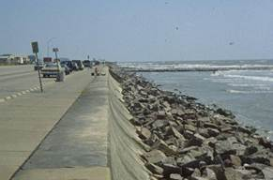
Figure 13. The Galveston Seawall.

December 31, 1968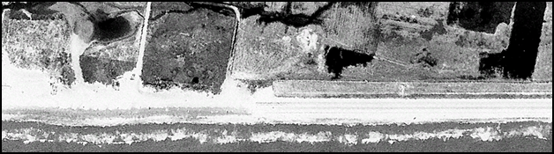
January 22, 1995
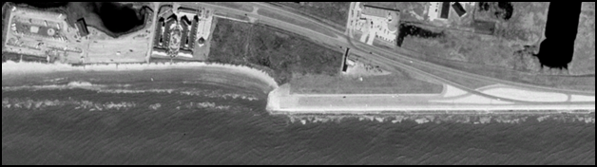
September 24, 2005
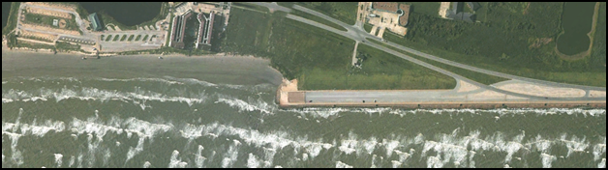
March 24, 2025
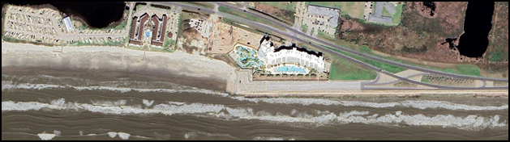
Figure 14. The west end of the Galveston Seawall in 1968, 1995, 2005, and 2025.

4. Summary of Policies Regarding use of Hard Structures in other U.S. States (provided by DCM)

U.S. East Coast
Maine
The Maine Natural Resources Protection Act (NRPA: Title 38 M.R.S.A., Chapter 3, Section 480D, 2000) requires that new coastal development will not unreasonably (1) interfere with the natural supply or movement of sand within or to the sand dune system; (2) increase the erosion hazard to the sand dune system; (3) cause or increase the flooding of the dunes or adjacent properties; (4) interfere with the natural flow of any surface or subsurface waters; (5) inhibit the natural transfer of soil from the terrestrial to marine environments; (6) harm any significant wildlife habitat, threatened or endangered plant habitat, travel corridor, freshwater, estuarine or marine life; or (7) interfere with existing scenic, aesthetic, recreational, or navigational uses.
Within Coastal Dune areas Construction of new seawalls or other shoreline hardening structures is prohibited in these zones due to their damaging effect on dune dynamics and natural sand replenishment

Massachusetts
Massachusetts regulates construction on coastal beaches, dunes, and barrier beaches under 310 CMR 10.27–10.29. Massachusetts restricts hardened structures (seawalls, revetments, geotubes) along its coastline, legally favoring non-structural alternatives like beach nourishment and dune restoration.
- Construction may not increase erosion, reduce beach volume, or alter beach morphology.
Hard structures interfering with littoral drift (groins, jetties) are allowed only when minimized in size, scientifically justified, and paired with sediment management (e.g., backfilling or sand bypassing).
- Dune‑adjacent construction must avoid harming vegetation, weakening dune resilience, or obstructing natural migration.
- Barrier beaches are presumed environmentally significant, and engineering structures are limited under Executive Order 181. Executive Order No. 181: Barrier Beaches, was issued on August 8, 1980 requires Engineering structures are permissible only for preserving navigation at inlets—and only if sediment supply to downdrift beaches is ensured.

Rhode Island
No new hardened structures may be built on barrier beaches, headlands, coastal wetlands, or areas classified as Type 1 Waters, which includes all open ocean shores prone to high waves, flooding, and erosion (RI Coastal Resources Management Program RI CRMP 1.3.1(G)(3).

This restriction applies to over 75% of Rhode Island’s coastline, essentially barring seawalls and other armoring in most beach areas. Applicants must first consider all non-structural alternatives—such as relocation, beach nourishment, or "living shorelines"—before any permit may be approved.

Connecticut
Under the Connecticut Coastal Management Act, the state prioritizes non‑structural erosion solutions such as nourishment.
- Structural armoring is allowed only when unavoidable and necessary to protect pre‑1995 homes, critical infrastructure, or water‑dependent uses.
- Applicants must demonstrate lack of feasible alternatives.
- Most projects require an individual DEEP permit; minor maintenance of authorized structures may fall under a general permit.

New York
New York tightly regulates hardened oceanfront structures in designated Coastal Erosion Hazard Areas (CEHA).
- Hard armoring is generally discouraged unless erosion control is necessary and impacts can be minimized.
- A CEHA permit—and often a Tidal Wetlands Permit—is required.
- Replacement structures should not extend seaward beyond the existing footprint.
- Groins must follow low‑profile design standards; revetments must follow natural bluff/dune slopes.

New Jersey
Through the Resilient Environments and Landscapes (REAL) rules (effective 2026), New Jersey has strengthened coastal resilience standards.
- New and substantially improved structures must be built 4 feet above FEMA Base Flood Elevation.
- New hard armoring is generally discouraged due to downdrift erosion and seawalls, groins are jetties only allowed if proven last resort.
- Preferred approaches include nourishment, dune restoration, and living shorelines.
- Repairs to existing pre‑1981 structures are allowed under strict controls, including groin notching to improve sediment transport.

Delaware
Delaware’s Beach Preservation Act imposes strong restrictions on hardened structures.
- New seawalls, bulkheads, and riprap are generally prohibited on ocean‑facing beaches.
- Policy favors managed retreat, renourishment and living shorelines to maintain natural processes.
- Construction seaward of the DNREC building line requires a Coastal Construction Permit.

Maryland
Maryland limits hardened structures within Beach Erosion Control Districts under Natural Resources § 8‑1102.
- Permanent structures are generally prohibited on dunes and ocean beaches.
- Exceptions exist for approved storm‑control projects, essential utilities, and repairs to existing public structures in Ocean City—without footprint expansion.

Virginia
Under the Coastal Primary Sand Dunes and Beaches Act, hardened structures on dunes and beaches are largely prohibited.
- Alterations that affect dune contours, vegetation, or ecological function require VMRC or wetlands board approval.
- Hard structures are permitted only if no ecological harm will occur and the project serves a clear public interest.
- Virginia strongly favors living shorelines and nourishment over structural armoring.

South Carolina
South Carolina prohibits new hardened structures seaward of the statewide setback line.
- Exceptions exist only to protect public roads predating the Beachfront Management Act.
- Groins may be approved only on nourished beaches with required monitoring.

Georgia
Georgia’s Shore Protection Act restricts hardened structures on beaches, dunes, and submerged lands.
- Seawalls and bulkheads are generally prohibited because they intensify erosion.
- The Shore Protection Committee may allow exceptions for public‑works needs.
- The state encourages soft stabilization and living shoreline projects.

Florida
Florida regulates coastal armoring under the Beach and Shore Preservation Act.
- Rigid armoring is allowed when vulnerable structures or infrastructure require protection.
- Applicants must demonstrate structural vulnerability, assess alternatives, minimize impacts to dunes and wildlife, and maintain public access.
- Structures must be set as landward as practicable.
- Gap‑closures between existing armoring may be permitted under strict conditions.

U.S. Gulf Coast
Alabama
Under ACAMP (Alabama Coastal Area Management Program):
- Applicants must consider retreat or soft alternatives before pursuing hard armoring.
- Hardened structures are allowed only when soft options are infeasible and impacts are minimized.
- Local governments administer permits in coordination with state programs.

Louisiana
- Louisiana regulates shoreline armoring on a project‑by‑project basis via the Coastal Use Permit (CUP) process.
- There is no statewide prohibition on hardened structures.
- CUPs are required for seawalls, bulkheads, breakwaters, and similar structures.
- Review focuses on environmental impacts, alternatives analysis, and compliance with the Louisiana Coastal Resources Program.

Texas
Texas maintains prohibitions on beachfront armoring.
- 31 TAC § 15.7 requires local governments to prohibit seawalls and bulkheads seaward of, or within 200 feet landward of, the vegetation line.
- Hard structures may only be placed on private upland property outside the public beach area.
- Texas prioritizes nourishment approaches.
U.S. West Coast

California
California regulates hardened shoreline structures—like seawalls, revetments, riprap, groins, and bulkheads—on its beaches under the California Coastal Act and Coastal Commission policies.
California Coastal Act (§ 30235)
Allowed only to protect: Coastal-dependent uses, or
- Existing development (buildings or infrastructure) endangered by erosion.
- Must be designed to eliminate or mitigate adverse impacts on shoreline sand supply, including effects on littoral drift and beach migration
Coastal Development Permit (CDP) Requirements
- Applicants must provide:
  - Technical/geologic reports
  - Wave run-up studies
  - Beach profile analysis
  - Demonstrations that impacts to sand supply and beach access are minimized

Oregon
Land Use Planning Goal 18 (Beaches and Dunes) forms the backbone of the state's armoring policy.
- The Ban: It limits shoreline armoring for any development that occurred after January 1, 1977.
- Grandfathering: Protective structures are only allowed to protect homes, commercial buildings, and functionally improved properties that existed prior to the 1977 cutoff.
- Exceptions: Local jurisdictions (cities/counties) and the state can grant rare exceptions, but the state prioritizes "soft" alternatives such as vegetation, sandbagging, or managed retreat.

Washington
Washington limits ocean-facing hardened structures, such as seawalls and bulkheads, through the Shoreline Management Act and local programs. New hard armoring is prohibited unless an existing primary structure (like a home or road) is in danger of substantial damage. State law mandates a strict hierarchy: regulators require property owners to use "soft" stabilization or retreat before considering hard walls

- Science Panel Recommendations
Although coastal erosion and the loss of private property and infrastructure are significant concerns for coastal communities and the State of North Carolina, the use of hardened structures to mitigate erosion or reduce risk to infrastructure involves important physical, ecological, recreational, and economic tradeoffs. This report distinguishes between structures intended to trap sand and reduce erosion within a project area, such as groins and breakwaters, and structures intended to harden or fix the backshore in place, such as seawalls, bulkheads, revetments, and sandbags, with the goal of reducing risk to landward infrastructure. These approaches may achieve localized management objectives, but they also alter natural coastal processes, making them likely to cause adverse effects within and beyond a project area. The Science Panel, therefore, recommends that North Carolina maintain a cautious approach to any expansion of the use of hardened structures along its sandy, open-ocean coastline.
The economic implications of implementing structures to mitigate erosion or reduce risk are complex and warrant careful consideration. While these approaches may provide localized benefits by reducing erosion or infrastructure risk within a project area, they can also generate adverse effects and costs within and beyond project areas as described herein, including costs associated with ongoing maintenance and mitigation needs, which can be considerable. Considering overall net benefits, which may be positive or negative, requires a comprehensive economic analysis; however, not all tradeoffs can be easily monetized or fully captured through economic analysis alone. Benefits and costs may be distributed unevenly among private property owners, local governments, state agencies, recreational users, adjacent communities and future taxpayers. The Science Panel therefore recommends that any major reconsideration of North Carolina’s oceanfront management policies include a broad assessment of the benefits, costs, limitations and distribution of effects arising from an expanded use of hard structures, prior to a change in policy.
If the current policies are changed, we recommend that any consideration of projects involving the construction of hard structures that would not be permitted under the State’s current, long-standing oceanfront management policies require a comprehensive evaluation, including evaluation of intended project outcomes and the likelihood of achieving them, as well as the myriad adverse effects described in detail in this report, and net benefits (positive or negative). Evaluation should also include consideration of who will likely benefit and who will likely suffer adverse effects (e.g., Siders and Kennan et al., 2020). We recommend avoiding authorization of projects for which evaluations reveal that adverse effects cannot be mitigated sufficiently to make the tradeoffs acceptable.
The thoroughness of project review will depend on the expertise of the reviewers. If the use of hard structures in NC is expanded, the Science Panel recommends impartial third party scientific and engineering review of project evaluations. To support rule making, project evaluation and review, and permitting processes, we recommend that the Division of Coastal Management receive the funding needed to hire professional staff trained in coastal science and engineering
The Science Panel recommends that reconstruction of existing structures be evaluated independent of their historical presence. Where repair would restore or substantially extend the sand-trapping or shoreline-hardening function of a deteriorated structure, the project should be reviewed for the same types of physical, ecological, recreational, fiscal, and downdrift impacts as a new or replacement structure.
We further recommend that any authorized shoreline modification project require, by permit, a funded long-term monitoring, maintenance, and mitigation plan, assessed during project evaluation. This plan should identify expected nourishment needs, inspection and repair obligations, funding responsibilities, performance metrics, downdrift and adjacent-shoreline monitoring requirements, and triggers for mitigation, modification, or removal if adverse effects are more extreme or impactful than anticipated.
Finally, there are valuable insights to be gained from other coastal regions. In parts of Europe, “managed realignment” is being used to remove, modify or set back shoreline defenses such as constructed dunes, groins and seawalls in selected locations, with the goal of reducing the long-term adverse effects and allowing natural coastal processes to resume. Similarly, like North Carolina, many U.S. states limit the use of hard structures on sandy oceanfront shorelines, and some states that historically allowed more extensive shoreline armoring have shifted toward stronger limitations on their use. These examples suggest that expanding the use of hard structures in North Carolina would be a move counter to a broader trend among jurisdictions that have gained long-term experience with hardened structures and are now placing stronger limits on their use.
Ultimately, the function (including protection of mainland shorelines), and long-term habitability of the NC barrier island landscape is more likely to be sustained if priority continues to be given to erosion-mitigation and risk-reduction strategies that maintain the alongshore sand transport system, allow natural barrier-island processes to occur, and reduce exposure of infrastructure rather than to methods that attempt to indefinitely hold in place a changing shoreline through the use of hard structures.
5. REFERENCES
Able, K. W., M. J. Wuenschel, T. M Grothues, J. M. Vasslides, & Rowe, P.M. (2013). Do surf zones in New Jersey provide “nursery” habitat for southern fishes. Environmental Biology of Fishes 96:661-675.
Airoldi, L., Abbiati, M., Beck, M.W., Hawkins, S.J., Jonsson, P.R., Martin, D., Moschella, P.S., Sundelo, A., R.C. Thompson, R.C., Berg, P.A. (2005). An ecological perspective on the deployment and design of low-crested and other hard coastal defence structures. Coastal Engineering 52: 1073-1087
American Shore and Beach Preservation Association (ASBPA). 2025. National Beach Nourishment Database. Accessed June 10, 2026.
Anarde, K. A., Moore, L. J., Murray, A. B., & Reeves, I. R. (2024). The future of developed barrier systems: 1. Pathways toward uninhabitability, drowning, and rebound. Earth's Future, 12(4), e2023EF003672.
Anarde, K. A., Moore, L. J., Murray, A., & Reeves, I. (2024). The future of developed barrier systems: 2. Alongshore complexities and emergent climate change dynamics. Earth's Future, 12(4), e2023EF004200.
Anthony, E. J., Vanhee, S., & Ruz, M. H. (2007). An assessment of the impact of experimental brushwood fences on foredune sand accumulation based on digital elevation models. Ecological Engineering, 31(1), 41–46. https://doi.org/10.1016/j.ecoleng.2007.05.005
Antolínez, J. A. A., Murray, A. B., Méndez, F. J., Moore, L. J., Farley, G., & Wood, J. (2018). Downscaling changing coastlines in a changing climate: the hybrid approach. Journal of Geophysical Research: Earth Surface, 123(2), 229-251.
Arb, E. (2018). The effect of beach nourishment on the site fidelity and long-shore movements of two species of surf zone fishes on a southeastern North Carolina barrier island. MSc Thesis, University of North Carolina Wilmington, 71 pp
Ashton, A., Murray, A. B., & Arnoult, O. (2001). Formation of coastline features by large-scale instabilities induced by high-angle waves. Nature, 414(6861), 296-300.
Ashton, A. D., & Murray, A. B. (2006). High‐angle wave instability and emergent shoreline shapes: 2. Wave climate analysis and comparisons to nature. Journal of Geophysical Research: Earth Surface, 111(F4).
Barnett, M.R. & Wang H. (1988). Effects of a Vertical on Profile Response. Proceed. Coastal Engineering 1988, ASCE, 1493-1507.
Basco, D.R. and Pope, J. (2004). Groin Functional Design Guidance from the Coastal Engineering Manual, Journal of Coastal Research, Special Issue 33, 121-130.
Balaji, R., Sathish Kumar, S., & Misra, A. (2017). Understanding the effects of seawall construction using a combination of analytical modelling and remote sensing techniques: Case study of Fansa, Gujarat, India. The International Journal of Ocean and Climate Systems, 8(3), 153-160.
Banks v. United States, 78 Fed. Cl. 603 (2007), vacated in part, 721 F. App'x 928 (Fed. Cir. 2017) (in protracted litigation that lasted two decades and appears to have eventually been resolved by settlement, 37 landowners sued the United States for erosion caused by jetties constructed and maintained by the US Army Corps of Engineers, and at various times various courts ruled that the government was responsible for the erosion)
Borland, H.P., Schlacher, T., Gilby, B., Connolly, R.M., Yabsley, N., & A. Olds, A. (2017). Habitat type and beach exposure shape fish assemblages in the surf zones of ocean beaches. Mar. Ecol. Prog. Ser. 570: 203-211
Benedet, L., & List, J. H. (2008). Evaluation of the physical process controlling beach changes adjacent to nearshore dredge pits. Coastal Engineering, 55(12), 1224-1236.
Beuzen, T., Turner, I. L., Blenkinsopp, C. E., Atkinson, A., Flocard, F., & Baldock, T. E. (2018). Physical model study of beach profile evolution by sea level rise in the presence of seawalls. Coastal Engineering, 136, 172-182.
Board of Trustees of Internal Imp. Trust Fund of State of Fla. v. Sand Key Associates, Ltd., 458 So.2d 369 (1984): Case from the Supreme Court of Florida. The case arose as a quiet title dispute as to whether a landowner or the state of Florida owned accreted land caused by a jetty that the state of Florida constructed. The court held that the landowner had the right to that land.
Burdick, S. A., Puckett, B. J., Currin, C., Davis, J., Exar, L., & Murray, A. B. (2025). Bulkheads Reduce Salt Marsh Extent: A Multidecadal Assessment Using Remote Sensing. Journal of Coastal Research, 41(4), 666-674.
Cangemi v. United States, 13 F.4th 115 (2d Cit. 2021) (Seaside property owners sued federal, state, and local government entities for erosion caused by two jetties, including claims for trespass, nuisance, interference with property, and takings; after a decade of protracted litigation, the courts eventually denied the claims—despite the fact that the jetties appeared to be causing the erosion of the plaintiffs’ property—on the basis that the U.S. Army Corps of Engineers owned and maintained jetties so the town and state agencies could not be held responsible, yet the Corps was protected by constitutional sovereign immunity).

Chapoton, R.B., Sykes, J.E. (1961). Atlantic Coast Migration of Large Striped Bass as Evidenced by Fisheries and Tagging Get access Arrow. Transactions of the American Fisheries Society, 90, 13–20.
Charbonneau, B. R., & Wnek, J. P. (2016). Reactionary fence installation for post-Superstorm Sandy dune recovery. Shore and Beach, 84(3), 42–48.
Coastal Engineering Research: International Coastal Management (ICM).” International Coastal Management, www.coastalmanagement.com.au/coastal-engineering-research. Accessed 7 June 2026.
Dare County. 2026. Buxton Beach Nourishment Project. Dare County, North Carolina. Accessed June 7, 2026.
Davis Jr, R. A., & FitzGerald, D. M. (2009). Beaches and coasts. John Wiley & Sons.
de Schipper, M. A., Ludka, B. C., Raubenheimer, B., Luijendijk, A. P., & Schlacher, T. A. (2021). Beach nourishment has complex implications for the future of sandy shores. Nature Reviews Earth & Environment, 2(1), 70-84.
Dean, R. G. (2003). Beach nourishment: theory and practice (Vol. 18). World scientific publishing company.
Donohue, K.A., Bocamazo, L.M, and Dvorak, D. (2004). Experience with Groin Notching Along the Northern New Jersey Coast, Journal of Coastal Research, Special Issue 33, 198-214.
Dugan, J. E., Hubbard, D. M., Rodil, I. F., Revell, D. L., & Schroeter, S. (2008). Ecological effects of coastal armoring on sandy beaches. Marine Ecology, 29, 160-170.
Dundas, S.J., and Lewis, D.J. (2020). Estimating Option Values and Spillover Damages for Coastal Protection: Evidence from Oregon’s Planning Goal 18. Journal of the Association of the Environmental and Resource Economists. 7:3, 519-554.
Eggleston, D.B., Bell, G.W., & Searcy, S.P. (2009). Do Blue Crab Spawning Sanctuaries in North Carolina Protect the Spawning Stock? Transactions of the American Fisheries Society, 138: 581-592.
Eisemann, E. R., Rodriguez, A. B., Wallace, D. J., & Gremillion, S. L. (2025). Constructed dunes and roads reduce decadal washover flux on transgressing barrier islands. Journal of Geophysical Research: Earth Surface, 130, e2024JF008089. https://doi.org/10.1029/2024JF008089
Elko, N., Brodie, K., Stockdon, H., Nordstrom, K., Houser, C., McKenna, K., Moore, L., Rosati, J., Ruggiero, P., Thuman, R. and Walker, I., 2016. Dune management challenges on developed coasts. Shore & Beach, 84(1), pp. 15-28.
Elko, N., Briggs, T. R., Benedet, L., Robertson, Q., Thomson, G., Webb, B. M., & Garvey, K. (2021). A century of US beach nourishment. Ocean & Coastal Management, 199, 105406.
Esteves, L. (2014). What is Managed Realignment?. In: Managed Realignment: A Viable Long-Term Coastal Management Strategy?. SpringerBriefs in Environmental Science. Springer, Dordrecht. https://doi.org/10.1007/978-94-017-9029-1_2
Finkl Jr, C. W., Khalil, S. M., & Andrews, J. L. (1997). Offshore sand sources for beach replenishment: potential borrows on the continental shelf of the eastern Gulf of Mexico. Marine georesources & geotechnology, 15(2), 155-173.
Fischbach, J. R., Dalyander, S., Carruthers, T., McHugh, C., DeJong, A., McMann, B., Littman, A., Haertling, A., Kane, P. and Bond, C.A. (2023). Case Study Analysis Results and Recommendations. The Water Institute of the Gulf. Funded by the U.S. Army Corps of Engineers Engineer Research and Development Center, Vicksburg, MS.
FitzGerald, D. M. (1988). Shoreline erosional‐depositional processes associated with tidal inlets. Hydrodynamics and sediment dynamics of tidal inlets, 29, 186-225.
Franklin, B.F., Moore, L.J., Anarde, K., Murray, A.B., Busch, K.C., Corbett, D.R., Flynn, M.J., Johnson, M.E., Hallac, D.E., and Sahraei, R. (2026). Multi-decadal Barrier Island Fate Varies as a Function of Management Strategy, EarthArxiv pre-print.
Fredsoe, J., & Deigaard, R. (1992). Mechanics of coastal sediment transport (Vol. 3). World scientific publishing company.
Flyvbjerg, B., and Bester, D.W. (2021). The cost-benefit fallacy: Why cost-benefit analysis is broken and how to fix it. Journal of Benefit-Cost Analysis.
Galgano, F.A. (2004). Long-Term Effectiveness of a Groin and Beach Fill System: A Case Study Using Shoreline Change Maps, Journal of Coastal Research, Special Issue 33, 3-18.
Gittman, R.K., Fodrie, F.J., Popowich, A.M., Keller, D.A., Bruno, J.F., Currin, C.A., Peterson, C.H. and Piehler, M.F. (2015), Engineering away our natural defenses: an analysis of shoreline hardening in the US. Frontiers in Ecology and the Environment, 13: 301-307. https://doi.org/10.1890/150065
Gittman, R. K., Scyphers, S. B., Baillie, C. J., Brodmerkel, A., Grabowski, J. H., Livernois, M., Poray, A., Smith, C & Fodrie, F. J. (2021). Reversing a tyranny of cascading shoreline‐protection decisions driving coastal habitat loss. Conservation Science and Practice, 3(9), e490.
Gittman, R. K., Scyphers, S. B., Smith, C. S., Neylan, I. P., & Grabowski, J. H. (2016). Ecological consequences of shoreline hardening: a meta-analysis. BioScience, 66(9), 763-773.
Golden v. Town Board of Town of Oyster Bay, 246 A.D. 732 (2026): Case from the New York Supreme Court, Second Department Appellate Division. A landowner sued their neighbor and the town because the town approved a plan that would have allowed the neighbor to replace their groin. The neighbors ended up abandoning their plans to construct the groin.
Gopalakrishnan, S., Smith, M.D., Slott, J.M., Murray, A.B. (2011). The value of disappearing beaches: A hedonic pricing model with endogenous beach width, Journal of Environmental Economics and Management, 61:3, pp. 297-310.
Gopalakrishnan, S., Landry, C. E., Smith, M. D., & Whitehead, J. C. (2016). Economics of coastal erosion and adaptation to sea level rise. Annual review of resource economics, 8(1), 119-139.
Griggs, 2005. The Impacts of Coastal Armoring. Shore & Beach Vol. 73, No. 1, Winter 2005, pp. 13-22.
Griggs, G., Patsch, K., Lester, C., and Anderson, R., 2020. Groins, sand retention, and the future of Southern California’s beaches, Shore and Beach, Vo. 88, No. 2.
Griggs, G.B., Tait, J.F., and Corona, W. (1998), The Interaction of Seawalls and Beaches: Seven Years of Monitoring, Monterey Bay, California Ry Gary B. Griggs, Shore and Beach, 62:3, pp. 21-28.
Griggs, G.B., Tait, J.F., Moore, L.J., Scott, K., Corona, W., and Pembrook, D. (1997). The interaction of seawalls and beaches: Eight years of field monitoring, Monterey Bay, California. Army Corps of Engineers, Coastal Engineering Research Center Technical Report, 34p.
Griggs, G., & Reguero, B. G. (2021). Coastal adaptation to climate change and sea-level rise. Water, 13(16), 2151.
Guy, D.E. and Moore, L.J., 2010. Geologic Setting and Processes along Lake Erie from Fairport Harbor to Marblehead. Department of Natural Resources, Ohio Division of the Geological Survey, Cleveland, OH, 78p.
Hall, M. J., & Pilkey, O. H. (1991). Effects of hard stabilization on dry beach width for New Jersey. Journal of Coastal Research, 771-785.
Hackney C. T., Posey, M.H., S. W. Ross, S.W., & A.R. Norris, A.R.. (1996). A review and synthesis of data on surf zone fishes and invertebrates in the south Atlantic bight and the potential effects from beach nourishment. Contract Report to the US Army Engineer Wilmington District, Wilmington, NC. 119pp.
Hadley, J. (2012). A social and economic profile of ocean fishing piers in North Carolina. Report prepared for North Carolina Division of Marine Fisheries.
Hapke, C. J., Himmelstoss, E. A., Kratzmann, M. G., List, J. H., & Thieler, E. R. (2010). National assessment of shoreline change: Historical shoreline change along the New England and Mid-Atlantic coasts. US Geological Survey.
Hapke, C. J., Kratzmann, M. G., & Himmelstoss, E. A. (2013). Geomorphic and human influence on large-scale coastal change. Geomorphology, 199, 160-170.
Hino, M., Field, C. B., & Mach, K. J. (2017). Managed retreat as a response to natural hazard risk. Nature climate change, 7(5), 364-370.
Houston, J. (2023). The economic value of America’s beaches. Shore and Beach 92: 33-43.
IPCC, 2023: Climate Change 2023: Synthesis Report. Contribution of Working Groups I, II and III to the Sixth Assessment Report of the Intergovernmental Panel on Climate Change [Core Writing Team, H. Lee and J. Romero (eds.)]. IPCC, Geneva, Switzerland, 184 pp., doi: 10.59327/IPCC/AR6-9789291691647.
Itzkin, M., Moore, L.J., Ruggiero, P., Hacker, S.D., & Biel, R.G., 2021. The relative influence of dune aspect ratio and beach width on dune erosion as a function of storm duration and surge level, Earth Surface Dynamics, 9, 1223-1237, https://doi.org/10.5194/esurf-9-1223-2021.
Jackson, N. L., & Nordstrom, K. F. (2018). Aeolian sediment transport on a recovering storm-eroded foredune with sand fences. Earth Surface Processes and Landforms, 43(6), 1310–1320. https://doi.org/10.1002/esp.4315
Johnson, J. M., Moore, L. J., Ells, K., Murray, A. B., Adams, P. N., MacKenzie III, R. A., & Jaeger, J. M. (2015). Recent shifts in coastline change and shoreline stabilization linked to storm climate change. Earth Surface Processes and Landforms, 40(5), 569-585.
Jones, B.N. & Basco, D.R. (1996). Seawall Effects on Historically Receding Shorelines. Proceed. Coastal Engineering, ASCE, 1985-1997.
Kaczkowski, H. L., & Kana, T. W. (2012). Final design of the Nags Head beach nourishment project using a longshore numerical model. Coastal Engineering Proceedings, (33), 64-64.
Komar, P. D. (1998). Beach processes and sedimentation, 2nd edition. ISBN 0-13-754938-5
Kossin, J. P., Knapp, K. R., Olander, T. L., & Velden, C. S. (2020). Global increase in major tropical cyclone exceedance probability over the past four decades. Proceedings of the National Academy of Sciences, 117(22), 11975-11980.
Kriebel, D.L. (1987). Beach Recovery Following Hurricane Elena. Proceed. Coastal Sediments ’87, ASCE, 990-1005.
Lamsal, S., Haus, B. K., & Rhode-Barbarigos, L. (2026). An experimental study on wave transmission over submerged SEAHIVE® breakwaters. Coastal Engineering Journal, 1-13.
Landry, C.E., Shonkwiler, J.S, and Whitehead, J.C. (2020). Economic Values of Coastal Erosion Management: Joint Estimation of Use and Existence Values with Recreation Demand and Contingent Valuation Data Journal of Environmental Economics and Management, 103(Sept): 1023-64. https://doi.org/10.1016/j.jeem.2020.102364
Landry, C.E., Turner, D., and Allen, T. (2022). Hedonic Property Prices and Coastal Beach Width Applied Economic Policy & Perspectives 44(3): 1373-1392. https://doi.org/10.1002/aepp.13197
Landry, C. and Smith, T. (2026). Single-site Recreation Demand Models. Chapter 8, Handbook on Nonmarket Valuation
Lauzon, R., Murray, A. B., Cheng, S., Liu, J., Ells, K. D., & Lazarus, E. D. (2019). Correlation between shoreline change and planform curvature on wave‐dominated, sandy coasts. Journal of Geophysical Research: Earth Surface, 124(12), 3090-3106.
Layman, C. A. (2000). Fish assemblage structure of the shallow ocean surf-zone on the eastern shore of Virginia barrier islands. Estuarine, Coastal and Shelf Science 51:201-213.
Lazarus, E. D., & Murray, A. B. (2011). An integrated hypothesis for regional patterns of shoreline change along the Northern North Carolina Outer Banks, USA. Marine Geology, 281(1-4), 85-90.
Leatherman, S. P. (1976). Barrier island dynamics: overwash processes and eolian transport. In Coastal Engineering 1976 (pp. 1958-1974).
Lester, C.; Griggs, G.; Patsch, K., and Anderson, R., 2022. Shoreline retreat in California: Taking a step back. Journal of Coastal Research, 38 (6), 1207–1230. Coconut Creek (Florida), ISSN 0749-0208.
Limber, P. W., Adams, P. N., & Murray, A. B. (2017). Modeling large-scale shoreline change caused by complex bathymetry in low-angle wave climates. Marine Geology, 383, 55-64.
List, J. H., & Farris, A. S. (1999). Large-scale shoreline response to storms and fair weather. In Proceed. Coastal Sediments '99, Amer. Soc. Civil Eng., Reston, VA (1999), pp. 1324-1338
List, J. H., Farris, A. S., & Sullivan, C. (2006). Reversing storm hotspots on sandy beaches: Spatial and temporal characteristics. Marine Geology, 226(3-4), 261-279.
Magliocca, N. R., McNamara, D. E., & Murray, A. B. (2011). Long-term, large-scale morphodynamic effects of artificial dune construction along a barrier island coastline. Journal of Coastal Research, 27(5), 918-930.
Manning, L. M., Peterson, C.H., & Fegley., S.R. (2013). Degradation of surf-fish foraging habitat driven by persistent sedimentological modification caused by beach nourishment. Bulletin of Marine Science, 89(1):83-106.
McDougal, W.G., Sturtevant, M.A. & Komar, D. (1987). Laboratory and Field Investigation of the Impact of Shoreline Stabilization on Adjacent Properties. Proceed. Coastal Sediments ’87, ASCE, 961-973.
McNinch, J. E., & Wells, J. T. (1999). Sedimentary processes and depositional history of a cape-associated shoal, Cape Lookout, North Carolina. Marine Geology, 158(1-4), 233-252.
Miller, D. L., Thetford, M., & Yager, L. (2001). Evaluation of Sand Fence and Vegetation for Dune Building following Overwash by Hurricane Opal on Santa Rosa Island, Florida. Journal of Coastal Research, 17(4), 936–948. Retrieved from http://www.jstor.org/stable/4300253
Miselis, J. L., & Lorenzo‐Trueba, J. (2017). Natural and human‐induced variability in barrier‐island response to sea level rise. Geophysical Research Letters, 44(23), 11-922.
Mohr, M.C. (1994). Presque Isle Shoreline Erosion Control Project, Shore & Beach, Vol 62, No. 2, 23-28.
Moore, L. J., List, J. H., Williams, S. J., & Stolper, D. (2010). Complexities in barrier island response to sea level rise: Insights from numerical model experiments, North Carolina Outer Banks. Journal of Geophysical Research: Earth Surface, 115(F3).
Moore, L.J., McNamara, D.E., Murray, A.B, and Brenner, O. (2013). Observed changes in hurricane-driven waves explain the dynamics of modern cuspate shorelines. Geophysical Research Letters, 40(22), pp. 5867-5871, DOI: 10.1002/2013GL057311.
Moore, L. J., & Murray, A. B. (Eds.). (2018). Barrier dynamics and response to changing climate. Springer.
National Research Council (1988). Saving Cape Hatteras Lighthouse from the Sea: Options and Policy Implications, National Academy Press.
National Research Council (1995). Beach Nourishment and Protection. Washington, DC: The National Academies Press.
Nordstrom, K. F., Jackson, N. L., Freestone, A. L., Korotky, K. H., & Puleo, J. A. (2012). Effects of beach raking and sand fences on dune dimensions and morphology. Geomorphology, 179, 106–115. https://doi.org/10.1016/j.geomorph.2012.07.032
North Carolina Division of Coastal Management, 2025a, North Carolina 2025 Oceanfront Setback Factors & Long-Term Average Annual Erosion Rate Update Study: Methods. August 10, 2025. Prepared by Richardson, K., 362 pp.
North Carolina Division of Coastal Management, 2025b, Inlet Hazard Area Boundaries, 2025 Update: Science Panel Recommendations to the North Carolina Coastal Resources Commission, August 1, 2025. Prepared by NC CRC Science Panel (Moore, L.J., Corbett, D.R., Hawkes, A., Long, J., McNinch, J., Murray, A.B., Posey, M., Rogers, S., and Rudolph, R.), 256 pp.
North Carolina Department of Transportation, 2021, NC 12 Hot Spots. June 2021. Prepared by Midgett, Craig A., 30pp.
North Carolina Ecosystem Restoration Projects.” Reef Innovations, 3 Oct. 2023, reefinnovations.com/projects/us-south-east/north-carolina-projects/.
Peterman v. Department of Natural Resources, 446 Mich. 177 (1994): Case from the Supreme Court of Michigan. Landowners sued the state environmental agency alleging an unconstitutional taking because the agency constructed a jetty and a boat launch which destroyed the landowner’s beachfront property due to erosion. The court found that the erosion caused by the jetty was a taking and the government was to pay for the lost value of the property ($35,000).
Pilkey, O. H. (1998). The North Carolina shore and its barrier islands: restless ribbons of sand. Duke University Press.
Pilkey, O.H. (2012). Presque Isle Breakwaters: Successful Failures? in Pitfalls of Shoreline Stabilization: Selected Case Studies, ed. J.A.G. Cooper and O.H. Pilkey, Coastal Research Library 3, Springer.
Pilkey, O. H., & Wright III, H. L. (1988). Seawalls versus beaches. Journal of Coastal Research, 41-64.
Pope, J. and Dean, J.L. (1986). Development of Design Criteria for Segmented Breakwaters. Proceedings 20th International Conference on Coastal Engineering. ASCE, 2144-2158.
Program for the Study of Developed Shorelines (2026), Beach Nourishment Database, Western Carolina University, https://psds.wcu.edu/projects-and-research/beach-nourishment/, Accessed June 15, 2026.
Rankin, K.L., Herrington, T.O., Bruno, M.S., Burke, P.B. and Pence, A.M. (2004). Cross-shore Distribution of Alongshore Currents and Sediment Fluxes in the Vicinity of Notched Groins, Journal of Coastal Research, Special Issue 33, 255-268.
Rogers, L., Moore, L.J., Goldstein, E.B., Hein, C., Lorenzo-Trueba, J., and Ashton, A., 2015. Anthropogenic controls on overwash deposition: Evidence and consequences, Journal of Geophysical Research-Earth Surface, 120, 2609–2624.
Ross, S. W., & Lancaster, J.E.. (2002). Movements and site fidelity of two juvenile fish species using surf zone, nursery habitats along the southeastern North Carolina coast. Environ. Biol. Fish. 63:161-172.
Sallenger, Jr., Asbury H. (2000). Storm Impact Scale for Barrier Islands. Journal of Coastal Research, 16(3), 890–895. http://www.jstor.org/stable/4300099
Scyphers, S. B., Powers, S. P., & Heck Jr, K. L. (2015). Ecological value of submerged breakwaters for habitat enhancement on a residential scale. Environmental management, 55(2), 383-391.
N.C. Coastal Resources Commission Science Panel (2025). Inlet Hazard Area Boundaries, 2025 Update: Recommendations to the NC Coastal Resources Commission, NC Department of Environmental Quality, Division of Coastal Management.
N.C. Coastal Resources Commission Science Panel (2024). North Carolina 2024 Sea Level Rise Science Update. NC Department of Environmental Quality, Division of Coastal Management. https://www.deq.nc.gov/2024-north-carolina-sea-level-rise-science-update/open
Shamblott, K.M., Reneker, J.L. and Kamel, S.J. (2021). The thermal impacts of beach renourishment across a regionally important loggerhead sea turtle (Caretta caretta rookery. Ecosphere (12): e03396. 10.1002/ecs2.3396
Siders, A. R., & Keenan, J. M. (2020). Variables shaping coastal adaptation decisions to armor, nourish, and retreat in North Carolina. Ocean & Coastal Management, 183, 105023.
Siders, A.R. et. al., (2019). The case for managed climate retreat. Science 365, 761-763,
Siders, A. R. (2019). Managed retreat in the United States. One Earth, 1(2), 216-225.
Sigren, J., Figlus, J., & Armitage, A. (2014). Coastal sand dunes and dune vegetation: Restoration, erosion, and storm protection. Shore & Beach, 82(4), 5-12.
Slott, J. M., Murray, A. B., Ashton, A. D., & Crowley, T. J. (2006). Coastline responses to changing storm patterns. Geophysical Research Letters, 33(18).
Smith, C. S., Puckett, B., Gittman, R. K., & Peterson, C. H. (2018). Living shorelines enhanced the resilience of saltmarshes to Hurricane Matthew (2016). Ecological Applications, 28(4), 871-877.
Smith, M., McNamara, D., Williams, Z., Gopalakrishnan, S. and Landry, C.E. (2024). “Policy and Market Forces Delay Inevitable Real Estate Price Declines on the Coast” Nature Communications 15: 2209 https://doi.org/10.1038/s41467-024-46548-6
Stick, D. (2015). The Outer Banks of North Carolina, 1584-1958. UNC Press Books.
Silberman, J., & Klock, M. (1988). The recreation benefits of beach renourishment. Ocean and Shoreline Management, 11(1), 73-90.
Sweet, W. V., Hamlington, B. D., Kopp, R. E., Weaver, C. P., Barnard, P. L., Bekaert, D., ... Zuzak, C. (2022). Global and regional sea level rise scenarios for the United States. Rutgers University. https://doi.org/10.7282/00000540.
Van der Meer, J. W., & Daemen, I. F. (1994). Stability and wave transmission at low-crested rubble-mound structures. Journal of waterway, port, coastal, and ocean engineering, 120(1), 1-19.
Vecchi, G. A., Landsea, C., Zhang, W., Villarini, G., & Knutson, T. (2021). Changes in Atlantic major hurricane frequency since the late-19th century. Nature Communications, 12(1), 4054.
Walker, R., G. Rudolph, and S. Rogers (2010). Fort Macon Terminal Groin, Beaufort Inlet, North Carolina. Shore &. Beach. 78(4), 75-83.
Walton, T.C. & Sensabaugh, W. (1985). Seawall Design on the Open Coast. Report No. 29, Florida Sea Grant.
Wang, P. and Kraus, N.C. (2004). Moveable-Bed Model Investigation of Groin Notching, Journal of Coastal Research, Special Issue 33, 342-367.
UNEP (2026). Sand and sustainability: An essential resource for nature and development. GRID-Geneva, United Nations Environment Programme, Geneva, Switzerland. https://doi.org/10.59117/20.500.11822/49463
USACE (1981). Galveston’s Bulwark Against the Sea: history of the Galveston seawall, Galveston District.
USACE (1992). Engineer Manual EM 1110-2-1617, “Coastal Groins and Nearshore Breakwaters.
USACE (1993). ort Fisher, NC: Phase II General Design Memorandum-Supplement, Wilmington District.
USACE (2008). Engineer Manual EM 1110-2-1100, “Coastal Engineering Manual.” Parts I - VI
USACE (U.S. Army Corps of Engineers) 2013. “Hurricane Sandy Coastal Projects Performance Evaluation Study: Disaster Relief Appropriations Act.” Washington, DC: U.S. Army Corps of Engineers
USACE (2021). “South Atlantic Coastal Study (SACS): North Carolina Appendix.”
Walker, R., Rudolph, R.R. and Rogers, S.M. (2010). Fort Macon Terminal Groin, Beaufort Inlet, North Carolina. Shore & Beach Magazine, American Shore & Beach Preservation Association, (78-4)
Whitehead, J. C., Dumas, C. F., Herstine, J., Hill, J., and Buerger, B. (2008). Valuing beach access and width with revealed and stated preference data. Marine Resource Economics, 23(2), 119-135.
Whitehead J.C., Poulter B., Dumas C.F., and Bin O. (2009). Measuring the economic effects of sea level rise on shore fishing. Mitig. Adapt. Strateg. Glob. Change. 14 (8) :777.
Zeigler, S.L., Gutierrez, B.T., Hecht, A., Plant, N.G., Studivant, E.J. (2021). Piping plovers demonstrate regional differences in nesting habitat selection patterns along the U.S. Atlantic coast. Ecosphere12(3):e03418. 10.1002/ecs2.3418

