Name of Facility

Standard Operating Procedure
for the Analysis of
Dissolved Oxygen

Method: SM 4500 O G-2016

Effective Date:

Supervisor Signature: ___________________ Date:__________
Supervisor Name (print):________________________________

Table of Contents
1.0 – Summary of Method Pg. x
2.0 – Definitions Pg. x
3.0 – Safety and Waste Handling Pg. x
4.0 – Apparatus and Equipment Pg. x
5.0 – Interferences Pg. x
6.0 – Sample Collection, Preservation and Holding Time Pg. x
7.0 – Calibration Pg. x
8.0 – Procedure Pg. x
9.0 – Documentation Pg. x
10.0 – Reporting Pg. x
11.0 – Quality Assurance and Quality Control Pg. x
12.0 – Preventative Maintenance Pg. x
13.0 – Troubleshooting and Corrective Action Pg. x
14.0 – Employee Training Pg. x
15.0 – References Pg. x
16.0 – Revision History Pg. x
Appendix A – DO meter calibration verification Pg. x

Blue text is replaceable instructional language to be customized for your facility.
- Summary of Method

  - Oxygen-sensitive membrane electrodes are composed of two solid metal electrodes in contact with supporting electrolyte separated from the test solution by a selective membrane. The diffusion current is linearly proportional to the concentration of molecular oxygen.

  - State what type of samples are analyzed, e.g., wastewater effluent, ground water monitoring well, etc.

- Definitions

  - Dissolved Oxygen (DO): The level of free, non-compound oxygen present in water or other liquids.

  - (If needed) Post-Analysis Calibration Verification: A theoretical DO value is calculated based on the current air calibration conditions to verify the meter is reading accurately. Performed after analyzing samples at multiple locations.

  - mg/L: Units for the measurement of DO.

  - NC WW/GW LCB: North Carolina Wastewater Groundwater Laboratory Certification Branch

  - Add any applicable acronyms or terms used by your facility

- Safety and Waste Handling

  - Items that would be included in this section are things such as:

- Precautionary measures (list here and at the critical steps in the procedure- particularly in terms of site safety)
- Personal protective equipment (e.g., gloves, eye protection, lab coat, work in a hood, etc.)
- Hazardous chemicals/reagents
- Storage and disposal of samples and reagents
- Reference to Chemical Hygiene Plan, if applicable
- Location of Safety Data Sheets (SDS)

- Apparatus and Equipment
When sampling water of varying salinity, for example in brackish waters such as estuaries or coastal wetlands, it is recommended that you use a dissolved oxygen instrument that also measures conductivity for highest data accuracy. A dissolved oxygen instrument that also has a conductivity sensor will use the real-time salinity readings from the conductivity sensor for every mg/L calculation. This will make sampling easier since it will not be necessary to manually change the correction factor (perform a new calibration) at each new sampling site.

  - List your DO meter make and model

  - List probe

  - List electrolyte solution

  - List extra membranes

  - If needed: Barometer

- Interferences

  - Prolonged use of membrane electrodes in waters containing such gases as hydrogen sulfide (H₂S) tends to lower cell sensitivity. Eliminate this interference by frequently changing and calibrating the membrane electrode.

- Sample Collection, Preservation and Holding Time

  - State what containers samples are collected in, if applicable. Samples must be collected in glass containers (e.g., glass BOD bottle and stopper)

  - State where the sample is analyzed e.g., in the stream, immediately at the sampling site, in the lab within holding time, etc.

  - There is no preservation requirement for DO.

  - The holding time for DO is 15 minutes.

- Calibration

  - The DO meter must be calibrated daily before compliance sample analysis.
  - Use this section if the meter measures Conductivity to obtain a Salinity value for use in DO meter calibration- delete if not needed: In order to obtain accurate Salinity values for the DO meter calibration, the meter must first be calibrated for Conductivity. (recommend referring to your Conductivity SOP here for the proper calibration steps, or you can copy and paste the instructions)

  - State the calibration steps per the manufacturer’s instructions, for example, amount of time for the meter to warm up and where the probe is placed during warm up and calibration, for instance, in a plastic bag, the probe storage cup, the storage well of the meter (each containing a wet sponge), or a BOD bottle partially filled with water.

    - State what variables are used by the meter to perform calibration, for example, temperature, pressure, elevation, salinity. Some of these might be programmed into the meter and don’t change, others will change each day depending on conditions. Since the effect on oxygen solubility is < 0.5 mg/L when Salinity values are ≤ 9.0 ppt and sample temperatures are above 11 °C, all facilities may use the DO meter calibration default Salinity value of zero, unless it is known or suspected that the Salinity value of the samples being analyzed is > 9.0 ppt. When samples with different salinities above 9.0 ppt are analyzed, the meter must be calibrated for each salinity value. If barometric pressure is used, state where that value is obtained (note that it must be uncorrected for sea level)
  - Use this if the meter is transported by vehicle after calibration: Post-Analysis Verification. State where the probe is placed while the verification reading is obtained; for instance, in a plastic bag, the probe storage cup, the storage well of the meter (each containing a wet sponge), or a BOD bottle partially filled with water.

    - Read and record the DO and temperature to the nearest 0.5 °C.

    - Apply the appropriate correction factor based on the atmospheric (barometric) pressure or altitude found in Table 2 to the DO value from Table 1 in Appendix A. Document the atmospheric pressure or altitude and salinity that is being used to determine the correction factor. (These tables have already been included at the end of the SOP and include an example calculation.)

    - Compare the meter reading to the calculated theoretical DO determined by Section 7.3.2. (update section reference if needed) to verify the meter is within the acceptable range according to Section 11.1.

- Procedure

  - State the manufacturer’s instructions for meter operation.

  - State what is done to provide sufficient sample flow across the membrane surface e.g., slowly lowering and raising the probe in the sample

  - Measure and record sample DO.

  - The rest of this procedure section is if the meter is transported by vehicle. Use either #1: When the meter is transported by vehicle, a meter calibration is performed before analysis at each site per Section 7. or use #2: When the meter is transported by vehicle after calibration, a post analysis calibration verification must be performed after the last sample per Section 7.x. Delete whichever option (#1 or #2) you are not using.

- Documentation

The following must be documented in indelible ink whenever sample analysis is performed.

  - Date and time of sample collection

  - Date and time of sample analysis to verify the 15- minute holding time is met. Alternatively, one time may be documented for collection and analysis with the notation that samples are measured in situ or immediately at the sample site.

  - Permitted facility name or permit number, and sample site (ID or location).

  - Collector’s/analyst’s name or initials

  - Conductivity calibration standard concentration, if applicable

  - Conductivity check standard true value and observed value and check standard evaluation, if applicable.

  - Calibration variables (either elevation or barometric pressure [in mmHg], temperature and salinity. If you have entered constant values for elevation and/or salinity into the meter, those constant values are also required to be documented and could be included as a blanket statement on the benchsheet)

  - Meter calibration (and verification, if applicable) date and time(s).

  - Final calibration information (i.e. what the meter displays after calibration is complete such as, final DO reading in mg/L, the slope or % saturation)

  - If applicable- Temperature, pressure or altitude, salinity, theoretical DO value and meter reading obtained for the post analysis calibration verification

  - Units of measure (mg/L)

  - Instrument identification (serial number preferred)

  - Parameter analyzed

  - Final value to be reported

  - Method reference (refer to Certified Parameters Listing (CPL) for correct method description)

  - Data qualifier(s), where applicable.

  - Equipment maintenance (recommended)

- Reporting

  - All data must be reported in mg/L.

- Quality Assurance and Quality Control

  - (only keep this if the lab is performing a post-analysis calibration verification) The theoretical DO value and the meter reading for the post-analysis calibration verification must agree within ± 0.5 mg/L. See Section 13.0 for corrective actions if the acceptance criterion is not met.

  - State who is transcribing the data to the DMR and whether anyone peer reviews (checks) it. Peer review is recommended, but if that is not possible, it is recommended that the employee rechecks their own transcription for errors after a certain amount of time has passed

  - All documentation errors shall be corrected by drawing a single line through the error so that the original entry remains legible. Entries shall not be obliterated by erasures or markings. Wite-Out®, correction tape, or similar products designed to obliterate documentation are not to be used; instead the correction shall be written adjacent to the error. The correction shall be initialed by the responsible individual and the date of change documented. All manual data and log entries shall be written in indelible ink.

- Preventative Maintenance

  - State if a maintenance log or record is maintained

  - Take care in changing the membrane to avoid contamination of sensing element and also trapping of minute air bubbles under the membrane, which can lead to lowered response and high residual current.

  - State the probe storage conditions

  - State if there is any scheduled timeframe for replacing membranes and/or electrolyte solution and include the procedure for doing so.

- Troubleshooting and Corrective Action

  - State what your corrective action will be if the verification checks are not within ± 0.5 mg/L e.g., allow more time for the probe to equilibrate, recalibrate meter and reanalyze previous samples, qualify samples on the DMR, etc.

  - Some troubleshooting items that can be listed here include checking the membrane and replacing the membrane and/or electrode solution and checking the sponge/calibration chamber for biological growth and keeping the chamber moist. Verifying the internal barometer if the meter is equipped with one. Check the manufacturer’s instructions for additional times

- Employee Training

The following employee training must be documented and kept on file.

  - Include education, training, experience and/or demonstrated skills required for the position

  - Employee must have read and acknowledged understanding of this SOP – may also include reading the Approved Procedure for the Analysis of Dissolved Oxygen.

  - Employee must demonstrate proficiency (e.g., side-by-side comparison with trained analyst, acceptable post calibration verification, etc.) before analyzing compliance samples for reporting. Specify how proficiency is demonstrated and how the results are evaluated.

- References

  - Standard Methods, 4500 O G-2016.

  - North Carolina Wastewater/Groundwater Laboratory Certification Approved Procedure for the Analysis of Dissolved Oxygen, Revision 11/29/2023 (consult WW/GW LCB website for latest revision).

  - 15A NCAC 02H .0800

  - Appendix A, Tables 1 and 2. The Dissolved Oxygen Handbook, YSI Incorporated, September 2009.

- Revision History

Type: Review or Revision | Date | Summary of Changes Made if Revision

Appendix A
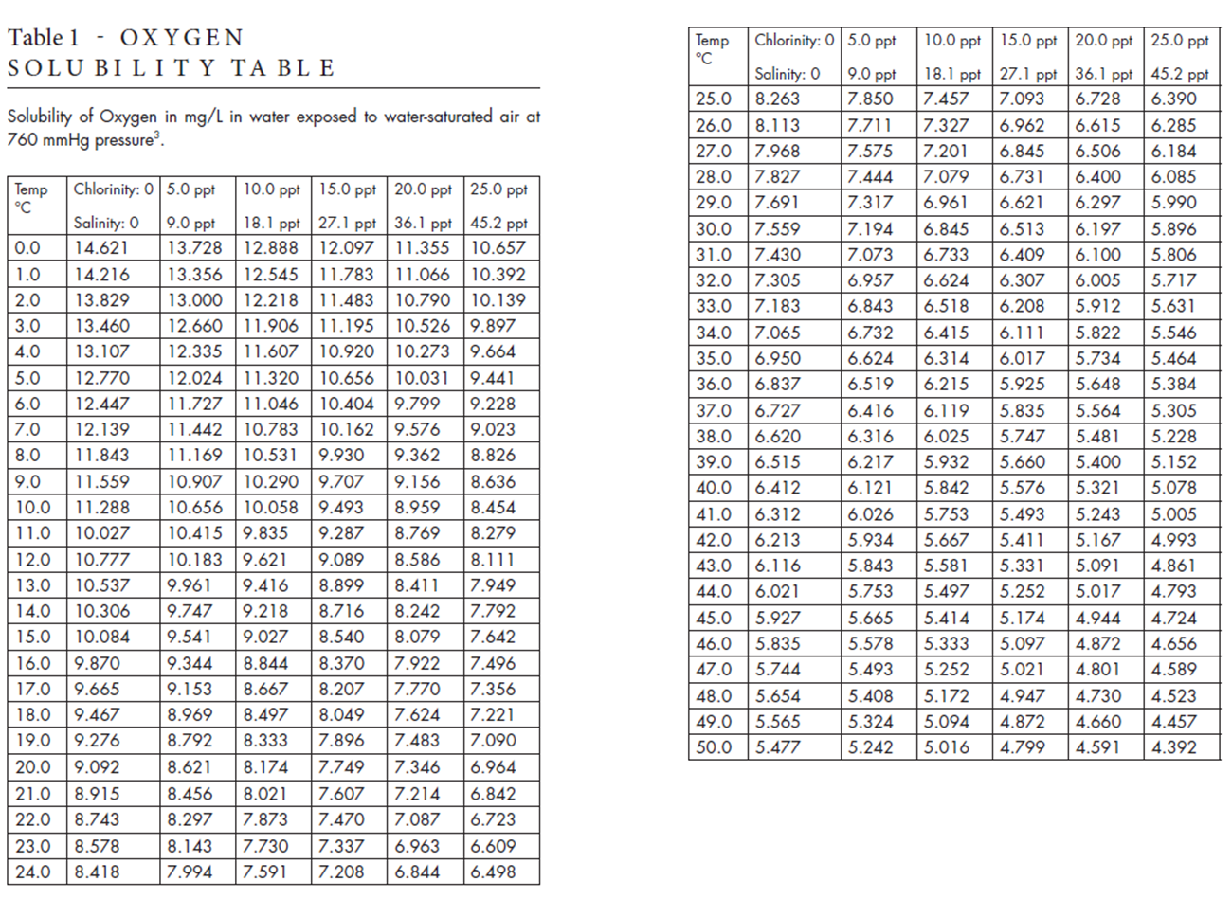

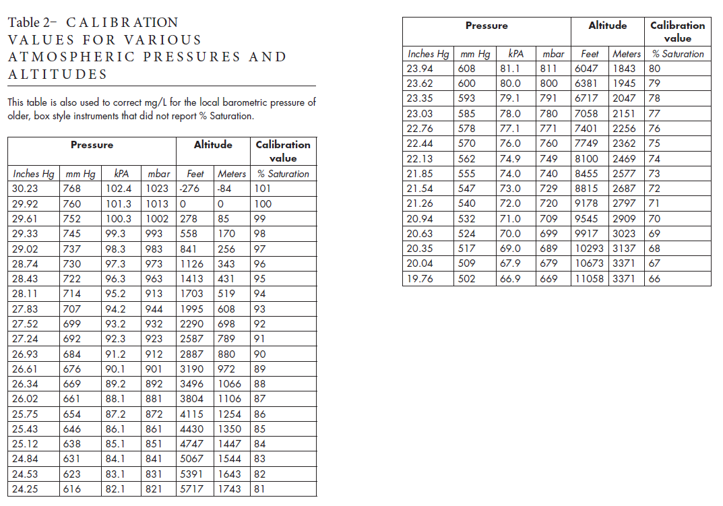
Example calculation for the theoretical DO value:
Assume the barometric pressure is 27.83 mmHg and the sample temperature is 22°C and has 0 ppt salinity.
From Table 2, the correction factor is determined by the % saturation at that pressure, i.e., 93% (0.93).
From Table 1, look in the cell where 22 °C and 0 ppt salinity overlap to get 8.743 mg/L.
Apply the correction factor to this value and compare to the reading on the meter.
Theoretical DO = 8.743 mg/L * 0.93 = 8.13 mg/L

