Cartography Treasure Hunt
Cartography is the study of maps. A cartographer is a person who makes maps. In this activity, you'll test your own cartography skills, making a map for a treasure hunt!

Choose an area to map
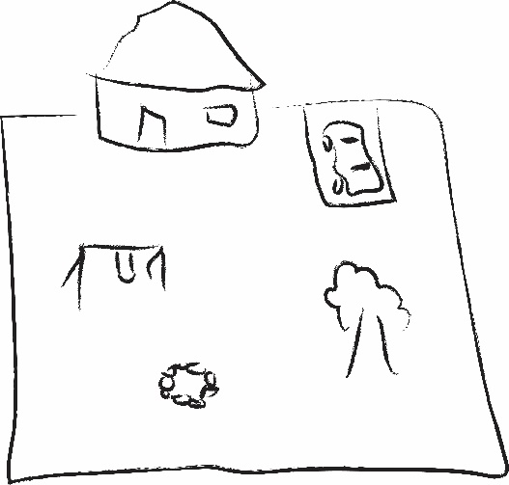
Any area can be mapped. It’s fun to map outside, but you can map the inside of a house, or even just a single room. Choose an area to map! It can be outside or inside, big or small, but it should be an area you know well.
Figure 2. A map of a backyard.
Figure 1. A map of a bedroom.

How to make a map
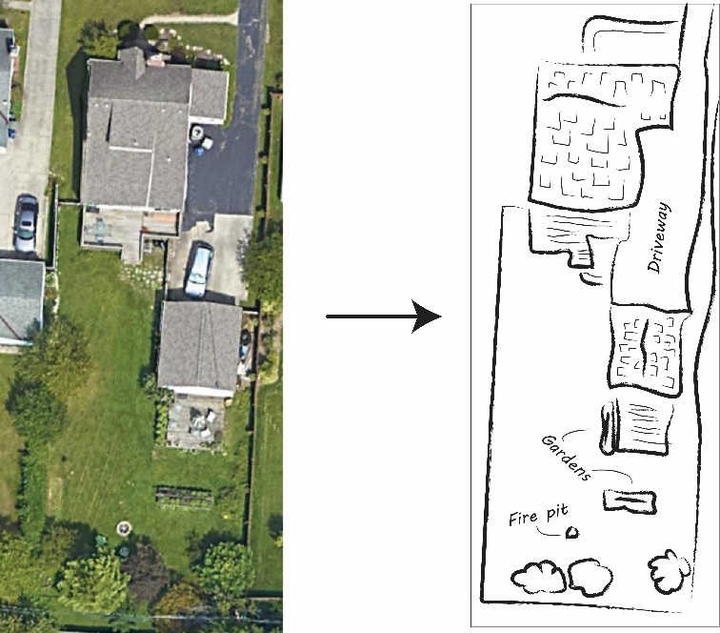
A map is kind of like a picture of an area, but it can be very simple. It’s not important if the things on the map are really good drawings of the things they represent – it’s only important that they are arranged the same way. You don’t have to be good at drawing. If your symbols are unclear, you can always label them. Using different colors is a great idea, if you can.

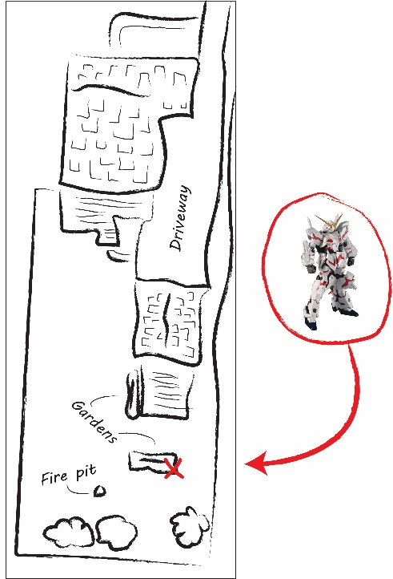
Treasure Hunt
Once you have made your map, hide an object somewhere in your area and mark its location on the map with a special symbol.
The best test of your map is whether or not someone can find your hidden object, using only your map!
After you’ve hidden your object, ask someone to find the object using your map.
Maybe they find it right away, or maybe they need some help. If you think they need help, it’s okay to give them clues, but only give them clues by referring to your map.
- If they ask you what something on the map represents, tell them, or better yet, label it!
- If they ask you where they are, point to where they are on the map.
Did your map pass the test? Once your helper finds the object, ask them to hide it for you! Have them mark its location on the map and then use your own map to find it.

Reflection
- What was the hardest part of making the map?

- What was the hardest part of using the map, for you or your helper?

- What’s a good trick for figuring out where you are on a map?

- What are some ways that people could use maps in real life?

