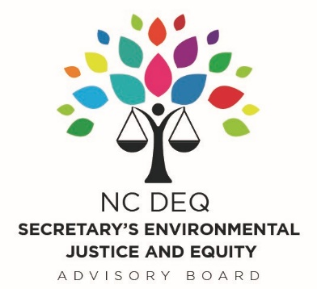

Secretary’s Environmental Justice and Equity Advisory Board

Wednesday, May 22, 2019
10:30 am
- Call to Order- Chairman Jim Johnson
- Discussion of Charlotte’s Strategic Energy Action Plan
    - Gina Shell- Deputy Director, Engineering & Property Management and Robert Phocas, Director of Sustainability, City of Charlotte
    - Dimple Ajmera: Charlotte City Councilmember
12:00-12:50 PM– Lunch Break
- Coal Ash - Status Update Presentation
- Sheila Holman, DEQ Assistant Secretary for the Environment

- Executive Order 80 – Presentation and Discussion
  - Jennifer Mundt, DEQ Senior Policy Advisor

- DEQ Mapping System – Beta Version Demo and Discussion
  - Jennifer Mundt, DEQ Senior Policy Advisor and Renee Kramer, DEQ Title VI and EJ Coordinator

- Animal Feeding Operations and General Permit- Status Update Presentation
  - Sheila Holman, DEQ Assistant Secretary for the Environment

3:30-3:45 PM- Break
- Subcommittee Breakouts
- Board Discussion

- Adjourn

5:00– 6:00 PM – Dinner on your own
6:00 – 7:00 – Public Comment Period

