What's the Right Way To Plow Your Garden?
If your garden is on a slope, plant your vegetables along the curve, or contour of the land rather than up and down, or against the slope. This will help slow down water runoff and decrease the rate of soil erosion.
Here's an experiment that will show you how contour plowing works.
You will need:
- 2 9-inch pie pans
- enough soil to fill them equally
- A sprinkle watering can
Put equal amounts of soil in the pie pans, forming a mound. With a pencil or your finger make furrows, or plow up and down in one pan and in circles in the other one.
ACTIVITY 9
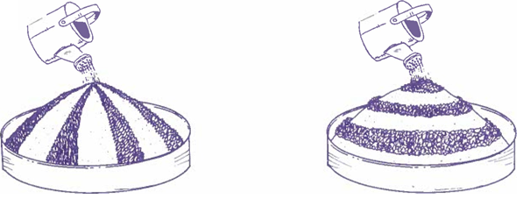
Sprinkle about half of the water from the watering can over the pan with the up and down furrows. What happens to the soil?
Now sprinkle the other half of the water from the watering can over the pan with the furrows plowed in circles. How long does it take for the water to reach the bottom?
Compare the condition of the soil. Which pan had more erosion to occur? Can you explain why?

