Guidelines for Owner Completion of the EZ Emergency Action Plan (EAP) (Template)

- This Emergency Action Plan (EAP) template is intended for use only if the dam is classified as a small intermediate hazard dam, a medium intermediate hazard dam, or a small high hazard dam. For more information on size and hazard classification, please refer to the North Carolina Administrative Code, Title15A, Subchapter 2K - Dam Safety, Section .0100 - General Provisions.

- The Dam Owner is required to replace all highlighted text (MAGENTA) with the appropriate information. Once the document is final, please remove all highlighting.

- If you need assistance in completing the portions of this template highlighted in BLUE, information may be obtained from the Division of Energy, Mineral and Land Resources at (919) 707-9220 or DamSafety@deq.nc.gov.

- A list of county Emergency Managers is available at https://www.ncdps.gov/emergency-management/em-community/directories/counties. Contact your relevant Emergency Manager to ensure all addresses and contacts are current and that the implementation of EAPs have not instead been delegated to a local program in your area.

- EAPs are required to be updated and resubmitted annually to the North Carolina Dam Safety Program, one year from the anniversary date of the most recent approval. Before this resubmittal, the EAP should be reviewed for correctness and modified to include any changes to the downstream hazards. If no updates are necessary to the EAP at the time of annual resubmittal, update the date of the EAP on each page and include a cover letter that states there have been no changes in the last year when resubmitting. The annually resubmitted EAP must use the most current EAP template available on the Dam Safety website at: https://deq.nc.gov/about/divisions/energy-mineral-and-land-resources/dam-safety/planning-dam-emergency. The North Carolina Dam Safety Program recommends that a periodic test, including a tabletop exercise, is conducted prior to the annual resubmission of the EAP.

- Downstream inundation maps are required for all EAPs. These maps should be created using engineering computer models like HEC-RAS Unsteady Model or other two-dimensional hydraulic analysis models as recommended in FEMA P-64 guidelines. The HEC-RAS models are available to anyone at no cost from the US Army Corps of Engineers at:: https://www.hec.usace.army.mil/software/hec-ras/.

  - Inundation maps should include two-foot interval topographic contours.

  - All electronic files and models must be submitted each time the EAP is submitted.

  - The inundation map should include inundation zones for both the Sunny-Day Breach (a pipe failure with the reservoir at normal pool elevation) and the Rainy-Day Breach (an overtopping failure at maximum pool elevation during passage of the State Design Flood or SDF). The two scenarios may be shown on the same map using different colors.

  - The 100-year flood elevations to determine structures “at risk,” may not be used

  - The inundation map must show all impacted structures, roads, railroads, and other pertinent features (located within the inundation zone extent) and reference each on Residents/Business/Roads/Infrastructure at Risk (Table 5.1).

  - Provide all supporting methodology used to develop the inundation map including: methodology used, assumptions made, modeling software used (if any), electronic files of the models, shapefiles of downstream inundation boundaries, associated inputs, date of creation, legend table, compass, topographic contours, scale size, and direction arrows.

- The North Carolina Dam Safety Program generally revises the EAP template (on an as-need basis) and associated guidance in January of each year. All submitted EAPs must use the most current EAP template available on the Dam Safety website at: https://deq.nc.gov/about/divisions/energy-mineral-and-land-resources/dam-safety/planning-dam-emergency.

When completed, submit one electronic pdf copy to | North Carolina Dam Safety Program (DamSafety@deq.nc.gov)  Division of Energy, Mineral and Land Resources  1612 Mail Service Center  Raleigh, North Carolina 27699-1612  Phone: (919) 707-9220

Dam Name
Emergency Action Plan (EAP)
State ID (First 5 Letters of County): COUNT-XXX
National Inventory of Dams ID (NID): NCXXXXX
County Name, North Carolina

Revision Number: 00
Month, Year

Dam Owner/Operator:
Name,
Email,
Physical Address,
Phone Number
24-Hour Emergency Phone Number

Dam Owner’s Engineer (If Available):
Name,
Email,
Phone Number (Office),
Phone Number (24-Hour Emergency):

OR
NC Dam Safety Central Office
damsafety@deq.nc.gov
(919) 707-9220
512 N Sailsbury St, 5th Floor
Raleigh NC, 27604
www.deq.nc.gov
Include a vicinity map for your dam that includes and adequately shows neighboring towns, any major highways, and the location of your dam here. Include a location marker clearly identifying your dam. You may use a web-based mapping application (e.g. Google Maps) for this requirement Please include Latitude and Longitude on or near the map.
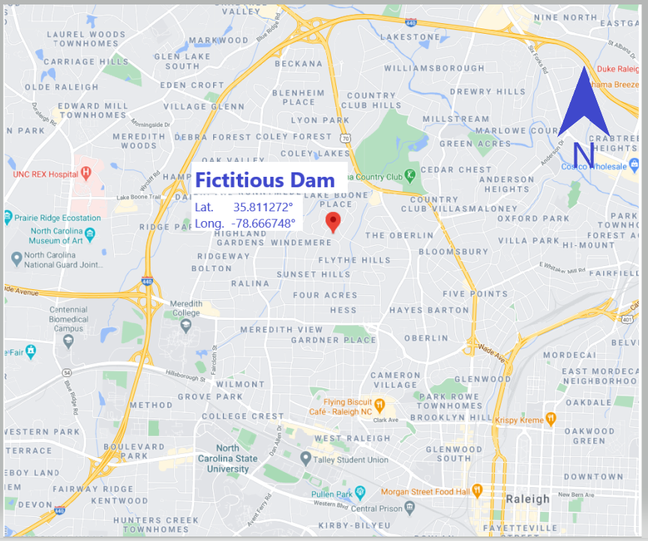

Figure 1.1 - Notification Flowchart

(1)
(2)
(1)
(1)
911 Dispatch

PERTINENT INFORMATION TO COMMUNICATE:

- Your Name
- Your Location
- Your Phone Number
Dam Name & State ID and Dam Address
- Reason for EAP Activation, Description of Event/Situation. Using Descriptive Language for the Event:
  - Event Level 1: Imminent Emergency
  - Event Level 2: Rapidly Developing Emergency
  - Event Level 3: Event Slowly Developing

Notes:
(1), (2) denotes suggested call sequence.
* See Appendix B for Regional Office contact information

State 24-Hour
Emergency Watch

1 (800) 858-0368

(2)
County or Local First Responders

Dam Owner/Operator
Name

Phone Number (Office)
Phone Number (Cell/24-Hour Emergency)
Dam Owner’s Engineer (If Available)
Name

Phone Number (Office)
Phone Number (Cell/24-Hour Emergency)

Or:

No Engineer at Time of EAP Preparation

NC Dam Safety

BUSINESS HOURS

Name of Regional Office
Engineer*

Regional Office*
Phone Number (Office)

Raleigh Central Office
(919) 707-9220 (Office)

EAP Overview

Statement of Purpose
- The purpose of this plan is to prescribe procedures to be followed in the event of an emergency associated with the dam, which is caused by an unusually large flood or earthquake, a malfunction (hydraulic or structural) of the spillway(s), or failure of the dam.

- This EAP defines responsibilities and procedures to:
- Identify unusual and unlikely conditions that may endanger the dam.
- Initiate remedial actions to prevent dam failure or minimize the downstream impacts of dam failure.
- Initiate emergency actions to warn downstream residents of impending or actual failure of the dam.

Summary of EAP Process
There are four steps that must be followed anytime an unusual or emergency event is detected at the dam. The four steps are:

Step 1: Event Detection and Level Determination
During the initial step, an unusual event or emergency event is detected at the dam and classified by NC Dam Safety into one of the following event levels (reference Table 1.1):

Event Level 3: Unusual event, slowly developing.
Event Level 2: Potential dam failure situation, rapidly developing.
Event Level 1: Urgent!! Dam failure is imminent or is in progress.

Step 2: Notifications and Communication
After the event level has been determined, notifications are made in accordance with the notification flowchart provided on page 2 of this EAP.

Step 3: Expected Actions
After the initial notifications are made, the Dam Owner should refer to Table 1.1 and coordinate with NC Dam Safety and the Local Emergency Management to develop and execute appropriate preventative actions. During this step of the EAP, there is a continuous process of taking action, assessing the status of the situation, and keeping others informed through communication channels established during the initial notifications. The EAP may go through multiple event levels during Steps 2 and 3 as the situation either improves or worsens.

Step 4: Termination and After-Action Review
Once the event has ended or been resolved, termination and follow-up procedures should be followed as outlined in Section 4 of this EAP. EAP operations can only be terminated after completing operations under Event Level 3 or Event Level 1. If Event Level 2 is declared, the operations must be designated Event Level 3 or Event Level 1 before terminating the EAP operations.

Step 1: Event Detection and Level Determination

1.1 Event Detection

Daily surveillance, observation, and/or instrumentation readings at the site are the normal methods of detecting potential emergency situations. Unusual or emergency events may be detected by:
• Observations at or near the dam.
• Evaluation of instrumentation data.
• Earthquakes felt or reported in the vicinity of the dam.
• Forewarning of conditions that may cause an unusual event or emergency event at the dam (for example, severe weather or flash flood forecast).

1.2 Emergency Level Definitions

Event Level 1 - Urgent!! Dam failure is imminent or is in progress.
This is an extremely urgent situation when a dam failure is occurring or is about to occur and cannot be prevented. When it is determined that no time is available to implement corrective measures to prevent failure, an order for the evacuation of residents in potential inundation areas shall be issued by the Local Emergency Management.

Event Level 2 - Potential dam failure situation, rapidly developing.
This classification indicates that a situation is developing that could lead to dam failure, but there is not an immediate threat of dam failure. The Dam Owner/Operator should closely monitor the condition of the dam and periodically report the status of the situation to NC Dam Safety. If the dam condition worsens and failure becomes imminent, the Local Emergency Management must be notified immediately of the change in the emergency level to evacuate the people at risk downstream. A reasonable amount of time is available for analysis before deciding on the evacuation of residents. If time permits, NC Dam Safety officials (and the Dam Owner’s Engineer if applicable) should be contacted to evaluate the situation and recommend remedial actions to prevent failure of the dam.

Event Level 3 - Unusual event, slowly developing.
This classification indicates a situation is developing but has not yet threatened the operation or structural integrity of the dam. NC Dam Safety officials should be contacted to investigate the situation and recommend actions to take. The condition of the dam should be closely monitored, especially during storm events, to detect any development of a potential or imminent dam failure situation

Table 1.1 - Event Level Determination Guidance
Event: Unexpected Failure
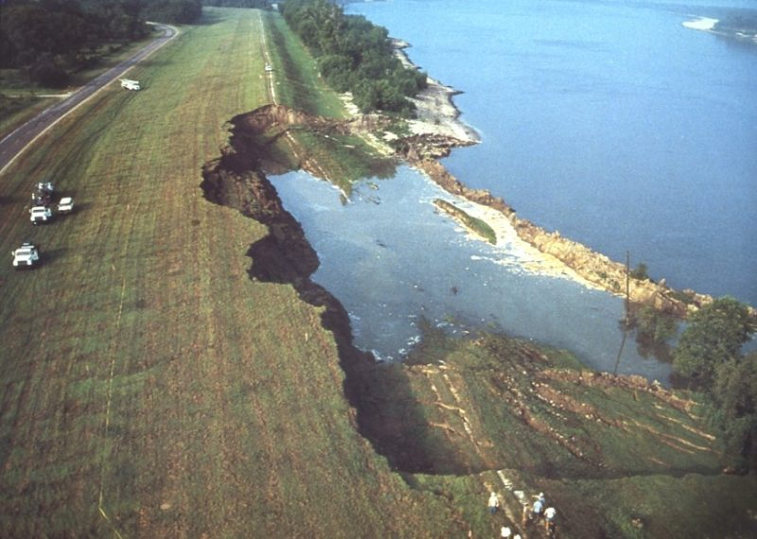 | Situation | Emergency level*
 | Dam unexpectedly and without warning begins to fail | 1
Event: Earth Spillway Flow
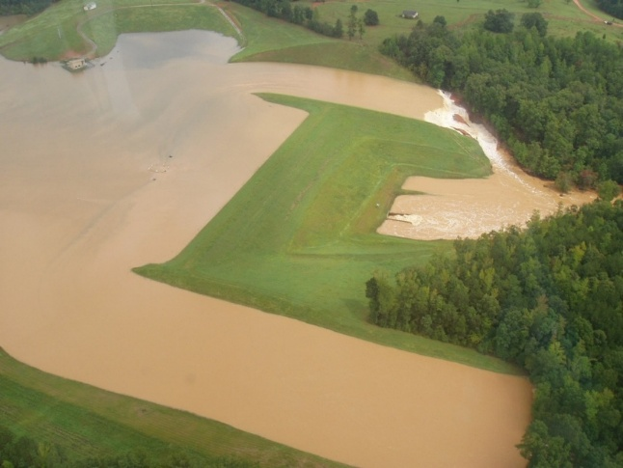 | Situation | Emergency level*
 | Spillway flow that is flooding people downstream | 1
 | Spillway flowing with active gully erosion or flow that could result in flooding of people downstream if the reservoir level continues to rise | 2
 | Reservoir water surface elevation at spillway crest or spillway is flowing with no active erosion | 3
Event: Embankment Overtopping
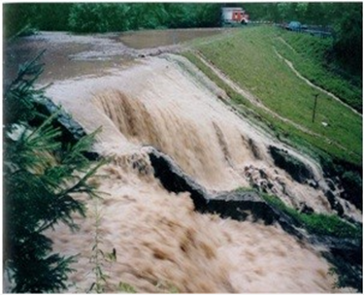 | Situation | Emergency level*
 | Water from the reservoir is flowing over the top of the dam | 1
 | Reservoir level is 1 foot below the top of the dam | 2
Event: Seepage
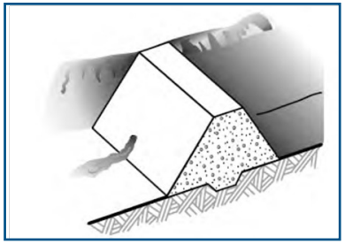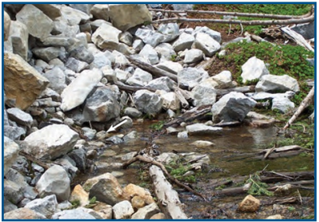  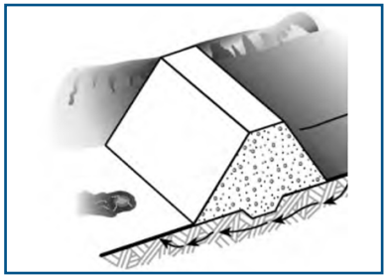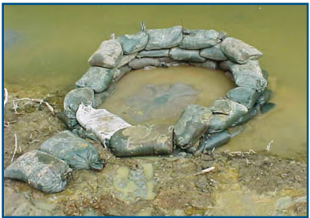 | Situation | Emergency level*
 | New seepage areas with cloudy discharge and increasing flow rate | 1
 | New seepage areas with cloudy discharge or increasing flow rate | 2
 | New seepage areas in or near the dam, water flowing clear | 3
Event: Sinkholes
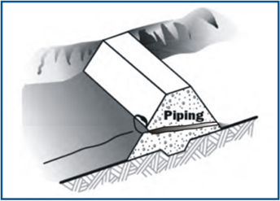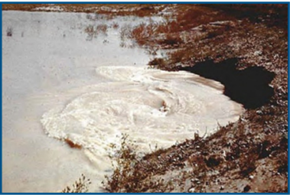 | Situation | Emergency Level*
 | Rapidly enlarging sinkhole(s) or new sinkhole(s) forming | 1
 | Observation of new sinkhole(s) in reservoir area or on embankment | 2
Event: Embankment Cracking
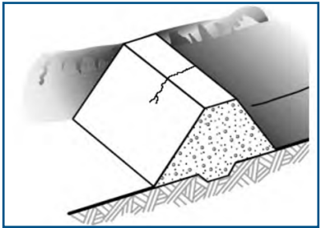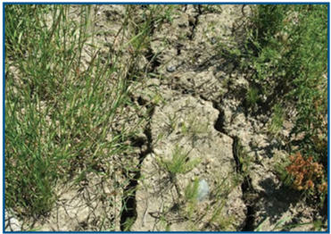  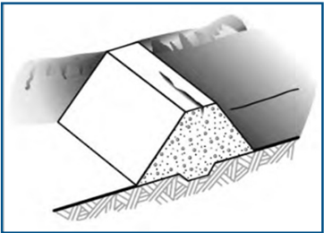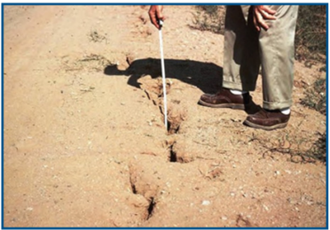 | Situation | Emergency Level*
 | New cracks in the embankment greater than ¼-inch wide without seepage | 3
Event: Embankment Movement
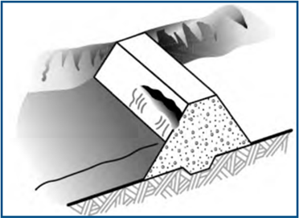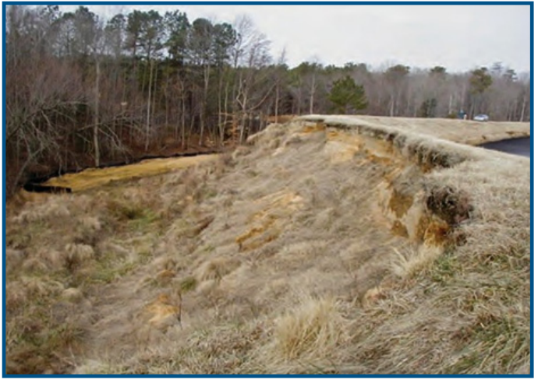 | Situation | Emergency Level*
 | Sudden or rapidly proceeding slides of the embankment slopes | 1
 | Visual movement/slippage of the embankment slope | 2
All photos in Table 1.1 were sourced from the FEMA Pocket Safety Guide for Dams and Impoundments, Association State Dam Safety Officials Lessons Learned, and Georgia Safe Dams Program.

Step 3: Expected Actions

3.1 Expected Actions
- The Dam Owner should coordinate with NC Dam Safety (and the Dam Owner’s Engineer if applicable) during an emergency event. If an event is not included in Table 1.1, it is recommended to describe the event and situation to NC Dam Safety and Local Emergency Management (and the Dam Owner’s Engineer if applicable) to the best of their ability.
- The Dam Owner should anticipate follow-up actions from NC Dam Safety and Local Emergency Management (and the Dam Owner’s Engineer if applicable), then it is recommended that two people split the following responsibilities:
- One person at the dam to handle on site actions.
- One person who can make the notifications.

Step 4: Termination and After-Action Review

4.1 Termination Responsibilities

The Local Emergency Management is responsible for terminating the emergency response operation and relaying the decision to NC Dam Safety and the Dam Owner/Operator. It is then the responsibility of each person to notify the same group of contacts that were notified during the original event notification process to inform those people that the event has been terminated.

Prior to termination of the Event Level 1 that has not caused actual dam failure, the Dam Owner’s Engineer (if applicable) or NC Dam Safety will inspect the dam or require the inspection of the dam to determine whether any damage has occurred that could potentially result in loss of life, injury, or property damage. If it is evaluated that conditions do not pose a threat to people or property, the Local Emergency Management and NC Dam Safety will determine when to terminate emergency response operations as described above.

4.2 After-Action Review

Event Level 3,– Following the termination of an Event Level 3, ensure all parties that participated in the EAP activities are involved in a comprehensive review process. Impose a time frame within which the review is to be completed. During the review, document any EAP procedures that were followed effectively, as well as any ways that the EAP could be improved. Following the termination of an Event Level 2 or Event Level 1, note any extra measures that must be taken due to the increased severity of the event.

Event That Has Caused a Loss of Life, Injury or Property Damage – In addition to the course of action outlined above for Event Level 2 or Event Level 1, note any special procedures that must be followed in the event of loss of life, injury, or property damage. In general, a closer look should be taken at the EAP operations. As before, impose a reasonable time frame on the completion of these activities, and document any EAP procedures that were followed effectively, as well as any ways that the EAP could be improved

Data for Emergency Management

- Residents/Businesses/Roads/Infrastructure at Risk (Table 5.1)
- Downstream Inundation Study (Figure 5.2)
- NC Inventory of Dams Data Sheet (Figure 5.1)
- Other available maps, charts or figures included that are deemed relevant in the case of an emergency event.

Table 5.1 – Entities at Risk
NC Dam Safety should summarize the list of entities as shown on the corresponding Downstream Inundation Study Map (Figure 5.2). All entity numbers listed below must match and be cross-referenced to the Downstream Inundation Study Map (Figure 5.2). Consult with your Local Emergency Management and County or Local Municipality to determine the proposed method of contact for at-risk parties downstream of a dam. Table 5.1 is a reference for Local Emergency Management as a backup to the Inundation Map presented in Figure 5.2. Any notification of risk to entities downstream is to be made by the Local Emergency Management or First Responders. The Dam Owner has no legal authority to evacuate entities downstream.
Entity Number (As shown on inundation study map) | Resident/Business/Road  or Other Impacted Entity  (All properties impacted must be listed) | Entity Property Address | Proposed Method of Contacting Entity (Phone Number, Emergency Alert System, Reverse 911, CODERED, etc.) | Entity’s Distance Downstream from Dam  (River miles)
1. | Name of entity | Address/location of entity | Phone Number  (XXX-XXX-XXXX) | X.XX miles
2. | Name of entity | Address/location of entity | Phone Number  (XXX-XXX-XXXX) | X.XX miles
3. | Name of entity | Address/location of entity | Phone Number  (XXX-XXX-XXXX) | X.XX miles
4. | Name of entity | Address/location of entity | County Emergency Alert System | X.XX miles
5. | Name of entity | Address/location of entity | County Emergency Alert System | X.XX miles
6. | Name of entity | Address/location of entity | County Emergency Alert System | X.XX miles
7. | Name of entity | Address/location of entity | Reverse 911 | X.XX miles
8. | Name of entity | Address/location of entity | Reverse 911 | X.XX miles
9. | Name of entity | Address/location of entity | Reverse 911 | X.XX miles
10. | Name of entity | Address/location of entity | CODERED | X.XX miles
11. | Name of entity | Address/location of entity | CODERED | X.XX miles
12. | Name of entity | Address/location of entity | CODERED | X.XX miles

(Use additional sheets if necessary)

Figure 5.1 - NC Inventory of Dams Data Sheet

You may obtain an official NC Inventory of Dams Data Sheet from North Carolina Dam Safety at (919) 707-9220 or DamSafety@deq.ncgov to be inserted here.

Appendices

Appendix A - Roles, Responsibilities, and Authority

Dam Owner/Operator
• As soon as an unusual or emergency event is observed or reported, immediately determine the emergency level as defined in Step 1.
• Immediately notify the personnel in the order shown on the notification chart for the appropriate level.

Local Emergency Management
• Coordinate with local responders and dispatchers to ensure that each has an opportunity for input into the EAP, each has a copy of the EAP, and each is aware of their responsibilities.
• During an event, maintain communication with NC Dam Safety staff.
• Maintain communication with the media when necessary.
• When an Event Level 2 or Event Level 3 situation occurs:
– Prepare response personnel for possible evacuations that may be needed if a Level 1 situation occurs.
– Alert the public as appropriate.
• When an Event Level 1 situation occurs:
– Alert the public.
– Immediately close roads and evacuate people within and possibly adjacent to the inundation area.
• Participate in the annual review and update of the EAP.

NC Dam Safety
• Advise the Dam Owner/Operator of remedial actions to take if an Event occurs, if time permits.

Dam Owner’s Engineer (if applicable)
• Advise the Dam Owner/Operator of the emergency level determination, if time permits.
• Advise the Dam Owner/Operator of remedial actions to take if a Level 2 event occurs, if time permits.

Figure 5.2 – Downstream Inundation Study

1. As required by NCGS § 143-215.31(a1)(2)(d), a downstream inundation map depicting areas affected by a dam failure and sudden release of the impoundment must be provided. Provide supporting methodology used to develop the inundation map including: methodology used, assumptions made, modeling software used (if any), electronic files of the models, associated inputs, date of creation, legend table, compass, topographic contours, scale size, and directional arrows. The inundation map should depict both the Sunny-Day Breach (simulating a piping failure with the reservoir at normal pool elevation) and the Rainy-Day Breach (simulating an overtopping failure at maximum pool elevation during passage of the SDF) inundation zones. The two scenarios may be shown on the same map or set of maps using different colors. Inundation maps should be developed using an engineering computer model (e.g., HEC-RAS Unsteady Model, or other two-dimensional hydraulic analysis model, etc.), as referenced in FEMA P-946, Federal Guidelines for Inundation Mapping of Flood Risks Associated with Dam Incidents and Failures. The HEC-RAS models are available to anyone at no cost from the US Army Corps of Engineers at: https://www.hec.usace.army.mil/software/hec-ras/. The inundation map must depict the inundated areas superimposed on recent aerial imagery or a topographic map (including labeled two-foot interval topographic contours) clearly showing all impacted structures, roads, railroads, and other well-known features (located within the inundation zone extent) and reference each on Residents/Business/Roads/Infrastructure at Risk (Table 5.1). Provide the following information at routine distance intervals on the inundation map: distance from embankment in miles, arrival time of breach wave in minutes, and maximum inundation depth in feet.

2. The downstream limit of the breach inundation zone analysis should be the most downstream point where habitable structures are not located in the non-hydrologic fair weather dam breach inundation zone and the with- and without-dam breach flood elevations for the hydrologic failure converging to a specified vertical tolerance of 1 foot, unless sufficient justification exists for a larger vertical tolerance. Please reference Section 8 of FEMA P-946, Federal Guidelines for Inundation Mapping of Flood Risks Associated with Dam Incidents and Failures for further clarification on the extent of downstream limits.

3. Inundation maps must be included within this EAP document, as they can be better distributed to emergency responders during an emergency within the same document.

4. Per NCGS § 143-215.31(a1)(2)(d), a downstream inundation map depicting areas affected by a dam failure and sudden release of the impoundment does not require preparation by a licensed professional engineer or a person under the responsible charge of a licensed professional engineer unless the dam is associated with a coal combustion residuals surface impoundment.

5. Inundation maps have been developed for this EAP from the best available information using reasonable assumptions and standardized methods. They are approximations of the maximum water surface extents resulting from a complete dam breach and draining of the full reservoir. Inundation maps are empirical hydrologic and hydraulic simulations that can only be field verified in the event of an actual breach. Evacuation areas and call lists should take into consideration the anticipated local impacts of flooding, knowledge of local infrastructure, both occupancy and ownership, and potentially interrupted services or cut-off access, which would be caused by dam failure. Depending upon actual circumstances, appropriate alert and evacuation areas could be either more or less extensive than the simulated inundation zones.

6. To ensure effective emergency response, please provide an inundation shapefile to NC Dam Safety. This will enable local emergency management to better identify and evacuate at-risk areas downstream if necessary.

Insert downstream inundation maps for your dam here.

Figure 5.3 – North Carolina Department of Environmental Quality Regional Offices
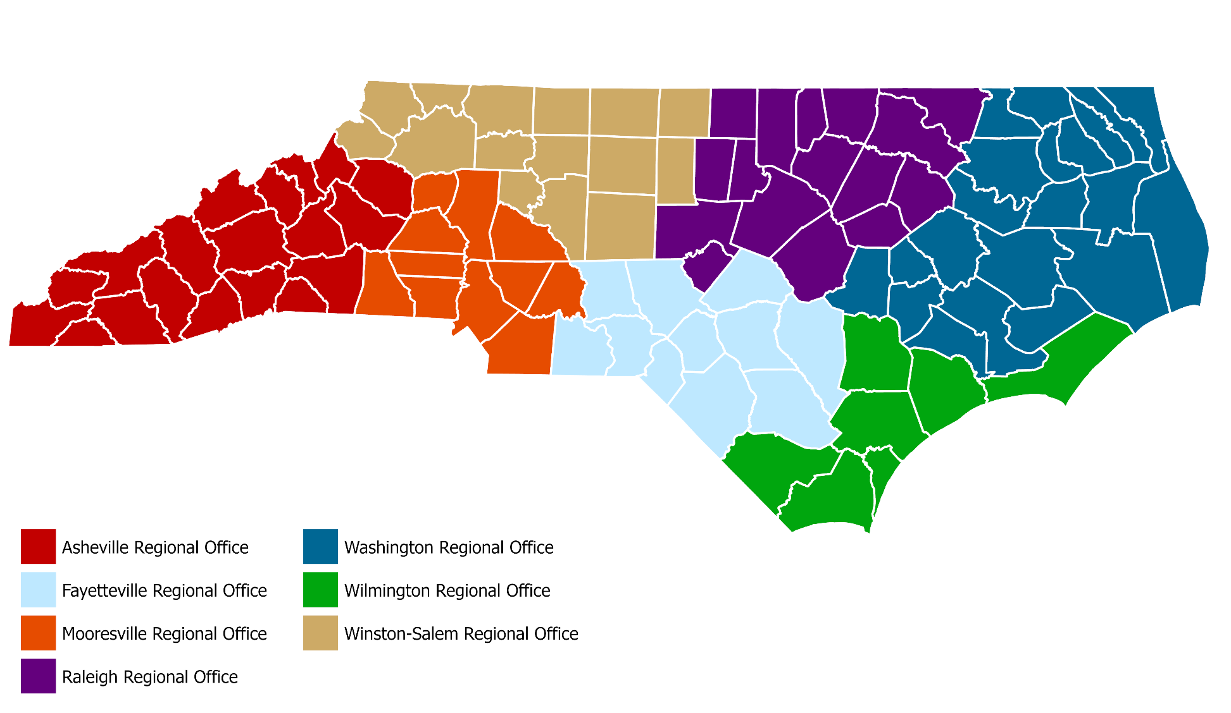

For more information about the regional offices see: https://www.deq.nc.gov/about/contact/regional-offices.

Appendix B – North Carolina DEQ Regional Office Contact Information
- Asheville Regional Office
  - Regional Office Phone Number: (828) 296-4500
  - 24-Hour Phone Number: (828) 296-4610

- Fayetteville Regional Office
  - Regional Office Phone Number: (910) 433-3300
  - 24-Hour Phone Number: (910) 433-3391

- Mooresville Regional Office
  - Regional Office Phone Number: (704) 235-2100
  - 24-Hour Phone Number: (704) 235-2147

- Raleigh Regional Office
  - Regional Office Phone Number: (919) 791-4200
  - 24-Hour Phone Number: (919) 791-4206

- Washington Regional Office
  - Regional Office Phone Number: (252)-948-3800
  - 24-Hour Phone Number: (252) 948-3859

- Wilmington Regional Office
  - Regional Office Phone Number: (910) 796-7215
  - 24-Hour Phone Number: (910) 796-7326

- Winston-Salem Regional Office
  - Regional Office Phone Number: (336) 776-9800
  - 24-Hour Phone Number: (336) 776-9654

Appendix C – Engineering Documents

Include all available engineering records and documentation, including but not limited to:
- Hydrology and Hydraulics Memorandum summarizing the analyses performed and assumptions to evaluate the dam breach inundation boundaries and develop the dam breach inundation maps. Include computer programs used, versions, etc.
- Reservoir Area – Capacity Curve
- Principal Spillway Rating Curve
- Emergency Spillway (Top of Dam) Rating Curve
- Annotated Site Pictures
- Plan View of the Dam
- As-Built and/or Survey Drawings

Appendix D – Glossary of Terms

Abutment | The part of the valley side against which the dam is constructed. The left and right abutments of dams are defined with the observer looking downstream from the dam.
Appurtenances | Structures incident to or annexed to dams essential to the proper operation, maintenance or functioning of the dam. This includes such structures as spillways, low-level outlet works, and water conduits, such as tunnels, pipelines, or penstocks, either through a dam or its abutments.
Breach | An opening through the dam that allows draining of the reservoir. A controlled breach is an intentionally constructed opening. An uncontrolled breach is an unintended failure of the dam.
Control section | A usually level segment in the profile of an open channel spillway above which water in the reservoir discharges through the spillway.
Dam | An artificial barrier generally constructed across a watercourse to impound or divert water.
Emergency spillway | The appurtenant structure that provides the controlled conveyance of excess water through, over, or around the dam.
Gully | A gully is a narrow valley or channel with steep sides, often formed by running water or heavy rains
Head cut | A type of erosion that occurs when water flow causes a sudden drop in the channel bed, creating a steep, vertical face
Left | The side of the dam that is on your left when you are facing downstream, looking from the upstream side towards the downstream side.
Low-level outlet works | An appurtenant structure, usually consisting of a pipe through the embankment or principal spillway structure equipped with a valve, whose purpose is to allow lowering the lake level.
Principal spillway | The appurtenant structure that conveys normal inflow through or around the embankment.
Right | The side of the dam that is on the right when you are facing downstream, looking from the upstream side towards the downstream side
Reservoir | The body of water is impounded or potentially impounded by the dam.
Seepage | The natural movement of water through the embankment, foundation, or abutment of the dam.
Unusual Event | An event which takes place, or a condition which develops, that is not normally encountered in the routine operation of the dam and reservoir or necessitates a variation from the operating procedures.

Figure 5.4 - Parts of a Dam
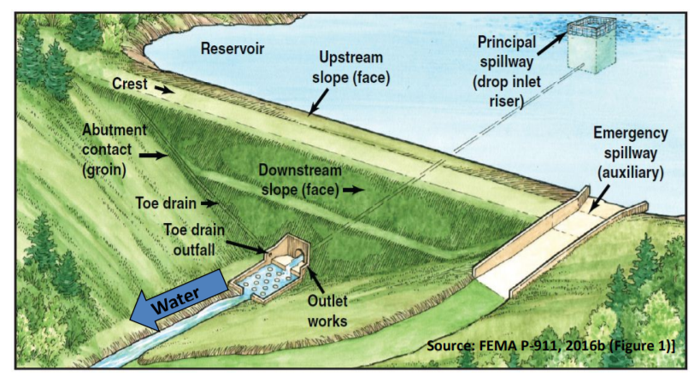

Appendix E – Locally Available Resources (Equipment, Labor, and Materials)

In the event of an emergency, resources may need to be sourced for mitigation efforts. The locally available resources that should be considered are, but not limited to:
- Heavy Equipment Service and Rental Company
- Sand Gravel and Supply
- Ready-Mix Concrete Supply
- Pumps
- Diving Service
- Sandbags

INDEX
Dam Name 1
EAP Overview 4
Statement of Purpose 4
Summary of EAP Process 4
Step 1: Event Detection and Level Determination 4
Step 2: Notifications and Communication 4
Step 3: Expected Actions 4
Step 4: Termination and After-Action Review 4
Step 1: Event Detection and Level Determination 5
1.1 Event Detection 5
1.2 Emergency Level Definitions 5
Step 3: Expected Actions 11
3.1 Expected Actions 11
Step 4: Termination and After-Action Review 12
4.1 Termination Responsibilities 12
4.2 After-Action Review 12
Data for Emergency Management 13

TABLES
Table 1.1 - Event Level Determination Guidance 6
Table 5.1 – Entities at Risk 14

FIGURES
Figure 1.1 - Notification Flowchart 3
Figure 5.1 - NC Inventory of Dams Data Sheet 15
Figure 5.2 – Downstream Inundation Study 18
Figure 5.3 – North Carolina Department of Environmental Quality Regional Offices 20
Figure 5.4 – Parts of a Dam…………………………………………………………………………………………………………22

APPENDICES
Appendix A - Roles, Responsibilities, and Authority 17
Appendix B – North Carolina DEQ Regional Office Contact Information 21
Appendix C – Engineering Documents 22
Appendix D – Glossary of Terms 23
Appendix E – Locally Available Resources (Equipment, Labor, and Materials) 24

