General Template Layout & Rules (DO NOT INCLUDE WITH PLAN SUBMISSION)
- Template Font can be custom, font size should be 11-12 font, with the exception for tables which should not exceed a size of 10
- Blue Highlight indicates text that is not allowed to be changed
- Yellow Highlight indicates text that can be customized & tailored to your project
- Italics text below each section are the instructions for what is needed to be included or described in that particular section. Do not delete italic instructions from the plan when you submit to DWR for review.
- Section Headings are to be bolded and underlined with a larger font size than subsections. Subsections are to be bolded but not underlined.
- Do not add or delete any tables or sections from the template unless the italic instructions advise you to do so. Every section is applicable for every project/bank and must be filled out. If a particular section does not apply to your project or bank, state “not applicable for this project or bank”.
- Make sure there are page numbers on every page of your plan, including figures and appendices
Table Rules:
- Font size should be between 9-10, Calibri is the best font style for tables in this template
- Tables depicted as pictures cannot be edited in any way, they shall remain as a picture
- Editable tables include blue-filled cells and clear cells. Do not change any text in blue-filled cells. Only add text in clear cells.
- Some tables may need to include more rows for your information. Only clear cells can be added or removed. Blue-filled cells cannot be added to, or removed from any table except in Table 6. Simply use “N/A” if a blue-filled cell doesn’t apply to your project/bank
- When completing a table, try to keep the entire contents of the table on the same page if possible. The only exception to this would be Table 6.
- Table 10 is the Project Credit Table. To ensure you are using the most up-to-date version of this table when you draft your mitigation plan, go directly to the website and download the version provided online. https://www.deq.nc.gov/about/divisions/water-resources/water-quality-permitting/401-buffer-permitting-branch/nutrient-offset-buffer-mitigation-program
Figure Symbology Rules:

Riparian Mitigation Activity Symbology
Restoration (R) | Enhancement (E) | Preservation (P) | Nutrient Offset (for both R & E)
Blue | Yellow | Green | Orange
Feature Symbology
Streams | In-line Ponds | Ephemerals | Ditches
Blue | Blue | Yellow | Pink or Purple
Hatching of different styles, sizes & colors can be used to differentiate riparian width categories (<20, 0-50, 0-100, 101-200, etc) and riparian areas adjacent to different feature types (I/P, Ephemeral, Ditch, etc) while not altering main colors for Mitigation activity. Conservation Easement Boundaries should all be depicted in Red or Yellow.

Attach the completed Mitigation Plan Checklist before this page.

PHOTO 1  Include photo representing the project | PHOTO2

Appendix # if part of a stream/wetland mitigation plan

Nutrient Offset & Buffer Mitigation Plan  MONTH,YEAR | NAME MITIGATION BANK PARCEL  NAME County, NC  DWR Project Number:  NAME River Basin  8-Digit HUC ########
 | PREPARED BY:

1.0 Project Introduction
The NAME Mitigation Bank Parcel (“Parcel”) is proposed under the terms and conditions of the proposed/approved NAME UMBRELLA Mitigation Banking Instrument (“UMBI”), made and entered into by SPONSOR NAME acting as Bank Sponsor (“Sponsor”) and the North Carolina Department of Environmental Quality (“NCDEQ”) Division of Water Resources (“NCDWR”). The Parcel shall be planned and designed according to the MBI, 15A NCAC 02B .0703 governing nutrient offset credit trading, and 15A NCAC 02B .0295 governing the mitigation program requirements for riparian buffers, which became effective on April 1, 2020 and November 1, 2015, respectively. If project is a multi-purpose joint project with the IRT, note that in detail here, providing the SAW project #, Appendix # of this Plan within the SAW plan, and acknowledge that mitigation activities and construction associated with the project will occur simultaneously.
The primary purpose of the Parcel is to provide riparian buffer mitigation credits and nutrient offset credits to compensate for authorized impacts in the NAME River Basin XXXXXXXX Hydrologic Unit Code (HUC)….

1.1 Site Description
This should not exceed 2 small paragraphs. Specific details of the site will be provided in following sections, so keep this section relatively broad. Provide driving directions to the parcel. Describe historical land uses (include supporting photos in Appendix) and land use changes within the proposed project boundary. Include NC stream classifications (Class A, Class C, WS-IV, etc) of features onsite as well as named tributaries and named rivers that onsite features ultimately drain to downstream. Describe receiving waters or conveyances where stormwater and, if applicable, agricultural runoff drains. Identify the main purpose of this bank site and how each credit type generated will be utilized.

1.2 Project Attributes
Table 1. Project Attributes
Project Name
12-digit Hydrologic Unit Code
River Basin
Geographic Location (Lat, Long)
Credit Types
Credit Service Area/s
Mitigation Plan Date
Initial Planting Date
Post Construction Inspection Request Date
As-Built Year 1 Monitoring Report Date
MY2 Report Date
MY3 Report Date
MY4 Report Date
MY5 Report Date

1.3 Project Goals

Summarize in 3-5 sentences, realistic nutrient reduction goals and how sponsor intends to achieve those reductions through proposed mitigation activities and land use changes. Fill in table below with more detail, add or delete rows if needed. If proposing buffer mitigation and/or nutrient offset, the rules require nutrient reductions be taking place on these projects. Make sure your Goals & Objectives are geared towards providing nutrient reductions/nutrient uptake and other benefits, such as stormwater runoff control, sediment control, infiltration improvements of riparian areas, water quality improvement, etc.
Table 2: Ecological and Water Quality Goals
Goals | Objectives

2.0 Site Characteristics (for sections 2.2-2.5, provide all relevant information needed to confirm this project does not or will not conflict with federal or state natural resource protections. Include supporting documentation in the Appendix and reference accordingly)

2.1 Existing Land Uses & Riparian Vegetative Communities
Describe in 3-5 sentences, the existing conditions of vegetation (woody and herbaceous) within riparian areas, as well as the land uses (CAFO, Ag, Timbered, farm path, etc). Include parcel photos (timestamped and labeled) of the riparian areas along each feature included in the project. One photo per feature is acceptable, unless vegetation conditions or land uses are different along that feature (forested, non forested, culverted, farm paths, etc). All photos for this section should be included immediately below the text in this section, not in the Appendix, and shall be presented in a format that is easy to discern the image. Do not provide soil types or tables in this section. Historical imagery photos need to be included in the Appendix and are not the type of photos required for this section.

2.2 Threatened and Endangered Species

2.3 Cultural Resources

2.4 FEMA Floodplain Compliance
2.5 Other Environmental Conditions (also include a summary of your findings with the EDR Report)

3.0 Regulatory Evaluation & Assessment

3.1 Stream Determination & Riparian Buffer Subjectivity
Reference the stream call determinations and riparian buffer subjectivity determination that was performed, and any other relevant information. Reference where in the Appendix this letter can be found.
3.2 On-Site Mitigation Determinations
Reference the site viability letter where the mitigation determinations were described. If the site viability letter included any contingencies or site constraints, those will be addressed in section 5.1 (Parcel Preparation) and do not need to be noted here.
Table 3: Project Features
Feature Name (NCDWR Evaluation) | Feature Type  (I/P, Eph, Ditch, Pond) | Subject to Buffer Rules?  (Y/N) | Location  (Rural/Urban) | Mitigation Activity¹  (R,E,P) | Credit Types Proposed | Alternative Buffer Mitigation²  (Y/N)
¹R = Restoration, E = Enhancement, P = Preservation
²Alternative Buffer Mitigation is proposed under 15A NCAC 02B .0295 (o) and further explained in Section 3.3

3.3 Alternative Mitigation for Riparian Buffer Credit
This section will describe which alternative is being proposed under 15A NCAC 02B .0295 (o). Depending on which alternative mitigation is being proposed in 15A NCAC 02B .0295 (o)(2-9), additional requirements may be noted in rule for a specific alternative. All alternatives must already be noted in the issued Site Viability letter referenced in Section 3.2. Use this section to describe how the sponsor meets all criteria for each alternative individually. For example: To use a ditch for buffer credits, the ditch must meet all the requirements in (o)(8). Sometimes, information is not always known at the site viability determination stage and therefore, the Plan must include that information to determine if a feature meets the requirements in rule to generate full credits. This section is used to confirm the sponsor will meet or has met the expectations to use a feature for buffer credits. Where a Figure or supporting information is necessary to confirm requirements are being met, specifically call out the relevant figure/s or Appendix in this section. This section will not apply to nutrient offset only projects, and the Sponsor will just say “not applicable for this project” when this is the case.

4.0 Site Protection Instrument & Long-Term Easement Management
The Sponsor agrees to facilitate and ensure the successful completion of transferring and assigning the conservation easement and its interests in perpetuity to a qualified holder under NC General Statute ("GS") 121-34 et seq. and 170(h) of the Internal Revenue Code prior to the submittal of the Year 4 Monitoring Report.
Describe, in 3-5 sentences, how the site will be protected during different stages of the process, and how many documents will need to be recorded to ensure full coverage of all parcels within the project boundary. Explain who will protect the integrity of the site through year 4 monitoring year. List long-term management stewards that the sponsor intends to reach out to prior to year 4. DWR will determine if these prospects are acceptable land stewards.

Table 4: Parcel Details
Landowner | PIN | County | Site Protection Instrument | Deed Book and Page Number | Acreage to be Protected
 |  |  | Conservation Easement | To Be Recorded

5.0 Project Proposal Details
In 3-5 sentences, summarize the overall work entailed to produce nutrient offset credits and/or riparian buffer credits.

5.1 Parcel Preparation
Use table 5 to describe all site constraints and contingencies in detail that are noted in the Site Viability Letter. Include any site constraints that may have occurred or were identified after issuance of the site viability letter. Explain how these constraints will be remedied. Figure 3 must depict the location of all existing constraints where plausible, and Figure 5 must depict proposed remedies. Try and fit Table 5 all on one page when complete.
Table 5: Site Preparation Plan
Parcel Issues  (includes site constraints & contingencies) | Applicable  (Y,N,N/A) | Description of activities used to remedy parcel issues (or enter N/A)
Bank Stabilization
Bare Soils
Certified Animal Feeding Operation
Compact Soils/Hardpans
Culvert Removals
Drain Tiles
Easements/Existing
Erosion Control
Invasive Species Management
Livestock
Non-Diffused Flows
Pond Removal
Soil Testing
Stream Mitigation |  | Not necessarily an issue, but an additional piece of information that must be noted. No credits can be claimed in areas where existing trees are removed for purposes of constructing stream mitigation. Delete this text if N/A
Timbered & Deforested Areas
Utilities
Wetland Mitigation |  | Not necessarily an issue, but an additional piece of information that must be noted. No credits can be claimed in areas where existing trees are removed for purposes of constructing wetland mitigation. Delete this text if N/A
Other

5.2 Activities Proposed for Generating Credits
In Table 6, describe in 3-5 sentences how Sponsor will restore, enhance and/or preserve riparian areas for each applicable situation below to ensure final performance standards of 260 stems/acre across the bank parcel and all relevant expectations of the rule/s are being met. Include specific features where these activities are occurring and specify the minimum and maximum widths and any other relevant information needed to address the rule and/or UMBI. Remove any tables that do not apply. Make sure these activities meet criteria for buffer credit and/or nutrient offset credit and are identified in the site viability letter for the specific features being proposed. If this is a joint stream/wetland project, no credits can be claimed in areas where existing trees will be removed as part of the construction plan for the stream/wetland project, and that will need to be noted in the appropriate table. This would mostly impact Preservation Sites but may also may impact Enhancement Sites.

Table 6: Mitigation Activity Plan
Restoration Site Activities along Intermittent/Perennial streams and/or Eph Channels
Proposed under 15A NCAC 02B .0295 (n) and/or 15A NCAC 02B .0295 (o)(3) & (o)(7)
Use this section to describe how buffer mitigation credits are being generated under the applicable rule citation
For example: Agricultural activities will immediately cease adjacent to UT1 and all 4 ditches. Hardwood trees and appropriate seeding will be planted across the entire riparian areas, including all tops of banks and extend landward 100’ from UT1 and only 50’ from the 4 ditches. No restoration area will be less than 50’ from all features. All parcel issues noted in Table 5 located in restoration areas will be addressed. (Delete this text)
Proposed under 15A NCAC 02B .0703 (c)(d)&(e)
Use this section to describe how nutrient offset credits are being generated under the applicable rule citation. To use this section, all riparian areas being restored must be noted as viable to generate nutrient offsets in the Site Viability Determination letter.
For example: Nutrient loadings from agricultural runoff will be addressed through seeding all bare areas with temporary and permanent seeding as well as planting native hardwood trees. Additionally, any sediment loading from erosional rills or unstable banks will be remediated through appropriate sediment and erosion control efforts. All plantings and seeding efforts will start at tops of banks and extend landward 200’ to the easement boundaries. No restoration area will be less than 50’ from all features. All parcel issues noted in Table 5 located in restoration areas will be addressed. (Delete this text)

Restoration Site along Coastal HW Stream Mitigation Sites
Proposed under 15A NCAC 02B .0295 (o)(2)
Use this section to describe how buffer mitigation credits are being generated under the applicable rule citation

Restoration Site along Ditches
Proposed under 15A NCAC 02B .0295 (o)(8)
Use this section to describe how buffer mitigation credits are being generated under the applicable rule citation
For example: make sure minimum and maximum widths are achieved, note which ditches are proposed, and ensure both sides are protected with an easement. (Delete this text)
Proposed under 15A NCAC 02B .0703 (c)(d)&(e)
Use this section to describe how nutrient offset credits are being generated under the applicable rule citation. To use this section, all riparian areas being restored must be noted as viable to generate nutrient offsets in the Site Viability Determination letter.

Enhancement Site via Supplemental Planting
Proposed under 15A NCAC 02B .0295 (n) and/or 15A NCAC 02B .0295 (o)(3) & (o)(7)
Use this section to describe how buffer mitigation credits are being generated under the applicable rule citation. If this is a Joint project with stream and/or wetland mitigation activities, no credits can be claimed within areas where trees will be removed for purposes of constructing streams and/or wetlands, as this would be a direct violation of the rule for enhancement of grazing areas.
Proposed under 15A NCAC 02B .0703 (c)(d)&(e)
Use this section to describe how nutrient offset credits are being generated under the applicable rule citation. To use this section, all riparian areas being enhanced via supplemental planting must be noted as viable to generate nutrient offsets in the Site Viability Determination letter. If this is a Joint project with stream and/or wetland mitigation activities, no credits can be claimed within areas where trees are removed for purposes of constructing streams and/or wetlands as this would be a direct violation of the rule for Enhancement Site and the enhancement of riparian areas.

Enhancement Site via Livestock Exclusion
Proposed under 15A NCAC 02B .0295 (o)(6)
Use this section to describe how buffer mitigation credits are being generated under the applicable rule citation. If this is a Joint project with stream and/or wetland mitigation activities, no credits can be claimed within areas where trees are removed for purposes of constructing streams and/or wetlands. Since these areas are already in a forested condition and would have been determined a Preservation Site if no cattle were present, removal of trees would be a direct violation of the rule for Preservation Site & Enhancement Site

Preservation Sites
Proposed under 15A NCAC 02B .0295 (o)(4) & (o)(5)
Use this section to describe how buffer mitigation credits are being generated under the applicable rule citation. If this is a Joint project with stream and/or wetland mitigation activities, no credits can be claimed within areas where trees are removed for purposes of constructing streams and/or wetlands, as this would be a direct violation of the rules for a Preservation Site and the preservation of buffers for mitigation credit.

5.3 Calculating Nutrient Offsets (remove this section if not applicable to this Plan)
The Division accepts the use of reforestation buffer restoration and enhancement, defined in 15A NCAC .0295 (b) and described in 15A NCAC 02B .0295 (n)(2-4), on agricultural lands to generate nutrient offset credits. The square footage proposed for Nutrient Offset Credits, will be determined by applying the applicable ratio for in 15A NCAC 02B .0295 (m) for a Restoration Site and Enhancement Site. Credits are then determined using the Clarified Procedures for Calculating Buffer Mitigation Credits and Nutrient Offset Credits issued by the DWR. To comply with all requirements, all nutrient offset credit areas are populated within the Project Credit Table in Section 7.0

5.4 Planting Plan & Performance Standards
In 3-5 sentences, describe the spacing that trees will be spaced upon planting, include the anticipated planting density to achieve 260 stems/acre by year 5. Include the acreage that will be planted and identify any unique/specialized areas that may be planted differently than the rest of the site. Specialized areas would include sandy soils, ridges, wetland areas/wet soils, areas where live stakes may be necessary for bank stabilization, marsh treatment areas, and the like. If there are no specialized areas applicable to the site, add N/A to that section on Table 7. Also need to include the template language below in this section:
No one species will be planted at a composition higher than 50% throughout the Parcel. Stems will be well mixed prior to planting to ensure diversity of bare root species across the Parcel. Due to the nature of random mixing, some stems of the same species might be planted together in some areas. Figure 5 illustrates areas proposed for planting. Planting is scheduled for SEASON, YEAR. The final performance standard shall include a minimum of four native hardwood tree species or four native hardwood tree and native shrub species, where no one species is greater than 50 percent of stems. Native hardwood and native shrub volunteer species may be included to meet the final performance standard of 260 stems per acre upon DWR approval.

Table 7: Proposed Planting List
Species | Common Name | %Density | Forest Strata | Tree/Shrub/Herb
Possible Substitutions
Herbaceous Landcover Species
Specialized Planting Areas

6.0 Post Construction Documentation

6.1 Post Construction Inspection Request
Within 30 calendar days after completing the activities noted in Section 5.0 of this Plan, the Sponsor will submit written notification to DWR requesting a site visit to inspect the post-construction site conditions of the Bank Parcel. Written notification will include all the following:

  - All activities completed that are associated with riparian restoration, enhancement, and/or preservation, including planting details, invasive species control, confirmation of fence installation if applicable, cattle exclusions if applicable, confirmation that all easement boundary markers are installed, monitoring vegetation plot and photo point locations well marked, and all seeding, grading and stabilization efforts where necessary are completed.

  - Georeferenced figure representing all riparian restoration, riparian enhancement and riparian preservation activities where applicable;

  - Georeferenced figure representing the location of all monitoring plots installed;

  - Detailed planting plan including the type of species planted, the density of species planted, and any modifications to the planting plan from what was approved in the Plan;

  - Description of how the conservation easement boundaries were marked;

  - Any major changes to the conservation easement boundary from what was proposed in the approved Plan.

6.2 Easement Boundary Identification
In 3-5 sentences, describe how the easement will be identified and what materials will be used. Commit to having the assignment of your long term steward chosen prior to Year 4 monitoring report submittal.

6.3 As-Built Year 1 Monitoring Report

The following contents must be included in the report:

- Site visit notes documenting the inspection of post-construction site conditions performed by DWR. If DWR required remedial work or other items to be completed after inspecting the post-construction site conditions of the Bank Parcel, then the Sponsor is required to address these items in the and document a timeline for completion.

- Boundary Survey of the conservation easement area signed and sealed by a licensed surveyor, including an inventory of the final areas for Riparian Buffer Credits and Nutrient Offset Credits in square feet. The survey must depict square feet according to the guidelines in the Clarified Procedures for Calculating Buffer Mitigation Credits and Nutrient Offset Credits document (reference #5). Therefore, the square footage of all buffer and nutrient offset areas must be depicted out to the nearest whole number and must match the Project Credit Table and corresponding Credit generation figures from the approved Plan. All non-credit generating areas must also be depicted per the approved Plan.

- As-Built maps depicting specific mitigation types and where the riparian buffer and nutrient offset credit generation areas are located. Maps must depict any deviations to the Bank Parcel from what was approved in the Plan. As-Built maps must match the signed and sealed boundary survey and must depict buffer and nutrient offset credit areas out to the nearest whole number. Non-credit generating areas must also be depicted per the approved Plan.

- Project Credit Table, updated to match boundary survey and corresponding As-Built maps

- Individual Vegetation plot data submitted in accordance with the monitoring protocol in Section 7.0 of this Plan. Data will be collected at least five months after initial planting has been completed, no earlier than July 1, and no later than leaf drop.

7.0 Monitoring and Maintenance Plan

Data collected for the As-Built Year 1 Monitoring Report will be collected at least five months after planting has been completed, no earlier than July 1, and no later than leaf drop. Data can be collected between July 1 and leaf drop for monitoring years 2-5. Visual site inspections and easement boundary checks must be conducted at least twice a year. All documentation must be provided in the annual monitoring reports and submitted to DWR before December 31 of each year. All vegetation monitoring must follow the CVS Level 2 Protocol version 4.2 for planted stems and volunteers. All plot data will be recorded on Woody Stem Data: CVS Level 2 datasheets and included in each monitoring report.

7.1 Plot Details
Table 8: Monitoring Plot Details
Total Acreage Proposed for Planting for Buffer/Nutrient Offset | Plot Type | Quantity in Buffer Credit Area | Quantity in Nutrient Offset Credit Area | Plot Size & Shape | Quantity Shared w/ IRT  (N/A if not a Joint Site)
Fixed
2% of planted area
Rotating
No more than 10% of total DWR plots
Transects
Only if req’d or needed

7.2 Monitoring Parameters
Table 9: Monitoring Parameters
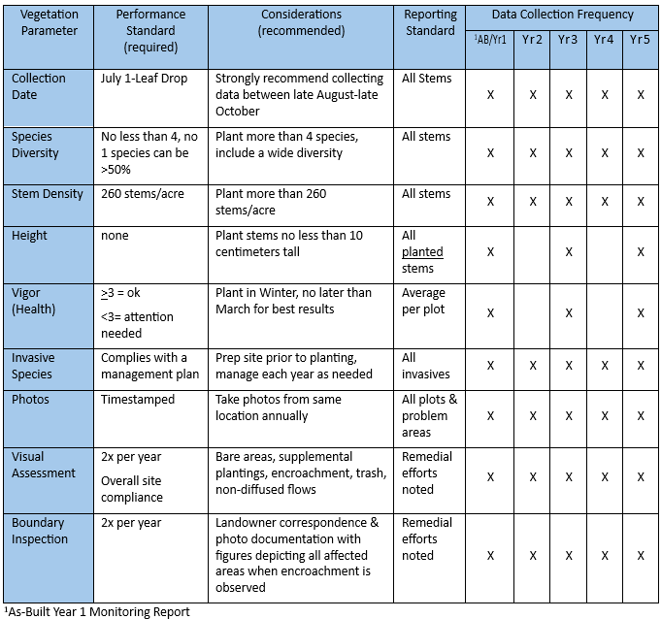

7.3 Parcel Maintenance
In 3-5 sentences, describe how the Sponsor is prepared to conduct maintenance of the site when and if it becomes necessary. Describe specific methods that will likely be used to maintain the integrity of the site should they be necessary (i.e. mowing, herbicide, erosion, etc). If using herbicides, they must be aquatic safe and if mowing, then DWR must be informed beforehand to ensure no violations of easement or rule.

7.4 Adaptive Management Plans
In 3-5 sentences, describe how the sponsor will address issues that trigger adaptive management. All plans must be submitted to DWR and receive approval prior to implementation.

8.0 Financial Assurance
In 3-5 sentences, describe the form of financial assurance that will be used, and the amount of each. This section must comply with the UMBI requirements

9.0 Project Credit Potential
Of the # acres protected under the conservation easement, the Mitigation Activity for # acres is riparian restoration, for # acres is riparian enhancement and for # acres is riparian preservation.
Add descriptions of any non-credit generating areas and why, including any 25% caps for preservation or ephemerals and any areas that are not meeting diffused flow, wetland credit areas, >200’, <20’, utility corridors, violation areas, etc. Figure 6 would need to depict non-credit areas appropriately. Ensure that Figure Reference the Buffer Interpretation /Clarification Memo #2008-019 in Appendix # will be applied if diffused flows into the conservation easement cannot be attained. If this is a Joint project with stream and/or wetland mitigation activities, no credits can be claimed within areas where trees are removed for purposes of constructing streams and/or wetlands, as this would be a direct violation of the rules for a Preservation Site and the preservation of buffers. Add the additional template language below:
All Riparian Buffer Credits shall be determined based on the ratios and percentages provided in 15A NCAC 02B .0295 (m) and (n) following guidance provided in the Clarified Procedures for Calculating Buffer Mitigation Credits and Nutrient Offset Credits letter issued by DWR (see reference #5) including the most recent Project Credit Table template (see Appendix C) provided online
Any credit conversions must be calculated using the guidance provided in the Clarified Procedures for Calculating Buffer Mitigation Credits and Nutrient Offset Credits letter issued by the NCDWR.
The management objectives, mitigation type, and proposed amount of riparian buffer credits and nutrient offset credits are presented in Table 10 below. There will be # credit ledgers for the project: a Buffer Restoration Credit Ledger, a Buffer Preservation Credit Ledger, and a Nitrogen Nutrient Offset Credit Ledger.

Insert completed Project Credit Table here, using the most up-to-date version available on the DWR website. This will need to be labeled Table 10. As of the date this template was made available, the most-up-to-date template for Table 10 is dated January 2026.
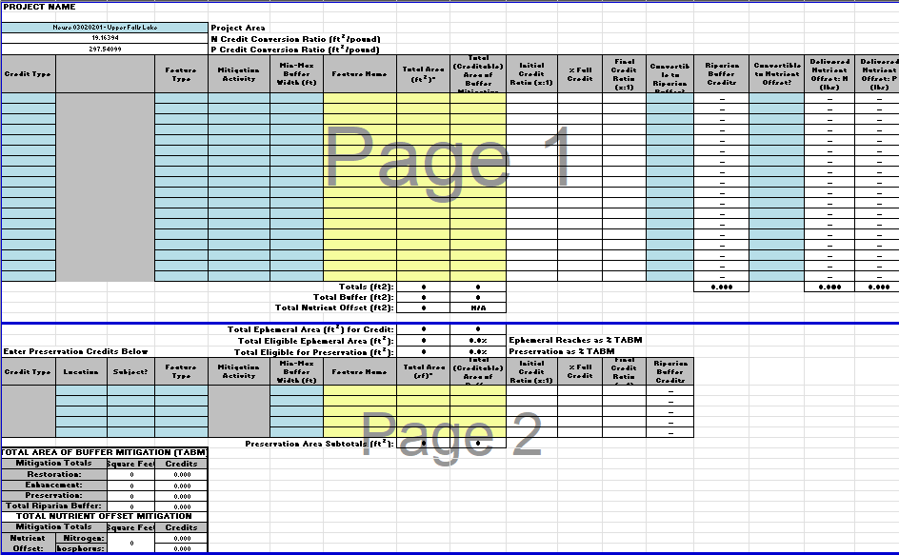

10.0 References

Insert all nine figures here (use the Checklist to make sure you have all the required figures and correct figure titles). Use the figure templates online to help draft Figure 3 (Existing Conditions), Figure 6 (Project Credits Map), Figure 7 (Riparian Buffer Zones Map) and Figure 9 (Monitoring Components Maps)

Insert all Appendices (use the Checklist to make sure you have all the required appendices, including any additional supporting information relevant for this project)

