General Template Layout & Rules (DO NOT INCLUDE WITH REPORT SUBMISSION)
- Template Font can be custom, font size should be 11-12 font, with the exception for tables which should not exceed a size of 10
- Blue Highlight indicates text that is not allowed to be changed
- Yellow Highlight indicates text that can be customized & tailored to your project
- Italics text below each section are the instructions for what is needed to be included or described in that particular section. Do not delete italic instructions from the report when you submit to DWR for review.
- Section Headings are to be bolded and underlined with a larger font size than subsections. Subsections are to be bolded but not underlined.
- Do not add or delete any tables or sections from the template unless the italic instructions advise you to do so. Every section is applicable for every project/bank and must be filled out. If a particular section does not apply to your project or bank, state “not applicable for this project or bank”.
- Make sure there are page numbers on every page of your report, including figures and appendices
Table Rules:
- Font size should be between 9-10, Calibri is the best font style for tables in this template
- Tables depicted as pictures cannot be edited in any way, they shall remain as a picture
- Editable tables include blue-filled cells and clear cells. Do not change any text in blue-filled cells. Only add text in clear cells.
- Some tables may need to include more rows for your information. Only clear cells can be added or removed. Blue-filled cells cannot be added to or removed from any table. Simply use “N/A” if a blue-filled cell doesn’t apply to your project/bank
- When completing a table, try to keep the entire contents of the table on the same page if possible.
Figure Symbology Rules:

Riparian Mitigation Activity Symbology
Restoration (R) | Enhancement (E) | Preservation (P) | Nutrient Offset (for both R & E)
Blue | Yellow | Green | Orange
Feature Symbology
Streams | In-line Ponds | Ephemerals | Ditches
Blue | Blue | Yellow | Pink or Purple

Hatching of different styles, sizes & colors can be used to differentiate riparian width categories (<20, 0-50, 0-100, 101-200, etc) and riparian areas adjacent to different feature types (I/P, Ephemeral, Ditch, etc) while not altering main colors for Mitigation activity. Conservation Easement Boundaries should all be depicted in Red or Yellow.

Attach the completed Monitoring Report Checklist before this page.

PHOTO 1  Include photo representing the project | PHOTO2

MY# Monitoring Report  MONTH,YEAR | NAME MITIGATION BANK PARCEL  NAME County, NC  DWR Project Number: ####-####v#  NAME River Basin  8-Digit HUC ########

PREPARED BY:

- Project Introduction
The SITE NAME Mitigation Bank Parcel (“Parcel”) was created under the terms and conditions of the SITE NAME Mitigation Banking Instrument (“MBI”), made and entered into by SPONSOR NAME acting as Bank Sponsor (“Sponsor”) and the North Carolina Department of Environmental Quality (“NCDEQ”) Division of Water Resources (“NCDWR”). THE NUTRIENT OFFSET AND/OR BUFFER PLAN (Buffer Plan) was approved in MONTH YEAR. The Parcel/Project etc. has been planned, designed, and constructed according to the MBI, 15A NCAC 02B .0703, and the Consolidated Buffer Mitigation Rule 15A NCAC 02B.0295. The Buffer Plan has also been designed in concurrence with the RELEVANT USACE MITIGATION PLAN(SAW ###, DWR ID ###), which is generating stream and wetland credits.
The primary purpose of the Parcel is to provide riparian buffer mitigation credits and nutrient offset credits to compensate for unavoidable impacts in the NAME River Basin ####### Hydrologic Unit Code (HUC), outside the Falls Lake Watershed.
The Parcel creates a protected riparian area ranging from top of bank and up to XX feet along LIST PROJECT FEATURES/STREAMS/DITCHES AND STATE IF A FEATURE IS NOT GENERATING CREDITS BUT IS WITHIN THE PROJECT AREA. The riparian area along the tributaries was restored, enhanced, or preserved to provide ecological and water quality enhancements to the NAME River Basin and create a functional riparian corridor. This project protects XXX acres along the project features by a permanent conservation easement. The conservation easement was recorded on the Parcel in YEAR.

Table 1. Project Attributes
Project Name
12-digit Hydrologic Unit Code
River Basin
Geographic Location (Lat, Long)
Credit Types
Credit Service Area/s
Mitigation Plan Date
Initial Planting Date
Post Construction Inspection Request Date
As-Built Year 1 Monitoring Report Date
MY2 Report Date
MY3 Report Date
MY4 Report Date
MY5 Report Date

Table 2: Riparian Planting List
Species | Common Name | %Density | Forest Strata | Tree/Shrub/Herb
Possible Substitutions
Herbaceous Landcover Species
Specialized Planting Areas

- Monitoring Results
Table 3: Monitoring Parameters
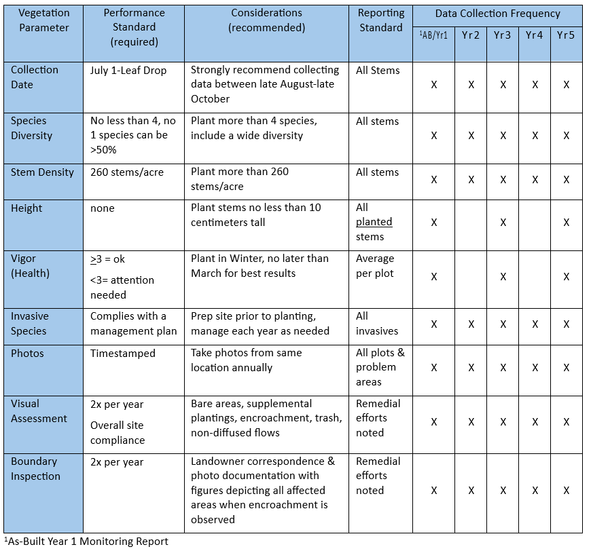

Table 4: Monitoring Plot Details
Total Acreage Planted for Buffer/Nutrient Offset | Plot Type | Quantity in Buffer Credit Area | Quantity in Nutrient Offset Credit Area | Plot Size & Shape | Quantity Shared w/ IRT  (N/A if not a Joint Site)
Fixed
2% of planted area
Rotating
No more than 10% of total plots
Transects
Only if re’q or needed

Table 5: MY# Vegetation Monitoring Summary
Description
- Number of Veg Plots meeting/failing Success Criteria (Species Density, Diversity, Richness)
- Conditions of overall site vegetation health, any previous AMP areas, and any management actions taken during the current monitoring year.
- For all failing plots/areas of the site, describe all planned management activities or include justification as to why no management is proposed
- Description of Easement Boundary Check. If any easement violations were found, provide a description of remedial actions & landowner notification.
- Description of other vegetation and site issues/considerations (Culverts, non-diffuse flows, erosion stabilization, etc)

Appendix A: Figures

Figure 1: Project Location Map

Figure 2: Project Credits Map

Figure 3: Current Conditions Plan View (CCPV)
- Color coded veg plots (Green = Pass, Red = Fail)
- All previous and current encroachment, supplemental planting, and AMP areas depicted
- Multiple versions of this map can be included if needed

Appendix B: Vegetation Assessment Data

Table 6: MY# Vegetation Performance Standards Summary Table
Add rows as needed
Plot # | Planted Living Stems per acre | Total Living Stems per acre | Stem Density Criteria Met? | Species Diversity Criteria Met? | Average Stem Height (ft)¹ | Average Stem Vigor¹
 |  |  | Yes | Yes
 |  |  | Yes | No
 |  |  | No | No
¹Only required in As-Built Year 1, MY3, MY5

Table 7: Plot Planted Stems and Densities
Either CVS or Shiny summary output table format may be used

EXAMPLE
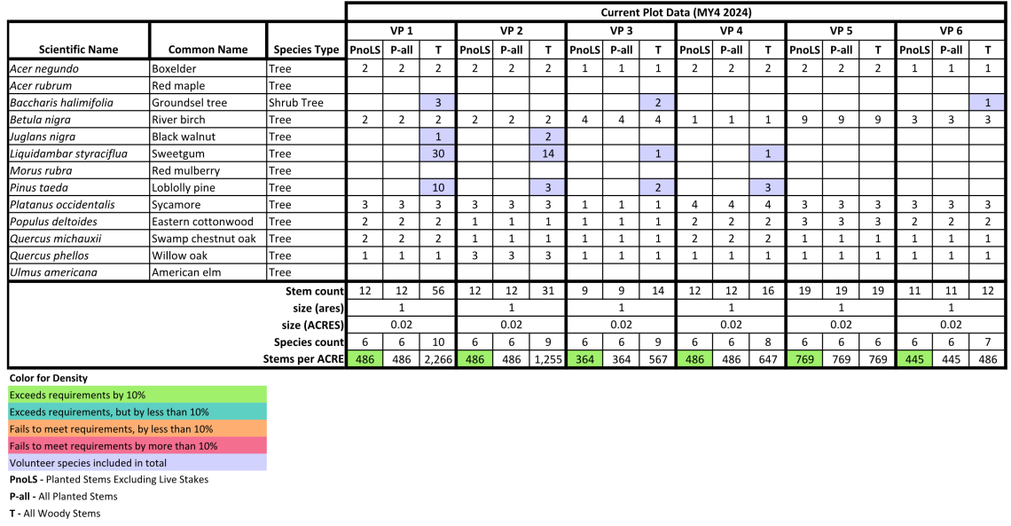
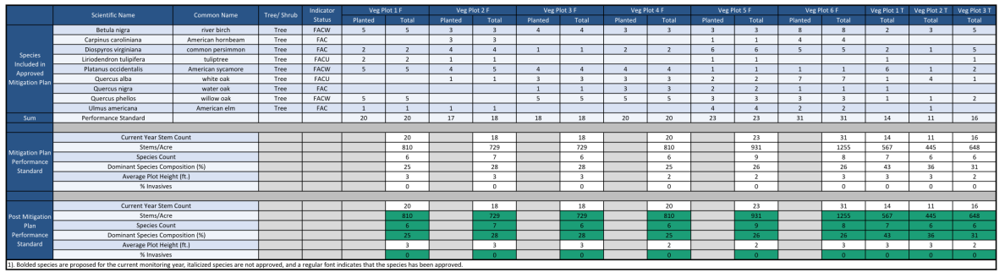

Woody Stem Data: CVS Level 2 Vegetation Plot Data Sheets
Include alternating full-page vegetation plot photos and scanned Woody Stem Data: CVS Level 2 worksheets. CVS sheets must be fully filled out using the CVS Level 2 Protocol version 4.2 and include Party Initials, Date, Plot Number, Living Stem Species and coordinates in all years. As-Built Year 1, MY3 and MY5 must include individual stem heights and average plot vigor.
Appendix C: Additional Documentation
- Previous year’s DWR comments and responses
- If any easement encroachments, include photos of violation, proof of landowner correspondence, and remediation plan
- If large scale maintenance or AMP is proposed, attach narrative document and site map showing location and extent of proposed actions
- Follow-up photos from previous years of encroachment or supplemental planting
- Photos of any culverts, non-diffuse flows, erosion stabilization, etc.

