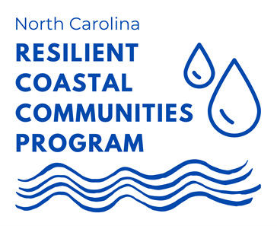

**North Carolina** **Resilient Coastal Communities Program Phases 1 & 2 Grant Application: Communities**

**2022-2023**

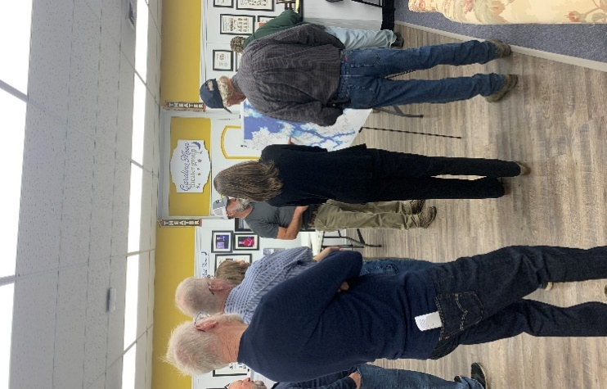

The Resilient Coastal Communities Program (RCCP) is a component of the North Carolina Resilient Communities Program, called for in the [2020 North Carolina Climate Risk Assessment and Resilience Plan](https://deq.nc.gov/energy-climate/climate-change/nc-climate-change-interagency-council/climate-change-clean-energy-plans-and-progress/nc-climate-risk-assessment-and-resilience-plan). The North Carolina Division of Coastal Management (DCM) has received funding from the NC State Legislature and the National Fish and Wildlife Foundation (NFWF) to implement the RCCP in coordination with the NC Office of Recovery and Resiliency (NCORR), The Nature Conservancy (TNC), and NC Sea Grant (NCSG).

**REQUEST FOR APPLICATIONS (RFA)**

Phases 1 & 2 - Community Engagement, Risk and Vulnerability Assessment, Planning, Project Identification and Prioritization

**Released: december 7, 2022**

**All applications due: feburary 3, 2023**

The North Carolina Division of Coastal Management (DCM) is pleased to announce the availability of grants for Phases 1 and 2 of the RCCP. The objectives of these phases include performing data- and community-driven risk and vulnerability assessments, and developing portfolios of locally identified and prioritized projects and actions to address risks.

The RCCP is a state-local partnership designed to help overcome barriers in coastal resilience and adaptation planning, boost local government capacity, and support a proactive, sustainable, and equitable approach to coastal resilience planning and project implementation.

The RCCP is a four-phase program that seeks to:

* 1. Address barriers to coastal resilience in North Carolina at the local level, such as limited capacity, economic constraints, and social inequities;
  2. Assist communities with risk and vulnerability assessments and developing a portfolio of planned and prioritized projects;
  3. Advance coastal resilience projects to “shovel-ready” status; and
  4. Link communities to funding streams for project implementation.

The four phases are:

Phase 1: Community Engagement and Risk/Vulnerability Assessment

Phase 2: Planning, Project Identification, and Prioritization

*Phase 3: Engineering and Design

*Phase 4: Project Implementation

* *To be eligible for Phases 3 & 4 funding a community must complete Phases 1 and 2 or an equivalent level of planning and community engagement.*

## **NOTICE OF AVAILABLE FUNDS AND REQUIREMENTS (2022)**

**Overview:** DCM is seeking applications from eligible communities to receive no-cost direct technical assistance services for completion of Phases 1 and 2 of the RCCP. Phases 1 and 2 walk communities through a series of steps to assess risks and vulnerabilities specific to their location, engage representative stakeholders, and complete a community-involved process to prioritize projects and action items to improve the resiliency of their community and critical assets. Grants will be awarded based upon the criteria identified in this document.

**Eligible Applicants:** All county and municipal governments within the [20 CAMA counties](https://deq.nc.gov/about/divisions/coastal-management/about-coastal-management/cama-counties), federal and state-recognized tribes, and any qualified owner's association defined in [G.S. 47F-1-103(3)](https://www.ncleg.gov/EnactedLegislation/Statutes/HTML/BySection/Chapter_47F/GS_47F-1-103.html). Adjacent communities may submit a joint application for a regional grant.

County applicants are encouraged to consider targeting a specific geographic area within their jurisdiction.

DCM will match successful applicants with competitively-selected service providers. Community applicants may indicate a preference to work with a specific service provider and should consider providing letters of support to their preferred provider.

**Anticipated Project Period:** April 2023 – January 2024

**Match Requirements:** There is no cash or in-kind match requirement from community applicants or service providers.

**Program Criteria and Prioritization:** DCM will review applications and select applicants based on available funding and alignment with program goals and objectives. Funding will be prioritized for communities that have not previously participated in Phases 1 and 2. In addition to evaluating applications in accordance with the above priorities, DCM shall consider the following factors:

* Level of risk exposure to critical assets (hospitals, schools, roads) natural infrastructure (rivers, wetlands, etc.), and socially vulnerable populations
* Impact of coastal hazards
* Internal capacity
* Level of current momentum in resilience planning (i.e., previous work completed)

**Contracting:** DCM will be contracting directly with 3rd party service providers to assist communities in completing Phases 1 and 2.

**Deliverables:** The main deliverable will include a Resilience Strategy based on guidance provided in the [RCCP Handbook](https://deq.nc.gov/media/19867/download). The two components of a Resilience Strategy include:

1. **Risk and Vulnerability Assessment Report**- A key outcome of this process is a quantitative risk and vulnerability assessment, which will evaluate the vulnerability of the community’s population and critical community assets to several coastal and climate risks, including tidal flooring, sea level rise, storm surge, and high-intensity rain events. Special attention will be given to socially vulnerable and underrepresented segments of the population, and natural infrastructure that provides both environmental and community resilience benefits.
2. **Project Portfolio**- Participants will develop a project portfolio of options aimed at reducing exposure and sensitivity or increasing adaptive capacity to flooding and other hazards. A combination of policy, nonstructural, hybrid, and structural approaches should be considered.

**Ownership and Credit Due:** Products generated by this effort will be owned by the N.C. Division of Coastal Management and the respective community and made publicly available.

**Application Checklist**

🞎 Application cover sheet

🞎 Question responses

🞎 Supplemental documentation, if applicable, not to exceed 20 pages

**Submission:** Submit theapplication to [rccp@ncdenr.gov](mailto:rccp@ncdenr.gov) by 5:00 pm, Friday, February 3, 2023.

Direct questions regarding the application to Mackenzie Todd, DCM Coastal Resilience Specialist: [Mackenzie.todd@ncdenr.gov](mailto:Mackenzie.todd@ncdenr.gov)

To see final deliverables from the first round of Phases 1 and 2 click [here](https://deq.nc.gov/about/divisions/coastal-management/coastal-adaptation-and-resiliency/nc-resilient-coastal-communities-program#2020-2022-community-resilience-strategies).

**DCM is hosting an informational webinar on the Phase 1 and 2 application process on January 12, 2023, from 2-4 p.m. You can register for it** [**here**](https://events.r20.constantcontact.com/register/eventReg?oeidk=a07ejikbucf879f75fa&oseq=&c=&ch=)**.**

**North Carolina Resilient Coastal Communities Program**

**Phase 1 & 2 Community Application 2022-2023**

Provide answers to the following questions.

**County Applicants**

1. Counties are encouraged to select an area of interest within their jurisdiction to evaluate. Describe your specific area of study and its boundaries. Include a map of the planning area.

**Municipal and Owners’ Association Applicants**

1. Name the municipality/municipalities or owners’ association applying for technical assistance. Please describe the jurisdictional boundaries and any previous planning. Include a map of the planning area.

**Tribal Applicants**

1. Name the state or federally recognized tribe applying for technical assistance. Please describe the jurisdictional boundaries and any previous planning. Include a map of the planning area.

**Risk & Vulnerability**

1. Of the following risks, which are most applicable and impactful to your community and why? Storm surge, heavy precipitation events, sea level rise, tidal flooding, erosion, and riverine flooding.
2. Describe the impact these risks have had on your community and its residents?
3. What efforts has your community undertaken to understand these risks? If you have conducted previous resilience planning, how would this program expand upon those previous planning efforts? If none, what are the barriers?
4. What critical assets (i.e., roads, hospitals, schools) are vulnerable to flooding? How often are your critical assets affected by flooding or other coastal hazards?
5. What type of natural infrastructure (i.e., wetlands, rivers, streams) do you have that protects you from storm events?

**Vulnerable Communities**

*People who are considered socially vulnerable to climate impacts such as: communities of color, children and seniors, low-income communities, people with disabilities, pregnant people, people with Limited English Proficiency (LEP), other historically disadvantaged people, people impacted by the social determinants of health, and populations identified by the American Public Health Association.*

1. Who are the socially vulnerable populations in your community?
2. Describe the impact of flooding or other coastal hazards on socially vulnerable groups in your community.

**Community Engagement**

1. Please describe any efforts your locality has undergone to engage with or educate the public regarding coastal resilience, storm preparedness, and/or hazard mitigation.
2. How does your community best engage? Do you have barriers to community engagement? If so, please describe them. What upcoming community events could provide opportunities for engagement?

**Internal Capacity & Partnerships**

1. Which of the following plans and ordinances related to land use and development has your locality adopted? Please check and denote adoption date(s).

☐Resilience Plan (Adopted _________________________ )

☐Watershed Restoration (Adopted _________________________ )

☐Stormwater Plan (Adopted _________________________)

☐Comprehensive or Land Use Plan (Adopted _________________________)

☐Unified Development Ordinance (Adopted _________________________)

☐Hazard Mitigation Plan (Adopted _________________________)

☐Capital Improvement Plan (Adopted _________________________)

☐Other Plan: _______________ (Adopted _________________________)

1. What projects from these existing plans have been implemented. If none, what are your barriers to implementation.
2. Identify staff, officials and community members that would be willing and able to participate in the program.
3. Is there a person in your community who has the capacity to be a leader on the Community Action Team to help champion the effort? If so, please list that person in your community.
4. Briefly describe any partnerships your community has built with any agencies or organizations to help address coastal hazards.