North Carolina Department of Environmental Quality
Division of Water Resources – Water Sciences Section
Wastewater/Groundwater Laboratory Certification Branch

Proficiency Testing Requirements

Revision 8

Effective 1/1/2026

Beth Swanson
Wastewater/Groundwater Laboratory Certification Branch Manager

Table of Contents
1.0 Introduction 4
2.0 Definitions 4
3.0 Proficiency Testing (PT) Requirements 9
3.1 Initial Certification 10
3.2 Certification Maintenance 11
3.3 Decertification 12
3.4 Recertification 14
3.5 EPA Lab Code 15
3.6 General PT Analysis and Reporting Requirements 16
3.7 Parameter-Specific PT Requirements 19
3.7.1 Total Residual Chlorine (low-level) 19
3.7.2 Microbiological Samples 19
3.7.3 Biochemical Oxygen Demand (BOD) 19
3.7.4 Chlorophyll-a 20
3.8 DMR-QA PT Study Exemption for NC Permittees 20
4.0 PT Sample Record Retention 20
5.0 Evaluating and Grading PT Sample Results 21
5.1 Selective Ion Mode (SIM) Analysis 22
5.2 Single-Analyte PT Samples 22
5.3 Multi-Analyte Group PT Samples 23
5.3.1 80% Rule 23
5.3.2 Individual Analyte Corrective Actions and Provisional Certification 24
5.4 Multiple Concentration Levels 25
5.5 Parameter-Specific PT Evaluations 26
5.6 Multiple Studies Analyzed at the Same Time 26
6.0 Complaint Resolution 26
7.0 Auditor Oversight and Tracking 26
8.0 References 28
Attachment 1: Notice of Missed Proficiency Testing Deadline Letter 29
Attachment 2: Unacceptable PT/Notice of Intent to Decertify Method Letter 30
Attachment 3: Decertification Effective Date Letter 32
Attachment 4: Decertified Parameter Method Report 34
Attachment 5: Notice of Decertification for Failure to Submit Information by the Due Date 35
Attachment 6: Parameter Method Recertification Letter 36
Attachment 7: EPA DMR-QA PT Study Exemption Letter 37
Attachment 8: PT Evaluation Letter – Acceptable Results Complete 39
Attachment 9: PT Evaluation Letter – Acceptable Results Incomplete 40
Attachment 10: Provisional Certification Notification Letter 41
Attachment 11: Provisional Certification Form 42
Attachment 12: Provisional Certification Rescission Letter 43
Attachment 13: Example Root Cause Analysis 44
Attachment 14: Corrective Action Plan (CAP) Form 45
Attachment 15: Corrective Action Response (CAR) Form 46
Attachment 16: PT Inspection Checklist 47
9.0 Revision History 48

1.0 Introduction

This document is a regulatory supplement to the NC Department of Environmental Quality (DEQ), Division of Water Resources, Water Sciences Section, Wastewater/Groundwater Laboratory Certification Branch (NC WW/GW LCB) Proficiency Testing (PT) requirements found in North Carolina Administrative Code, 15A NCAC 02H .0805 (a) (2). In addition to clarifying the regulatory requirements for Proficiency Testing, this document answers many common questions concerning evaluation of PT Sample results. Also included are important deadlines, penalties and corrective actions for PT failures, and links to the current list of all Accredited PT Sample Providers.

PT Samples are standards whose true value concentrations are unknown to the laboratory and are supplied by an Accredited PT Sample Provider. PT Samples are analyzed by a laboratory to evaluate its ability to accurately perform analyses for specified analytes by a particular Parameter Method. They are an integral part of a laboratory’s quality management system and the laboratory Certification process. The NC WW/GW LCB uses the results of these samples to assess a laboratory’s analytical performance between on-site evaluations. All laboratories must submit acceptable PT Sample results annually to maintain their Certifications. The laboratory must obtain PT Samples from an Accredited PT Sample Provider recognized by The National Environmental Laboratory Accreditation Congress Institute (TNI) and approved by the NC WW/GW LCB. These PT Samples may be part of an official study, a supplemental study or quick-response type PT Samples. PT Samples from providers not accredited by a Proficiency Testing Provider Accreditor (PTPA) cannot be accepted. A list of Accredited PT Sample Providers may be found on the TNI website at http://nelac-institute.org/content/NEPTP/ptproviders.php. A list of required PT Samples per Parameter Method is updated annually and can be found on the Laboratory Certification Proficiency Testing Requirements web page: http://deq.nc.gov/about/divisions/water-resources/water-resources-data/water-sciences-home-page/laboratory-certification-branch/pt-requirements

The NC WW/GW LCB reserves the right to determine acceptable performance of a laboratory on any PT or Split Sample which includes, but is not limited to, the elements contained in this policy.

2.0 Definitions

2.1 Acceptable Proficiency Testing Results: Those results on Proficiency Testing Samples that are within the Vendor-specified acceptable range as indicated by a Vendor or Split Samples that are within the specified acceptance range as provided by the NC WW/GW LCB.

2.2 Acceptance Limits: Limits established by an Accredited Proficiency Testing (PT) Provider, based upon the US EPA National Standards for Water Proficiency Testing Program Criteria Document (NERL-Ci-0045), which are used to determine if a laboratory has analyzed a PT Sample successfully. For the Water Pollution Program (WP), EPA Acceptance Limits are defined as ± three Standard Deviations from the Mean.

2.3 Accredited Proficiency Testing (PT) Sample Provider: Where the North Carolina Administrative Code requires use of a State Laboratory-approved Vendor, this shall mean a proficiency testing program accredited by a Proficiency Testing Provider Accreditor (PTPA) that meets the TNI requirements for the design, preparation, and operation of PT schemes. A list of Accredited PT Providers can be found here:
http://www.nelac-institute.org/content/NEPTP/ptproviders.php

2.4 Analysis Date: The calendar date of analysis associated with the analytical result reported for Certification requirements.

2.5 Analyte: The chemical substance, physical property or organism being analyzed in a reference sample.

2.6 Analyte Group: A set of chemical substances possessing structural and reactive similarities that are analyzed as a group using the same method of analysis or technology (e.g., VOCs, PCBs, etc.).

2.7 Certification: A declaration by the NC WW/GW LCB that the personnel, equipment, records, quality control procedures, and methodology cited by the applicant are accurate and that the applicant’s proficiency has been considered and found to be acceptable pursuant to NC Administrative Code 15A NCAC 02H .0800.

2.8 Certified Data: Any analytical result, including the Supporting Records, obtained using a method or procedure pursuant to NC Administrative Code 15A NCAC 02H .0800.

2.9 Certified Parameters Listing (CPL): A list of all the analytical methods that a laboratory is Certified to perform and report to clients or the State of North Carolina as Certified Data.

2.10 Commercial Laboratory: Any laboratory, including its agents or employees, which is seeking to analyze or is analyzing samples in a chemistry laboratory or in a field setting, including Field Parameters, for others for a fee.

2.11 Compliance Sample: For the purposes of this document, Compliance Samples are defined as environmental samples that are analyzed for the purpose of reporting to the State pursuant to 15A NCAC 02H .0800.

2.12 Corrective Action Plan (CAP): A report, due within 10 business days of the date of the unacceptable PT letter from your auditor, detailing what the laboratory intends to investigate in terms of troubleshooting an existing out-of-control event, nonconformity or undesirable condition and what possible corrective actions might be taken for each troubleshooting scenario.

2.13 Corrective Action Response (CAR): A report, due within 90 days of the issue date of the PT report that contained the unacceptable result, which details the measures that effectively corrected an out-of-control event, nonconformity or undesirable condition and is believed will prevent the recurrence of the situation. A good Corrective Action Response report addresses and documents the following: the initial problem, the root cause of the problem, corrective actions taken to correct the problem and any objective evidence (e.g., calibration curves, revised procedures, records, training records, standard operating procedures, etc.) to indicate that the corrective actions have been implemented/completed and data that required qualification or rejection as a result of this problem.

2.14 Decertification: Loss of Certification.

2.15 Discharge Monitoring Report–Quality Assurance (DMR-QA) Proficiency Testing (PT) Study Program: The DMR-QA PT Study Program evaluates the analytical and reporting ability of the laboratories that routinely perform inorganic chemistry, microbiology and whole effluent toxicity self-monitoring analyses required by their National Pollutant Discharge Elimination System (NPDES) permit. North Carolina permittees are exempt from the DMR-QA PT Study Program and the NC WW/GW LCB will no longer accept DMR-QA PT Study results for Certification maintenance. However, laboratories must meet all other requirements of this document.

2.16 EPA: Acronym for the United States Environmental Protection Agency.

2.17 EPA Lab Code: A laboratory identification system used to identify participant laboratories in Proficiency Testing Studies when grading and reporting results. EPA Lab Codes are assigned by the EPA.

2.18 Field Laboratory: A laboratory, including its agents or employees, which is seeking Certification to analyze or is analyzing samples in a chemistry laboratory or a field setting for Field Parameters only.

2.19 Field Parameters: For the purpose of the North Carolina Wastewater/Groundwater Laboratory Certification Rules (15A NCAC 02H .0800), Field Parameters shall include Total Residual Chlorine, Free Available Chlorine, Conductivity, Dissolved Oxygen, pH, Settleable Residue, Salinity, Sulfite, Turbidity, Temperature, Vector Attraction Reduction Option 5, Vector Attraction Reduction Option 6, and Vector Attraction Reduction Option 12.

2.20 Industrial Laboratory: A laboratory, including its agents or employees, operated by an industry to analyze samples in a chemistry laboratory or in a field setting, including Field Parameters, from its wastewater or wastewater from its water treatment plant(s) pursuant to NC Administrative Code 15A NCAC 02H .0800.

2.21 Multi-analyte Group Proficiency Testing (PT) Sample: A PT Sample containing more than one analyte of interest where Certification is granted for the analytes as a group based on acceptable results for all of the existing analytes (e.g., PCBs).

2.22 Municipal Laboratory: A laboratory, including its agents or employees, operated by a municipality or other local government to analyze samples in a chemistry laboratory or in a field setting, including Field Parameters, from its wastewater or wastewater from its water treatment plant(s) pursuant to NC Administrative Code 15A NCAC 02H .0800.

2.23 NC WW/GW Laboratory Certification Number: A unique identifying number assigned to each laboratory Certified by the NC WW/GW LCB.

2.24 Non-Field Laboratory: A laboratory, including its agents or employees, which is seeking Certification to analyze or is analyzing samples for any parameters including and/or beyond those defined as Field Parameters.
2.25 Not Acceptable Proficiency Testing (PT) Sample Result: Those results on Proficiency Testing (PT) Samples that exceed the specified acceptable range as indicated by an Accredited PT Sample Provider as well as any false negative or false positive results. This term is synonymous with “Unacceptable Proficiency Testing (PT) Sample Result” (see Section 2.48).

2.26 Other Laboratory: A facility that is not required to obtain NC WW/GW LCB Certification as part of its routine operation and does not analyze samples in a chemistry laboratory or in a field setting for a fee or is doing business as a non-profit facility.

2.27 Parameter: Analyte, element, compound, or property being measured.

2.28 Parameter Method: A type of analytical technique, including materials and tools, used to measure a parameter.

2.29 Practical Quantitation Limit: The Practical Quantitation Limit (PQL) is defined and proposed as "the lowest level achievable among laboratories within specified limits during routine laboratory operation". The PQL is about three to five times the calculated Method Detection Limit (MDL) and represents a practical and routinely achievable detection limit with a relatively good certainty that any reported value is reliable". For methods requiring a calibration curve, a calibration standard must be analyzed at the PQL concentration.

2.30 Primary Analyte List: The list of analytes in the scope of a published method.

2.31 Proficiency Testing (PT) Calendar Year: For the purposes of performance evaluation, the PT calendar year is defined as January 1 to September 30.

2.32 Proficiency Testing Provider Accreditor (PTPA): The detailed requirements for The NELAC Institute’s (TNI’s) designated Proficiency Testing Provider Accreditors (PTPA) in the TNI Proficiency Testing (PT) Program are in Volume 4 of TNI’s Environmental Sector Standards and in Module 2 of the Stationary Source Audit Sample Standards. The designated PTPA is expected to ensure that its accredited PT Providers that provide PT Samples under the TNI PT Program meet the requirements in Volume 3 of TNI’s Environmental Sector Standards and its accredited SSAS providers that provide audit samples under the TNI program meet the requirements in Module 3 of the SSAS Standards. The process by which TNI evaluates an organization to become a TNI-recognized PTPA is found in TNI SOP 4-104, Evaluating Proficiency Testing Provider Accreditors. The TNI Standards and TNI SOP 4-104 are available at The NELAC Institute’s internet site (www.nelac-institute.org).

2.33 Proficiency Testing (PT) Samples: A performance evaluation sample whose true value is unknown to the laboratory and provided by a NC WW/GW LCB -approved Vendor to test whether the laboratory can produce analytical results within the specified acceptance criteria. PT Sample true value concentrations are not made known until all laboratories analyzing the same PT Samples have submitted their results and the final report is issued. PT Samples are also known as Performance Evaluation (PE) Samples.

2.34 Proficiency Testing (PT) Study: A single complete sequence of circulation of PT Samples to all participants in a PT program.
2.35 Proficiency Testing (PT) Study Closing Date: The calendar date on or by which analytical results for a PT Sample shall be received by the Accredited PT Sample Provider from the laboratory.

2.36 Provisional Certification: A temporary conditional status of Certification which requires a laboratory to qualify specified individual analyte results as “estimated” until acceptable performance is demonstrated or until method Certification is dropped or revoked. This Provisional status is initiated when two consecutive unacceptable results are obtained for one or more individual analytes, in a multi-analyte Proficiency Testing Sample, when the method evaluation is graded acceptable (refer to the 80% Rule in Sections 5.3.1 and 5.3.2).

2.37 Quick Response Proficiency Testing (PT) Sample: A PT Sample that is not part of a scheduled study, but the results are evaluated and reported back to the participant laboratory within a short time after the results are reported. They may also be referred to as Rapid Turnaround Time, Rapid Response or PT Express Samples.

2.38 Recertification: The re-instatement of Certification at the end of the Decertification period imposed by the Division pursuant to 15A NCAC 02H .0807 by showing to the satisfaction of the NC WW/GW LCB that the laboratory has corrected the deficiency(ies).

2.39 Remedial Proficiency Testing (PT) Sample: A PT Sample, analyzed as a follow-up to PT Samples for which unacceptable results were obtained, intended to demonstrate correction or improvement of the analysis of the analyte in question using the same specific Parameter Method. A Remedial PT Sample also applies to a follow-up PT Sample analyzed when the September 30th deadline was exceeded and counted as a first unacceptable result.

2.40 Root Cause Analysis (RCA): A technique used in problem solving to identify the underlying reason why something has gone wrong or why a difficulty has occurred. It is a step-by-step method that leads to the discovery of a fault's first or core cause. In compliance testing, the root cause analysis often takes the investigator back to the laboratory’s quality system protocols.

2.41 Round Robin Study: A sample testing study involving multiple independent analysts and/or laboratories performing analytical testing for a given parameter with the use of the same method with different equipment, or a variety of methods and equipment. This type of study is used to measure the precision of the measurement of a given target analyte or group of analytes and/or relative performance of the participating entities. The overall objective is to make test results from different testing laboratories comparable; thereby creating the necessary confidence in the accuracy of test results between the parties involved.

2.42 Single Analyte Reference Sample: A Proficiency Testing Sample containing only one analyte of interest where Certification is granted for an analyte based on methodology.

2.43 Split Sample: A Split Sample is two or more representative portions taken from a sample or subsample and analyzed by two or more laboratories approved by the NC WW/GW LCB and are used to measure the precision of the measurement of a given target analyte or group of analytes and/or relative performance of the participating entities.

2.44 State: The North Carolina Department of Environmental Quality, or its successor.

2.45 Study: This term applies to a Proficiency Testing Study or Supplemental Proficiency Testing Study.

2.46 Supplemental Proficiency Testing (PT) Study: A PT Sample that may be from a lot previously released by an Accredited PT Sample Provider that meets the requirements for supplemental PT samples, but that does not have a pre-determined opening date and closing date.

2.47 Supporting Record: Any document or other source of information compiled, recorded, or stored in written form, by electronic process, or in any other manner that provides any information necessary to reconstruct or characterize a reported value.

2.48 Unacceptable Proficiency Testing (PT) Sample Result: Those results on Proficiency Testing Samples that do not fall within the Vendor-specified acceptable range as stated by a NC WW/GW LCB -approved Vendor, or Split Samples that do not fall within the specified acceptable range as indicated by the NC WW/GW LCB, or a failure to meet a reporting deadline imposed by the Vendor or the NC WW/GW LCB. Results graded as Unacceptable by the PT Vendor for “less than” and “greater than” values may be re-evaluated as Acceptable by the NC WW/GW LCB (See Section 5.0). This term is synonymous with “Not Acceptable Proficiency Testing (PT) Sample Result” (see Section 2.25).

2.49 Uncertified Data: Any analytical result, including the Supporting Records, obtained using a method or procedure, which is not acceptable to the NC WW/GW LCB pursuant to NC Administrative Code 15A NCAC 02H .0800, or data obtained using a method or procedure for which the laboratory is not certified to use.

2.50 Vendor: An accredited Proficiency Testing Sample provider recognized by The NELAC Institute (TNI). See also Section 2.3, Accredited Proficiency Testing (PT) Sample Provider.

3.0 Proficiency Testing (PT) Requirements

All Certified laboratories are required to demonstrate technical competence through PT Sample analyses sufficient to cover the scope of their accreditation. PT Samples are required for initial Certification, Certification maintenance/renewal and Recertification. At least once within the first nine (9) months of each Certification cycle, and more often if requested by the NC WW/GW LCB. Each laboratory must have at least one laboratory analyst demonstrate proficiency by successfully analyzing a PT Sample provided by an Accredited PT Sample Provider. Additional PT Sample results submitted voluntarily at any time during the PT Calendar Year (including Water Supply [WS] study samples when the appropriate method is employed during analysis) will be graded similarly.

The NC WW/GW LCB shall make available a list of Accredited PT Sample Providers and/or provide access to the list on the NC Division of Water Resources Water Sciences Section, Laboratory Certification Branch website for Field Laboratory PT Requirements and Non-Field Laboratory PT Requirements (see URLs below). Accredited PT Providers offer several PT Sample options that will meet NC WW/GW LCB initial Certification, Certification maintenance/renewal and Recertification requirements. These include the Quick Response PT Samples and WS study samples when the appropriate Parameter Method is employed during analysis. However, WS studies will not be accepted for any organic methods except EPA 504.1. Corrective-action PTs, that are provided with the true values in a sealed envelope, are not considered PT Samples as they are defined in this document and do not meet the PT requirements outlined in 15A NCAC 02H .0800. PT Samples that are not taken through the entire preparation procedure (e.g., ‘ready to use’ PTs) are also not acceptable. For a detailed list of the PT Samples required for initial Certification, Certification maintenance/renewal, remedial requirements and Recertification, consult the following Laboratory Certification PT Requirements web page:

http://deq.nc.gov/about/divisions/water-resources/water-resources-data/water-sciences-home-page/laboratory-certification-branch/pt-requirements

When such PT Samples are not available or relevant to the scope /of accreditation, the NC WW/GW LCB will rely on the laboratory’s quality system checks in accordance with State regulations or the approved methodology for assuring the quality of testing, calibration results and/or Split Samples provided by the Division of Water Resources. Quality control checks include (but are not limited to) the following types of activities: regular use of certified reference materials and/or internal quality control using secondary reference materials; replicate tests or calibrations using the same or different methods; re-testing or re-calibration of retained items; and correlation of results for different characteristics of an item. The results of these quality control checks do not need to be provided to this office but must be retained so that they are readily available for examination during on-site inspection according to NC WW/GW LCB mandated record retention schedules. Split Sample testing or Round Robin testing may also be required.

Laboratories must have a documented plan [this is usually detailed in the laboratory’s Quality Assurance Manual (QAM) or may be a separate Standard Operating Procedure (SOP)] of how they intend to cover the applicable program requirements for Proficiency Testing per their scope of accreditation. This plan shall cover any commercially available PT Samples and any inter-laboratory organized studies, as applicable. The plan must also address how and from whom these samples are obtained, the annual schedule on which they are obtained and/or when the analytical results of the PT Samples are due to be received by the NC WW/GW LCB, and the laboratory’s process for submission of PT Sample results, including Remedial PT Sample results and related corrective action reports (i.e., CAPs and CARs).

The documented Proficiency Testing plan must address situations where the instructions from the Accredited PT Provider for the preparation, analysis or result calculations would constitute a deviation from the laboratory’s routine procedure. Examples of this may include how low-level PT Samples will be analyzed, including concentration of the sample or adjustment of the normality of a titrant. These instructions shall be followed when the concentration of a PT Sample is below the range of their routine analytical method. Instructions shall also be included in the laboratory’s SOP for how high-level PT Samples will be analyzed, including preparation of multiple dilutions of the sample. These instructions will be followed when the concentration of a PT Sample is above the range of their routine analytical method.

3.1 Initial Certification

NC WW/GW LCB regulations for the Certification and operation of environmental laboratories in the North Carolina Administrative Code, 15A NCAC 02H .0800, state that a laboratory applying for Certification must satisfactorily analyze Proficiency Testing Samples from a NELAC approved Proficiency Testing Provider Accreditor (PTPA) that meets TNI requirements and those of the NC WW/GW LCB for the parameters, analytes, methods and matrices for which Certification is sought. Available parameters and sources for approved methods are described in 15A NCAC 02H .0804 and .0805. NELAC approved Proficiency Testing Providers can be found here: https://nelac-institute.org/content/NEPTP/ptproviders.php. The study close dates of all testing results submitted with applications must have occurred within the six months prior to the date of application. When determining whether PT Sample results are sufficiently recent, the NC WW/GW LCB counts back 6 months (i.e., 180 days) from the date the application is received in our office. Any PT Sample result submitted with an application must be the most recent attempt and have a study close date no earlier than this date. All PT Sample Results must be provided to this office directly from the Accredited PT Sample Provider.

Laboratories that submit two consecutive Unacceptable PT Sample Results for a Parameter Method while attempting to gain Certification, shall then submit CARs and two consecutive Acceptable PT Sample Results, analyzed within the previous six months prior to being granted Certification.

Note: Initial Certification for multiple analyte parameters will be granted if the PT Sample Results meet the 80% Rule (see Section 5.3.1). However unacceptable analytes must be reported as “estimated” similarly to Provisional Certification described in Section 5.3.2 until acceptable results are submitted.

3.2 Certification Maintenance

Laboratories must have acceptable PT Sample results submitted to the NC WW/GW LCB, directly from the Accredited PT Sample Provider, for each Parameter Method and matrix combination (as required by this document) by September 30 of the current Certification cycle.

NOTE: Even if a laboratory analyzes PT Samples prior to September 30, it does not mean that those samples will be graded and reported to the NC WW/GW LCB by the September 30 deadline. Laboratories must choose a study that meets all reporting and posting deadlines. Most PT studies are open for 45 days from the day the PT Samples are shipped to the laboratories. After a study closes, Accredited PT Sample Providers may take up to 30 days to issue reports to participating laboratories and their designated authorities. This means, that in order to meet the September 30 deadline, laboratories may need to participate in a PT study that begins no later than Mid-July, unless using “Rapid Response” type samples. It is recommended that laboratories check turn-around times with the proposed PT Sample Provider before ordering.

The results must be obtained from PT Samples analyzed during the current PT Calendar Year (i.e., January 1 – September 30). The NC WW/GW LCB will not accept PT Sample results directly from the participant laboratories. When a PT Sample result is not reported by the Accredited PT Sample Provider to this office by the September 30 deadline, the laboratory will be notified in writing (see Attachment 1) and the omission will be counted as a first unacceptable result for that PT Calendar Year. CAP and CAR reports must be submitted by their individual due dates and a remedial PT Sample must be analyzed with a satisfactory result received in this office within 90 days of the date of the PT report containing the unacceptable result to maintain Certification for that Parameter Method and matrix. When the unacceptable result is due to missing the September 30 deadline, the remedial PT result must be received in this office by December 28 (90 days from September 30).

When two PT Samples for the same Parameter Method are analyzed and submitted at the same time, an unacceptable result on one or both samples will be considered the first unacceptable result for Certification purposes and a remedial PT Sample in the same matrix must be submitted within 90 days of the first unacceptable result.

A laboratory that receives a first Unacceptable PT Sample Result for a Parameter Method, or for an individual analyte when multi-analyte parameter PT Samples are analyzed and greater than 80% are acceptable, must:

- Submit a CAP report to this office by the due date (See Section 2.12);
- Take corrective action;
- Analyze an acceptable Remedial PT Sample and,
- Submit a CAR report to this office by the due date (See Section 2.13).
A laboratory receiving a second consecutive Unacceptable PT Sample Result may be Decertified for that Parameter Method in the associated matrix, pursuant to 15A NCAC 02H .0807. At that time, the NC WW/GW LCB may initiate an assessment of the laboratory’s quality control records to determine if reported data has been adversely affected and evaluate if further corrective actions are needed. A laboratory may also be Decertified for failing to provide a CAP or CAR report pursuant to 15A NCAC 02H .0807 (13). If the remedial PT Sample results are acceptable and acceptable CAP and CAR reports are received within the associated deadlines, no further action is necessary.

NOTE: Laboratories must report all analytes for multi-analyte group reference sample remedial PT Samples when less than 80% of the constituent analytes are graded acceptable. Analyzing only a single failed constituent for the analyte group is acceptable only when 80% or greater of the constituent analytes are acceptable. Refer to sections 5.3.1 and 5.3.2 for additional information.

For multi-analyte Parameter Methods (e.g., organic analyses), when greater than 80% of analytes are acceptable, but one or more individual analytes are graded unacceptable, acceptable performance has been demonstrated for the Parameter Method. The laboratory must, however, analyze a remedial PT Sample for the individual analytes that were graded unacceptable. NOTE: If the analyte is not detected in the remedial PT Sample, it must be reported as a “less than” value. When a remedial PT Sample is graded unacceptable for an individual analyte (constituting a second consecutive unacceptable result), the laboratory must immediately begin to qualify data for those individual analytes as “estimated” (whether detected or not) until acceptable results are obtained on two consecutive remedial PT Samples for the analyte in question. Notification will be sent from this office of this single analyte Provisional Certification stating the effective date (see Attachment 10). The laboratory must complete and return the Provisional Certification Form within 10 days of receipt (see Attachment 11). Refer to sections 5.3.1 and 5.3.2 for additional information.

3.3 Decertification

A laboratory’s receipt of a second consecutive Unacceptable PT Sample Result indicates the corrective action taken earlier by the laboratory was inadequate and may signal major problems with the laboratory’s system for testing that analyte or group of analytes. After a second consecutive unacceptable result, Decertification of that Parameter Method in the applicable matrix for a period of 30 days may be initiated. In limited cases, an additional third try may be offered for Field Parameters only, at the discretion of the NC WW/GW LCB Environmental Program Supervisor and/or Water Sciences Section Chief. Further corrective action must be taken by the laboratory and documentation of that action sent to this office for approval before the laboratory can request Recertification. After reviewing the corrective action documentation submitted by a laboratory and prior to remedial PT Sample analyses, an auditor may conduct an on-site inspection/audit of the laboratory, recommend training for laboratory staff, and/or recommend that the laboratory obtain third-party assistance in laboratory analytical technique, quality control and instrument operation.

If the results of a PT Sample are not received in this office by September 30, this may be evaluated as an unacceptable result. If the results of a remedial PT Sample analyzed beyond the September 30 deadline is unsatisfactory (i.e., the September 30 deadline was missed and counted as a first unacceptable result), Decertification for that Parameter Method may be initiated. A laboratory that reports no PT Sample results in a calendar year for any Parameter Method for which it is Certified may be Decertified for that Parameter Method in all associated matrices for a period of up to one year pursuant to 15A NCAC 02H .0807. The laboratory’s scope of accreditation found on their CPL will be revised to reflect any Decertifications. A laboratory that reports no PT Sample results in a PT Calendar Year for all Parameter Methods for which it is Certified may be Decertified for all Parameter Methods for a period of up to one year pursuant to 15A NCAC 02H .0807. An initial notice of intent to issue a Decertification is sent either electronically or by mail to the laboratory (see example in Attachment 2). Notices of Decertification with effective dates are sent via email and certified mail to the laboratory (see example in Attachment 3).

NOTE: Notices of Decertification with effective dates are generally sent within one day of the initial notice of intent to issue Decertification. The effective date is usually 10 business days from the date of the notice of intent. However, the laboratory is encouraged to take immediate corrective action once a problem has been identified (i.e., as soon as a second consecutive Unacceptable PT Sample Result is received) and immediately suspend analysis or qualify reported values until a contract/subcontract arrangement with another certified laboratory is made.

All PT Sample results received by the NC WW/GW LCB will be evaluated according to all evaluation schemes and criteria, as described in this document, regardless of whether the PT requirements of the current PT calendar year had already been completed.

A laboratory may appeal a Decertification within 10 business days of receipt of the notice of intent to decertify. This appeal may be made in writing to the NC WW/GW LCB Environmental Program Supervisor and/or Water Sciences Section Chief, who will review the case and submit a ruling within one week of the appeal. A laboratory may also appeal a 30-day Parameter Method Decertification any time after issuance of the notice of the effective date of the Decertification. This Decertification appeal may be made to the N.C. Office of Administrative Hearings (https://www.oah.nc.gov/hearings-division) in accordance with Chapter 150B of the N.C. General Statutes.
When a laboratory is Decertified for any or all Parameter Methods, the following conditions shall apply:

(1) A revised CPL that omits the Decertified Parameter Method(s) will be issued to the laboratory and will remain effective until Certification is regained. A laboratory shall not analyze, test, measure, or monitor any samples regulated under G.S. 143, Article 21 by the decertified Parameter Method.

(2) A Commercial Laboratory decertified for all Parameters shall supply written notification of its Decertification to clients that are required to report to the Department of Environmental Quality under G.S. 143, Article 21. Within 30 days of Decertification, the decertified laboratory shall provide the NC WW/GW LCB with a list of those clients and copies of the notices sent to each.

(3) A Commercial Laboratory that has received a Parameter Method Decertification shall supply written notification of the Parameter Method Decertification to clients that are required to report to the Department of Environmental Quality under G.S. 143, Article 21. The laboratory may also make arrangements to supply analyses through another laboratory certified by the NC WW/GW LCB for the same Parameter(s) during any Decertification period. Within 30 days of Decertification, the laboratory shall supply the NC WW/GW LCB with a list of clients involved, copies of the notices sent to each, and the name and Certification number of the certified laboratory to be used during the Decertification period (see Decertified Parameter Method Report form in Attachment 4). Failure to complete and return the supplied form and requested information may result in further enforcement actions (e.g., Decertification of the entire laboratory for up to one year – see Attachment 5) pursuant to 15A NCAC 02H .0807 (a) (13).

(4) A Commercial Laboratory decertified for all Parameters shall not subcontract samples for analyses to other certified laboratories during the Decertification period.

(5) A Municipal or Industrial Laboratory that has received a Parameter Method Decertification shall have samples requiring that Parameter Method analyzed by another laboratory certified by the NC WW/GW LCB for the contracted Parameter Method during any Decertification period. Within 30 days of Decertification, the decertified laboratory shall supply the NC WW/GW LCB with the name and Certification number of the certified laboratory to be used during the Decertification period (see Decertified Parameter Method Report form in Attachment 4). Failure to complete and return the supplied form and requested information may result in further enforcement actions (e.g., Decertification of the entire laboratory for up to one year – see Attachment 5) pursuant to 15A NCAC 02H .0807 (a) (13).

3.4 Recertification

A laboratory Decertified in accordance with 15A NCAC 02H .0807 (a) may be Recertified at the end of the Decertification period by showing, to the satisfaction of the NC WW/GW LCB, that it has corrected the deficiency(ies). Upon approval, a letter with the effective date of the Recertification will be sent from this office (see Attachment 6).

A laboratory Decertified for a Parameter Method due to unacceptable results on two consecutive PT Samples submitted by an Accredited PT Sample Provider, or on two consecutive Split Samples may be Recertified after 30 days by reporting acceptable results on two consecutive PT Samples submitted by an Accredited PT Sample Provider, or on two consecutive Split Samples in accordance with 15A NCAC 02H .0808 (b). PT Samples from an Accredited PT Sample Provider may be analyzed at any time within two years of the Decertification effective date. Recertification must then be requested in writing by completing an Amendment to Laboratory Certification Application found at:
https://www.deq.nc.gov/about/divisions/water-resources/water-sciences/chemistry-laboratory/laboratory-certification-branch/forms-and-inspection-checklists . Select Amendment to Laboratory Certification Application in either Word or .pdf format.

NOTE: In addition to the two consecutive acceptable PT Sample results, an acceptable CAR, a Decertified Parameter Method Report, a written request for Recertification and payment of the Recertification invoice are required before Recertification will be issued.

If a laboratory has not requested Recertification for a Decertified Parameter Method within two years, any requests for Certification for that Parameter Method will be considered as an initial Certification request and the requirements for initial Certification must be met.

For Recertification of organic methods that were Decertified for failing the 80% rule on two consecutive PT Sample results, the laboratory must submit two consecutive PT Sample results that pass the 80% rule. Any analytes that are graded as unacceptable in either of the two remedial PT Samples will be given Provisional Certification status until two consecutive PT Samples with acceptable results for those analytes are received.

The study close dates of all testing results submitted with applications for Recertification must have occurred after the dates of the Unacceptable PT Sample Results that prompted the Decertification and within the six months prior to the date of application. When determining whether PT Sample results are sufficiently recent, the NC WW/GW LCB counts back 6 months (i.e., 180 days) from the date the Recertification application is received in our office. Any PT Sample result submitted with an application for Recertification must have a study close date no earlier than this date.

3.5 EPA Lab Code

Since different accreditation programs use a wide array of laboratory identification systems, the Accredited PT Sample Providers need a singular means of identifying participant laboratories when grading and reporting PT Sample results. Therefore, each Certified laboratory must have an EPA Lab Code.

NOTE: The EPA Lab Code is not the same as the NC WW/GW Laboratory Certification Branch Number assigned to each laboratory by the NC WW/GW LCB or NPDES permit number. Do not report PT Sample results without including the EPA Lab Code.

The EPA Lab Code assigned to the laboratory performing the analysis must be documented on the results reported to the Accredited PT Sample Provider. Without this EPA Lab Code, the NC WW/GW LCB may be unable to credit the PT Sample results to the correct laboratory. The EPA contact, for Lab Code assignments for PT studies, is:

Mr. Jeffrey Wilmoth
U.S. EPA Region 4
980 College Station Road
Athens, GA 30605-2720

Email: Wilmoth.Jeffrey@epa.gov
Phone: 706-355-8623

When making the request to the EPA, you must provide the following information:

Contact name
Laboratory or Facility Name
Physical Address (with zip code)
PO address (if different)
Lab/Facility phone number
Fax number (if available)
Contact individual’s e-mail address
Type of Study (WP, WS, etc.)

3.6 General PT Analysis and Reporting Requirements

Laboratories are required to analyze an appropriate PT Sample by each Parameter Method and in each associated matrix on the laboratory’s CPL. The same PT Sample may be analyzed by one or more methods. Laboratories shall conduct the analyses in accordance with their routine testing, calibration and reporting procedures, unless otherwise specified in the instructions supplied by the Accredited PT Sample Provider. This means that they are to be logged in and analyzed using the same staff, sample tracking systems, standard operating procedures including the same equipment, reagents, calibration techniques, analytical methods, preparatory techniques (e.g., digestions, distillations and extractions) and the same quality control acceptance criteria. PT Samples shall not be analyzed with additional quality control. They are not to be replicated beyond what is routine for Compliance Sample analysis. Although it may be routine to spike Compliance Samples, it is neither required nor recommended for PT Samples. PT Sample results from multiple analyses (when this is the routine procedure) must be calculated in the same manner as routine Compliance Samples.

As specified in 15A NCAC 02H .0800, in order to meet the minimum standards for Certification, laboratories must use acceptable analytical methods. The acceptable methods are those defined or referenced in the current State and federal regulations for the environmental matrix being tested. All samples, (including PT Samples) that are, or that may, be used for Certification purposes, must be analyzed using approved methods only. All PT Samples are to be analyzed and the results reported in a manner consistent with the routine analysis and reporting requirements of Compliance Samples. Laboratories must document any exceptions. All PT Sample analyses must be recorded in the same daily analysis records (e.g., benchsheets) as for any Compliance Sample. This serves as the permanent laboratory record.

A laboratory may use more than one Accredited PT Sample Provider in order to obtain PT Samples for all analytes, methods and matrices for which it is Certified or is seeking Certification by the NC WW/GW LCB. Check your CPL before analyzing and reporting PT Sample results to make sure you are reporting results by all the applicable methods and associated matrices on your CPL. You can report results from several different methods for any given PT Sample. The only limitation is the volume of PT Sample available for analysis. This happens frequently with wet chemistry methods.

NOTE: Free Available Chlorine PT Samples are only available in Water Supply (WS) studies.

NOTE: Flash Point PT Samples are received as a liquid, but only available in soil or hazardous waste PT studies.

A list of methods for which PT Sample analysis is required can be found on the following Laboratory Certification PT Requirements web page: http://deq.nc.gov/about/divisions/water-resources/water-resources-data/water-sciences-home-page/laboratory-certification-branch/pt-requirements
The laboratory records used to track PT Samples (e.g., chain-of-custody, sample transmittal forms, etc.) can be initiated by laboratory personnel such as the Quality Assurance Officer. PT Samples received as ampules are diluted according to the Accredited PT Sample Provider’s instructions. It is important to remember to document the preparation of PT Samples in a traceable log or other traceable format. The diluted PT Sample then becomes a routine Compliance Sample and is added to a routine sample batch for analysis. No documentation is needed for whole volume PT Samples which require no preparation; however, the instructions must be maintained.

NOTE: For those laboratories that do not have adequate glassware for PT Sample preparation, and have another laboratory assist with preparing the PT Sample, it is the participant laboratory’s responsibility to retain the PT Sample preparation documentation.

NOTE: Corrective-action/quality control PT Standards, which are provided with the true values and acceptance ranges are not considered PT Samples and do not meet the PT requirements outlined in 15A NCAC 02H .0800. In general, laboratories must not analyze quality control PT Standards of known concentrations with PT Samples, as this would be considered additional quality control and is not the routine testing protocol for Compliance Samples. However, they are recommended when performing troubleshooting prior to analyzing a remedial PT Sample. This would be considered part of the corrective action plan. However, the analysis of quality control PT Standards of known concentrations for troubleshooting purposes shall not be performed on the same day as remedial PT Sample analyses.

Laboratories shall also ensure that, from year to year, PT Samples are equally distributed among personnel trained and qualified for the relevant tests and instrumentation (when more than one instrument is used for routine Compliance Sample analyses), that represents the routine operation of the work group at the time the PT Sample analysis is conducted.

Before the close of a PT study, a laboratory must arrange with the Accredited PT Sample Provider for the study results to be sent directly from the Accredited PT Sample Provider to the North Carolina Wastewater/Groundwater Laboratory Certification Branch before or at the same time that results are released to the laboratory. PT Sample results submitted directly from the participant laboratory will not be accepted. The Accredited PT Sample Providers should have the NC WW/GW LCB email address on file and an area to select this office as a PT Sample report recipient in the data-reporting packet. Contact your Accredited PT Sample Provider if there is any question about this. Electronic format reports are preferred and should be emailed directly from the Accredited PT Sample Provider to: dwrcertpt@deq.nc.gov. Alternately, hard copy reports may be mailed to:

NC WW/GW Laboratory Certification Branch
Water Sciences Section
1623 Mail Service Center
Raleigh, NC 27699-1623

Each laboratory must report their EPA Lab Code with the reported data. If this information is not included, the laboratory may not receive proper credit for the PT Sample analyses or may be required to submit an amended report. If you are unsure of your EPA Lab Code, refer to Section 3.5 of this document. NELAC codes are not required to be reported.

Laboratories must also be careful to designate the correct method code(s) being used for each PT Sample result. To ensure that you are reporting the correct method, review your CPL. If you are using a method that is not listed on your CPL, please contact your auditor so that your CPL can be updated. The reported method code must include the entire method reference as documented on your CPL. For instance, for pH, you must write or enter (when electronic submission of data results is employed) the entire method (e.g., SM 4500 H+ B-2021). Reporting SM 4500, SM 4500 B, SM 4500 H, 4500 H, or any other incomplete combination is not acceptable. When an Accredited PT Sample Provider utilizes a web-based submittal system, where the laboratory selects the analytical method from a pull-down list, it may be necessary to edit the choices given. Technical difficulties should be addressed with the Accredited PT Sample Provider. You must also indicate the correct revision of a method (e.g., SW-846 8015 C) as listed on your CPL. If an incorrect revision is associated with a PT Sample result, you may receive a letter notifying you that there is a discrepancy and may not receive proper credit for the result. When certified for multiple methods for a single parameter, results from a single PT Sample analysis may be reported for multiple methods when the same technology is employed and the most stringent QC requirements among the reported methods are applied. For example, the result obtained for COD (manual colorimetric) method EPA 410.4, Rev. 2.0, 1993 may be reported for other manual colorimetric methods such as, Standard Methods, 5220 D-2011, Hach 8000 and ASTM D1252-06 B. However, a result must be reported for each Certified method on the laboratory’s CPL. Additionally, when merging organics methods (e.g., EPA 600 series and SW-846 8000 series methods) by adhering to the most stringent QC from the two methods, results from a single PT Sample analysis may be reported for the multiple methods. Results must be reported for each method to receive proper credit.

PT Samples must be obtained, analyzed, and reported by each individual laboratory. Individual laboratories are determined by their NC WW/GW LCB Number and their associated EPA Lab Code. If separate NC WW/GW LCB Numbers are issued by the NC WW/GW LCB, then separate PT Samples are required. It is not acceptable to report one result for any PT Sample for two different EPA Lab Codes. It is also not acceptable to split a PT Sample between laboratories.

Results must be reported to the Accredited PT Sample Provider prior to the study close date and time using the reporting format specified by the Accredited PT Sample Provider. Any results provided after the close date and time will not be accepted even if the Accredited PT Sample Provider accepts and grades the data. In general, changes to the reported data submitted to the Accredited PT Sample Provider after the study close date will not be accepted for Certification purposes even when the Accredited PT Sample Provider submits an amended report; however, amended reports will be evaluated by the NC WW/GW LCB on an individual basis. Most Accredited PT Providers make results available shortly after the study close date so that laboratories can grade their own data and order remedial PT Samples as necessary. Prior to the study close date and time, the laboratory shall authorize the Accredited PT Sample Provider to release the laboratory’s final evaluation report directly to the NC WW/GW LCB.

A laboratory must not send or subcontract analysis of any PT Sample, or a portion of a PT Sample, to another laboratory or unassociated entity for any analysis for which it is Certified or seeking Certification. Conversely, a laboratory must not knowingly receive and analyze any PT Sample or portion of a PT Sample from another laboratory for which the results of the PT Sample are intended for use for initial or continued Certification.

A laboratory must not communicate with any other laboratory (including laboratories within the same company) or person regarding the results obtained from the analysis of the PT Sample, before the Accredited PT Sample Provider releases the study results (i.e., prior to the closing date of the study).

A laboratory must not attempt to obtain the assigned value of any PT Sample used to satisfy initial or continued Certification requirements prior to the closing date of the study.

3.7 Parameter-Specific PT Requirements

3.7.1 Total Residual Chlorine (low-level)

For colorimetric procedures, Total Residual Chlorine (TRC) PT Samples must be analyzed on the same spectrophotometric program using the same procedure that is used for routine Compliance Sample analysis. There are two options for achieving this when you have a low-level permit requirement:

1. If a facility having a low-level permit requirement analyzes a regular-level TRC PT Sample, it must be diluted to the verified range of the low-level curve routinely used. The reported result must then be calculated using the dilution factor and the TRC value obtained.

2. Since the dilution factor in option 1 may introduce error, it is recommended that facilities having a low-level permit requirement order and analyze a low-level TRC PT Sample. This PT Sample should be within the range of your verified curve on the low-level program.

3.7.2 Microbiological Samples

The results for microbiology PT Samples (i.e., total coliform, fecal coliform, E. coli, Enterococci and Salmonella) must be reported as a number of colonies per 100 mL (CFU/100 mL or MPN/100 mL). This applies to both Membrane Filtration (MF) methods and Most Probable Number (MPN) methods. Microbiology PT Samples for the Water Supply (WS) study are reported as presence/absence and are not acceptable for demonstrating proficiency for the NC WW/GW LCB.

3.7.3 Biochemical Oxygen Demand (BOD)

Laboratories are reminded that the pH of BOD PT Samples must be adjusted prior to analysis. In order to obtain accurate results for this test, the analysis must be performed at a pH between 6.0 and 8.0 S.U. In some Municipal laboratories, adjusting the pH of “real” samples is never required as they always fall in the method-defined range and when PT Samples are analyzed, this step may be overlooked. Accredited PT Sample Providers must prepare the DEMAND concentrate with acid in order to produce a homogenous, stable PT Sample. After the PT Sample is prepared according to manufacturer’s instructions, the pH will still be slightly acidic. If the pH is not adjusted prior to preparing analytical dilutions, there is a significant risk of receiving an unacceptable result. The best way to adjust the pH is to use a dilute solution of sodium hydroxide (~0.2 molar) and add it one drop at a time to the diluted sample, mixing and then checking the pH after each addition until the pH is between 6.0 and 8.0 S.U., as required by the approved analytical method.

3.7.4 Chlorophyll-a

Because of the lack of commercially prepared PT Samples for Chlorophyll-a, NC DWR will conduct Chlorophyll-a round robin studies in the spring or summer of each year, and follow-up studies in the fall as needed, for laboratories Certified for this parameter. NC DWR staff will collect the samples and distribute them to participating laboratories. Participating laboratories analyze these samples at their own expense and will not charge a fee for the analyses. The round robin studies will also include volunteer academic and governmental laboratories to increase the data pool for statistical evaluation purposes. The Division will use the results of the round robin studies to assess laboratory performance and comparability. Laboratories will be notified and given instruction prior to each study. A link to the Chlorophyll-a Round Robin Study SOP can be found on the NC WW/GW LCB website at https://www.deq.nc.gov/about/divisions/water-resources/water-sciences/chemistry-laboratory/laboratory-certification-branch/proficiency-testing-requirements.

3.8 DMR-QA PT Study Exemption for NC Permittees

In 2008, the NC WW/GW LCB appealed to the US EPA Clean Water Enforcement Branch, Water Protection Division for permittee exemption from the National Pollution Discharge Elimination System (NPDES) DMR-QA PT program. After a thorough review of the NC WW/GW LCB, it was deemed that the NCDEQ PT program provides adequate quality assurance to replace EPA’s DMR-QA PT study program. Therefore, all NC dischargers; classified as both Major and Minor, are exempt from the DMR-QA PT Study program as of May 13, 2009. NC dischargers will no longer receive DMR-QA PT study reporting packages from EPA. (See Attachment 7 for the EPA letter granting exemption to NC permittees from the DMR-QA PT study). In accordance with this agreement, the NC DEQ PT program will be assessed by EPA Region 4 on a triennial basis and the NC WW/GW LCB must submit annual reports (similar to a DMR-QA pass/fail report) to EPA Region 4, which includes the following statistical information with regard to DMR-QA analytes:

- Pass/fail rates for laboratories;
- Pass/fail rates for analytes;
- Number of laboratories certified by the NC WW/GW LCB and
- Number of audits conducted.

NOTE: Due to the length of time that the DMR-QA studies remain open, the NC WW/GW LCB will no longer accept DMR-QA PT Samples for Certification maintenance.

Refer to Section 7.0 for additional information on NC WW/GW LCB auditor oversight and tracking of laboratory participation in the PT process.

4.0 PT Sample Record Retention

The laboratory shall retain all records necessary to facilitate historical reconstruction of the analysis for PT Samples. This means the laboratory must have available and retain for five years [pursuant to 15A NCAC 02H .0805 (a) (7) (E) and (g) (1)] all of the raw data, including benchsheets, instrument printouts and calibration data, for all PT Sample analyses and the associated QC analyses conducted by all Parameter Methods.
The laboratory shall make these records available for review upon request by the NC WW/GW LCB. Auditors will review PT records during on-site evaluations.

5.0 Evaluating and Grading PT Sample Results

Accredited PT Sample Providers are currently required to follow Volume 3, Section 5.9 of the 2016 TNI Standard for PT Sample results reporting and grading. For Water Pollution (WP) studies, the Accredited PT Sample Providers use the same pooled-result grading system used formally by EPA when determining whether a result is scored “Acceptable” or “Not Acceptable”.

- An “Acceptable” PT Sample result is one where the reported value falls within the acceptance limits.

- A “Not Acceptable” grade is assigned when the submitted PT Sample result falls outside the acceptance limits.

NC will accept the PT Providers’ evaluation with a few exceptions in regard to reported “less than” and “greater than” value results. All “less than” and “greater than” results that are graded as “Not Acceptable”, “Unacceptable”, “Fail”, or any other term used to indicate exceedances of the acceptable limit by the Accredited PT Sample Provider will be reviewed by the NC WW/GW LCB to determine if the results were reported to levels consistent with the laboratory’s routine reporting limits. If the laboratory reports a “less than” value that is above the lower concentration of the PT Sample Providers acceptance limits and is evaluated as unacceptable, the results may be accepted by NC. Supporting documentation that the value reported is consistent with the laboratory’s routine lower reporting limit would be required in those cases.

The 2016 TNI standard evaluations are listed below:

1) Greater-than value reporting (“>”) and scoring of all “>” results: If a laboratory reports results that are qualified with a “>” symbol, those results will be scored as “Not Acceptable” under the 2016 TNI Standard. Please note that this scoring protocol will also be applied to quantitative microbiology results and may conflict with historically acceptable and method-allowable reporting practices, particularly for most probable number (MPN) methods.

2) Less-than value reporting (“<”): Similar to the 2003 TNI Standard, there is an emphasis on laboratories being able to quantitate and report down to the TNI Proficiency Testing Reporting Limits (PTRLs). If a laboratory uses a method that is incapable of detecting a PT analyte down to the PTRL, the laboratory risks reporting a false negative result when an analyte is spiked into the PT sample. If the analyte is spiked into a PT sample, a reported result of <PTRL, <LOQ, or a value of “0” will receive an evaluation of “Not Acceptable.”

NC requires laboratories to report analytical results for PT Samples as follows:

For instrument technologies that employ multi-point calibrations, the laboratory shall report the analytical results down to the value of the lowest calibration standard established for the test method used to analyze the PT Sample. The working range of the calibration under which the PT Sample is analyzed shall be the same range as used for routine Compliance Samples.

- Any PT Sample result at a concentration above or equal to the lowest calibration standard shall be reported as the resultant value.

- Any PT Sample result at a concentration less than the lowest calibration standard shall be reported as less than (“<”) the value of the lowest calibration standard.

For instrument technologies (e.g., ICP-AES or ICP-MS) that employ standardization with a zero-point and a single-point calibration standard, the laboratory shall evaluate the analytical result to the established practical quantitation limit (this may be a laboratory’s Limit of Quantitation or LOQ) established for the test method used to analyze the PT Sample.

- Any PT Sample result at a concentration above or equal to the PQL shall be reported as the resultant value.

- Any PT Sample result at a concentration less than (“<”) the PQL shall be reported as less than the value of the PQL.

Any test or measurement results that are evaluated as “Not Acceptable”, “Unacceptable”, “Fail”, or any other term used to indicate exceedances of the acceptable limit by the Accredited PT Sample Provider and conform to the evaluation of grading as described in this document, will require both CAP and CAR reports, as described in Sections 2.13, 2.12 and 3.2, and remedial PT Sample analysis as described in the following sections.

Each time the NC WW/GW LCB receives and evaluates PT Sample results for a laboratory, an electronic or hard copy letter of acknowledgement with the NC WW/GW LCB’s evaluation and instructions for remedial actions, if required, will be sent to the participant laboratory. Examples of these notices can be found in Attachments 2, 8 and 9. These letters may also contain additional optional verbiage.

5.1 Selective Ion Mode (SIM) Analysis

When SIM is the routine method of analysis for a particular analyte, analysis of that analyte utilizing SIM shall be required. If the analyte is reported in both SIM and non-SIM modes, based on client needs, PT Samples must be analyzed and reported in both modes. PT Samples analyzed using SIM will be evaluated and graded the same as for any other single-analyte or multi-analyte group as described in Sections 5.0 and 5.2 through 5.6. If unacceptable results are obtained using SIM, remedial PT Samples must also be analyzed using SIM. Remedial PT Sample results will be evaluated, and Decertification may be recommended for the Parameter Method in the matrix analyzed for those PT Samples. The same principle is applied to Provisional Certifications.

5.2 Single-Analyte PT Samples

For single-analyte PT Samples, laboratories must report acceptable results for that analyte.

5.3 Multi-Analyte Group PT Samples

Multi-analyte evaluation applies to the various analyte groups for which Certification is offered by the NC WW/GW LCB and PT Sample analysis is required. These include:

1,2, Dibromoethane (EDB)
Acrolein, Acrylonitrile
Base/Neutral and Acid Organics
Benzidines
Chlorinated Acid Herbicides
Chlorinated Hydrocarbons
Haloethers
Nitroaromatics and Isophorone
Nitroaromatics and Nitramines Nitrosamines
N-Methylcarbamates
Organic Phenols
Organochlorine Pesticides
Organophosphorus Pesticides
Per- and polyfluoroalkyl Substances (PFAS)
Phthalate Esters
Polychlorinated Biphenyls (PCBs)
Polynuclear Aromatic Hydrocarbons
Purgeable Aromatics
Purgeable Halocarbons
Purgeable Organics
Total Organic Halides

5.3.1 80% Rule

For multi-analyte groups containing five or more analytes, laboratories must report acceptable results for greater than or equal to 80% of each of the individual analytes in the PT Sample for the cumulative result to be evaluated by the NC WW/GW LCB as acceptable. This is called the “80% Rule.” For example, if acceptable results are reported for 9 of 15 Volatile Organic Compounds (VOCs) in a given PT Sample, the cumulative result is not acceptable because only 60% of the analyte results reported fell within the established acceptance limits. The laboratory needs to report correct results for at least 12 of the 15, or 80%, of the analytes for the result to be considered acceptable for the Parameter Method. Results for all spiked components from the primary list of the target group specified in the analytical method must be reported. If a component is spiked, and on the primary list of the target group, and the laboratory elects not to report that component, it counts as an individual analyte failure towards the 80% rule.

Abbreviated lists must be submitted to this office prior to analyzing the PT Sample when reporting an abbreviated list. Alternatively, the laboratory may appeal to report an abbreviated analyte list for a PT Sample if they can demonstrate that the abbreviated list is a routine reporting scheme for their NC data reporting.

It is also important to understand how false positive and false negative results affect the acceptability of multi-analyte group PT Samples:

- A false positive result occurs when a laboratory incorrectly reports an analyte concentration greater than the limit of detection when that analyte is not present in the PT Sample. Each false positive counts as an individual failure towards the 80% rule.

- A false negative result occurs when a laboratory incorrectly reports an analyte concentration less than the limit of detection for an analyte that is actually present in the PT Sample. Each false negative counts as an individual failure towards the 80% rule. Unreported results for analytes present in the PT Sample are also considered false negatives and count as individual failures toward the 80% rule unless reporting of an abbreviated list has been previously approved by the NC WW/GW LCB.

Determining the overall percentage may become more complicated when these type errors are encountered. Consider the following example:

A laboratory submits PT Sample results for the Base/Neutral and Acid Organics (BNAs) analyte group. The PT Sample contained a total of 40 primary list analytes and the laboratory submitted acceptable results for 35 of the analytes and obtained unacceptable results for 2 analytes. Three spiked analytes were not reported and, therefore, considered false negatives. The laboratory also reported 4 compounds that were not present (i.e., false positives).

The evaluation is determined by the following equation:

% Acceptable = [(Total – (Unacceptable + False Negatives + False Positives)) / Total] x 100%
= [(40 – (2 + 3 + 4)) / 40] x 100
= [(40 – (9)) / 40] x 100
= [31 / 40] x 100
= 77.5%

The four false positives, the three false negatives and the two unacceptable results count against the number of acceptable results reported (i.e., 40-9) and since the false positives are not in the PT Sample, they are not added to the total number of analytes (i.e., 40). Since the overall evaluation yielded less than 80%, the laboratory must analyze another PT Sample successfully within 90 days of the report date to maintain Certification for that analyte group.

NOTE: Analytes not spiked in a PT Sample and appropriately reported as less than (<) values will be counted toward the number of acceptable analytes.

Laboratories must analyze a remedial PT Sample if they do not attain a score of at least 80%. In this case, the results of all individual analytes detected in the remedial PT Sample must be reported – not just the individual analytes that were graded unacceptable in the first PT Sample. The results shall be evaluated against the 80% Rule and any analytes graded as unacceptable will require corrective action.

5.3.2 Individual Analyte Corrective Actions and Provisional Certification

When a score of 80% or better is obtained, but one or more individual analytes are graded unacceptable, the laboratory must successfully analyze a remedial PT Sample for those analytes within 90 days of the report date to demonstrate there is not a systemic problem with the analysis of those specific analytes.

After two consecutive unacceptable results are obtained for an individual analyte, the laboratory should immediately begin qualifying data as “estimated”. Upon receipt of the Provisional Certification notification letter (sent via certified mail, see Attachment 10), the laboratory must qualify any reported results for those analytes as “estimated”. The laboratory must also complete a Provisional Certification Form (See Attachments 11), within 10 days of receipt, identifying North Carolina clients for which affected data may be reported. Failure to complete and return this form by the date due may result in further enforcement actions. The laboratory must then obtain acceptable results on two consecutive PT Samples for the specific analyte in order to remove the Provisional Certification status. Upon approval, a letter with the effective date of rescission of the Provisional Certification status will be sent to the laboratory (see Attachment 12). If the laboratory is unable to obtain acceptable results on two consecutive PT Samples, Decertification for the entire Parameter Method may be recommended. Failing to report results or to submit CAP and CAR reports by the dates due may result in a recommendation for Decertification for the parameter. If acceptable results are obtained on two consecutive PT Samples, the Provisional Certification status for those analytes will be removed and the PT requirements for that Parameter Method will be met.

    - Multi-Analyte Group PT Samples Containing Less Than or Equal to Four Analytes

For these multi-analyte group PT Samples containing up to four analytes, laboratories must report acceptable results for 100% of each of the individual analytes in the PT Sample for the cumulative result to be acceptable.

5.4 Multiple Concentration Levels

When a PT Sample for a parameter includes multiple ampules, each containing a different concentration level, the results reported for each level are first graded separately using the 80% rule. Once the acceptability of each level has been determined, the ”50% Rule” is applied to determine the overall acceptability of the results. The 50% Rule requires passing >50% of the different concentration levels to be considered acceptable (i.e., if 2 levels are analyzed, you must obtain acceptable results on both levels). If the 50% Rule is not satisfied, remedial PT Samples for all analytes in both concentration levels must be submitted.

The acceptability of the overall result is not determined by the average acceptability rate of the multiple levels.

Failing 50% Rule Example – A laboratory submits results for a two-level BNA PT Sample and 92% of the analytes in one PT Sample level are reported correctly, but only 70% of the analytes in the other level are reported correctly. The overall result is unacceptable because only 50% of the individual levels satisfy the 80% rule. The laboratory must analyze remedial PT Samples for all analytes in both concentration levels.

Passing 50% Rule Example – A laboratory submits results for a two-level BNA PT Sample and 92% of the analytes in one PT Sample level are reported correctly, and 80% of the analytes in the other level are reported correctly. The laboratory must analyze remedial PT Samples for only the target analytes that were unacceptable in each concentration level that was unacceptable. For example, if Vinyl Chloride was unacceptable in the low concentration level and Chloroethane was unacceptable in the high concentration level, the remedial for Vinyl Chloride would be analyzed in a low concentration level PT and the remedial for Chloroethane would be analyzed in a high concentration level PT.

NOTE: A remedial PT Sample may or may not contain any or all of the unacceptable target analytes that were in the original PT Sample. This is acceptable.

5.5 Parameter-Specific PT Evaluations

Parameter evaluations that do not follow the schemes detailed in sections 5.2 through 5.4 are described in this section.

- Polychlorinated Biphenyls (PCBs)

Accredited PT Sample Providers generally spike PCB PT Samples with one or more Aroclors. Acceptable results require proper identification and accurate quantitation of the correct Aroclor(s). In order to evaluate PCB PT Sample results consistently, NC treats them as a single analyte parameter (i.e., any unacceptable result will be considered a parameter miss and require analysis of a remedial PT Sample for the entire parameter). Laboratories must report acceptable results (including “less than” values at the laboratory’s reporting limit) for all Aroclors in order for the cumulative result to be acceptable. Additionally, since specific Aroclors may not be requested from the Accredited PT Sample Provider, a remedial PT Sample may or may not contain any or all of the unacceptable Aroclors that were in the original PT Sample. This is acceptable.

5.6 Multiple Studies Analyzed at the Same Time

When multiple study results are reported at about the same time, the closing dates of the individual PT studies will be used to determine the sequence of the analytical results. When results are in the same study or concurrent studies, the “50% Rule” (see Section 5.4) will be applied.

6.0 Complaint Resolution

The laboratory shall submit questions about PT Samples or evaluations made by the Accredited PT Sample Provider to the Accredited PT Sample Provider. If the Accredited PT Sample Provider is not able or is unwilling to resolve the question to the satisfaction of the laboratory, the laboratory shall refer those questions to the PT Sample Provider’s Accreditor.

7.0 Auditor Oversight and Tracking

Certified laboratories and laboratories seeking Certification are assigned to an auditor, in general, by region. Each auditor is assigned to the laboratories in one or more of the following regions:

- Asheville Region
- Fayetteville Region
- Mooresville Region
- Raleigh Region
- Washington Region
- Wilmington Region
- Winston-Salem Region
- Out-of-state Labs

The auditors are responsible for tracking and evaluating the PT Sample analyses and results for each of their assigned laboratories to verify that the requirements of 15A NCAC 02H .0800 and this document are adequately satisfied. This is accomplished through a PT tracking system, which is maintained by each auditor for the laboratories they track. The tracking system contains all the methods that a laboratory is Certified for and tracks associated PT Sample results, CAP and CAR reports, evaluation letters and any applicable Decertification, Recertification and Provisional Certifications. The tracking systems maintained by each auditor are also independently assessed for accuracy and completeness.

The auditors are responsible for ensuring:

- Each laboratory has an assigned EPA Lab Code.
- PT Samples are entered into the laboratory sample receipt log as samples and are tracked through the laboratory as routine Compliance Samples.
- Each laboratory has successfully analyzed a PT Sample for each Parameter Method and matrix on their CPL, where a PT Sample is required. If the laboratory has not met that requirement, then the assigned auditor shall notify the laboratory. The auditor will not recommend initial Certification for Parameter Methods for which the laboratory has not completed satisfactory PT Sample analyses within the last six months.
- Each laboratory’s PT Sample results are reported directly from the Accredited PT Sample Provider to this office by the September 30 deadline.
- Each laboratory reported PT Sample results to the Accredited PT Sample Provider prior to the closing date or deadline issued by the Accredited PT Sample Provider.
- Each laboratory takes corrective action for any unacceptable results. The auditor is also responsible for providing technical assistance during troubleshooting when asked or as deemed necessary. This may involve initiating an on-site inspection of the laboratory facilities or records.
- Remedial PT Sample results are received in this office within 90 days of the date the unacceptable results report was issued.
- Recommending Decertification or Provisional Certification (depending upon the circumstances), any time the requirements of 15A NCAC 02H .0800 or this document are not met and ensuring the analyses are contracted to or performed by a Certified laboratory.
- Each laboratory successfully analyzes two consecutive PT Samples for a particular Parameter Method before Recertification for a Decertified Parameter Method is issued.
- PT data is reviewed during on-site inspections to check compliance with the requirements outlined in 15A NCAC 02H .0800 and this document (e.g., appropriately analyzed and documented, appropriately qualified when under Provisional Certification status, appropriately subcontracted when Decertified, Proficiency, etc.). Refer to Attachment 16 the Proficiency Testing (PT) Checklist.
- PT Sample results are entered into a central PT tracking spreadsheet.

Chemist IIs are responsible for directing and supervising the monitoring of each Certified laboratory’s analysis of PT Samples for all Certified Parameter Methods. Auditor recommendations for method Decertifications are evaluated by the Chemist IIs for recommendation to the Environmental Program Supervisor II.

The Environmental Program Supervisor II has delegated authority to issue Decertification and Recertification. The Environmental Program Supervisor II is also responsible for preparing and submitting an annual report (similar to a DMR-QA pass/fail report) to EPA Region 4, which includes the statistical information listed in Section 3.8 of this document.

This document and subsequent revisions will be posted on the Laboratory Certification website at http://deq.nc.gov/about/divisions/water-resources/water-resources-data/water-sciences-home-page/laboratory-certification-branch. Hard copies may be requested from this office. At the beginning of each PT Calendar Year, a memorandum will be sent to each Certified laboratory detailing any changes to this document or the PT requirements pertinent to the NC WW/GW LCB. The memorandum may be sent to Certified laboratories in either electronic (for laboratories that have an email address on file) or hard copy (for laboratories that do not have an email address on file) format.

8.0 References

8.1 North Carolina Administrative Code Title 15A, Department of Environment and Natural Resources Chapter 2, Environmental Management Division, Subchapter 02H, Procedures for Permits, Approvals, Section .0800 Laboratory Certification.

8.2 United States Code of Federal Regulations. Title 40 Chapter I. Subchapter D. Part 136 et. Seq. Guidelines Establishing Test Procedures for the Analysis of Pollutants. U.S. Government Printing Office. Washington, D.C.

8.3 US EPA NERL-Ci-0045 “National Standards for Water Proficiency Testing Studies, Criteria Document,” December 30, 1998.

Attachment 1: Notice of Missed Proficiency Testing Deadline Letter
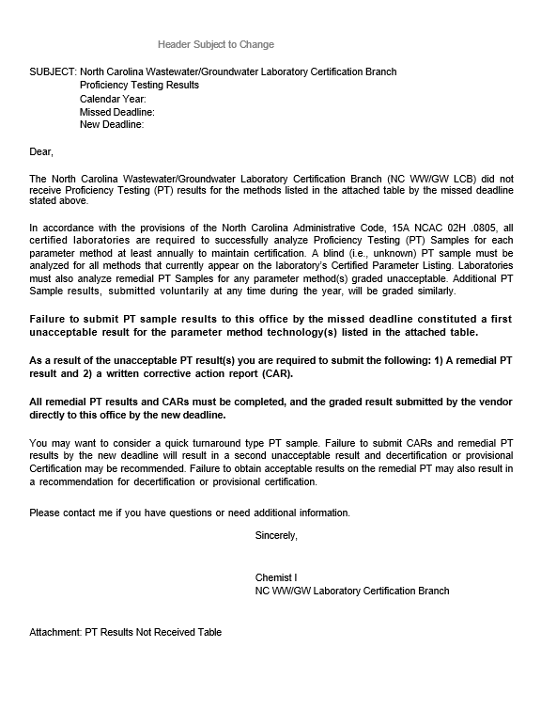

Attachment 2: Unacceptable PT/Notice of Intent to Decertify Method Letter
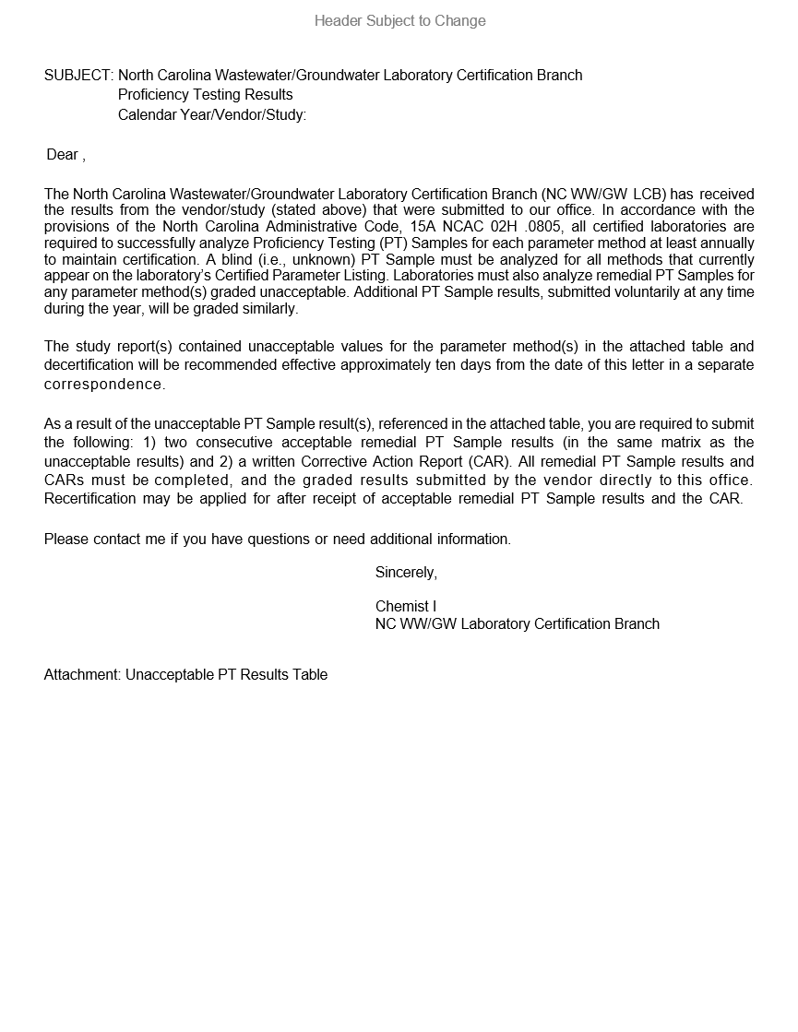

Attachment 3: Decertification Effective Date Letter
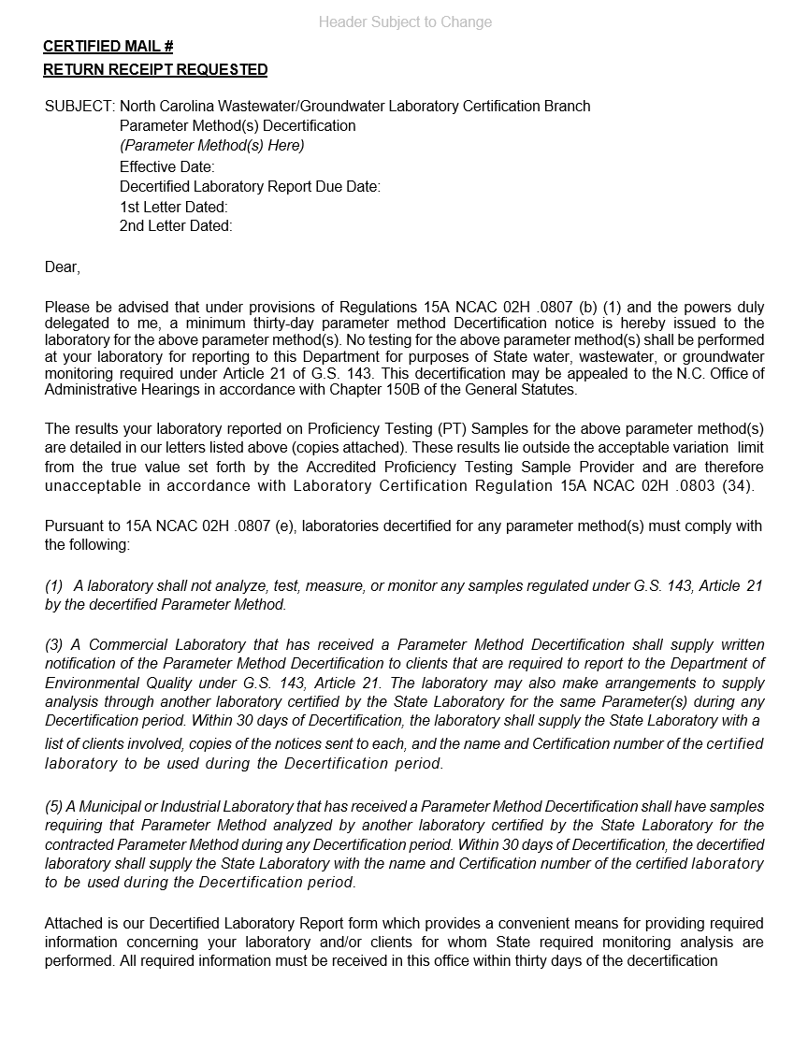
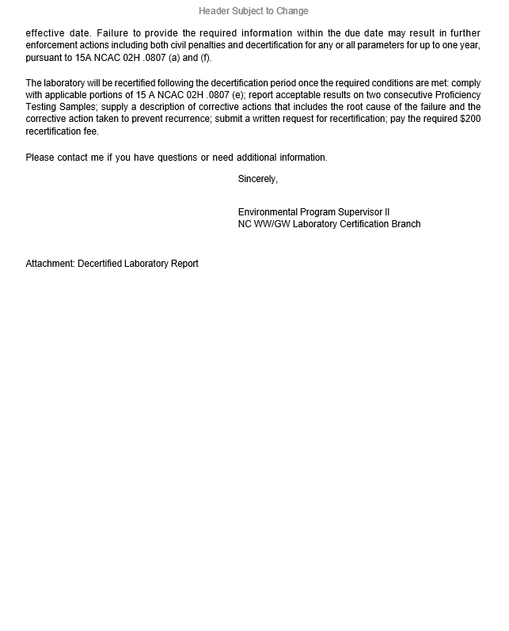

Attachment 4: Decertified Parameter Method Report
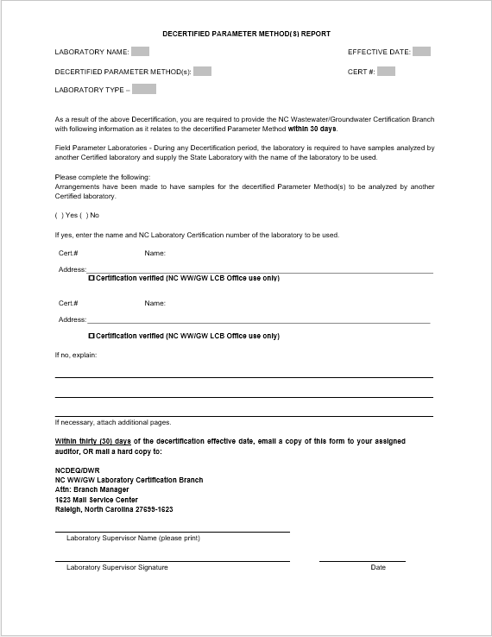

Attachment 5: Notice of Decertification for Failure to Submit Information by the Due Date
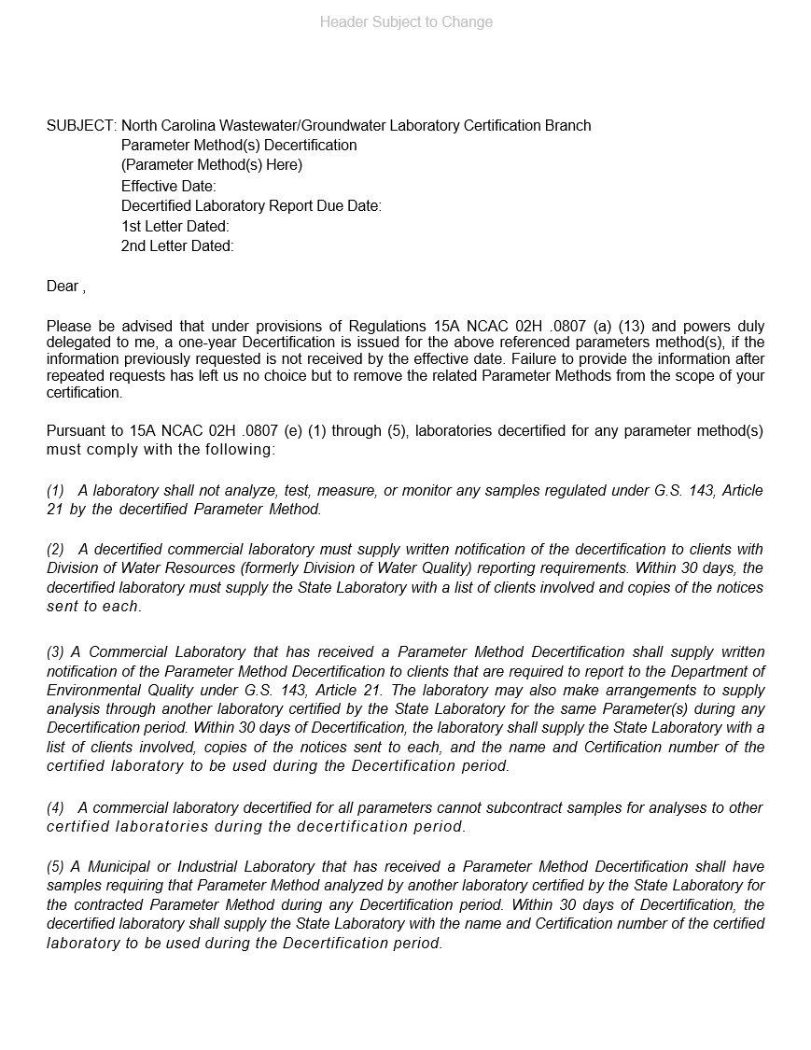

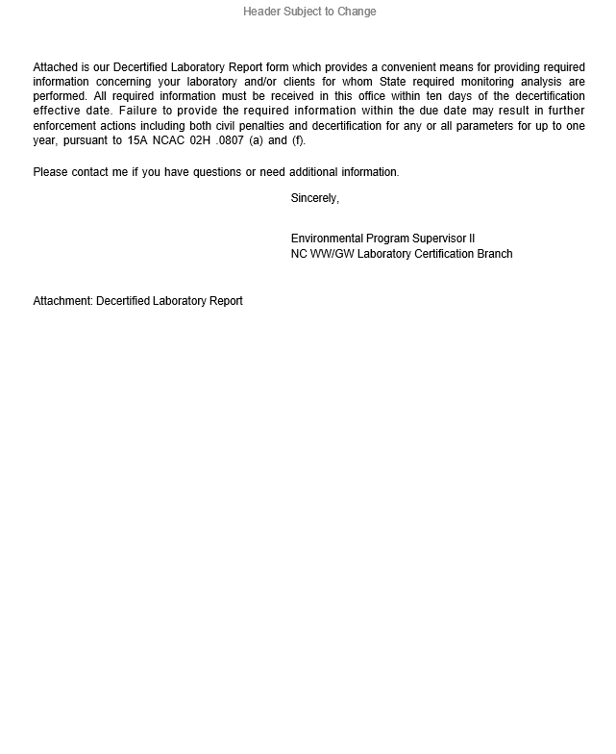

Attachment 6: Parameter Method Recertification Letter
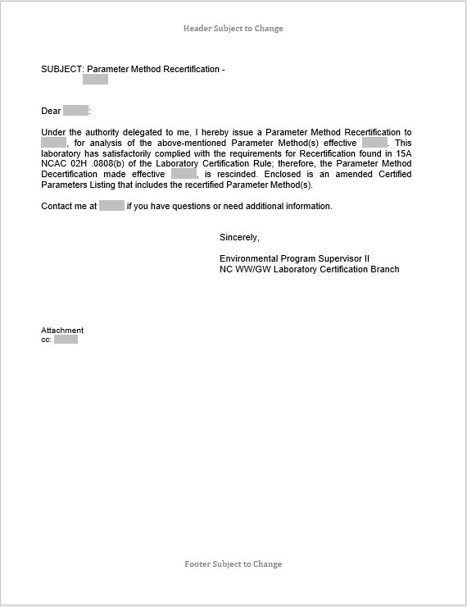

Attachment 7: EPA DMR-QA PT Study Exemption Letter

Attachment 8: PT Evaluation Letter – Acceptable Results Complete
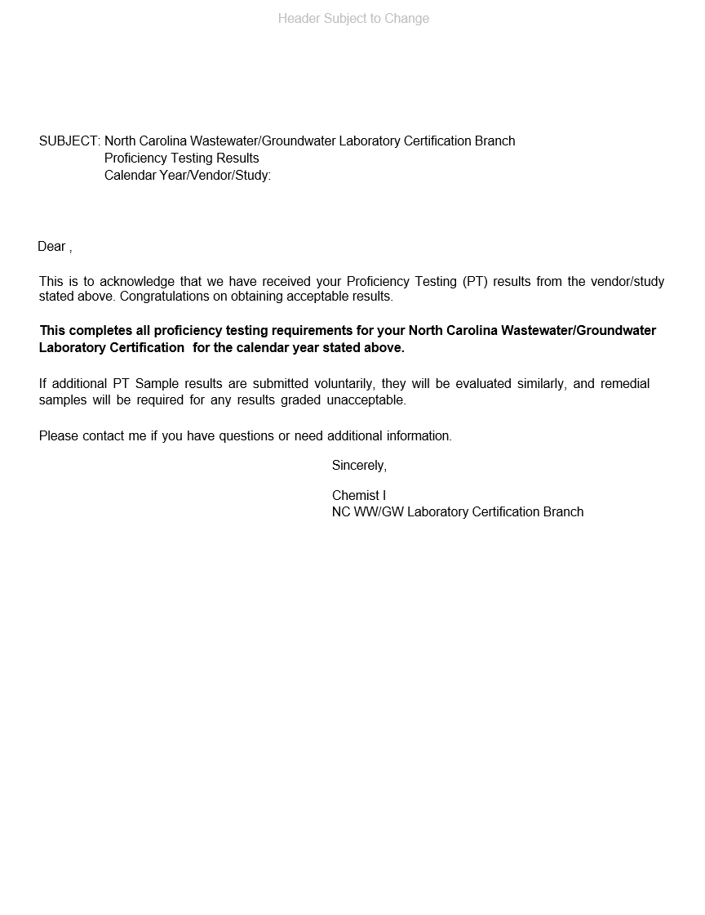

Attachment 9: PT Evaluation Letter – Acceptable Results Incomplete
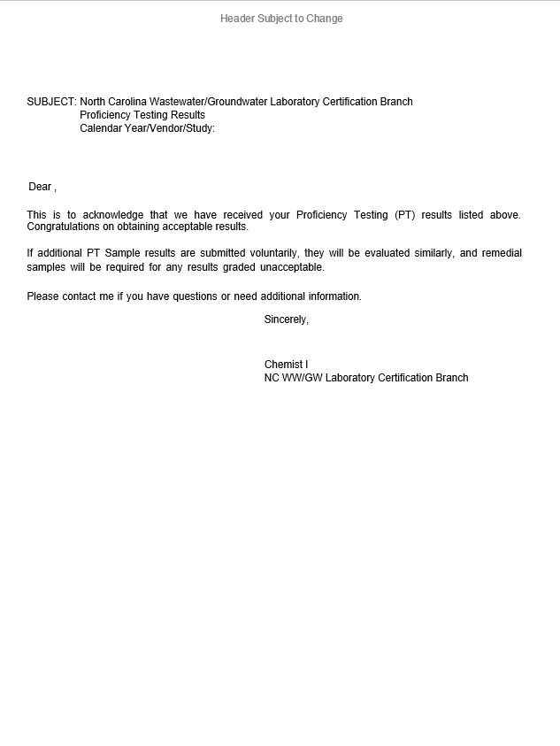

Attachment 10: Provisional Certification Notification Letter
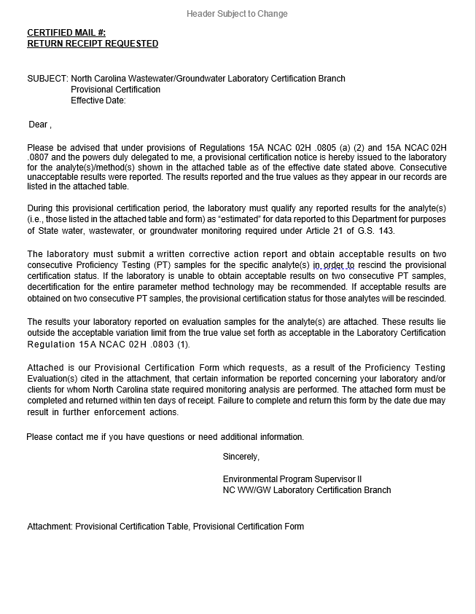

Attachment 11: Provisional Certification Form
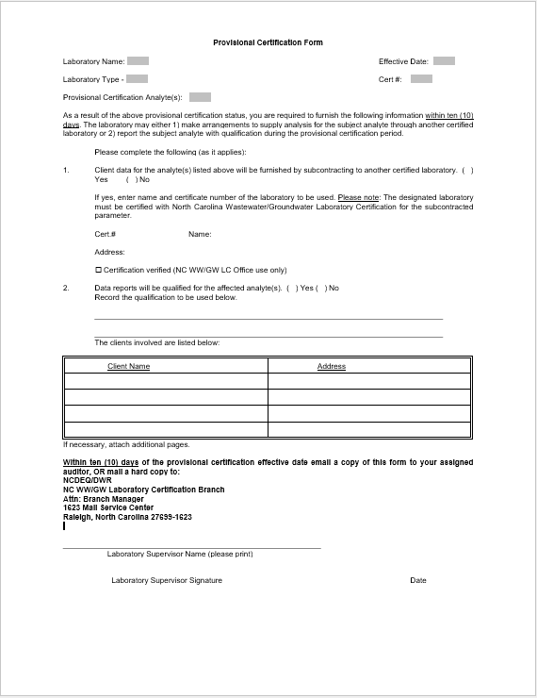

Attachment 12: Provisional Certification Rescission Letter
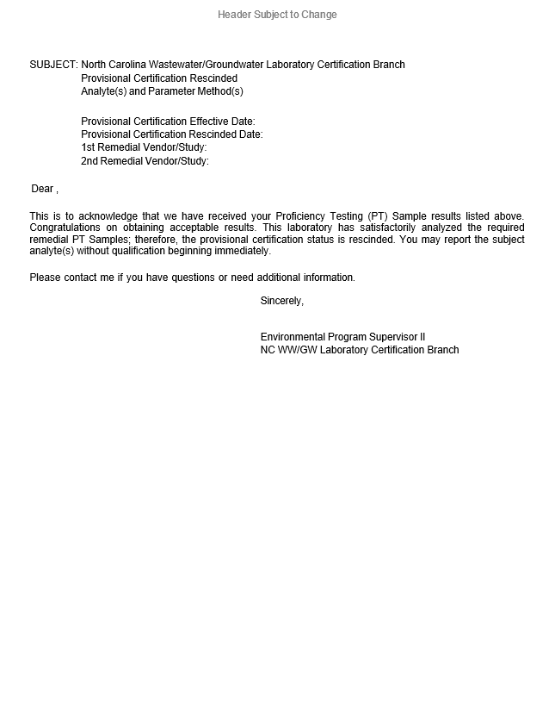

Attachment 13: Example Root Cause Analysis
Root Cause Analysis (RCA) is a technique used in problem solving to identify the underlying reason why something has gone wrong or why a difficulty has occurred. It is a step-by-step method that leads to the discovery of a fault's first or core cause. In compliance testing, the root cause analysis often takes the investigator back to the laboratory’s quality system protocols.

Root cause analysis may include the following actions and checks: Raw data and calculations, laboratory reagent water criteria, the suitability of chemical reagents used in the test, the expiration dates of calibration and check standards, instrument calibration, responses and maintenance, sample conditions upon delivery to the laboratory and storage conditions or preservation if applicable, workplace cleanliness, staff training and competency, standard operating procedures, data entry and review processes, undue job pressures, etc. There are a variety of problem-solving tools that may be employed to diagnose the problem including flowcharts, cause and effect diagrams (also referred to as fishbone diagrams) or any combination used to drill down to cause of the problem. A simplified iterative process often used in root cause analysis is the Five Whys method. An investigator would continue asking “Why did this happen?” until they arrive at the root cause. Refer to the following example:

The laboratory obtains unacceptable results on a semivolatile organic proficiency testing (PT) sample and asks the following:

Why did this happen? A review of the raw data package reveals that the software improperly integrated a peak.

Why? The result was reported from this integration because the analyst was not aware that when this occurs, manual integration must be performed.

Why? Manual integration is not addressed in the standard operating procedure or in a stand-alone procedure and training in manual integration using the software has not been provided.

Why? The new organic unit supervisor has also not been trained in the
software with respect to the ability to manually integrate peaks when necessary.

Why? A documented system for training in all aspects of calibration and quantitation of semivolatile organic target analytes has not been implemented in the laboratory’s quality system.

The corrective action plan would then include steps to eliminate failure at each of these points in the process, beginning with the root cause. The ultimate goal of Root Cause Analysis (RCA) is to eliminate the core cause of the problem. If a corrective action, or a series of actions, is implemented and only corrects the symptoms and does not eliminate the cause, the process leaves the possibility of recurrence.

Attachment 14: Corrective Action Plan (CAP) Form

A Corrective Action Plan is a report, due within 10 business days of the date of the unacceptable PT letter from your auditor, detailing what the laboratory intends to investigate in terms of troubleshooting an existing out-of-control event, nonconformity, or undesirable condition and what possible corrective actions might be taken for each troubleshooting scenario. A good Corrective Action Plan addresses and documents the following:

- the existing problem – describe the problem referencing specific data and dates,
- the anticipated root cause of the problem,
- possible corrective actions that may be taken to correct the problem prevent recurrence,
- anticipated implementation dates of possible corrective actions, and
- data that required qualification or rejection as a result of this problem.

The format of this report is up to the individual laboratory. It may be written in a narrative format, entered into a table or documented on a template form. An example CAR form is given below.

Example Corrective Action Plan Report Form
Lab Name | Corrective Action Plan (CAP) Report
Lab Name | Document Control #:
Lab Name | Effective Date:
Non-conformance type: | □Sampling □Sample Receiving □Proficiency Testing  □Calibration □Analysis □QC □External Audit  □Other:
CAP Initiated by: | Date Initiated:
Description of Non-conformance:
Description of Suspected Root Cause:
Proposed Corrective Actions to Prevent Recurrence:
Sample Data Requiring Qualification/Rejection:
Follow-up Investigation/Continuous Monitoring:
Supporting Documents Attached: □Yes □No

Attachment 15: Corrective Action Response (CAR) Form
A Corrective Action Response (CAR) report details the ultimate measures taken that effectively eliminated an existing out-of-control event, nonconformity or undesirable condition and is believed will prevent the recurrence of the situation. A good Corrective Action Response addresses and documents the following:

- the existing problem – describe the problem referencing specific data and dates,
- the root cause of the problem,
- corrective actions taken that corrected the problem and actions taken to prevent recurrence,
- future monitoring to check resolution – describe quality of data after corrective action
- implementation referencing specific data and dates – is further corrective action needed, and
- data that required qualification or rejection as a result of this problem.

The format of this report is up to the individual laboratory. It may be written in a narrative format, entered into a table or documented on a template form. An example CAR report form is given below.

Example Corrective Action Response Report Form
Lab Name | Corrective Action Response (CAR)
Lab Name | Document Control #:
Lab Name | Effective Date:
Non-conformance type: | □Sampling □Sample Receiving □Proficiency Testing  □Calibration □Analysis □QC □External Audit  □Other:
CAR Initiated by: | Date Initiated:
Description of Non-conformance:
Description of Root Cause Analysis:
Corrective Actions Taken to Prevent Recurrence:
Sample Data Requiring Qualification/Rejection:
Follow-up Investigation/Continuous Monitoring:
Corrective Action Successful: □Yes □No
Supporting Documents Attached: □Yes □No
Date CAR Closed:

Attachment 16: PT Inspection Checklist
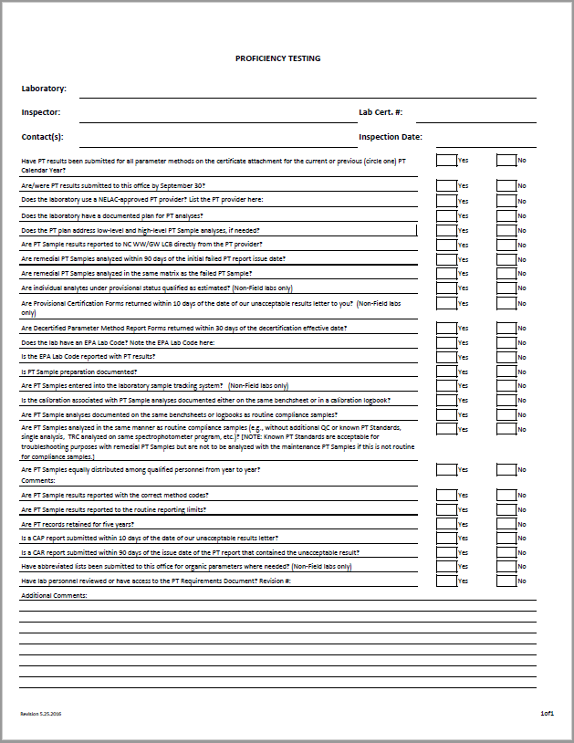

9.0 Revision History

Revision Number | Date Revised | Revision Summary
1.0 | 01/18/2011 | Section 4.2.1, pg. 24 – An error in the example PT evaluation was corrected. The equation was changed to %Acceptable = [(35-6)/40] x 100% = 72.5% and “false negative” was corrected to read “false positive”.
1.1 | 02/14/2011 | Sections 2.2.1, pg. 5 and 2.4.1, pg. 7 – Added false positives and false negatives to the definitions of Not Acceptable and Unacceptable.  Section 2.3.1, pg. 6 – It was found that some Quick Response PT Samples have deadlines for reporting, so this was removed from the definition.  Section 3.4, pg. 15 – Added the requirements for recertification when a lab voluntarily drops certification to avoid decertification.  Section 3.6, pg. 17 – Omitted the reference to matrix-matched samples since this is covered two paragraphs preceding which states that PT samples must be analyzed in the same manner as routine environmental samples.  Section 4.2.1, pg. 24 – An error in the example PT evaluation was corrected with input from EPA Region 4. The equation was changed to %Acceptable = [(40-9)/40] x 100% = 77.5%  Attachments 7 and 18 were added and the remaining attachments appropriately renumbered.
1.2 | 02/20/2012 | Sections 1.0, pg. 3; 2.3 pg. 4; 2.21 pg. 5; 3.1, pg. 10 – ACLASS was added as an approved PT Provider Accreditor.  Section 2.10, pg. 4 – A definition of Corrective Action Report (CAR) was added.  Section 2.27, pg. 6 – The PT Calendar Year was redefined as January 1 to September 30, moving the PT deadline up one month to accommodate the 90-day remedial PT deadline.  Sections 2.33, pg. 7; 3.2, pg. 13; 3.3, pg. 14; 3.8, pg. 22; 6.0, pg. 30 – All references to the initial PT deadline were changed from October 31 to September 30.  Section 3.2, pg. 13; 4.2.1, pg. 26; 4.2.2, pg. 26 – The remedial PT deadline was changed from 60 to 90 days.  Section 3.3, pg. 15 – Added that labs must take immediate corrective action (in the form of qualifying data results, suspending analysis, etc.) once it is known a second PT failure has occurred and not wait for the provisional or decertification effective date.  Section 3.6, pg. 18 – For those laboratories that do not have adequate glassware for PT sample preparation, and have another lab assist with making up the PT sample, it is the participant laboratory’s responsibility to retain the PT sample preparation documentation.  Section 3.6, pg. 18 – Decertification and provisional certifications will be issued for the parameter method technology, not just the matrix of the PT failed.  Section 3.7, pg. 22 – The website address for the Chlorophyll a Round Robin Study SOP was added.  Section 3.9, pg. 23 – Added 2009 TNI Standard PT grading requirement.  Section 4.2.2, pg. 27 – Added 30-day deadline for Provisional Certification Form.  Section 4.4, pg. 28 – Added reference to Section 4.2.2 guidelines to TCLP Metals section.  Section 6.0, pg. 30 – Added reference to the Proficiency Testing Checklist and the Field Parameter On-site Inspection Checklist.  Attachments 1, 2, 3, 7, 8, 10, 11, 12, 13, 14 and 16 were updated to the new deadline requirements and new DWQ Director.  Attachment 17 was updated to include a description of the Corrective Action Report and an example Corrective Action Report Form.  Attachments 19 and 20 were added.
2.0 | 02/21/2016 | Minor non-substantive editorial changes such as capitalizations, web link updates and document header and department name changes were made throughout the document.
2.0 | 02/21/2016 | Uses of the term “environmental sample” were changed to “Compliance Sample” to better reflect the type of sample for which PT samples analyses are intended to be a measure of.
2.0 | 02/21/2016 | Updated the Table of Contents
2.0 | 02/21/2016 | Updated Attachments to reflect current letters
2.0 | 05/05/2017 | Section 2, pgs. 5-8 – Definitions were added for Certified Parameters Listing, Compliance Sample, NC WW/GW Laboratory Certification Number, Non-Field Laboratory, Proficiency Testing Provider, Proficiency Testing Provider Accreditor (PTPA) and Recertification and sub-section numbers adjusted accordingly.  The definition for Proficiency Testing (PT) Provider was combined with the definition for Accredited Proficiency Testing (PT) Provider and then deleted.
2.0 | 05/05/2017 | Section 3.0, pg. 9 – Language stating that Water Supply studies will not be accepted for organic methods was added.  Language stating that ready-use type PTs will not be accepted and that SOPs must address how low-level and high-level PTs, including preparation of multiple dilutions of the sample, will be analyzed.
2.0 | 05/05/2017 | Section 3.1, pg. 11 – The following language was added: A specific PT Sample matrix is required in cases where a method is matrix-specific (e.g., SW-846 9071B and SW-846 7471B) and/or when requesting only one matrix when two are available. The exception to this is SW-846 Method 9045D. A PT for that method is not required.
2.0 | 05/05/2017 | Section 3.1, pg. 11 – The following language was deleted: A laboratory must submit an amendment application each time it wishes to become certified for an additional parameter method technology, even if it is already currently certified for other parameter and/or parameter method technologies. Parameters for which certification may be requested are excerpted from 15A NCAC 2H .0804 below.
2.0 | 05/05/2017 | Section 3.1, pg. 11 – Sub-sections (a), (b), (c) and (d) were deleted.
2.0 | 05/05/2017 | Section 3.2. pg. 11 – Section title changed from “Maintenance/Renewal” to “Certification Maintenance/ Renewal”.  Because the submission of PT Sample results directly from the Accredited PT Sample Provider is a requirement and the word “encouraged” did not convey that and because the preceding sentence was revised to make that clear, the following sentence was deleted: Laboratories are encouraged to have these results reported directly by the PT provider to the NC WW/GW LC Program by early September to avoid delays in processing the renewal of their Certification.
2.0 | 05/05/2017 | Section 3.3, pg. 13 – The following language was added: All PT Sample results received by the NC WW/GW LC Program will be evaluated according to all evaluation schemes and criteria, as described in this document, regardless of whether or not the PT requirements of the current PT Calendar Year had been already completed.
2.0 | 05/05/2017 | Section 3.4, pg. 15 – The following language was added: For Recertification of organic methods that were Decertified for failing the 80% rule on two consecutive PT results, the laboratory must submit two consecutive PT results that pass the 80% rule. Any analytes that are graded as unacceptable in either of the two remedial PT Samples will be given Provisional Certification status until two consecutive PT Samples with acceptable grades results for those analytes are received.
2.0 | 05/05/2017 | Section 3.5, pg. 15 – The EPA Lab Code contact information was updated to reflect the replacement of Mr. Charles Feldman with Mr. Jeffrey Wilmoth.
2.0 | 05/05/2017 | Section 3.6, pg. 16 – Language was added and deleted to require that a PT Sample be analyzed for each applicable parameter method on the laboratory’s CPL instead of one PT Sample for each parameter technology. Language stating that the spiking of PT Samples was neither required, nor recommended, was also added.
2.0 | 05/05/2017 | Section 3.6, pg. 17 – Language was added to clarify that the requirement to equally distribute PT Samples among trained personnel was on a year to year basis.
2.0 | 05/05/2017 | Section 3.6, pg. 18 – Language was added to clarify that when results from a single PT Sample are reported for multiple methods of the same technology, the most stringent QC requirements among the report methods must have been applied.
2.0 | 05/05/2017 | Section 3.7.3, pg. 20 – The pH adjustment range language was changed from “between 6.5 and 7.5” to “between 7.0 and 7.2” to reflect current requirements.
2.0 | 05/05/2017 | Section 3.7.4, pg. 20 – Language was added to state that chlorophyll a round robin studies may be conducted during the summer. Language was also added to clarify that NC DWR staff would collect and distribute samples and that laboratories will analyze the samples at their own expense and not charge a fee for the analyses.
2.0 | 05/05/2017 | Section 3.8, pg. 20 – The Section name was changed from “DMR-QA PT Study Exemption for NC Permittees” to “Matrix-Specific PT Requirements” and the following language was added: The NC WW/GW LC Program has opted not to require use of solid or hazardous waste PTs PT Samples for methods that are not matrix-specific to soil analyses. A laboratory may, however, elect to analyze one or more matrices for a given method. When Certified for a method by both aqueous and non-aqueous matrices, a single PT Sample in either matrix shall suffice for demonstration of proficiency for that parameter method. A specific PT Sample matrix is required only in cases where a method is matrix-specific (e.g., SW-846 9071B and SW-846 7471B) or if the laboratory is only certified for one matrix when multiple matrices are available. One exception to this is SW-846 9045D. No PT Sample analysis is required for that method. If Unacceptable PT Sample Results are obtained, remedial PT Samples must represent the same matrix as the unacceptably graded failed PT Sample. If the remedial PT Sample result is unacceptable, Decertification may be recommended for the parameter method in any or all matrices, not just the matrix analyzed for those PT Samples. The same principle is applied to Provisional Certifications.
2.0 | 05/05/2017 | Section 3.9, pg. 20 – This Section was labeled as Section 3.8 in the previous Revision.
2.0 | 05/05/2017 | Section 4.0, pg. 21 – This Section was labeled as Section 3.9 in the previous Revision.
2.0 | 05/05/2017 | Section 5.0, pg. 22 – This Section was labeled as Section 4.0 in the previous Revision.
2.0 | 05/05/2017 | Section 5.1, pg. 23 – The following language was added: SIM analysis of PT Samples is not required to maintain Certification. However, if PT Samples are analyzed using SIM, they will be evaluated and graded the same as for any other single-analyte or multi-analyte group as described in Sections 5.0 and 5.2 through 5.7. If unacceptable results are obtained, remedial PT Samples must also be analyzed using SIM. Remedial PT Sample results will be evaluated and Decertification may be recommended for the parameter method in any or all matrices, not just the matrix analyzed for those PT samples. The same principle is applied to Provisional Certifications. After two consecutive unacceptable results are obtained for an individual analyte, the laboratory should immediately begin qualifying data as “estimated”. Upon receipt of the Provisional Certification notification (sent via certified mail), the laboratory must qualify any reported results for those analytes as “estimated”. The laboratory must also complete a Provisional Certification Form (See Attachments 15 and 16), within 30 days of receipt, identifying North Carolina clients for which affected data may be reported. Failure to complete and return this form by the date due may result in further enforcement actions.
2.0 | 05/05/2017 | Section 5.2, pg. 23 – This Section was labeled as Section 4.1 in the previous Revision.
2.0 | 05/05/2017 | Section 5.3, pg. 23 – This section was labeled as Section 4.2 in the previous Revision.
2.0 | 05/05/2017 | Section 5.3, pg. 23 – The following parameters were removed from the list of parameters for which PTs are required: TCLP Metals, TCLP Organics, Nonhalogenated Volatile Organics, Extractable Petroleum Hydrocarbons Volatile Extractable Hydrocarbons. While PTs for these parameters are available, they do not reflect the way Compliance Samples are analyzed in practice and not required to obtain or maintain Certification.
2.0 | 05/05/2017 | Section 5.3.1, pg. 24 – Section was labeled as Section 4.2.1 in the previous Revision.
2.0 | 05/05/2017 | Section 5.3.1, pg. 24 – Language was added to clarify the target group of analytes is specified within the analytical method.
2.0 | 05/05/2017 | Section 5.3.2, pg. 25 – Section was labeled as Section 4.2.2 in the previous Revision.
2.0 | 05/05/2017 | Section 5.4, pg. 26 – Section was labeled as Section 4.3 in the previous Revision.
2.0 | 05/05/2017 | Section 5.4, pg. 26 – The section title was changed from “Multiple Matrices and Concentration Levels” to “Multiple Concentration Levels”. All language pertaining to matrices was removed. Matrix-Specific PT Sample evaluations are now addressed in Section 5.6.
2.0 | 05/05/2017 | Section 5.5, pg. 26 – Section was labeled as Section 4.4 in the previous Revision.
2.0 | 05/05/2017 | Section 5.5, pg. 26 – Language was changed to state that PT Samples are not required for TCLP, EPH and VPH.
2.0 | 05/05/2017 | Section 5.5, pg. 27 – The following language concerning Polychlorinated Biphenyls (PCBs) was added: Accredited PT providers generally spike PCB PT Samples with one or more Arochlors. Acceptable results require proper identification and accurate quantitation of the correct Arochlor(s). In order to evaluate PCB PT results consistently, NC treats them as a single analyte parameter (i.e., any unacceptable result will be considered a parameter miss). Laboratories must report acceptable results (including “less than” values) for all Arochlors in order for the cumulative result to be acceptable. Additionally, since specific Arochlors may not be requested from the Accredited PT Provider, a remedial PT Sample may or may not contain any or all of the unacceptable Arochlors that were in the original PT Sample. This is acceptable.
2.0 | 05/05/2017 | Section 5.6, pg. 27 – The following language was added: Matrix-specific PT Samples are not required for methods with multiple matrix options. When Certified for multiple matrices for a single method, the laboratory may choose which matrix to analyze. If a laboratory chooses to analyze multiple matrices, each matrix (aqueous, non-aqueous and oil) will be evaluated and graded independently as described in Sections 5.0 through 5.5.  If a laboratory, certified for multiple matrices for a single method, chooses to analyze only one matrix, both matrices may be decertified for the parameter method if two consecutive unacceptable results are obtained for the only matrix analyzed.
2.0 | 05/05/2017 | Section 5.7, pg. 27 – Section was labeled as Section 4.5 in the previous Revision.
2.0 | 05/05/2017 | Section 6.0, pg. 27 – Section was labeled as Section 5.0 in the previous Revision.
2.0 | 05/05/2017 | Section 7.0, pg. 28 – Section was labeled as Section 6.0 in the previous Revision.
2.0 | 05/05/2017 | Section 7.0, pg. 28 – The following language was added to describe how auditor oversight and tracking is performed: This is accomplished through a PT tracking system, which is maintained by each auditor for the laboratories they track. The tracking system contains the all the methods that a laboratory is Certified for and tracks associated PT Sample results, CARs, evaluation letters and any applicable Decertification, Recertification and Provisional Certifications. The tracking systems maintained by each auditor are also independently assessed for accuracy and completeness.
3 | 10/29/18 | Title Page – Updated header and footer.
3 | 10/29/18 | Section 3.0, Pg. 9 – Added clarification that WS studies would be accepted for EPA method 504.1.
3 | 10/29/18 | Section 3.1, Pg. 11 – The following language was added for clarification: If a laboratory submits two unacceptable PT Sample results while attempting to gain Certification, two consecutive acceptable PT Sample results and CARs shall then be required prior to being granted Certification.
3 | 10/29/18 | Section 3.6, Pg. 17 – Language was added to the second Note to clarify that the analysis of quality control PT Samples of known concentrations at the same time as PT Samples, is considered additional quality control and not allowed.
3 | 10/29/18 | Section 5.4, Pg. 26 – Examples were added to clarify the application of the > 50% rule.
3 | 10/29/18 | Section 5.5, Pg. 27 – The following language was added for clarification: Both WP And WS studies will be accepted for EPA Method 504.1.
3 | 10/29/18 | Section 5.6, Pg. 27 – In the following sentence, the word “both” was changed to “all”: If a laboratory, certified for multiple matrices for a single method, chooses to analyze only one matrix, both matrices may be decertified for the parameter method if two consecutive unacceptable results are obtained for the only matrix analyzed.
4 | 11/26/19 | The spelling of Aroclor was corrected throughout the document.
4 | 11/26/19 | All references to 60-day decertification period were changed to 30-day decertification period to coincide with NC Administrative Code 15 NCAC 2H .0800.
4 | 11/26/19 | Section 2.8, Pg. 5 – The term “supporting documentation” was changed to “Supporting Records” and the term was added to the definitions section to coincide with NC Administrative Code 15 NCAC 2H .0800.
4 | 11/26/19 | Section 2.14, Pg. 6 – The following language was added to the end of the last sentence: “… but must meet all other requirements of this document”.
4 | 11/26/19 | Section 2.27, Pg. 7 – The following definition was inserted here, and subsequent sections were re-numbered: Parameter: Analyte, element, compound, or property being measured.
4 | 11/26/19 | Section 2.28, Pg. 7 – The following definition was deleted: Parameter Method Technology: A type of analytical technology used to measure a parameter which is significantly different from other analytical technologies used to measure the same parameter.
4 | 11/26/19 | Section 2.28, Pg. 7 – The following definition was added: Parameter Method: A type of analytical technique, including materials and tools, used to measure a parameter.
4 | 11/26/19 | Section 2.33 (previously 2.32), Pg. 8 – The following language was deleted: “PT Samples are standards whose true value concentrations are unknown to the laboratory and are supplied by an Accredited PT Sample Provider”.
4 | 11/26/19 | Section 2.33 (previously 2.32), Pg. 8 – The following language was added: “A performance evaluation sample whose true value is unknown to the laboratory and provided by a State Laboratory-approved Vendor to test whether the laboratory can produce analytical results within the specified acceptance criteria”.
4 | 11/26/19 | Section 2.43 (previously 2.42), Pg. 9 – The following language was deleted: “A split sample is one that has been equally divided into two or more sub-samples. Split samples are submitted to different analysts or laboratories and are used to measure the precision of the measurement of a given target analyte or group of analytes and/or relative performance of the participating entities”.
4 | 11/26/19 | Section 2.43 (previously 2.42), Pg. 9 – The following language was added: “A Split Sample is two or more representative portions taken from a sample or subsample and analyzed by two or more laboratories approved by the State Laboratory and are used to measure the precision of the measurement of a given target analyte or group of analytes and/or relative performance of the participating entities”.
4 | 11/26/19 | Section 2.45, Pg. 9 – The following language was deleted: “The Water Sciences Section of the North Carolina Division of Water Resources, or its successor”.
4 | 11/26/19 | Section 2.45, Pg. 9 – The following language was added: “The Water Sciences Section, including the Laboratory Certification Branch of the North Carolina Division of Water Resources, or its successor”.
4 | 11/26/19 | Section 2.48, Pg. 9 – The following language was added: “Supporting Record: Any document or other source of information compiled, recorded, or stored in written form, by electronic process, or in any other manner that provides any information necessary to reconstruct or characterize a reported value”.
4 | 11/26/19 | Section 2.49, Pg. 9 – The following language was deleted: “A PT Sample Result evaluation that exceeds the specified acceptable range as indicated by an Accredited PT Sample Provider, as well as, any false positive or false negative results”.
4 | 11/26/19 | Section 2.49, Pg. 9 – The following language was added: “Those results on Proficiency Testing Samples that do not fall within the Vendor-specified acceptable range as stated by a State Laboratory-approved Vendor, or Split Samples that do not fall within the specified acceptable range as indicated by the State Laboratory, or a failure to meet a reporting deadline imposed by the Vendor or State Laboratory”.
4 | 11/26/19 | Section 2.50, Pg. 9 – The following language was deleted: “supporting documentation”.
4 | 11/26/19 | Section 2.50, Pg. 9 – The following language was added: “Supporting Records”.
4 | 11/26/19 | Section 2.51, Pg. 9 – The following language was added: “Vendor: An accredited Proficiency Testing Sample provider recognized by The NELAC Institute (TNI). See also Section 2.3, Accredited Proficiency Testing (PT) Sample Provider”.
4 | 11/26/19 | Section 3.0, Pg. 11 – The following language was deleted: “NOTE: Standard Operating Procedures are not currently required for Field Laboratories; however, they are recommended”.
4 | 11/26/19 | Section 3.1, Pg. 11 – The following language was deleted: “Any PT Sample result submitted with an application must have a study close date no earlier than this date.
4 | 11/26/19 | Section 3.1, Pg. 11 – The following language was added: “Any PT Sample result submitted with an application must be the most recent attempt and have a study close date no earlier than this date”.
4 | 11/26/19 | Section 3.1, Pg. 11 – The following language was deleted: “If a laboratory submits two Unacceptable PT Sample Results while attempting to gain Certification, two consecutive Acceptable PT Sample Results and CARs shall then be required prior to being granted Certification”.
4 | 11/26/19 | Section 3.1, Pg. 11 – The following language was added: “Laboratories that submit two consecutive Unacceptable PT Sample Results for a particular Parameter Method while attempting to gain Certification, shall then submit CARs and two consecutive Acceptable PT Sample Results, analyzed within the previous six months, prior to being granted Certification”.
4 | 11/26/19 | Section 3.2, Pg. 12 – The following language was deleted: “This means, that in order to meet the September 30 deadline, laboratories should participate in a PT study that begins no later than Mid-July, unless using “Rapid Response” type samples”.
4 | 11/26/19 | Section 3.2, Pg. 12 – The following language was added: “This means, that in order to meet the September 30 deadline, laboratories may need to participate in a PT study that begins no later than Mid-July, unless using “Rapid Response” type samples. It is recommended that laboratories check turn-around times with the proposed PT Sample Provider before ordering”.
4 | 11/26/19 | Section 3.2, Pg. 12 – The following language was deleted: “When two PT Samples for the same parameter method are submitted and analyzed at the same time, an unacceptable result on one or both samples will be considered the first unacceptable result for Certification purposes and a remedial sample must be submitted in accordance with 15A NCAC 2H .0805 (a) (2) (B)”.
4 | 11/26/19 | Section 3.2, Pg. 12 – The following language was added: “When two PT Samples for the same parameter method are submitted and analyzed at the same time, an unacceptable result on one or both samples will be considered the first unacceptable result for Certification purposes and a remedial sample must be submitted in accordance with North Carolina Administrative Code, 15A NCAC 2H .0805 (a) (2)”.
4 | 11/26/19 | Section 3.2, Pg. 12 – The following language was deleted: “Participate in a second PT meeting the criteria listed previously in this policy ”.
4 | 11/26/19 | Section 3.2, Pg. 12 – The following language was added: “Analyze a remedial PT Sample”.
4 | 11/26/19 | Section 3.3, Pg. 14 – The following language was deleted: “When a laboratory is Decertified for any or all parameter methods, the laboratory is required to report certain information to this office within 30 days of the effective date of the 60-day Decertification period. This includes the clients for whom State required monitoring analyses are performed, a copy of the notification of Decertification sent to clients, and the Certified laboratory to be used (see Decertified Laboratory Report forms in Attachments 5 and 6). Failure to complete and return the supplied form and requested information may result in further enforcement actions (e.g., Decertification – see Attachment 8) pursuant to 15A NCAC 2H .0807 (a) (13).  No testing for the revoked parameter method shall be performed by the laboratory for permittees, clients or wastewater treatment plants reporting to this Department for purposes of State water, wastewater, or groundwater monitoring required under Article 21 of G.S. 143.  A revised CPL that omits the Decertified parameter method(s) will be issued to the laboratory and will remain effective until Certification is regained.  A Commercial Laboratory Decertified for all parameters cannot subcontract samples for analyses to other Certified laboratories during the Decertification period pursuant to 15A NCAC 2H .0807 I (1) through (4)”.
4 | 11/26/19 | Section 3.3, Pg. 14 – The following language was added: “When a laboratory is Decertified for any or all parameter methods, the following conditions shall apply:  (1) A revised CPL that omits the Decertified parameter method(s) will be issued to the laboratory and will remain effective until Certification is regained. A laboratory shall not analyze, test, measure, or monitor any samples regulated under G.S. 143, Article 21 by the decertified Parameter Method.  (2) A decertified Commercial Laboratory shall supply written notification of its Decertification to clients that are required to report to the Department of Environmental Quality under G.S. 143, Article 21. Within 30 days of Decertification, the decertified laboratory shall provide the State Laboratory with a list of those clients and copies of the notices sent to each.  (3) A Commercial Laboratory that has received a Parameter Method Decertification shall supply written notification of the Parameter Method Decertification to clients that are required to report to the Department of Environmental Quality under G.S. 143, Article 21. The laboratory may also make arrangements to supply analysis through another laboratory certified by the State Laboratory for the same Parameter(s) during any Decertification period. Within 30 days of Decertification, the laboratory shall supply the State Laboratory with a list of clients involved, copies of the notices sent to each, and the name and Certification number of the certified laboratory to be used during the Decertification period (see Decertified Laboratory Report form in Attachments 5). Failure to complete and return the supplied form and requested information may result in further enforcement actions (e.g., Decertification – see Attachment 8) pursuant to 15A NCAC 2H .0807 (a) (13).  (4) A Commercial Laboratory decertified for all Parameters shall not subcontract samples for analyses to other certified laboratories during the Decertification period.  (5) A Municipal or Industrial Laboratory that has received a Parameter Method Decertification shall have samples requiring that Parameter Method analyzed by another laboratory certified by the State Laboratory for the contracted Parameter Method during any Decertification period. Within 30 days of Decertification, the decertified laboratory shall supply the State Laboratory with the name and Certification number of the certified laboratory to be used during the Decertification period (see Decertified Laboratory Report form in Attachments 6). Failure to complete and return the supplied form and requested information may result in further enforcement actions (e.g., Decertification – see Attachment 8) pursuant to 15A NCAC 2H .0807 (a) (13)”.
4 | 11/26/19 | Section 3.4, Pg. 15 – The following language was deleted: “NOTE: In addition to the two consecutive acceptable PT Sample results, an acceptable CAR, a Decertified Laboratory Report and payment of the Recertification invoice are required before Recertification will be issued”.
4 | 11/26/19 | Section 3.4, Pg. 15 – The following language was added: “NOTE: In addition to the two consecutive acceptable PT Sample results, an acceptable CAR, a Decertified Laboratory Report, a written request for Recertification and payment of the Recertification invoice are required before Recertification will be issued”.
4 | 11/26/19 | Section 3.4, Pg. 15 – The following language was deleted: “After two years, if a laboratory has not requested Recertification for a Decertified parameter method or if a laboratory voluntarily drops Certification to avoid a Decertification, any requests for Certification for that parameter method will be considered as an initial Certification request and the requirements for initial Certification must be met”.
4 | 11/26/19 | Section 3.4, Pg. 15 – The following language was added: “If a laboratory voluntarily drops Certification to avoid Decertification or if a laboratory has not requested Recertification for a Decertified parameter method after two years, any requests for Certification for that parameter method will be considered as an initial Certification request and the requirements for initial Certification must be met”.
4 | 11/26/19 | Section 3.5, Pg. 17 – The following language was added: “When making the request to the EPA, you must provide the following information:  Contact name  Laboratory or Facility Name  Physical Address (with zip code)  PO address (if different)  Lab/Facility phone number  Fax number (if available)  Contact individual’s e-mail address  Type of Study (WP, WS, DMR-QA)
4 | 11/26/19 | Section 3.6, Pg. 17 – The following language was added: “NOTE: Free Available Chlorine PT Samples are only available in Water Supply (WS) studies”.
4 | 11/26/19 | Section 3.6, Pg. 17 – The following language was deleted: “No documentation is needed for whole volume PT Samples which require no preparation (e.g., pH), but it is recommended that the instructions be maintained”.
4 | 11/26/19 | Section 3.6, Pg. 17 – The following language was added: “No documentation is needed for whole volume PT Samples which require no preparation, however the instructions must be maintained”.
4 | 11/26/19 | Section 3.6, Pg. 18 – The following language was deleted: “In cases where there is more than one laboratory in your network (e.g., corporate organizations, multiple permitted facilities, etc.), each laboratory must be treated independently”.
4 | 11/26/19 | Section 3.6, Pg. 19 – The following language was deleted: “If you work at two locations, you must analyze one PT Sample at the first location using all the equipment and reagents at the first location. You must then order and analyze another PT Sample at the second location using the equipment and reagents at the second location”.
4 | 11/26/19 | Section 3.9, Pg. 21 – The following language was deleted: “Every PT study is open for 45 days from the day the PTs are shipped to the laboratories”.
4 | 11/26/19 | Section 5.1, Pg. 23 – The following language was deleted: “SIM analysis of PT Samples is not required to maintain Certification. However, PT Samples analyzed using SIM, will be evaluated and graded the same as for any other single-analyte or multi-analyte group as described in Sections 5.0 and 5.2 through 5.7”.
4 | 11/26/19 | Section 5.1, Pg. 23 – The following language was added: “SIM analysis of PT Samples is not required to maintain Certification. However, if it is the routine method of analysis for a particular analyte, then analysis of that analyte utilizing SIM shall be required. PT Samples analyzed using SIM, will be evaluated and graded the same as for any other single-analyte or multi-analyte group as described in Sections 5.0 and 5.2 through 5.7”.
4 | 11/26/19 | Section 5.1, Pg. 23 – The following language was deleted: “If unacceptable results are obtained, remedial PT Samples must also be analyzed using SIM”.
4 | 11/26/19 | Section 5.1, Pg. 23 – The following language was added: “If unacceptable results are obtained using SIM, remedial PT Samples must also be analyzed using SIM”.
4 | 11/26/19 | Section 5.5, Pg. 26 – The following language was deleted:  Toxicity Characteristic Leaching Procedures (TCLP)  PT Sample analysis is not required for TCLP.
4 | 11/26/19 | Section 5.5, Pg. 27 – The language in red was added: In order to evaluate PCB PT results consistently, NC treats them as a single analyte parameter (i.e., any unacceptable result will be considered a parameter miss and require analysis of a remedial PT Sample for the entire parameter). Laboratories must report acceptable results (including “less than” values at the laboratory’s reporting limit) for all Aroclors in order for the cumulative result to be acceptable.
4 | 11/26/19 | Attachment 2. Notice of Intent to Decertify Inorganic Method Letter, Pg. 45 – Updated
4 | 11/26/19 | Attachment 3. Notice of Intent to Decertify Organic Method Letter, Pg. 46 – Updated
4 | 11/26/19 | Attachment 4. Decertification Effective Date Letter, Pg. 47 – Updated
4 | 11/26/19 | Attachment 5. Decertified Laboratory Report (For Commercial Laboratories), Pg. 49 – Updated
4 | 11/26/19 | Attachment 11. PT Evaluation Letter – Unacceptable Results, Pg. 56 – Updated
4 | 11/26/19 | Attachment 12. PT Evaluation Letter – Acceptable Results Complete, Pg. 58 – Updated
4 | 11/26/19 | Attachment 13. PT Evaluation Letter – Acceptable Results Incomplete, Pg. 59 – Updated
4 | 11/26/19 | Attachment 14. Provisional Certification Notification Letter, Pg. 60 – Updated
5 | 2/19/20 | Section 2.49, Pg. 9 – The following language was added: “Results graded as Unacceptable by the PT Vendor for “less than” and “greater than” values may be re-evaluated as Acceptable by the NC WW/GW LC Program (See Section 5.0).”
5 | 2/19/20 | Section 5.0, Pg. 22 – The following language was deleted: “The NC WW/GW LC Program will follow the 2009 TNI Standard for PT Sample results reporting and grading.”
5 | 2/19/20 | Section 5.0, Pg. 22 – The following language was added: “Accredited PT Sample Providers are currently being required to follow Volume 3, Section 5.9 of the 2016 TNI Standard for PT Sample results reporting and grading. For Water Pollution (WP) studies, the Accredited PT Sample Providers use the same pooled-result grading system used formally by EPA when determining whether a result is scored “Acceptable” or “Not Acceptable”.  • An “Acceptable” PT Sample result is one where the reported value falls within the acceptance limits.  • A “Not Acceptable” grade is assigned when the submitted PT Sample result falls outside the acceptance limits.”
5 | 2/19/20 | Section 5.0, Pg. 22 – The following language was deleted:  “The 2009 TNI standard evaluations of less than (<) values are listed below:  a) As “Acceptable” when the assigned value is greater than “0” and the value reported with the less than (<) sign is greater than the lower acceptance limit.  b) As “Not Acceptable” when the assigned value is greater than “0” and the value reported with the less than (<) sign is less than the lower acceptance limit.  c) As “Acceptable” when the assigned value is equal to < PTRL (Proficiency Testing Reporting Limit).”
5 | 2/19/20 | Section 5.0, Pg. 22 – The following language was added:  “1) Greater-than value reporting (“>”) and scoring of all “>” results: If a laboratory reports results that are qualified with a “>” symbol, those results will be scored as “Not Acceptable” under the 2016 TNI Standard. Please note that this scoring protocol will also be applied to quantitative microbiology results and may conflict with historically acceptable and method-allowable reporting practices, particularly for most probable number (MPN) methods.  2) Less-than value reporting (“<”): Similar to the 2003 TNI Standard, there is an emphasis on laboratories being able to quantitate and report down to the TNI Proficiency Testing Reporting Limits (PTRLs). If a laboratory uses a method that is incapable of detecting a PT analyte down to the PTRL, the laboratory risks reporting a false negative result when an analyte is spiked into the PT sample. If the analyte is spiked into a PT sample, a reported result of <PTRL, <LOQ, or a value of “0” will receive an evaluation of “Not Acceptable”.”
5 | 2/19/20 | Section 5.0, Pg. 23 – The following language was deleted:  “This means that the laboratory shall report the analytical results for PT Samples as follows:”
5 | 2/19/20 | Section 5.0, Pg. 23 – The following language was added:  “NC requires laboratories to report analytical results for PT Samples as follows:”
6 | 1/1/2023 | Minor non-substantive editorial changes throughout.
6 | 1/1/2023 | All references to “State Laboratory” were changed to North Carolina Wastewater/Groundwater Laboratory Certification Branch or its acronym “NC WW/GW LCB”.
6 | 1/1/2023 | Last sentence of section 2.2 was changed from “For the Water Pollution Program (WP), EPA Acceptance Limits are defined as ± three EPA Standard Deviations from the EPA Mean” to “For the Water Pollution Program (WP), EPA Acceptance Limits are defined as ± three Standard Deviations from the Mean”.
6 | 1/1/2023 | Section 2.12 – The following language was deleted:  “Corrective Action Report (CAR): A report detailing the measures taken to eliminate or prevent the recurrence of the causes of an existing out-of-control event, nonconformity or Proficiency Testing Requirements undesirable condition. It is a retrievable documentation of those actions and follow-up monitoring to ensure resolution. A good corrective action report addresses and documents the following: the existing problem, the root cause of the problem, corrective actions taken to correct the problem, actions taken to prevent recurrence, future monitoring to check resolution and data that required qualification or rejection as a result of this problem. References to CARs in this document relate to Proficiency Testing evaluations.
6 | 1/1/2023 | Section 2.12 – The following language was added:  “Corrective Action Response (CAR): A report, due within 90 days of the issue date of the PT report that contained the unacceptable result, detailing the measures that effectively corrected an out-of-control event, nonconformity or undesirable condition and is believed will prevent the recurrence of the situation. A good Corrective Action Response report addresses and documents the following: the initial problem, the root cause of the problem, corrective actions taken to correct the problem and any objective evidence (e.g., calibration curves, revised procedures, records, training records, standard operating procedures, etc.) to indicate that the corrective actions have been implemented/completed. and data that required qualification or rejection as a result of this problem”.
6 | 1/1/2023 | Section 2.13 – The definition appearing here was re-numbered 2.14 and all subsequent definitions were re-numbered according. The following definition was inserted in Section 2.12: “Corrective Action Plan (CAP): A report, due within 10 business days of the date of the unacceptable PT letter from your auditor, detailing what the laboratory intends to investigate in terms of troubleshooting an existing out-of-control event, nonconformity or undesirable condition and what possible corrective actions might be taken for each troubleshooting scenario”.
6 | 1/1/2023 | Section 2.44, which defined “State Laboratory” was deleted. This made all follow Section number realign with those from Version 5 of this document.
6 | 1/1/2023 | Section 2.50 - “or data obtained using a method or procedure for which the laboratory is not certified to use” was added to the end of the definition.
6 | 1/1/2023 | Section 3.0 - The following language was deleted from the next to the last paragraph; “The laboratory must also be able to explain when PT Sample analysis is not possible for certain methods and provide a description of what the laboratory is doing in lieu of Proficiency Testing. This shall be detailed in the plan”.
6 | 1/1/2023 | Section 3.1 – The first sentence was edited to specify that PT samples would be required for each matrix for which certification is sought.
6 | 1/1/2023 | Section 3.1 – The following language was removed: “A specific PT Sample matrix is required in cases where a method is matrix-specific (e.g., SW-846 9071B and SW-846 7471B) and/or when requesting only one matrix when two are available. The exception to this is SW-846 Method 9045D. A PT Sample for that method is not required”.
6 | 1/1/2023 | Section 3.1 – The following language was added: “Available parameters and sources for approved methods are described in 15 NCAC 02H .0804 and .0805. NELAC approved Proficiency Testing Providers can be found here: https://nelac-institute.org/content/NEPTP/ptproviders.php.
6 | 1/1/2023 | Section 3.2 was changed as follows:  3.2 Certification Maintenance  Laboratories must have acceptable PT Sample results submitted to the NC WW/GW LCB, directly from the Accredited PT Sample Provider, for each Parameter Method and matrix combination (as required by this document) by September 30 of the current Certification cycle.  NOTE: Even if a laboratory analyzes PT Samples prior to September 30, it does not mean that those samples will be graded and reported to the NC WW/GW LCB by the September 30 deadline. Laboratories must choose a study that meets all reporting and posting deadlines. Most PT studies are open for 45 days from the day the PTs are shipped to the laboratories. After a study closes, Accredited PT Sample Providers may take up to 30 days to issue reports to participating laboratories and their designated authorities. This means, that in order to meet the September 30 deadline, laboratories may need to participate in a PT study that begins no later than Mid-July, unless using “Rapid Response” type samples. It is recommended that laboratories check turn-around times with the proposed PT Sample Provider before ordering.  The results must be obtained from PT Samples analyzed during the current PT Calendar Year (i.e., January 1 – September 30). The NC WW/GW LCB will not accept PT Sample results directly from the participant laboratories. When a PT Sample result is not reported by the Accredited PT Sample Provider to this office by the September 30 deadline, the laboratory will be notified in writing (see Attachment 1) and the omission will be counted as a first unacceptable result for that PT Calendar Year. CAP and CAR reports must be submitted by their individual due dates and a remedial PT Sample must be analyzed with a satisfactory result received in this office within 90 days of the date of the PT report containing the unacceptable result to maintain Certification for that Parameter Method and matrix.  When two PT Samples for the same Parameter Method are submitted and analyzed at the same time, an unacceptable result on one or both samples will be considered the first unacceptable result for Certification purposes and a remedial PT Sample in the same matrix must be submitted in accordance with North Carolina Administrative Code, 15A NCAC 02H .0805 (a) (2).  A laboratory that receives a first Unacceptable PT Sample Result for a Parameter Method, or for an individual analyte when multi-analyte parameter PT Samples are analyzed and greater than 80% are acceptable, must:  Submit a CAP report to this office by the due date (See Section 2.13);  Take corrective action;  Analyze an acceptable Remedial PT Sample and,  Submit a CAR report to this office by the due date (See Section 2.12).  A laboratory receiving a second (or remedial) consecutive Unacceptable PT Sample Result may be Decertified for that Parameter Method in the associated matrix, pursuant to 15A NCAC 02H .0807. At this point, the NC WW/GW LCB may initiate an assessment of the laboratory’s quality control records to determine if reported data has been adversely affected and evaluate if further corrective actions are needed. A laboratory may also be Decertified for failing to provide a CAP or CAR report pursuant to 15A NCAC 02H .0807 (13). If the remedial PT Sample results are acceptable and acceptable CAP and CAR reports are received, no further action is necessary.  NOTE: Laboratories must report all analytes for multi-analyte group reference sample remedial PT Samples when less than 80% of the constituent analytes are graded acceptable. Analyzing only a single failed constituent for the analyte group is acceptable only when 80% or greater of the constituent analytes are acceptable. Refer to sections 5.3.1 and 5.3.2 for additional information.  For multi-analyte Parameter Methods (e.g., organic analyses), when greater than 80% of analytes are acceptable, but one or more individual analytes are graded unacceptable, acceptable performance has been demonstrated for the Parameter Method. The laboratory must, however, analyze a remedial PT Sample for the individual analytes that were graded unacceptable. NOTE: If the analyte is not detected in the remedial PT Sample, it must be reported as a “less than” value. When a remedial PT Sample is graded unacceptable for an individual analyte (constituting a second consecutive unacceptable result), the laboratory must immediately begin to qualify data for those individual analytes as “estimated” (whether detected or not) until acceptable results are obtained on two consecutive remedial PT Samples for the analyte in question. Notification will be sent from this office of this single analyte Provisional Certification stating the effective date (see Attachment 10). The laboratory must complete and return the Provisional Certification Form within 10 days of receipt (see Attachment 11). Refer to sections 5.3.1 and 5.3.2 for additional information.
6 | 1/1/2023 | Section 3.3 Decertification, was changed as follows:  A laboratory’s receipt of a second consecutive Unacceptable PT Sample Result indicates the corrective action taken earlier by the laboratory was inadequate and may signal major problems with the laboratory’s system for testing that analyte or group of analytes. After a second consecutive unacceptable result, Decertification of that Parameter Method in the applicable matrix for a period of 30 days may be initiated. Further corrective action must be taken by the laboratory and documentation of that action sent to this office for approval before the laboratory can request Recertification. After reviewing the corrective action documentation submitted by a laboratory and prior to remedial PT Sample analyses, an auditor may conduct an on-site inspection/audit of the laboratory, recommend training for laboratory staff, and/or recommend that the laboratory obtain third-party assistance in laboratory analytical technique, quality control and instrument operation.  If the results of a PT Sample are not received in this office by September 30, this may be evaluated as a first unacceptable result. If the results of a remedial PT Sample analyzed beyond the September 30 deadline is unsatisfactory (i.e., the September 30 deadline was missed and counted as a first unacceptable result), Decertification for that Parameter Method may be initiated. A laboratory that reports no PT Sample results in a calendar year for any Parameter Method for which it is Certified may be Decertified for that Parameter Method in all associated matrices for a period of up to one year pursuant to 15A NCAC 02H .0807. The laboratory’s scope of accreditation found on their CPL will be revised to reflect any Decertifications. A laboratory that reports no PT Sample results in a PT Calendar Year for all Parameter Methods for which it is Certified may be Decertified for all Parameter Methods for a period of up to one year pursuant to 15A NCAC 02H .0807. An initial notice of intent to issue a Decertification is sent either electronically or by mail to the laboratory (see example in Attachment 2). Notices of Decertification with effective dates are sent via email and certified mail to the laboratory (see example in Attachment 3).  NOTE: Notices of Decertification with effective dates are generally sent within one day of the initial notice of intent to issue Decertification. The effective date is usually 10 business days from the date of the notice of intent. However, the laboratory is encouraged to take immediate corrective action once a problem has been identified (i.e., as soon as a second consecutive Unacceptable PT Sample Result is received) and immediately suspend analysis or qualify reported values until a contract/subcontract arrangement with another certified laboratory is made.  All PT Sample results received by the NC WW/GW LCB will be evaluated according to all evaluation schemes and criteria, as described in this document, regardless of whether the PT requirements of the current PT calendar year had already been completed.  A laboratory may appeal a Decertification within 10 business days of receipt of the notice of intent to decertify. This appeal may be made in writing to the NC WW/GW LCB Environmental Program Supervisor and/or Water Sciences Section Chief, who will review the case and submit a ruling within one week of the appeal. A laboratory may also appeal a 30-day Parameter Method Decertification any time after issuance of the notice of the effective date of the Decertification. This Decertification appeal may be made to the N.C. Office of Administrative Hearings (http://www.ncoah.com/hearings/) in accordance with Chapter 150B of the N.C. General Statutes.  When a laboratory is Decertified for any or all Parameter Methods, the following conditions shall apply:  (1) A revised CPL that omits the Decertified Parameter Method(s) will be issued to the laboratory and will remain effective until Certification is regained. A laboratory shall not analyze, test, measure, or monitor any samples regulated under G.S. 143, Article 21 by the decertified Parameter Method.  (2) A decertified Commercial Laboratory shall supply written notification of its Decertification to clients that are required to report to the Department of Environmental Quality under G.S. 143, Article 21. Within 30 days of Decertification, the decertified laboratory shall provide the NC WW/GW LCB with a list of those clients and copies of the notices sent to each.  (3) A Commercial Laboratory that has received a Parameter Method Decertification shall supply written notification of the Parameter Method Decertification to clients that are required to report to the Department of Environmental Quality under G.S. 143, Article 21. The laboratory may also make arrangements to supply analysis through another laboratory certified by the NC WW/GW LCB for the same Parameter(s) during any Decertification period. Within 30 days of Decertification, the laboratory shall supply the NC WW/GW LCB with a list of clients involved, copies of the notices sent to each, and the name and Certification number of the certified laboratory to be used during the Decertification period (see Decertified Parameter Method Report form in Attachment 4). Failure to complete and return the supplied form and requested information may result in further enforcement actions (e.g., Decertification of the entire laboratory for up to one year – see Attachment 5) pursuant to 15A NCAC 02H .0807 (a) (13).  (4) A Commercial Laboratory decertified for all Parameters shall not subcontract samples for analyses to other certified laboratories during the Decertification period.  (5) A Municipal or Industrial Laboratory that has received a Parameter Method Decertification shall have samples requiring that Parameter Method analyzed by another laboratory certified by the NC WW/GW LCB for the contracted Parameter Method during any Decertification period. Within 30 days of Decertification, the decertified laboratory shall supply the NC WW/GW LCB with the name and Certification number of the certified laboratory to be used during the Decertification period (see Decertified Parameter Method Report form in Attachment 4). Failure to complete and return the supplied form and requested information may result in further enforcement actions (e.g., Decertification of the entire laboratory for up to one year – see Attachment 5) pursuant to 15A NCAC 02H .0807 (a) (13).
6 | 1/1/2023 | Section 3.5 – Reference to DMR-QA was removed.
6 | 1/1/2023 | Section 3.6 – First sentence revised as follows:  “Laboratories are required to analyze an appropriate PT Sample by each Parameter Method and in each associated matrix on the laboratory’s CPL”.
6 | 1/1/2023 | Section 3.6 – The following note was added: “Flash Point PT Samples are received as a liquid, but only available in soil or hazardous waste PT studies”.
6 | 1/1/2023 | Section 3.6 – In the fourth Note, the following sentence was added to end: “However, the analysis of quality control PT Samples of known concentrations for troubleshooting purposes shall not be performed on the same day as remedial PT Sample analyses”.
6 | 1/1/2023 | Section 3.6 – The following paragraph was edit as below:  “Before the close of a PT study, a laboratory must arrange with the Accredited PT Sample Provider for the study results to be sent directly from the Accredited PT Sample Provider to the North Carolina Wastewater/Groundwater Laboratory Certification Branch office before or at the same time that results are released to the laboratory. PT Sample results submitted directly from the participant laboratory will not be accepted. The Accredited PT Sample Providers should have the NC WW/GW LCB address on file and an area to select this office as a PT Sample report recipient in the data-reporting packet. Contact your Accredited PT Sample Provider if there is any question about this. The NC WW/GW LCB mailing address is as follows:  NC WW/GW Laboratory Certification Branch  Water Sciences Section  1623 Mail Service Center  Raleigh, NC 27699-1623  Electronic format reports may also be emailed directly from the Accredited PT Sample Provider to: dwrcertpt@ncdenr.gov.”
6 | 1/1/2023 | Revision 5, Section 3.8 – “Matrix Specific PT Requirements” was removed entirely. Subsequent Section numbers were renamed accordingly.
6 | 1/1/2023 | Revision 6, Section 3.8 was revised as follows:  NOTE: Due to length of time that the DMR-QA studies remain open, the NC WW/GW LCB will no longer accept DMR-QA PT Samples for Certification maintenance.
6 | 1/1/2023 | Section 5 – Language in the second paragraph was revised as follows:  “If the laboratory reports a “less than” value that is above the lower concentration of the PT Sample Providers acceptance limits and is evaluated as unacceptable, the results may be accepted by NC. Supporting documentation that the value reported is consistent with the laboratory’s routine lower reporting limit would be required in those cases”.
6 | 1/1/2023 | Section 5 – Language in the next to the last paragraph was revised as follows:  “Any test or measurement results that are evaluated as “Not Acceptable”, “Unacceptable”, “Fail”, or any other term used to indicate exceedances of the acceptable limit by the Accredited PT Sample Provider and conform to the evaluation of grading as described in this document, will require a CAP and CAR reports, as described in Sections 2.13, 2.12 and 3.2, and remedial PT Sample analysis as described in the following sections”.
6 | 1/1/2023 | Section 5.1- Selective Ion Mode (SIM) Analysis was revised as follows:  “When SIM is the routine method of analysis for a particular analyte, analysis of that analyte utilizing SIM shall be required. If the analyte is reported in both SIM and non-SIM modes, based on client needs, PT Samples must be analyzed and reported in both modes. PT Samples analyzed using SIM will be evaluated and graded the same as for any other single-analyte or multi-analyte group as described in Sections 5.0 and 5.2 through 5.6. If unacceptable results are obtained using SIM, remedial PT Samples must also be analyzed using SIM. Remedial PT Sample results will be evaluated, and Decertification may be recommended for the Parameter Method in the matrix analyzed for those PT Samples. The same principle is applied to Provisional Certifications. ”
6 | 1/1/2023 | Section 5.3 Multi-Analyte Group PT Samples was revised to remove acetonitrile.
6 | 1/1/2023 | Section 5.3.1 80% Rule – Paragraph two was revised as follows:  Alternatively, the laboratory may appeal to report an abbreviated analyte list for a PT Sample if they can demonstrate that the abbreviated list is a routine reporting scheme for their NC data reporting. Abbreviated lists must be submitted to this office prior to analyzing the PT Sample when reporting an abbreviated list.
6 | 1/1/2023 | Revision 5, Section 5.6 was removed entirely. All subsequent section were renumbered accordingly.
6 | 1/1/2023 | All Attachment letters were updated.
7 | 1/1/2025 | Minor non-substantive editorial changes throughout.
7 | 1/1/2025 | Table of Contents update to coincide with changes throughout.
7 | 1/1/2025 | Section 1.0 The first sentence of Paragraph 1 was revised as follows: This document is a guide regulatory supplement to the Proficiency Testing (PT) requirements of the Laboratory Certification Program, administered by the NC Department of Environmental Quality (DEQ), Division of Water Resources, Water Sciences Section, Wastewater/Groundwater Laboratory Certification Branch (NC WW/GW LCB) Proficiency Testing (PT) requirements found in North Carolina Administrative Code, 15A NCAC 02H .0805 (a) (2).
7 | 1/1/2025 | Section 1.0 & 3.0 The lists of required PT Samples on the LCB website were consolidated to appear at one location. The links in this document were updated to reflect that.
7 | 1/1/2025 | Section 2.1 The definition of the Acceptable Results was clarified as follows: Acceptable Proficiency Testing Results: Those results on Proficiency Testing Samples that are within the Vendor-specified acceptable range as indicated by a Vendor or Split Samples that are within the specified acceptance range as provided by the Proficiency Testing (PT) Sample results that are within the Vendor-specified acceptable range as indicated by a Vendor, or Split Samples that are within the specified acceptance range as provided by NC WW/GW LCB.
7 | 1/1/2025 | Section 1.0 The following language was deemed unnecessary for this document and deleted “A laboratory’s Certification status is determined not only by its performance in acceptable proficiency tests but by a combination of criteria including qualifications of personnel, its performance in on-site inspections, and, in the case of laboratories located outside of North Carolina seeking initial Certification by reciprocity, the status of its certification from its resident state. For more information about the NC WW/GW LCB’s processes and requirements, visit http://deq.nc.gov/about/divisions/water-resources/water-resources-data/water-sciences-home-page/laboratory-certification-branch”.
7 | 1/1/2025 | Section 2.22, which defined “Multi-analyte Proficiency Testing (PT) Sample” was deemed unnecessary and deleted. The remaining Definition Sections were re-numbered appropriately and any subsequent references to them corrected.
7 | 1/1/2025 | Section 3.0 The last sentence of the 4th paragraph was edited as follows: The plan must also address how and from whom these samples are obtained, the annual schedule on which they are obtained and/or when the analytical results of the PT Samples are due to be received by the NC WW/GW LCB, and the laboratory’s process for submission of PT Sample results, including Remedial PT Sample results and related Corrective corrective Action action Reportsreports (i.e., CAPs and CARs).
7 | 1/1/2025 | Section 3.0 The first sentence of the 5th paragraph was edited as follows: “SOPs” was replaced with “The documented Proficiency Testing plan …”.
7 | 1/1/2025 | Section 3.1 The clarification that all PT Samples must be provided to this office directly from the Accredited PT Sample Provider was added to the last sentence of the 1st paragraph.
7 | 1/1/2025 | Section 3.2 The sentence, “When the unacceptable result is due to missing the September 30 deadline, the remedial PT result must be received in this office by December 28 (90 days from September 30)” was added to the end of the 3rd paragraph.
7 | 1/1/2025 | Section 3.2 The 4th paragraph was amended as follows, “When two PT Samples for the same Parameter Method are analyzed and submitted at the same time, an unacceptable result on one or both samples will be considered the first unacceptable result for Certification purposes and a remedial PT Sample in the same matrix must be submitted within 90 days of the first unacceptable result in accordance with North Carolina Administrative Code, 15A NCAC 02H .0805 (a) (2)”. The stricken language was move to the Introduction Section 1.0.
7 | 1/1/2025 | Section 3.2 The last sentence of the 5th paragraph was amended as follows: “If the remedial PT Sample results are acceptable and acceptable CAP and CAR reports are received within the associated deadlines, no further action is necessary”.
7 | 1/1/2025 | Section 3.3 (2) was amended as follows: “A decertified Commercial Laboratory decertified for all Parameters shall supply written notification of its Decertification to clients that are required to report to the Department of Environmental Quality under G.S. 143, Article 21. Within 30 days of Decertification, the decertified laboratory shall provide the NC WW/GW LCB with a list of those clients and copies of the notices sent to each”.
7 | 1/1/2025 | Section 3.4 The 2nd paragraph was amended as follows: “A laboratory Decertified for a Parameter Method due to unacceptable results on two consecutive PT Samples submitted by an Accredited PT Sample Provider, or on two consecutive Split Samples may be Recertified after 30 days by reporting acceptable results on two consecutive PT Samples submitted by an Accredited PT Sample Provider, or on two consecutive Split Samples in accordance with 15A NCAC 02H .0808 (b). PT Samples may be requested from an Accredited PT Sample Provider may be analyzed at any time during the effective within two years of the Decertification period effective date. Recertification must then be requested in writing by completing an Amendment to Laboratory Certification Application found at: https://www.deq.nc.gov/about/divisions/water-resources/water-sciences/chemistry-laboratory/laboratory-certification-branch/forms-and-inspection-checklists . Select Amendment to Laboratory Certification Application in either Word or .pdf format”.
7 | 1/1/2025 | Section 3.4 The Last paragraph was move to the 4th paragraph and amended as follows: “If a laboratory voluntarily drops Certification to avoid Decertification or if a laboratory has not requested Recertification for a Decertified Parameter Method after within two years, any requests for Certification for that Parameter Method will be considered as an initial Certification request and the requirements for initial Certification must be met”.
7 | 1/1/2025 | Section 3.5 The requirement to report the LCB Certification number was removed. The Note was amended as follows: “NOTE: The EPA Lab Code is not the same as the NC WW/GW Laboratory Certification Branch Number assigned to each laboratory by the NC WW/GW LCB or NPDES permit number. Do not report PT Sample results using only the NC WW/GW Laboratory Certification Branch Number or permit number without including the EPA Lab Code”.
7 | 1/1/2025 | Section 3.6 The 4th Note was amended to clarify the difference between blind PT Samples and PT Standards of known concentration as follows: “NOTE: Corrective-action/quality control PT Samples Standards, which are provided with the true values and acceptance ranges in a sealed envelope, are not considered PT Samples and do not meet the PT requirements outlined in 15A NCAC 02H .0800. In general, laboratories must not analyze quality control PT Samples Standards of known concentrations with PT Samples, as this would be considered additional quality control and is not the routine testing protocol for Compliance Samples. However, they are recommended when performing troubleshooting prior to analyzing a remedial PT Sample. This would be considered part of the corrective action plan. However, the analysis of quality control PT Samples Standards of known concentrations for troubleshooting purposes shall not be performed on the same day as remedial PT Sample analyses”.
7 | 1/1/2025 | Section 3.7.3 The first sentence was amended as follows: “Laboratories are reminded that the pH of BOD PT Samples must be adjusted prior to analysis dilution.
7 | 1/1/2025 | Section 4.0 The requirement to retain copies of the PT Sample reporting forms was removed.
7 | 1/1/2025 | Section 5.3 Per- and polyfluoroalkyl Substances (PFAS) was added to the list of multi-analyte group PT Samples.
7 | 1/1/2025 | Section 5.3.3 This language was remove from Section 5.5 and given its own Section number
7 | 1/1/2025 | Section 5.5 Analysis of PT Samples for Extractable Petroleum Hydrocarbons (EPH) and Volatile Petroleum Hydrocarbons (VPH) are no longer required and therefor the reference to them was deleted.
7 | 1/1/2025 | Section 5.5 Evaluations of 1,2-Dibromomethane PT Sample results are covered in 5.3.3 and therefor the reference to that was deleted.
7 | 1/1/2025 | Section 5.6 Language was amended as follows: “When multiple study results are reported at about the same time, the closing dates of the individual PT studies will be used to determine the sequence of the analytical results. When results are in the same study or concurrent studies are concurrent, the >”50% Rule” (see Section 5.4) will be applied.
7 | 1/1/2025 | All Attachment letters were updated.
8 | 1/1/2026 | Section 2.15 Language was amended as follows: “Discharge Monitoring Report–Quality Assurance (DMR-QA) Proficiency Testing (PT) Study Program: The DMR-QA PT Study Program evaluates the analytical and reporting ability of the laboratories that routinely perform inorganic chemistry, microbiology and whole effluent toxicity self-monitoring analyses required by their National Pollutant Discharge Elimination System (NPDES) permit.”
8 | 1/1/2026 | Section 3.3 Language was amended as follows: “After a second consecutive unacceptable result, Decertification of that Parameter Method in the applicable matrix for a period of 30 days may be initiated. In limited cases, an additional third try may be offered for Field Parameters only, at the discretion of the NC WW/GW LCB Environmental Program Supervisor and/or Water Sciences Section Chief.”
8 | 1/1/2026 | Section 3.3 Broken link corrected
8 | 1/1/2026 | Section 3.8 Language was amended as follows: “In accordance with this agreement, the NC WW/GW LCB DEQ PT Program will be assessed by EPA Region 4 on a triennial basis and the NC WW/GW LCB must submit annual reports (similar to a DMR-QA pass/fail report) to EPA Region 4, which includes the following statistical information with regard to DMR-QA Analytes:”
8 | 1/1/2026 | Section 5.3.1 Language was amended as follows: “Laboratories must analyze a remedial PT Sample if they do not attain a score of at least 80%. In this case, the results of all individual analytes detected in the remedial PT Sample must be reported – not just the individual analytes that were graded unacceptable in the first PT Sample. The results shall be evaluated against the 80% Rule and any analytes graded as unacceptable will require corrective action.”
8 | 1/1/2026 | Most Attachment letters were updated to reflect new layout from database automation

