**SCS Organization Update Instructions**

Go to <https://encromerr.epa.gov> and login with your SCS username and password.

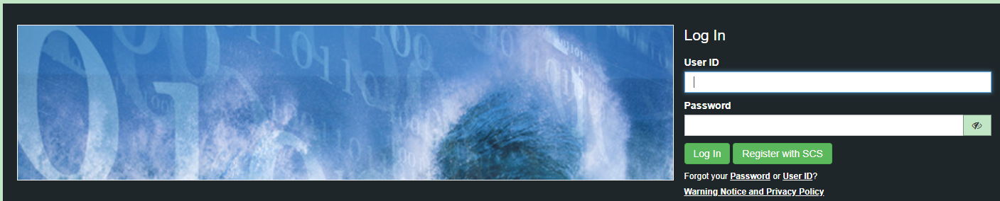

Select Services.

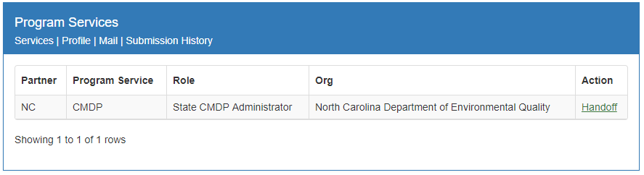

Select Add Program Service.

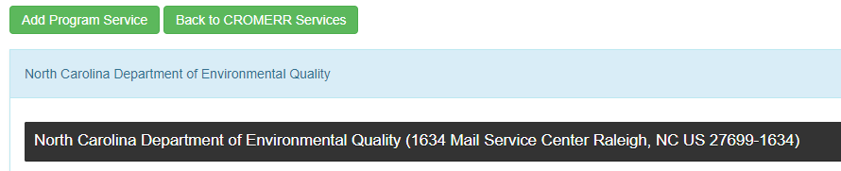

Choose North Carolina Department of Environmental Quality as your Partner.

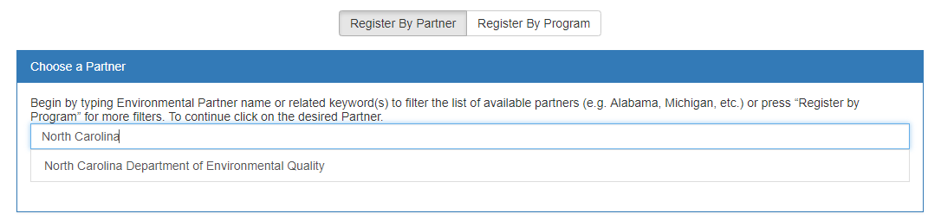

Choose CMDP: Complaince Monitoring Data Portal as your Program Service. 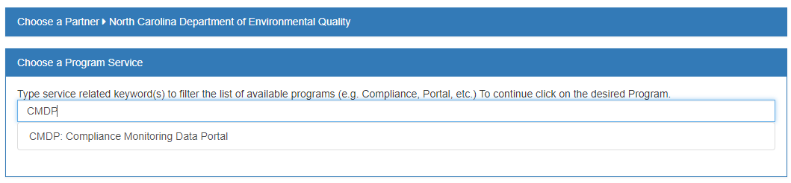

Choose Private Lab CMDP Admistrator as your Role.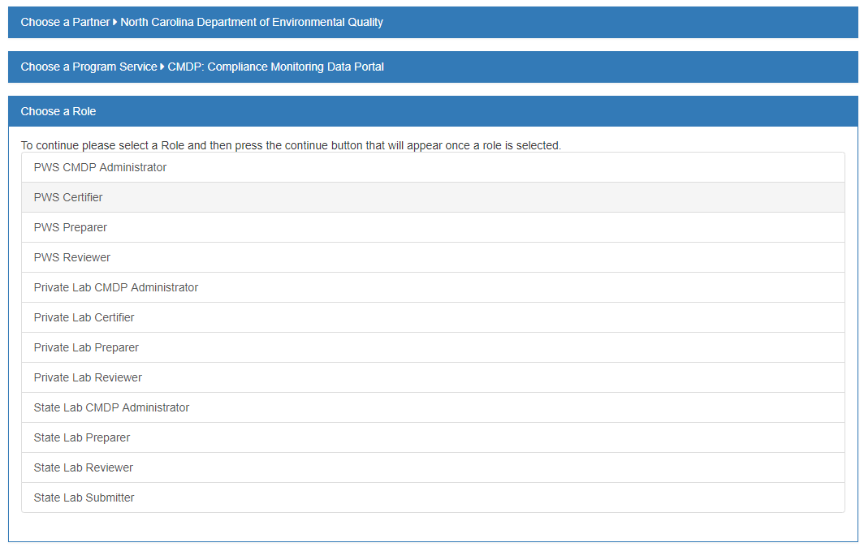

Click Continue.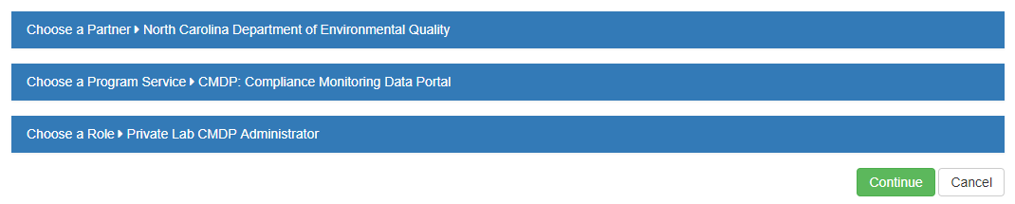

Search for your organization by typing in your 5-digit lab ID number.

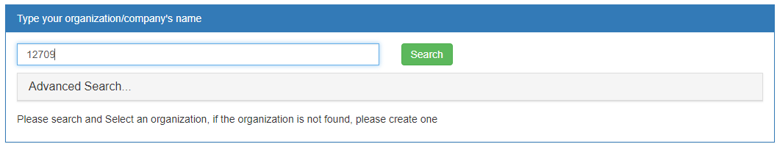

Click the Organization Name.

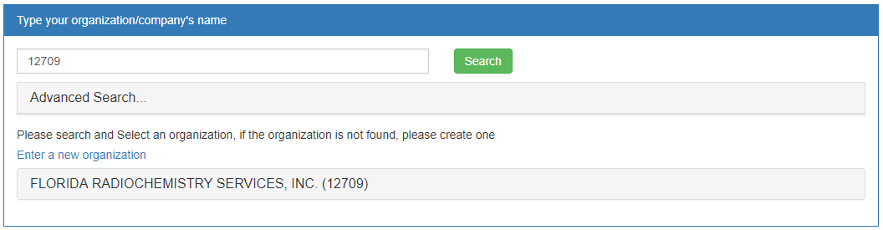

Click the address to fill out your contact information.   
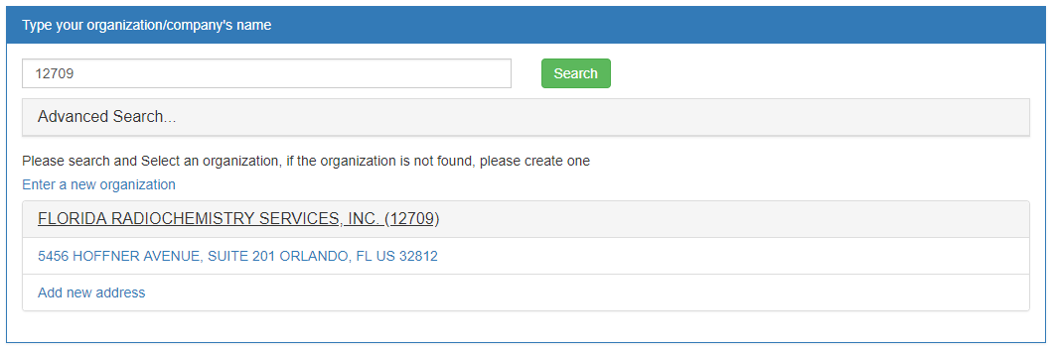

Fill out the contact Information and Click Continue. 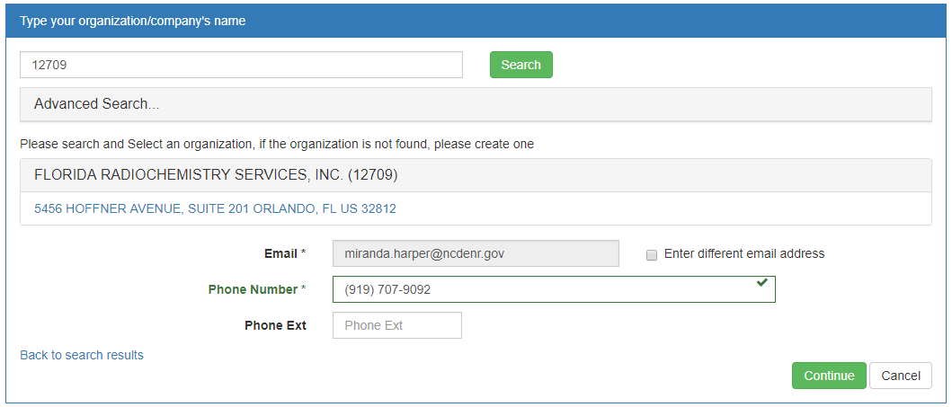

Fill out your contact information and verify the new organization with LexisNexis.

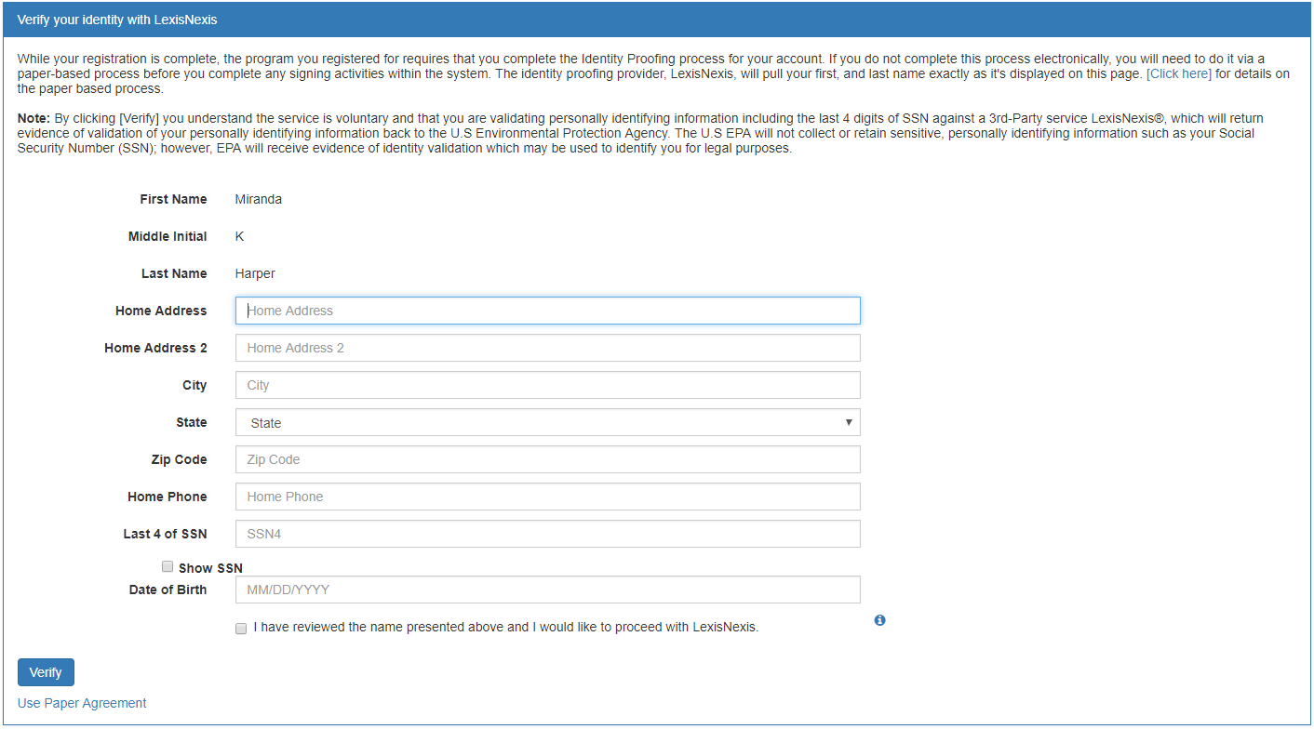

Once you have completed the electronic signature agreement with Lexis/Nexis and finished adding the new role, return to the SCS home page. Click Profile.   
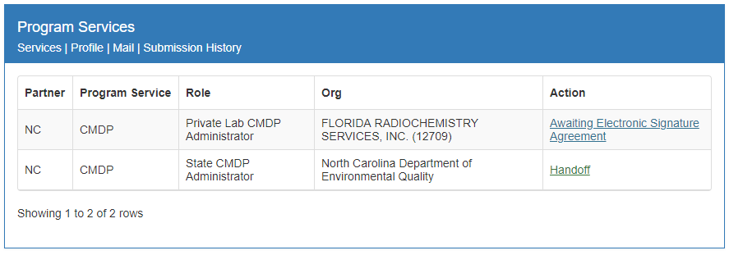

Change your primary organization by dragging the key image to the new organization.

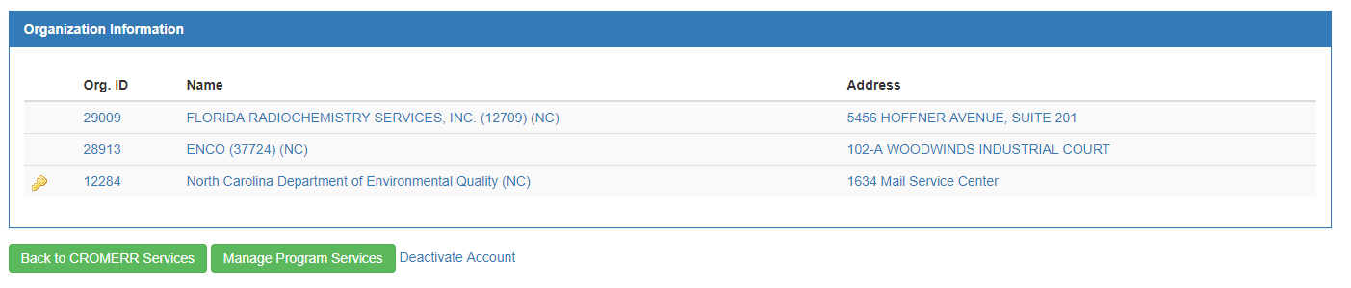

Or, click the organization you would like to be your primary and select the Make Primary option.

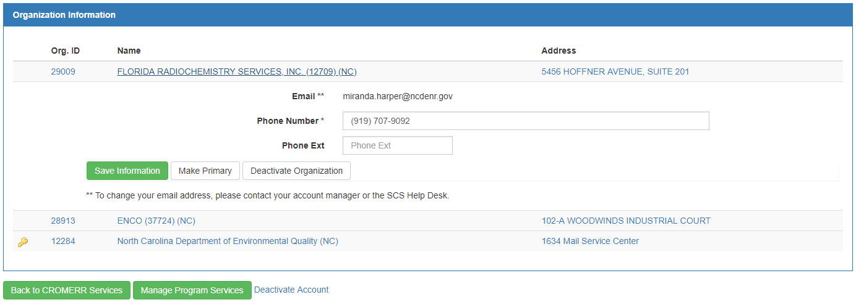

The Key icon should now be next to the organization with your 5-digit laboratory number in parenthesis.

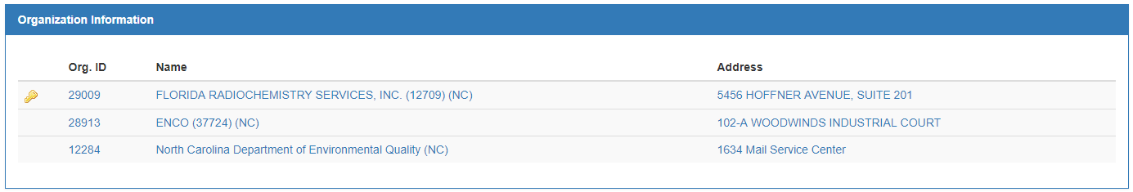

Then select your old organization name without the 5-digit lab number by clicking on the organization name. Deactivate this organization selecting the option Deactivate Organization.

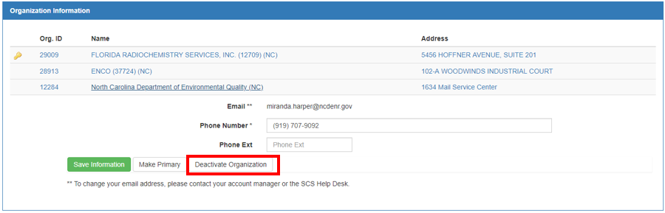

Once the organization with your 5-digit lab number has been made primary and the other organization is deactivated, your SCS account will have permission to upload sample data to CMDP.

The deactivated organization, however, cannot be deleted and will remain with your list of organizations.

**If you have any questions, contact Miranda Harper at (919) 707-9092 or miranda.harper@ncdenr.gov**