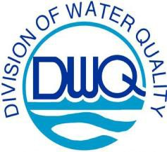

February 14, 2008
Michael F. Easley, Governor
William G. Ross Jr., Secretary North Carolina Department of Environment and Natural Resources

Coleen H. Sullins, Director Division of Water Quality

NPDES Stormwater Permit Owner/Operator

Subject: NPDES Stormwater Permit
Sampling and Certification Requirements -

Correction and Clarification

Dear Stormwater Permittee:

You may have received correspondence in the past about whether stormwater samples must be analyzed by a certified lab. If you are covered under a General Permit that was renewed in 2007, the information in our issuance letter and previous Technical Bulletins may have misguided you about how certification rules apply to stormwater sampling and results. We are sending this letter to correct our misunderstanding of the rules and provide more accurate direction to you on this issue. We have also posted this information on our website (http://h2o.enr.state.nc.us/su/Forms_Documents.htm#stormwaterGP) and in various revised stormwater General Permit Technical Bulletins.
In the fall of 2007, DWQ received a request for clarification of certification requirements during the public comment period of draft renewal stormwater General Permits NCG030000, NCG060000, NCG080000, NCG090000, NCG100000, and NCG120000. In the final issuance letter for those permits, we advised permittees that all analytical results (including pH, which must be measured within 15 minutes) must adhere to the certification requirements in T15A NCAC 2H .0800, as administered by DWQ’s Laboratory Section Certification Branch.

While that is true for wastewater discharges originating from Water Pollution Control Systems defined under T15A NCAC 8G
.0300, North Carolina certification procedures do not apply to stormwater-only discharges at this time. However, any monitoring of discharges under an NPDES permit (including stormwater) must be conducted in accordance to test procedures approved under federal regulations in 40 CFR §136. All labs certified by North Carolina perform analyses in accordance with those procedures.
So, even if your facility is not a classified Water Pollution Control System (which handles wastewater and not stormwater), any data gathered under an NPDES permit must conform to federal requirements. This includes measuring pH properly within the 15-minute hold time. Using a North Carolina certified lab is often the easiest way to comply with NPDES Program requirements. A list of North Carolina certified labs can be found on-line at: http://h2o.enr.state.nc.us/lab/cert.htm.

Information on labs certified to measure field parameters (such as pH) and technical guidance on field pH measurement can also be found at that website (see the downloads section). The alternative to using a certified lab is to adequately train personnel to perform analyses and use equipment in accordance with the same standards.

Please be sure to share this information with the employees responsible for stormwater management and NPDES permit compliance at your facility. If you have any questions regarding this information please contact a staff member of the Central Office Stormwater Permitting Unit at (919) 733-5083.

Sincerely,
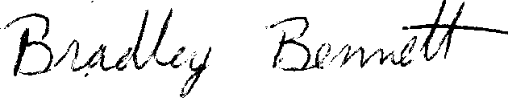

Bradley Bennett,
Stormwater Permitting Unit Supervisor
cc: DWQ Central Files
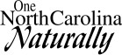
Stormwater Permitting Unit General Permit Files

North Carolina Division of Water Quality 1617 Mail Service Center | Raleigh, NC 27699-1617 | Phone (919) 733-7015 | Customer Service
Internet: h2o.enr.state.nc.us/su/stormwater.html 512 N. Salisbury St. | Raleigh, NC 27604 | FAX (919) 733-9612 | 1-877-623-6748
An Equal Opportunity/Affirmative Action Employer – 50% Recycled/10% Post Consumer Paper

