North Carolina Department of Environmental Quality – Division of Water Resources

NOTIFICATION TO CONSTRUCT THERMAL CONDUCTIVITY TEST WELLS

Thermal conductivity test wells are used to determine the amount of heat that the subsurface may transmit in a given depth interval for the purpose of designing geothermal heating and cooling systems.

Pursuant to 15A NCAC 02C .0230, thermal conductivity test wells shall be subject to the regulatory requirements applicable to geothermal aqueous or direct expansion closed-loop wells designed to serve single family residences.

These wells are “permitted by rule” and do not require an individual permit when constructed in accordance with the rules of 15A NCAC 02C .0200.
This notice must be submitted at least two (2) business days prior to construction.

Print Clearly or Type Information. Illegible Submittals Will Be Returned As Incomplete.

DATE: , 20____ PERMIT NO. ____________________(to be completed by DWR)

A. TYPE OF THERMAL CONDUCTIVITY TEST WELL TO BE CONSTRUCTED

(1) Aqueous (as per 15A NCAC 02C .0222): Number of wells:
(2) Direct Expansion (as per 15A NCAC 02C .0223) Number of wells:

B. STATUS OF WELL OWNER (choose one)

(1) Single Family Residence _____
(2) Business/Organization ______
(3) Government: State ____ Municipal ____ County ____ Federal ____

C. WELL OWNER(S) – For single family residences, list all persons listed on the property deed. For all others, list name of Business/Governmental Agency and name of person and title with delegated authority to sign:

Mailing Address:
City: State: ____ Zip Code: County:
Day Tele No.: Cell No.:
EMAIL Address: Fax No.:

D. PHYSICAL LOCATION OF WELL SITE

(1) Parcel Identification Number (PIN) of well site:
(2) Physical Address (if different than mailing address):
City: County Zip Code:
(3) Latitude (decimal degrees): _________________________(can be obtained on Google Maps or Earth)
Longitude (decimal degrees): _______________________(can be obtained on Google Maps or Earth)

E. MAPS, PLANS, AND SPECIFICATIONS

(1) Maps must be scaled or otherwise accurately indicate distances and orientations of features located within 250 feet of the injection well(s). Label all features clearly and include a north arrow. Attach a site-specific map showing the locations of the following:

- Proposed injection well locations
- Buildings
- Property boundaries
- Surface water bodies
- Water supply wells
- Septic systems and associated spray irrigation sites, drain fields, or repair areas

- Existing or potential sources of groundwater contamination

(2) Plans and specifications of the surface and subsurface construction details of the well system.

F. TYPES AND CONCENTRATIONS OF ADDITIVES – List any additives that will be used and their concentrations. Only additives that the Department of Health and Human Services’ Division of Public Health determines do not adversely affect human health shall be used. A list of approved additives can be found online at http://deq.nc.gov/about/divisions/water-resources/water-quality-regional-operations/groundwater-protection . All other additives require approval prior to use.

G. WELL DRILLER INFORMATION (if known)

Well Drilling Contractor’s Name:
NC Well Drilling Contractor Certification No.:
Company Name: Contact Person:
City: State: ____ Zip Code: County:
Day Tele No.: Cell No.:
EMAIL Address: Fax No.:

H. HEAT PUMP CONTRACTOR INFORMATION

Company Name:
Contact Person: EMAIL Address:
Address:
City: Zip Code: State: County:
Office Tele No.: ____________________ Cell No.: ______________________ Fax No.:

I. PROTECTION – Provide a brief description of how (1) water supply wells; (2) surface water bodies; and (3) septic systems and associated spray irrigation sites, drain fields, or repair areas within 250 feet of the proposed injection wells will be protected during construction of the wells:

J. VARIANCE – Pursuant to 15A NCAC 02C .0241 the Director of the Division of Water Resources may grant a variance from applicable well construction or operation standards provided that:
(1) use of the well(s) will not endanger human health and welfare or the groundwater; and
(2) that construction or operation in accordance with the standards is not technically feasible or the proposed construction provides equal or better protection of the groundwater.
Any variance request should accompany submittal of this notification to expedite evaluation of the request. The variance request form can be accessed online at http://deq.nc.gov/about/divisions/water-resources/water-quality-regional-operations/groundwater-protection

K. SIGNATURES – The following section is to be completed as required below or by that person’s authorized agent. 15A NCAC 02C .0211(e) requires signatures as follows:

(a) for a corporation: by a responsible corporate officer;
(b) for a partnership or sole proprietorship: by a general partner or the proprietor, respectively;
(c) for a municipality or a state, federal, or other public agency: by either a principal executive officer or ranking publicly elected official;
(d) for all others: by the well owner;
(e) for any other person authorized to act on behalf of the applicant: documentation shall be submitted with the notification that clearly identifies the person, grants them signature authority, and is signed and dated by the applicant.

“I hereby certify, under penalty of law, that I have personally examined and am familiar with the information submitted in this document and all attachments thereto and that, based on my inquiry of those individuals immediately responsible for obtaining said information, I believe that the information is true, accurate and complete. I am aware that there are significant penalties, including the possibility of fines and imprisonment, for submitting false information. I agree to construct, operate, maintain, repair, and if applicable, abandon the injection well and all related appurtenances in accordance with the 15A NCAC 02C 0200 Rules.”

Signature of Property Owner/Applicant

Print or Type Full Name

Signature of Authorized Agent, if applicable (if signing on behalf of Owner, provide letter or email authorization)

Print or Type Full Name and Title

L. SUBMITTAL INSTRUCTIONS – Submit one copy of the completed notification form to the following:

(1) The Division of Water Resources (DWR) Regional Office - Water Quality Regional Operation Section Supervisor serving the area in which the injection well facility will be located:
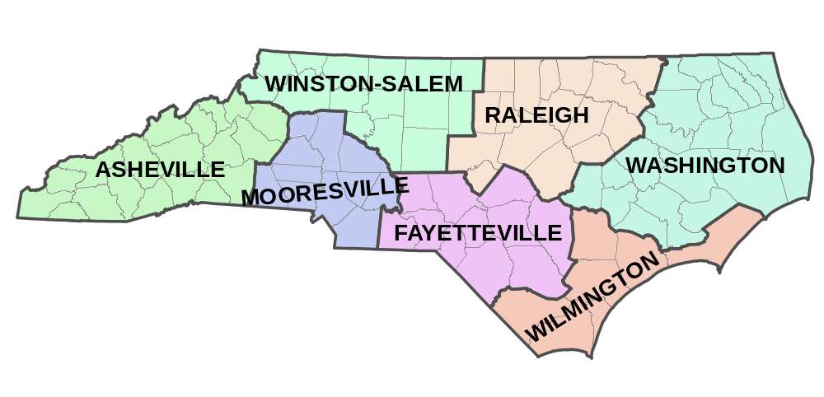

Asheville Regional Office
2090 U.S. Highway 70
Swannanoa, NC 28778
Telephone: (828) 296-4500
Fax: (828) 299-7043

Fayetteville Regional Office
225 Green Street, Suite 714
Fayetteville, NC 28301-5043
Telephone: (910) 433-3300
Fax: (910) 486-0707

Mooresville Regional Office
610 East Center Avenue, Suite 301
Mooresville, NC 28115
Telephone: (704) 663-1699
Fax: (704) 663-6040

Raleigh Regional Office
1628 Mail Service Center
Raleigh, NC 27699-1628
Telephone: (919) 791-4200
Fax: (919) 571-4718

Washington Regional Office
943 Washington Square Mall
Washington, NC 27889
Telephone: (252) 946-6481
Fax: (252) 975-3716

Wilmington Regional Office
127 Cardinal Drive Extension
Wilmington, NC 28405
Telephone: (910) 796-7215
Fax: (910) 350-2004

Winston-Salem Regional Office
450 W. Hanes Mill Rd., Suite 300
Winston-Salem, NC 27105
Phone: (336) 776-9800
Fax: (336) 776-9797

AND

(2) County Environmental Health Department in which the injection well facility will be located.

