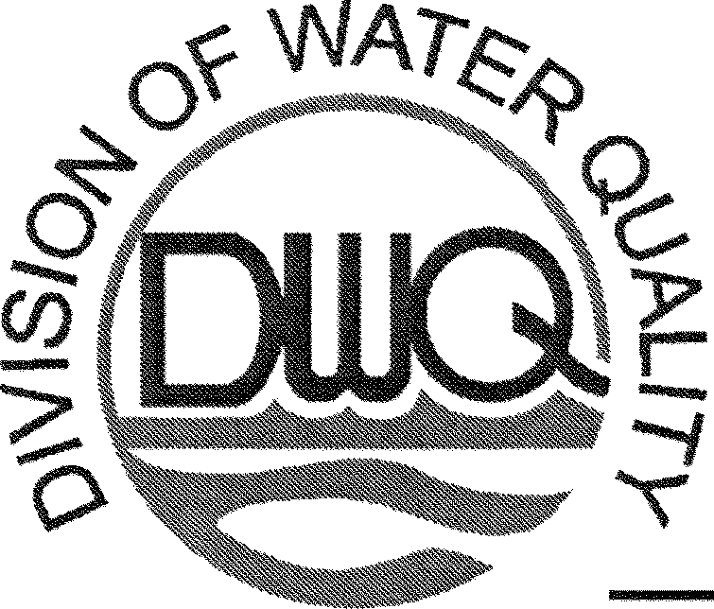
Michael F. Easley, Governor State of North Carolina
William G. Ross, Jr., Secretary Department of Environment and Natural Resources
Coleen H. Sullins, Director Division of Water Quality
May 1, 2008

To: Subject:
NPDES Permittees
Total Residual Chlorine 50 ug/1 Compliance Level

In a previous letter dated August 14, 2001, the Division of Water Quality (DWQ) notified NPDES permittees that water/wastewater treatment facilities with Total Residual Chlorine (TRC) effluent limits would be required to use analytical methods that produce detection levels below their permit limit by July 1, 2002. [Note: TRC permit limits are typically set between 17 to 28 ug/1 for discharge to freshwater systems, and 13 ug/1 for discharge to saltwater systems]. This requirement was based on an Environmental Protection Agency (EPA) audit of the NC enforcement program. It was also necessary to ensure water quality protection and compliance with state monitoring regulations [ISA NCAC 2B.0505(e)(4)].

Since that time, DWQ has received several inquiries regarding difficulties with the new analytical methods, primarily focused on 1) lack of precision with field instrumentation at low TRC levels for both water and wastewater treatment plants; and 2) manganese interference with TRC measurement at several water treatment plants. Some facilities have overcome these problems through various changes, such as: 1) switching dechlorination chemicals; 2) adding a second dechlorination feed; 3) changing analytical methods; 4) incorporating manganese correction; 5) switching to UV disinfection; 6) removing sludge from water treatment plant settling basins. Also, the DWQ Laboratory Certification staff have provided extensive field assistance for the new lab methods. Still, some analytical issues remain. In response to the permittee's concerns, the Division is providing the following changes to its TRC requirements:
□ TRC Compliance Level Changed to 50 ug/1. DWQ continued discussions with EPA regarding analytical difficulties with TRC measurements, and in March 2008 received EPA approval to allow a 50 ug/1 TRC compliance level. This will not change the analysis, annual verification of meter performance, or data reporting, but simply how the reported values will be evaluated by DWQ from a compliance standpoint. Facilities will still be required to report actual results on their monthly DMR submittals, but for compliance purposes all TRC values below 50 ug/1 will be treated as zero. For example, if the facility has a TRC limit of 17 ug/1 and reports a TRC value of 40 ug/1 on the DMR, this value will be considered compliant under this new policy. This new compliance level is effective March 1, 2008 (beginning with March 2008 DMR submittals).

DWQ will continue to incorporate TRC effluent limitations into NPDES permits for all water/wastewater treatment facilities that discharge chlorine-bearing wastestreams to surface waters. While this new TRC compliance level of 50 ug/1 is effective beginning March 1, 2008, it will be incorporated into existing NPDES permits with TRC effluent limits upon permit renewal. At that time, the following TRC footnote language will added to the Effluent Limitations Sheet: "The facility shall report all effluent TRC values reported by a NC certified laboratory including field certified. However, effluent values below 50 ug/1 will be treated as zero for compliance purposes."
;vatural/11

Page 2 of2
May 1, 2008
TRC 50 ug/1 Compliance Memo

DWQ reserves the right to modify this policy in the future as analytical methods evolve. If you have questions about the content of this letter, please contact Tom Belnick at (919) 733-5083, extension 543. If you need assistance with your TRC analytical methodology, please contact Gary Francies with the DWQ Water Quality Lab at (828) 296-4677
Sincerely,

Matt Matthews, Supervisor Point Source Branch .

