Instructions to access electronic files for DuPont Brevard site

Click this link to go to the DWM webpage to search correspondence for the DuPont Brevard site
http://edocs.deq.nc.gov/WasteManagement/Search.aspx?cr=1

On the left side of the webpage you will see this:
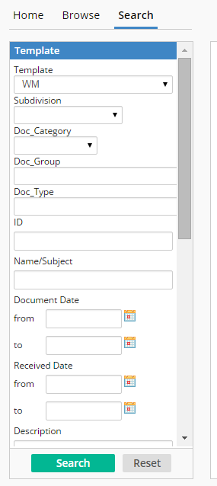

In the block under ID type the following: NCD003152329
Then click “Search”

You should now see all the documents related to the DuPont Brevard site. Just click on any document to open.

You can sort the documents by date. Scroll to the right until you get to the column heading “Document Date”. Click this heading block to sort the documents by date.

