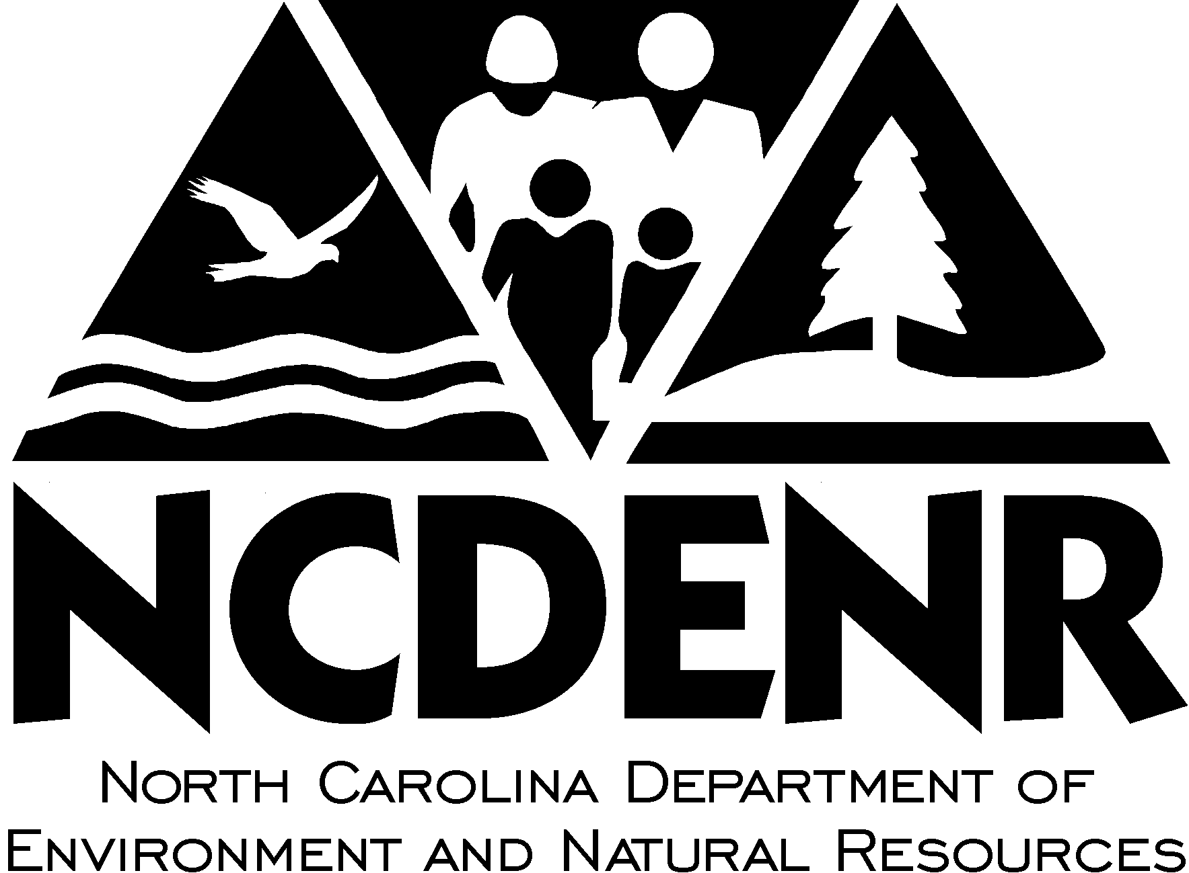  UST-26 |  | EMERGENCY RESPONSE OPERATOR TRAINING LOG
- This form must be utilized to document that all emergency response operators at this facility are trained according to North Carolina’s UST Operator Training Plan.
- Emergency response operators must be trained by this facility’s primary operator(s) using the training materials provided by the Department.
- Emergency response operators must be trained prior to assuming responsibility for responding to emergencies or alarms.
- This form must be kept at the facility and made available at the time of inspection.
UST OWNER |  |  | UST FACILITY
Owner Name |  |  | Facility Name |  | Facility ID#:
Street Address |  |  | Street Address
City |  | State | City |  |  | County
TRAINING DOCUMENTATION
By signing this log I (emergency response operator) certify that I have been trained by this facility’s primary operator (signed below) and that I have located and understand how to operate the following components and respond to an emergency:
- All emergency shutoffs
- Fire extinguishers
- Emergency phone numbers list
- Spill kit
- Tank monitor alarms and warnings (if applicable)
DATE: | EMERGENCY RESPONSE OPERATOR: |  |  | TRAINED BY PRIMARY OPERATOR:
 | PRINTED NAME: |  |  | PRINTED NAME:
 | SIGNATURE: |  |  | SIGNATURE:
 | PRINTED NAME: |  |  | PRINTED NAME:
 | SIGNATURE: |  |  | SIGNATURE:
 | PRINTED NAME: |  |  | PRINTED NAME:
 | SIGNATURE: |  |  | SIGNATURE:
 | PRINTED NAME: |  |  | PRINTED NAME:
 | SIGNATURE: |  |  | SIGNATURE:
 | PRINTED NAME: |  |  | PRINTED NAME:
 | SIGNATURE: |  |  | SIGNATURE:
 | PRINTED NAME: |  |  | PRINTED NAME:
 | SIGNATURE: |  |  | SIGNATURE:
 | PRINTED NAME: |  |  | PRINTED NAME:
 | SIGNATURE: |  |  | SIGNATURE:
NORTH CAROLINA DEPARTMENT OF ENVIRONMENT AND NATURAL RESOURCES, DIVISION OF WASTE MANAGEMENT, UST SECTION
1637 MAIL SERVICE CENTER, RALEIGH, NC 27699-1637 PHONE (919) 707-8171 FAX (984) 236-8310 http://www.wastenotnc.org/
03/2026

UST-26 |  | EMERGENCY RESPONSE OPERATOR TRAINING LOG |  | Page 2 of 2
DATE: | EMERGENCY RESPONSE OPERATOR: |  | TRAINED BY PRIMARY OPERATOR:
 | PRINTED NAME: |  | PRINTED NAME:
 | SIGNATURE: |  | SIGNATURE:
 | PRINTED NAME: |  | PRINTED NAME:
 | SIGNATURE: |  | SIGNATURE:
 | PRINTED NAME: |  | PRINTED NAME:
 | SIGNATURE: |  | SIGNATURE:
 | PRINTED NAME: |  | PRINTED NAME:
 | SIGNATURE: |  | SIGNATURE:
 | PRINTED NAME: |  | PRINTED NAME:
 | SIGNATURE: |  | SIGNATURE:
 | PRINTED NAME: |  | PRINTED NAME:
 | SIGNATURE: |  | SIGNATURE:
 | PRINTED NAME: |  | PRINTED NAME:
 | SIGNATURE: |  | SIGNATURE:
 | PRINTED NAME: |  | PRINTED NAME:
 | SIGNATURE: |  | SIGNATURE:
 | PRINTED NAME: |  | PRINTED NAME:
 | SIGNATURE: |  | SIGNATURE:
 | PRINTED NAME: |  | PRINTED NAME:
 | SIGNATURE: |  | SIGNATURE:
 | PRINTED NAME: |  | PRINTED NAME:
 | SIGNATURE: |  | SIGNATURE:
NORTH CAROLINA DEPARTMENT OF ENVIRONMENT AND NATURAL RESOURCES, DIVISION OF WASTE MANAGEMENT, UST SECTION
1637 MAIL SERVICE CENTER, RALEIGH, NC 27699-1637 PHONE (919) 707-8171 FAX (919) 715-1117 http://portal.ncdenr.org/group/wm/ 12/11

