 | North Carolina Department of Environmental Quality | 
 | Division of Water Infrastructure
 | Fall 2025 Application for Funding
 | (Last updated July 2025)

Low-interest loans, principal forgiveness (PF), and grants from the State Reserve Program (SRP), Viable Utilities Reserve (VUR), Community Development Block Grant – Infrastructure (CDBG-I), Drinking Water State Revolving Fund (DWSRF) and the Clean Water State Revolving Fund (CWSRF) are available for construction projects in the Fall 2025 funding round. Planning grants from the Asset Inventory and Assessment (AIA) and Merger / Regionalization Feasibility (MRF) study programs are also available in the Fall 2025 funding round. Principal forgiveness (PF) for construction projects from the Infrastructure Investment and Jobs Act (IIJA) DWSRF Emerging Contaminants (DWSRF-EC-C) funds and IIJA Clean Water State Revolving Fund (CWSRF-EC-C) are available for projects addressing PFAS contamination in drinking water and wastewater . Note: Funding for DWSRF-EC and CWSRF-EC study projects is now available on a rolling basis. A separate application for these projects is available on the Application Forms and Additional Resources page of the website. Low-interest CWSRF loans are available for green projects such as stormwater quality infrastructure, stream restoration, reclaimed water, or energy efficiency projects.
Complete this Application for Funding form and submit it along with required additional forms and documents to the Division of Water Infrastructure for consideration.
Note: there is a different application form for Lead Service Line Inventorying and Replacement funding, EC study funding, Decentralized Wastewater Treatment Systems (DWTS) Pilot Program, and State Revolving Fund Supplemental Appropriations for Hurricanes Helene and Milton and the Hawai’i Wildfires (SA-HMW).
Fall 2025 applications are due Tuesday, September 30, at 5:00pm.

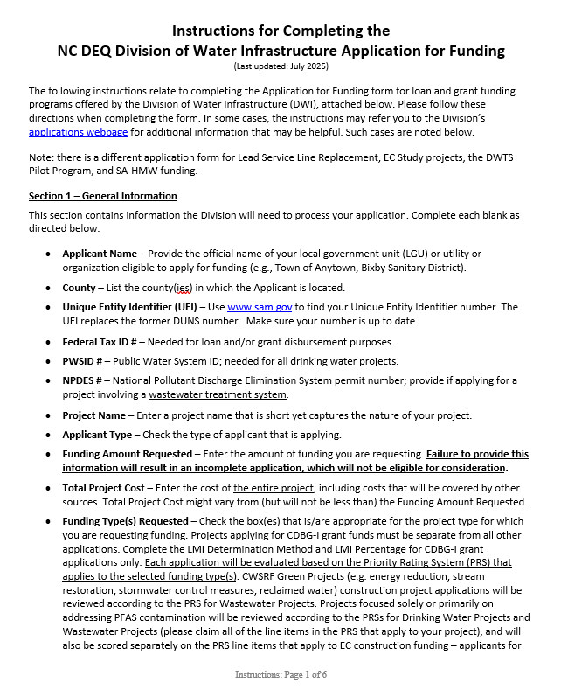 |  | 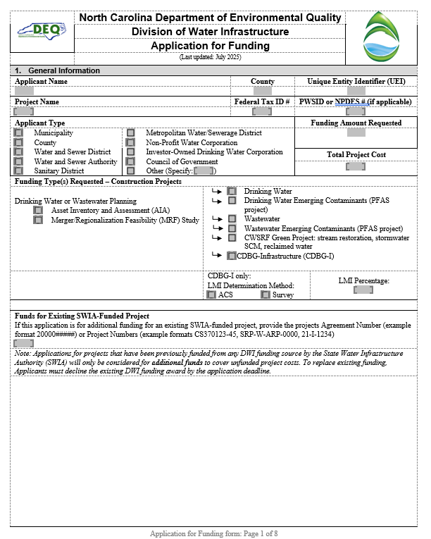
Instructions are enclosed. |  | Application form is attached after the Instructions.  Additional forms required for completing an application are available on the Division of Water Infrastructure’s application page.

(This page intentionally left blank)

Instructions for Completing the
NC DEQ Division of Water Infrastructure Application for Funding
(Last updated: July 2025)
The following instructions relate to completing the Application for Funding form for loan and grant funding programs offered by the Division of Water Infrastructure (DWI), attached below. Please follow these directions when completing the form. In some cases, the instructions may refer you to the Division’s applications webpage for additional information that may be helpful. Such cases are noted below.
Note: there is a different application form for Lead Service Line Replacement, EC Study projects, the DWTS Pilot Program, and SA-HMW funding.
Section 1 – General Information
This section contains information the Division will need to process your application. Complete each blank as directed below.
- Applicant Name – Provide the official name of your local government unit (LGU) or utility or organization eligible to apply for funding (e.g., Town of Anytown, Bixby Sanitary District).
- County – List the county(ies) in which the Applicant is located.
- Unique Entity Identifier (UEI) – Use www.sam.gov to find your Unique Entity Identifier number. The UEI replaces the former DUNS number. Make sure your number is up to date.
- Federal Tax ID # – Needed for loan and/or grant disbursement purposes.
- PWSID # – Public Water System ID; needed for all drinking water projects.
- NPDES # – National Pollutant Discharge Elimination System permit number; provide if applying for a project involving a wastewater treatment system.
- Project Name – Enter a project name that is short yet captures the nature of your project.
- Applicant Type – Check the type of applicant that is applying.
- Funding Amount Requested – Enter the amount of funding you are requesting. Failure to provide this information will result in an incomplete application, which will not be eligible for consideration.
- Total Project Cost – Enter the cost of the entire project, including costs that will be covered by other sources. Total Project Cost might vary from (but will not be less than) the Funding Amount Requested.
- Funding Type(s) Requested – Check the box(es) that is/are appropriate for the project type for which you are requesting funding. Projects applying for CDBG-I grant funds must be separate from all other applications. Complete the LMI Determination Method and LMI Percentage for CDBG-I grant applications only. Each application will be evaluated based on the Priority Rating System (PRS) that applies to the selected funding type(s). CWSRF Green Projects (e.g. energy reduction, stream restoration, stormwater control measures, reclaimed water) construction project applications will be reviewed according to the PRS for Wastewater Projects. Projects focused solely or primarily on addressing PFAS contamination will be reviewed according to the PRSs for Drinking Water Projects and Wastewater Projects (please claim all of the line items in the PRS that apply to your project), and will also be scored separately on the PRS line items that apply to EC construction funding – applicants for PFAS projects need only apply once and claim all line items in the full PRS that applies. Please see the drinking water/wastewater construction guidance for more information.
- Application for Existing Project – There may be situations when an Applicant is applying for more funds for a current, ongoing project. If this is the case, please list the Agreement Number or Project Numbers so that DWI staff can match the application to the appropriate project. Note: Applications for projects that have been previously funded from any DWI funding source by the State Water Infrastructure Authority (SWIA) will only be considered for additional funds to cover unfunded project costs. To replace existing funding, Applicants must decline the existing DWI funding award by the application deadline.
- Acceptance of Funding Offer (for construction projects only) – There are limited grants and PF funds available each round. Projects are eligible for grant/PF up to a percentage of the funding award, based on the results of the Affordability Calculator that is part of the funding application (available on DWI’s application page), or based on the type of project. Grant/PF is also limited by caps for each funding program as follows:
  - $500,000 PF in State Revolving Funds for most types of drinking water and wastewater construction projects. Additional $500,000 increments (up to the applicant’s percentage eligibility) may be provided if additional PF funds are available in a funding round, but it is not possible to tell during the application stage whether any or how much additional PF above the initial $500,000 may be available to selected projects;
  - $5 million in DWSRF-EC-C funds for drinking water construction projects addressing PFAS.
  - No cap in the CWSRF-EC-C funds for wastewater construction projects addressing PFAS

Due to the limited PF funds available, it is common for projects to be eligible for a funding offer, but for the funding package to not meet the financial needs of the applicant. The Division does not wish to award PF funds to projects when the funding package is not sufficient to meet the financial needs of the project. This practice can put an applicant in a position to decline a funding offer that does not meet their project needs, and it ties up a portion of the limited PF funds that could be award to other eligible projects. The questions in this section of the application are used by DWI to identify projects for which a funding offer would not meet the minimum requested PF amount and bypass those projects for funding.

The first question asks if the Applicant is willing to accept a low-interest loan with no PF. Selecting “Yes” does not limit the project eligibility for PF, nor will it limit the amount of PF offered if the project has sufficient priority to be awarded PF. If you select “Yes” and the project has sufficient priority for funding and PF is available, the maximum PF that the project is eligible for will be offered. If you select “No”, continue to the second question.

The second question asks the Applicant to specify the minimum amount of PF that is needed for the project to move forward. If the project is not eligible for the minimum PF indicated in the application, or if there is insufficient PF available to be offered to meet your requested minimum PF, no funding offer (loan or grant) will be made. Keep in mind that PF is limited based on the caps listed above and on the Applicant’s eligibility.

Section 2 – Drinking Water and Wastewater System Parameters (not applicable for stormwater projects)
This section contains information related to drinking water and wastewater system parameters, which are used across all programs. Please complete all blanks unless otherwise noted.
- Residential and Non-Residential Sewer and Water Connections – Follow the guidance found in Line Item 4.A of the Priority Rating System Guidance and Form for Division of Water Infrastructure Construction Funding Programs (Guidance, available on the Division’s application page). For wastewater applications, count only sewer connections. For drinking water applications, count only drinking water connections. Include only existing connections; do not include number of new connections resulting from the project.
- Monthly Sewer and Water Bills for 5,000 gallons – If your system offers both water and sewer service, provide the monthly bills for 5,000 gallons of use for sewer and water, each. These rates are (1) used to calculate Line Item 3.B operating ratio eligibility via rates to median household income; (2) used to determine points in Line Item 4.B; and (3) used to determine PF eligibility for some funding programs. See Line Item 4.B in the Guidance for more information about what is needed for this parameter.
- Service Population – Enter the number of individuals the utility serves directly, excluding wholesale customers. If your utility is primarily or solely a wholesale provider, please type “Wholesaler”.
Sections 3, 4, and 5 – Applicant, Application Preparer, and Engineer Contact Information
Complete this section with all pertinent information. The following bullet points contain specific information.
- Authorized Representative Name – This name must be either: (1) the top elected official (e.g., Mayor, Chair of the Board), (2) the top administrative official (e.g., Town Manager, Town Administrator, County Manager, CEO), or (3) must match the name listed on the Resolution by Governing Body of Applicant as the Authorized Representative. The Resolution by Governing Body authorizing filing of the application must be submitted as part of the application package. The top elected official, top administrative official, or Authorized Representative must be the person to sign the application.
- Mailing Address of the Applicant – Provide the mailing address where the Applicant receives mail. For example, if the Applicant has a PO Box, provide this information rather than the physical address.
- Application Preparer Contact Information – For the Application Preparer, provide the following: Preparer’s firm name, contact name, phone number, and email address.
- Engineer Contact Information – If your Application Preparer is the same as the Engineer Contact, check the “No” box. Section 5 may then be left blank. If the answer is “Yes”, provide the engineer’s firm name, contact name, phone number, and email address.
Note: Zip codes between PO Boxes and physical addresses may vary. If using a PO Box to receive mail, use the zip code that matches the PO Box.
Section 6 – Project Description
In this section, provide a brief description of the proposed project in a broad level of detail. Include the project purpose and what the project entails. For example: rehabilitation of approximately 2,000 linear feet (lf) of sewer, construction of a new well, stream restoration, construction of a new stormwater control measure, connecting 104 residences in a disadvantaged area to the water system along Orchard St., etc. Include information such as types of equipment to be included, capacity of equipment, estimates of line length, street names for sewer or waterline work, and/or neighborhoods or areas where work will occur, or benefits will accrue. Descriptions of the work related to the major line items in the Project Budget (Sections 8a – 8b) must be included in the project description. For example, if approximately 2,000 lf of 4-inch, 3,000 lf of 6-inch, 4,000 lf of 8-inch pipe, are listed in the project budget, they must be listed in the project description.
For projects rehabilitating and replacing infrastructure, we recommend that if you intend to utilize all funds requested to maximize the rehabilitation and replacement work while still meeting the project purpose discussed in the project description, use approximate linear footage or other measurements and clearly identify the project areas in which the work will occur.
For construction projects that address PFAS contamination, the project description must clearly indicate that the main purpose of the project (at least 75 percent of the project cost) is to address PFAS contamination.
If your drinking water construction, wastewater construction, or EC (PFAS) construction project will add new connections to the water and/or wastewater system (or to a new system or to a decentralized system owned, operated, and maintained by the public utility), please estimate the number of new connections in this section. For drinking water or wastewater projects that provide new public water or wastewater service to disadvantaged areas or to projects that create new public water systems to address PFAS contamination, provide the number of affected customers that will be incorporated into the new or existing public water system.
If 50 percent or more of the project cost will directly benefit one or more disadvantaged areas (see the Guidance for drinking water/wastewater construction projects for Line Item 4.C.4), please check the box. Identify the disadvantaged areas and their direct benefits from the project in the project description. Indicate in the project budget and the narrative the costs associated with the direct benefit to the disadvantaged areas.
For drinking water, wastewater construction, EC construction, or CWSRF Green Projects: check the appropriate box(es) if the project is a result of a study grant (Asset Inventory and Assessment grant and/or Merger/Regionalization Feasibility grant) previously awarded by SWIA or if it is a study grant that is a continuation of a previous AIA or MRF grant. If neither is the case, check None of the Above.
Section 7 – Additional Information for Consideration
In some situations, a construction project’s purpose might not be listed as eligible for points under Category 1 – Project Purpose of the relevant construction project’s PRS. In these situations, you may use the Supplemental Guidance for the Ranking of Applications and Providing Additional Information for Consideration found on the Division’s application page. Please note the following related to this section:
- This section does not apply to funds awarded from the DWSRF program.
- Information for this section must fit into the space provided.
Section 8a – Project Budget for All Construction Projects and Emerging Contaminants (PFAS)
Complete Section 8 for all construction projects.
Complete the project budget by addressing the categories provided in the table (insert rows as needed). Total the cost amount for each line and provide the total cost amount. Please note the following related to this section:
- The project budget is required.
- Include the pre-construction planning costs in the budget. Final design and permitting costs are eligible as pre-construction costs.
- Note the instructions at the top of Section 8 about separating costs and labeling them to show portions of the project costs that are attributable to certain factors, such as cost components for disadvantaged areas vs. non-disadvantaged areas, portions of the project that address PFAS contamination, and replacement/rehabilitation of older water/sewer lines vs. newer lines. This can be done by adding additional lines to the project budget (e.g.: [1] construction of 720 lf of waterline extensions in disadvantaged areas, and [2] 300 lf of waterline extensions in non-disadvantaged areas). You may also add additional rows for the sole purpose of separating and labeling costs as required at the top of Section 8.
- The project budget must be signed, dated and sealed by a properly licensed Professional Engineer (PE). If you do not provide a PE signature and seal on the budget, the application will be incomplete and not considered for funding. Note: If not using DocuSign to seal and sign the budget, put the seal/signature on the Word document or use a wet seal/signature with a scan of the wet seal/signature.
Section 8b – Project Budget for AIA and MRF Grants
Provide basic aspects of the AIA or MRF study costs. For example, if applying for an AIA grant, some budget items might include the following: (1) mapping of collection system, (2) condition assessment, and (3) grant administration. Note: AIA and MRF applications must be separate applications from each other and from construction projects.
Certification by Authorized Representative
The Authorized Representative must read and initial in the space beside each question, or use “N/A”.
Completeness Checklist
When assembling the application package, initial next to the checklist items to show that the information is in the package, if applicable. Failure to include or properly document an item marked with * will result in the application being incomplete and ineligible for consideration of funding. Forms are available separately on the Division’s application page.
Submittal Information
Applications must be submitted electronically no later than 5:00 pm on Tuesday, September 30, 2025.
- Submit the application electronically at: https://edocs.deq.nc.gov/Forms/Fall2025FundingApplication
- Follow the directions as shown on the form on the website.
- Complete the required fields, almost all of which can be found directly from this Application for Funding form.
- For construction projects addressing emerging contaminants via the IIJA SRF funds, select either Drinking Water or Wastewater.
- Upload each required document (e.g. completed Application for Funding form, Resolution by Governing Body and the Form of Certification by the Recording Officer, Narrative to Claim Points, etc.) individually; do not upload a single file with the entire application package. Individual file sizes must be limited to 250 MB.
- Uploading files may take several minutes and may be slow during high volume periods. It is strongly encouraged to submit applications several days before the application due date to avoid technical difficulties.
- Once you have submitted your application online, the applicant submitter should receive a confirmation email.
- Online submittal of the application package is sufficient for all applications.
Application Signature
Signing this application indicates the Applicant’s willingness to accept federal and state conditions. The top elected official, the top administrative official, or the Authorized Representative who is named in the Resolution by Governing Body of Applicant must sign the application.
Note: Use a scanned wet signature, or DocuSign signature if signing electronically.
An application without this signature is incomplete and will not be eligible for consideration.

 | North Carolina Department of Environmental Quality
 | Division of Water Infrastructure
 | Application for Funding
 | (Last updated: July 2025)
- General Information
Applicant Name |  |  |  |  |  |  | County |  |  | Unique Entity Identifier (UEI)
Project Name |  |  |  |  |  |  | Federal Tax ID # |  |  | PWSID or NPDES # (if applicable)
Applicant Type |  |  |  |  |  |  |  |  |  | Funding Amount Requested
Municipality  County  Water and Sewer District  Water and Sewer Authority  Sanitary District |  | Metropolitan Water/Sewerage District  Non-Profit Water Corporation  Investor-Owned Drinking Water Corporation  Council of Government  Other (Specify: )
 |  |  |  |  |  |  |  |  |  | Total Project Cost
Funding Type(s) Requested – Construction Projects
Drinking Water or Wastewater Planning  Asset Inventory and Assessment (AIA)  Merger/Regionalization Feasibility (MRF) Study |  |  |  |  | Drinking Water  Drinking Water Emerging Contaminants (PFAS project)  Wastewater  Wastewater Emerging Contaminants (PFAS project)  CWSRF Green Project: stream restoration, stormwater SCM, reclaimed water  CDBG-Infrastructure (CDBG-I)
 |  |  |  |  | CDBG-I only:  LMI Determination Method:  ACS Survey |  |  |  |  |  | LMI Percentage:
Funds for Existing SWIA-Funded Project
If this application is for additional funding for an existing SWIA-funded project, provide the projects Agreement Number (example format 20000#####) or Project Numbers (example formats CS370123-45, SRP-W-ARP-0000, 21-I-1234)

Note: Applications for projects that have been previously funded from any DWI funding source by the State Water Infrastructure Authority (SWIA) will only be considered for additional funds to cover unfunded project costs. To replace existing funding, Applicants must decline the existing DWI funding award by the application deadline.
Acceptance of Funding Offer (for Construction Projects) Please read the Instructions page for details.
Most funding available is in the form of low-interest loans. Offers of grant and principal forgiveness (PF) are based on availability and the applicant’s eligibility for grants/PF. Please indicate to the Division your willingness to accept a loan and the minimum amount of grant/PF you would accept for this project. The greatest amount of grant/PF available for your application based on eligibility and availability will be offered to your application if selected, even if you are willing to accept less.
- I am willing to accept a low-interest loan offer for the Funding Amount Requested above.
Yes (stop here) or No (answer the next question).
(Answering “Yes” does not reduce the amount of grant or PF the project will be offered if awarded. The project will be offered any grant or principal forgiveness for which it can receive based on eligibility and availability).

- I will only accept a funding offer if a minimum of $ is offered as a grant or principal forgiveness (PF). I understand that I will not be offered any funding if the minimum requested grant/PF amount cannot be offered.
(In many funding rounds projects will be limited to $500,000 in PF based on PF availability. Indicating a minimum grant/PF request above $500,000 has a higher likelihood that a potential funding offer would not meet the minimum grant/PF requested and result in the project being bypassed for funding. Applicants should indicate the lowest amount of grant/PF required.
- Drinking Water and Wastewater System Parameters (Not applicable for stormwater projects)
Residential Sewer Connections |  |  |  |  |  | Residential Water Connections
Non-Residential Sewer Connections |  |  |  |  |  | Non-Residential Water Connections
Monthly Sewer Bill for 5,000 gallons |  |  |  |  |  | Monthly Water Bill for 5,000 gallons
Service Population
Number of individuals directly served, excluding wholesale customers:
Percentage of Utility Bills Collected and Rate Increase Percentages

Year |  |  |  | Percentage of Utility Bills Collected |  |  |  |  | Rate Increase Percentage

- Applicant Contact Information (See Instructions regarding the Authorized Representative)
Authorized Representative Name:
Authorized Representative Title:
Mailing Address Line 1:
Mailing Address Line 2:
City:
State:
Zip Code:
Phone Number:
Email Address:
- Application Preparer Contact Information
Firm Name:
Contact Name:
Phone Number:
Email Address:
- Engineer Contact Information
Is the engineering firm different from the application preparer? | Yes No (skip contact information below)
Engineering Firm Name:
Contact Name:
Phone Number:
Email Address:

- Project Description (see Instructions)
Estimated number of new connections served by Drinking Water or Wastewater construction, Emerging Contaminants (PFAS):
50% or more of the project budget is to directly benefit a Disadvantaged Area. Both the Application Budget and Narrative must demonstrate that the project area includes a Disadvantaged Area and that 50% or more of the project budget directly benefits the Disadvantaged Area. See Application Guidance for Line Item 4.C.4 for details on the minimum documentation to be included in the Budget and Narrative.
For Drinking Water and Wastewater construction, Emerging Contaminants (PFAS) construction, CWSRF Green Project, and CDBG-I:
The proposed project is a result of an Asset Inventory and Assessment grant previously awarded by the Division.
The proposed project is a result of a Merger/Regionalization Feasibility Study grant previously awarded by the Division.
None of the above.

- Additional Information for Consideration

8a. Project Budget for All Construction Projects and for Emerging Contaminants Evaluation/Assessment Studies Do not use for other planning studies.
- Drinking Water/Wastewater: Costs for portions of the project that will fulfill the requirements related to rehabilitating or replacing waterlines, old infrastructure, lead service lines, or emerging contaminants (DW/WW PRS Line Items 1.C.1, 1.D.1, 1.J.1, 1.J.2, 1.J.3, or 2.B.2) must be labeled and shown separately to successfully claim points.
- All: Costs for portions of the project that will directly benefit disadvantaged areas (DW/WW PRS Line Items 1.E or 4.C.4, must be labeled and shown separately to successfully claim points.
- Add additional lines as needed.
Indicate construction costs by line item (e.g., linear feet of different-sized lines, pumps). Include a more detailed construction cost budget if needed. | Division Funding Requested | Other Secured Funding Source(s): | Total Cost Amount
Construction Costs
Contingency (10% of construction costs):
Construction Subtotal:
Engineering Costs
Engineering Design
Permitting
Land Surveying Costs
Other:
Engineering Subtotal:
Administration Costs
Planning (pre-construction costs)
Easement/Land Acquisition Costs
Engineering Report Preparation
Environmental Documentation Preparation (if applicable)
Legal Costs
Project Funding Administration (if applicable)
Other:
Administration Subtotal:
TOTAL FUNDING REQUESTED AND PROJECT COST:
A Professional Engineer seal, signature, and date for the estimate must be provided in the space to the right for the application to be considered complete.

(Note: If not using DocuSign to seal and sign the budget, put the seal/signature on the Word document or use a wet seal/signature with a scan of the wet seal/signature.)

8b. Project Budget for AIA and MRF Grants
Add additional lines as needed. Only include items that are intended to be included in the Scope of Work for the project.
Division Funding Requested
TOTAL DIVISION FUNDING REQUESTED:

Certification by Authorized Representative
The attached statements and exhibits are hereby made part of this application, and the undersigned representative of the Applicant certifies that the information in this application and the attached statements and exhibits are true, correct, and complete to the best of his/her knowledge and belief. By initialing each item and signature at the end of this application, he/she further certifies that:

_______ | - as Authorized Representative, I have been authorized to file this application by formal action of the governing body (e.g., by resolution) or as defined in this application as the Authorized Representative in Section 3 following the Instructions;
_______ | - the governing body agrees to provide for proper short-term and long-term maintenance and operation of the approved project after its completion;
_______ | - the Applicant has substantially complied with or will comply with all federal, state, and local laws, rules, regulations, ordinances, and funding conditions as applicable to this project;
_______ | - the Applicant will adopt and place into effect on or before the completion of the project a schedule of fees and charges which will provide for the adequate and proper operation, maintenance, and administration and repayment of all principal and interest on loans (if applicable) of the project [if not applicable, initial “N/A”];
_______ | - the Applicant has followed proper accounting and fiscal reporting procedures, as evidenced by the Applicant’s most recent audit report, and that the Applicant is in substantial compliance with provision of the general fiscal control laws of the State;
_______ | - the Project Budget for all construction projects provided in this application form (Section 8a, if applicable) includes all funding requested from all sources of funding proposed for this project;
_______ | - the (Town or County), North Carolina is organized and chartered under the laws of North Carolina, or the special purpose unit of local government is incorporated under the laws of North Carolina. All officials and employees are aware of, and in full compliance with NCGS 14-234, “Public officers or employees benefiting from public contracts; exceptions.” (For units of local government only. All others should initial “N/A”);
______ | - the Applicant acknowledges that all loans are subject to approval by the Local Government Commission;
______ | - the Applicant acknowledges that if the application is for a drinking water or wastewater project and any one of the local government units involved in the project is designated as distressed by the State Water Infrastructure Authority and the Local Government Commission, the local government unit(s) must complete the viable utility requirements in NCGS 159G-45(b) by conducting an asset assessment and rate study, participate in a training program, and develop a short-term and long-term action plan considering infrastructure repair, maintenance, and management, continuing education, and long-term financial management plan. Additional conditions may be imposed on the local government(s) designated as distressed by the State Water Infrastructure Authority and/or the Local Government Commission. (Initial “N/A” if does not apply to project type or all local governments involved in the project); and
_______ | - the Applicant acknowledges that, in accordance with G.S. 120-157.2, for local government debt to be issued greater than $1,000,000, the local government must report to Committee Chairs, Committee Assistant, and the Fiscal Research Division of the General Assembly at least 45 days prior to presentation before the Local Government Commission (For units of local government only. All others should initial “N/A”).

Completeness Checklist
In addition to this application, the following items must be included in the application package to be eligible or to successfully claim priority points. Failure to include or properly document an item marked with * will result in an incomplete and ineligible application which will not be considered for funding. Please initial that each item is included in this submittal. If not applicable for the project, please initial “N/A”.

______ | Resolution by Governing Body of Applicant and the Form for Certification/Attestation by the Recording Officer * †
______ | Comprehensive Narrative to Claim Points in the Priority Rating System *
______ | Documentation to Support the Comprehensive Narratives, including maps or images as needed
______ | Applicable Priority Rating System Form to Claim Points* †
______ | Affordability Calculator † or handwritten affordability calculations
______ | Fund Transfer Certification with appropriate box checked * †
______ | Water & Sewer Financial Information Form †
______ | Current water and wastewater rate sheets in effect on application deadline (for both water and sewer if the utility provides both water and sewer, or for water or sewer depending on the utility service)
______ | Professional Engineer seal with signature and date on Project Budget (construction projects only)*
* Required in the application package. Failure to include or properly document will result in an incomplete and ineligible application which will not be considered for funding.
† Forms and templates are available separately on the Division’s application webpage.

Submittal Information
All application packages must be submitted electronically at
https://edocs.deq.nc.gov/Forms/Fall2025FundingApplication

See Instructions on completing the form online.

Online submittal of the application package is sufficient for all applications, except for CDBG-Infrastructure applications.

For CDBG-Infrastructure applications only: in addition to submitting the application package electronically at the link above, you must send one (1) original hard copy* of the application package to:

Physical Address (FedEx, UPS)‡
Division of Water Infrastructure – 8th Floor, Archdale Building
512 North Salisbury Street
Raleigh, NC 27604
919.707.9160
* Provide a hard copy that is bound (3-ring binders). No paper clips, staples or binder clasps.
‡ For all courier services, please use the physical address, as having a courier deliver to the mailing address will delay package delivery.

Application Signature
Original signature is required for the application.
Application with no signature is incomplete and ineligible for consideration.
SIGNATURE OF TOP ELECTED OFFICAL, TOP ADMINISTRATIVE OFFICIAL, OR AUTHORIZED REPRESENTATIVE AS NAMED IN RESOLUTION*
 | , |  | ,
TYPED NAME |  | TYPED TITLE |  | DATE
*Note: The top elected official, top administrative official, or Authorized Representative must be the person to sign the application.

