CDBG-I National Objectives for LMA
To be eligible for CDBG funding, projects must meet one of the three National Objectives. These national objectives are 1) Benefit to low-to-moderate income (LMI) persons; 2) Aid in the prevention of slums and blight; and 3) Meet a need having a particular urgency.
For the CDBG-Infrastructure (CDBG-I) program, each project must benefit low-to- moderate-income (LMI) persons (either indirectly or directly). Activities may qualify for CDBG assistance if the activity benefits all the residents of a primary residential area where at least 51 percent of the residents are low- and moderate-income persons, i.e. area-benefit (LMA). Thus, applicants must demonstrate that the population of the project (service) area where they propose to undertake CDBG-funded activities is at least 51% LMI.
In June 2024, HUD published a new community planning and development (CPD) notice with Low- and Moderate-Income Summary Data Update CPD-24-04, effective 8/1/24. This notice updates Notices CPD-14-10, CPD-14-11, CPD-15-05 and CPD-19-02.
In the CDBG-I Program Priority Rating System and Guidance, under Category 1: Project Purpose, the types of LMI eligibility documentation for each purpose is stated. The project purpose must be determined before moving onto determining the project (benefit area) and its associated LMI.

This appendix will explain how an applicant will determine and document their project’s LMI when applying for CDBG-I funds through NCDEQ, Division of Water Infrastructure.
Implementation of January 2026 Appendix A:
The Effective Date of Appendix A is February 9, 2026. The Division recognizes that some LGUs for Spring 2026 may be under legacy Appendix A from August 2025. Division will review LMI% under both Appendix A. For Fall 2026 and beyond, the Appendix January 2026 is the standard.
**UPDATED** indicates updates made in January 2026 to align with CPD 24-04
Table of Contents
CDBG-I National Objectives for LMA 1
**UPDATED** CDBG-I National Objective – All Applications Must Meet this Requirement 4
Identify and Determine the Project Area and Benefiting Population 5
**UPDATED** Determining the LMI for Area Benefit Activities 5
**UPDATED** HUD Low- and Moderate-Income Summary Data (LMISD) 5
**UPDATED** Determining the LMI of the Identified Project (Limited Clientele Activities) 8
**UPDATED** Income Survey Types for Limited Clientele Activities 8
**UPDATED** Procedures for Conducting a Methodologically-Sound Survey Census Surveys 9
**UPDATED** Random-Sample Surveys (RSS) (NOTE: HUD CDBG-I Guidebook is currently unavailable – this section is now omitted from Appendix A) – Random-Sample Surveys will not be accepted with the application. 10
Income Survey Method(s) Allowed 10
Door-to-Door (Face-to-Face) Interviews 10
Mail-In (Self-Administered) 10
Web-Based Surveys 11
Telephone Surveys 11
**UPDATE** Conduct the Survey and Complete the Required Survey Form 12
Valid Surveys 12
Income Survey MOE Requirement: Vacant Residential Units and Abandoned Parcels 13
Income Survey Summary Tabulation Spreadsheet 17
Required LMI Documentation for Funding Application 17
Required LMI Documentation Checklist: 18
Required Low Mod Area Benefit (Project Area Map with LMI data) Map Checklist 19
Public Housing (Public Housing Authority/PHA) Residential Units within LMA 20
Definitions of CDBG Regularly Terms 20
Family 20
Household 21
LMI (Low-Mod-Income) Person 21
Income 21
Seasonal Residents 22

**UPDATED** CDBG-I National Objective – All Applications Must Meet this Requirement
To determine if CDBG assistance can qualify for the proposed project the LMI percentage must be determined. For a CDBG grant the project must meet one or more of the National Objectives. The national objectives for CDBG-I are for Activities Benefiting Low and Moderate Income (LMI) Persons. LMI is determined by two methods:
- Area Benefit Activities for CDBG-I:
  - The benefits of which are available to all the residents in a particular area, where at least 51 percent of the residents are low and moderate income persons. Such an area need not be coterminous with census tracts or other officially recognized boundaries but must be the entire area served by the activity (project). (§ 570.483 Criteria for national objectives.b.1.i.)
  - Where the assistance is to a public improvement that provides benefits to all the residents of an area, that is limited to paying special assessments levied against residential properties owned and occupied by persons of low and moderate income. (§ 570.483 Criteria for national objectives.b.1.ii.)
- Limited Clientele Activities: for CDBG-I is an activity restricted to certain geographic area that at least 51 percent of whom are low- and moderate- income persons.
  - Exception: Activities, the benefits of which are available to all the residents of an area. (§ 570.483 Criteria for national objectives.b.2.i.A).
  - To qualify under this activity: all applicants must submit information on family size and income so that it is evident that at least 51 percent of the clientele are persons whose family income does not exceed the low and moderate income limit. (§ 570.483 Criteria for national objectives.b.2.ii.B.)
The LMI percentage is to the nearest hundredth and not rounded up so if LMI percentage is 50.99% it cannot round to 51%. An activity with a project area that is not primarily residential may not qualify under the LMI area benefit category even if the activity provides benefits to all residents in the project area and the residents are primarily LMI persons.

Identify and Determine the Project Area and Benefiting Population
Before an applicant can determine the LMI beneficiaries, the service area (project area) must first be established. The project area must be clearly defined and delineated, project areas should be reasonably delineated based on the intended beneficiaries of the LMA activity. Once the project area is delineated, the LMISD geographies that most closely correspond are chosen.
IMPORTANT: The project/service area shall not be drawn to intentionally include LMI persons that would not benefit, nor shall it be drawn to intentionally exclude non-LMI persons that would benefit.
For CDBG-I projects, the project area may be determined by who is connected to the infrastructure, or who is served by the infrastructure. These are two means to determine LMI:
- Projects using the Low- and Moderate-Income Area (LMA) must fall under Area Benefit Activities to meet the National Objective.
- Projects with an area that is Limited Clientele Activities will need to perform Income Surveys for the defined project area.

Project Area guidelines for application:
- Describe: The project area may be described using streets or roads as boundaries, or even topographic features such as streams or hills include in the description the LMISD Data Block Group.
- Map: A map is required of the project area, with the project area boundaries, street names, and house numbers if the project provides direct benefit to residents. Include the LMISD Data Block Group boundary.

**UPDATED** Determining the LMI for Area Benefit Activities
Once an applicant has identified the project area of a proposed activity(ies) and the project purpose, area-wide LMI data is used to document the number and percentage of LMI beneficiaries.
NOTE: The use of income surveys and Low- and Moderate-Income Summary Data (LMISD), cannot be combined in any circumstance. The combination of income survey data and LMISD has been determined by HUD to not be methodologically sound and as such is not an acceptable method of documenting beneficiaries.

**UPDATED** HUD Low- and Moderate-Income Summary Data (LMISD)
All funding applications must use the most recent LMISD based on the American Community Survey if they are claiming LMI based on area-wide data.
LMISD website – https://www.hudexchange.info/programs/cdbg/cdbg-low-moderate-income-data/
- Project Area Corresponds to single LMISD (Figure 1: Using LMISD for LMI% determination) - LMI% from the most recent ACS data is used.
  - If the project area applies to only a certain portion/segment of the LMISD the applicant CANNOT prorate the LMI. The entire LIMSD must be used.

- Project Area Corresponds to multiple LMISD (Figure 2: Using Multiple LMISD for LMI determination (CPD 24-04)):
  - For specific information see CPD 24-04 on how to calculate the LMI of multiple block groups or other levels of LMISD data to compile a service area (project area). The following is general guidelines:
    - To calculate the LMI for multiple block groups an average of the LMI cannot be used to demonstrate project is 51% or greater.
    - The applicant must calculate the LMI percentage based a specific formula:
      - LMI % = (∑ LMI Population all block groups) ÷ (∑ LMI Universe population of all block groups).
      - Example project area crosses two block groups A and B.
        - A: 325 LMI persons of 600 total persons.
        - B: 1,500 LMI persons of 3,000 total persons.
        - (325 + 1,500) / (600 +3,000) = 50.69%
        - Cannot round up to 51%
        - LMI for Project Area = 50.69%
  - If the project area applies to only a certain portion of LMISD the applicant CANNOT prorate the LMI. The entire LIMSD must be used.
  - For additional information on LMISD and survey, see CPD 24-04.
When the Service Area Doesn’t Match the LMISD Geographies:
IMPORTANT: LMISD and income survey data cannot be used in conjunction to qualify for LMI area activities.
If the available LMISD geographies provided do not reasonably correspond to the service area, it may not be appropriate to use the LMISD to qualify an LMA activity. Grantees may consider conducting a methodologically-sound local income survey to determine LMA compliance for the specific service area. If this applies to the project then the project is a Limited Clientele Activity and must follow guidance to determine LMI.
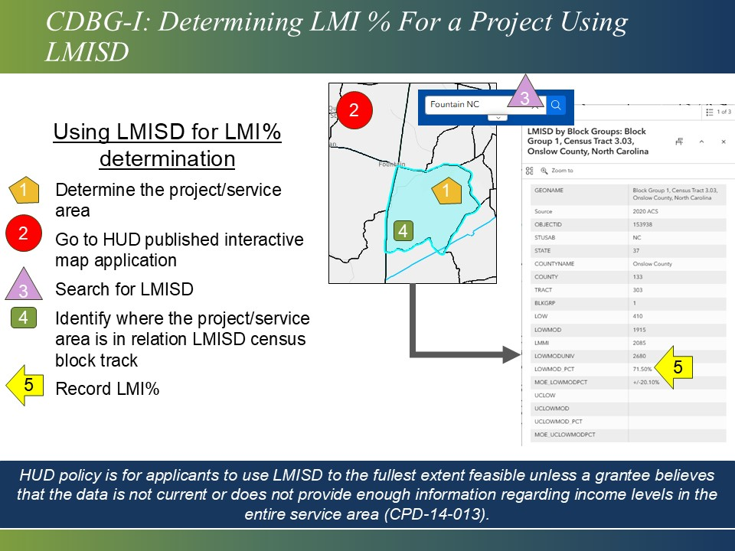
Figure 1: Using LMISD for LMI% determination
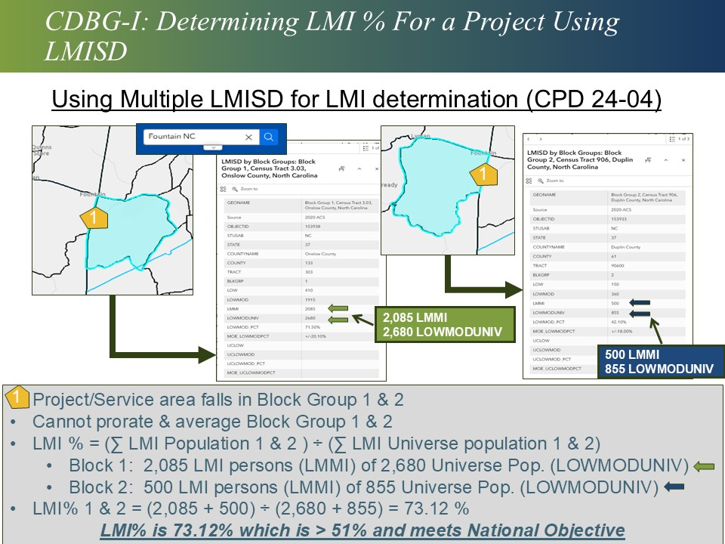
Figure 2: Using Multiple LMISD for LMI determination (CPD 24-04)

**UPDATED** Determining the LMI of the Identified Project (Limited Clientele Activities)
If the project area will not fall under Area Benefit Activities. Then it is a Limited Clientele Activity and must meet LMI requirements through means of Income Surveys. NOTE: HUD policy is for applicants to use LMISD to the fullest extent feasible unless a grantee believes that the data is not current or does not provide enough information regarding income levels in the entire service area (CPD-14-013). Therefore, the following scenarios may require an Income Survey:
- The service area comprises only a small portion of the unit of general local government, or of a census tract. (CPD-14-013)
- The service area includes all or part of several units of general local government and may contain both incorporated and unincorporated areas. (CPD-14-013)
- A census of the entire population may be undertaken and the percentage of LMI persons calculated from the entire population of the service area, and not from the proportion of participants who responded to the survey. For example, if a small rural town with a population of 640 conducts a census of the entire population to determine the percentage of LMI persons and gets an 80 percent response rate. Fifty-one percent of 640 is 326, and 80 percent of 640 is 512. Of the 512 respondents, 326 of them should be LMI persons. It is inaccurate to use 51 percent of 512 which is 261. (CPD-14-013)
  - For income surveys the MOE requirement must not exceed 10% or the LMISD MOE for the area whichever is less. See also Vacant Residential Units and Property/Parcels Section of Appendix A.

**UPDATED** Income Survey Types for Limited Clientele Activities
For CDBG-I, Limited Clientele Activities fall under the following test for CDBG regulation 24 CFR 570.483(b)(2)(ii)(B) which requires information on family size and income so that it is evident that at least 51 percent of the clientele are persons whose family income does not exceed the low and moderate income limit. (24 CFR 570.483(b)(2)(ii)(B))

CDBG regulation 24 CFR 570.483(b)(1)(i) requires that applicants conduct di in the project (service) area of a CDBG-funded activity.

To use survey data the following must be met:
- A local income survey’s sample size shall be determined using not less than a 90 percent confidence level. (CPD-24-04)
  - This establishes the z Factor for MOE at 1.645.
- The maximum allowable Margine of Error (MOE) of the local survey shall be the lesser of 10 percent AND the MOE of the HUD-provided data for the equivalent geography. (CPD-24-04)
  - Meaning an MOE of the survey cannot exceed 10% even if the LMISD data from HUD is over 10%.
- Income surveys are accurate based on the MOE. This will be determined based on the response rate of the sample size Figure 3: Income Survey and Margin of Error.
- Direct Beneficiaries (New Connections): any project purpose that has connections from water/sewer main to home must have survey done of that residence and meet 51% LMI.
  - If awarded a grant, additional income verification documentation will be required for these new connections prior to connection if survey is over 18 months at time of connection.
  - Income survey applies for well and septic abandonment type projects.
  - All connections must meet 100% LMI. A no-response to the survey does not constitute meeting LMI even if the project/service area LMI is above 51%.

With all the benefiting population identified for the specific project area and purpose, an applicant must determine the type of survey. There is one surveys that can be done: census surveys. Consideration must be given to the needs of LEP residents, as well as residents with visual, hearing, or speech impairments/disabilities.

**UPDATED** Procedures for Conducting a Methodologically-Sound Survey Census Surveys
This section will provide general guidance and required documentation. For specific on how to perform a survey refer to CPD-14-013 Section VI for procedures on performing a survey
Required documentation for census surveys for CDBG-I:
- Describe the method used to verify the income survey. The following methods are approved:
  - Mail survey (or self-administered questionnaire).
  - Face-to-face (or door-to-door) interviews.
  - Web-based surveys.
  - Telephone interview
  - An applicant may use multiple methods to ensure equal access to maximize response rates.
- All individual residences, no matter their occupancy (renter or owner), must have a completed (error-free).
- The income survey form must be completed (error-free), signed, and dated by the surveyor.
  - There is no signature requirement of the residence.
- If the project area has a Public Housing Authority (PHA) complex, see that section of this appendix for further information.

**UPDATED** Random-Sample Surveys (RSS) (NOTE: HUD CDBG-I Guidebook is currently unavailable – this section is now omitted from Appendix A) – Random-Sample Surveys will not be accepted with the application.

Income Survey Method(s) Allowed
LGUs are authorized four methods of gathering income surveys, instead of the previous one method of going door-to-door, to ensure the health and safety of all persons. These methods are discussed briefly below and in more detail (advantages and disadvantages) in HUD Notice CPD-14-013.
Regardless of the method of surveying used for determining LMI beneficiaries, consideration must be given to the needs of LEP residents, as well as residents with visual, hearing, or speech impairments/disabilities.

Door-to-Door (Face-to-Face) Interviews
- This is the most common and successful method for an interviewer to ask questions of the surveyee in a face-to-face encounter at the surveyee’ s place of residence.
- The interviewer must have copies of the income survey and instructions in English and Spanish at each residence.
- The income survey is filled out either by the interviewer asking each question or giving the survey and instructions to the individuals at the residence to read and complete.

Mail-In (Self-Administered)
- This method involves mailing the survey form, a letter of explanation and a self-addressed stamped envelope to each household within the project area for completion and returning of the survey.
- Since the surveyee/respondent will be expected to complete the survey and return it, surveyors must create a plan for contacting and/or follow-up with households that do not respond to the survey.
- Be mindful of response rate and valid surveys requirements. Thus, follow-up letters, telephone calls, or going door-to-door may be necessary to obtain the adequate response rate.
- These surveys must be reviewed carefully, signed and dated by the reviewer and the surveyee. If there are errors, the reviewer must call the surveyee to get permission to correct the survey. In that case, document the call with date and surveyee’s name and reviewer’s initials on the survey form.

Web-Based Surveys
- A web-based survey is administrated online through Google Forms, Survey Monkey, or another online surveying method. The survey must ask the same questions as a door-to-door or mail survey.
- Written notification to households within the project area must be done and why they need to respond to the survey. Also, post-notifications in the project area to ensure individuals are aware of the on-line surveys.
- A Spanish version of the web-based survey must be available.
- Surveyors using web-based surveys, must create a plan for contacting and/or follow-up with households without internet.
- The surveyor, or the person administering the web-based survey, will fill out a survey form, using the submitted data, for each household in the project area. The survey form should have “collected by web-based survey” or something similar and sign and date the survey and when the data came in via the internet.

- Be aware if the necessary response rate is not met via web-based surveys, another method will be needed.

Telephone Surveys
- A telephone interview with each household in the project area to gather the necessary data to fill out the income survey form. The surveyor/interviewer must ensure the surveyee/interviewee is someone from the household in question who is competent and knowledgeable enough to answer the questions on the survey form.
- Written notification to households within the project area must be done and why they need to respond to the survey. Also, post-notifications in the project area to ensure individuals are aware of the telephone surveys.
- The surveyor/interviewer will fill in the survey form with the information received over the phone, for each household in the project area. The survey form should have “collected by tele-phone survey” or something similar and sign and date the survey to reflect when the telephone call was done.
- As with web-based surveying, surveyors need to create a plan for contacting those households without telephones or have unlisted numbers.
- Be aware if the necessary response rate is not met via telephone surveys, another method will be needed.

**UPDATE** Conduct the Survey and Complete the Required Survey Form
The Division has provided sample survey forms and instructions in English and Spanish on our website.
The sample surveys must be slightly modified to include the most current income limits for the county the applicant resides in (e.g., use Pitt County income limits for the Applicant: Town of Ayden)
Be mindful that individuals may be hesitant to disclose their household’s income, so a thorough explanation as to why this information is being requested is crucial.
It is strongly encouraged that the applicant notifies the project area’s beneficiaries either through public notices in the local newspaper, signs or flyers within the project area or within their utility statements, public meetings within the project area. Outreach should convey why their information is important.
All provided income information is confidential, and not part of public records. Please read and follow the survey instruction posted online.

Valid Surveys
Income Limits. Surveys are good (valid) for eighteen (18) months prior to the application submission deadline and the applicant must use the most current HUD Income limits OR the released HUD income limits in place within the eighteen (18) months prior to the application.
- For example, September 2024 round applicants must use 2024 Income limits, or 2023 Income limits if the applicant completed the Income Surveys before the most updated 2024 Income limits have been released by HUD.
Applicants must ensure the most current and accurate income limits are placed in the survey templates. HUD provides updated income limits annually, between April and July. Visit the HUD website to pull down the most current income limits for the county in which the project is located. Applicants must use the most recent income limits. The limits are:
- Extremely Low (<30% of county MHI),
- Very Low (30% to 505 of county MHI),
- Low (Moderate) (50% to 80% of county MHI) and
- Above (>80% of county MHI)

Completeness. On the survey form(s), each question must be answered. If not applicable, the answer must be N/A or Zero (0) for questions inquiring a number for answer.
- If an incorrect number of persons or income level was circled, a correction will be valid only if both the surveyor and the person providing the information write their initials and date by the corrections made.

- If the answer is not legible or has multiple circles on the table, the survey will be considered over income, and the average per household will be used for that specific area impacting the applicant calculated LMI.

- Do not make unnecessary marks or changes to the survey forms, doing so may render the form invalid if there are no initials and dates.

The survey must have the date on the first page and last page must be included, interviewer and the surveyee providing the information.
- If the form is missing a date, the survey will be considered over income, and the average household size will be used for that specific area impacting the applicant calculated LMI.
  - The most recent data profile from the American Community Survey (ACS) for the applicant’s community will be used to determine the average household size. This information can be found at: https://www.census.gov/acs/www/data/data-tables-and-tools/data-profiles/ .
No Responses. Addresses where there is no answer/response (no one comes to the door or denies a response) are now considered no responses and not above income (per HUD 9/2024). Therefore, they will impact the overall MOE that must be at or above 90% response rate, not the LMI percentage.

Income Survey MOE Requirement: Vacant Residential Units and Abandoned Parcels
The vacancy rates will be considered during the application review to ensure the survey meets CP 24-04 states –
The maximum MOE (10 percent or the equivalent LMISD MOE, whichever is smaller) establishes a standard that a local income survey must be “at least as good as” the 2020 ACS LMISD

CDBG LMI survey definitions:

- Respond to Survey: is defined as a residential unit/lot in the sampled area that provides the income and population size of the residential unit/lot.
- Vacant Homes/Lot: is defined as a residential unit/lot in the sampled area that are uninhabited. They may be actively for sale, for rent, in the process of rehabilitation, or simply sitting empty between tenants.
- Abandoned Homes/Lot: is defined as a subset of vacant properties/lots in the sampled area that have been neglected, often characterized by tax delinquency, defaulted mortgages, boarded-up windows, or significant structural deterioration.
- Non-response: is defined as a residential unit/lot in the sampled area that cannot be reached or refuses to participate.
IMPORTANT: Abandoned properties will not count against the LMI Income Survey MOE see Example 1 and 2.

Example 1 MOE calculation with no abandoned homes:
- Project is Limited Clientele and the LGU elects to perform an income survey rather than using the LMISD.
- The method of survey performed: Door-to-Door
- Project Purpose: will perform sewer line rehabilitation work on Maple Street.
- Income Survey: Maple Steet has 10 homes, four (4) homes are surveyed, and six homes are vacant.
  - Homes surveyed have a population as follows:
    - Home A: 4
    - Home B: 3
    - Home C: 2
    - Home D: 1
- Income Survey’s MOE is 3.55
  - From the DEQ_DWI_LMI_WORKBOOK tab 3. LMI Information.
Example 2 MOE calculation with abandoned homes (Figure 4: Income Survey and Margin of Error Scenario 1 and 2):
- Project is Limited Clientele and the LGU elects to perform an income survey rather than using the LMISD.
- The method of survey performed: Door-to-Door
- Project Purpose: will perform sewer line rehabilitation work on Maple Street.
- Income Survey: Maple Steet has 10 homes, four (4) homes are surveyed, and six homes are vacant.
  - Homes surveyed have a population as follows:
    - Home A: 4
    - Home B: 3
    - Home C: 2
    - Home D: 1
- Income Survey’s MOE is 3.14
  - From the DEQ_DWI_LMI_WORKBOOK tab 3. LMI Information.

Abandoned properties are not counted in the LMI calculation. However, the application must list and show the vacancies in the survey summary/tabulation sheet and on the project area map. Also, provide a survey form for that address with vacancy status at the top of form.

Table of Vacancy for Income Survey:
Vacancy Status | Survey Requirement
Vacant – no response but not abandoned | Mark survey form and tabulation as “Vacant.”
No Response: property not vacant but did not respond to survey | Mark tabulation and survey as “Non-responsive”
Abandoned | Mark tabulation and survey as “Abandoned”
If there are questions whether an address is vacant or abandoned, find documentation for public sources (local water department, post office, etc.) to make the determination and include it in Tab 3. Documents required with Income Survey to demonstrate that property is abandoned:
- Utility Data: Records showing disconnected water, electric, or gas services.
- Tax/Assessor Rolls: Official documentation identifying properties as vacant, abandoned, or tax-foreclosed.
- Physical Inspection/Windshield Survey: A dated, documented drive-through or walk-through of the area by LGU staff, noting properties that are boarded up, dilapidated, or obviously unoccupied.
- Postal Service Records: Information from the USPS regarding vacant addresses.
SAMPLE SIZE and MOE REQUIREMENT
The Tabulation Form will calculate the MOE calculation for Sample Size of >30 and <30. This is important factor for the tabulation sheet to calculate MOE. If the Survey Area has <30 lots (occupied and vacant) the MOE uses the T-Distribution Rule and Degrees of Freedom to determine the MOE for the surveyed population. With a Survey Area that has >30 lots (occupied and vacant), the tabulation sheet will calculate MOE based on Standard Deviation and z factor of 90% = 1.645.
IMPORTANT: Do not make any edits to any formulas in LMI Information Tab of the DEQ_DWI_LMI Workbook.

Applicants must provide the MOE calculation for verification at the time of the application submittal. Failure to provide the MOE will disqualify the LMI Income Survey.

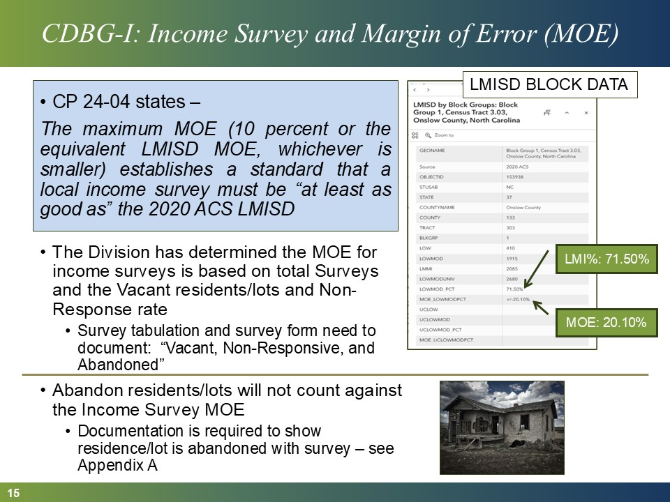
Figure 3: Income Survey and Margin of Error

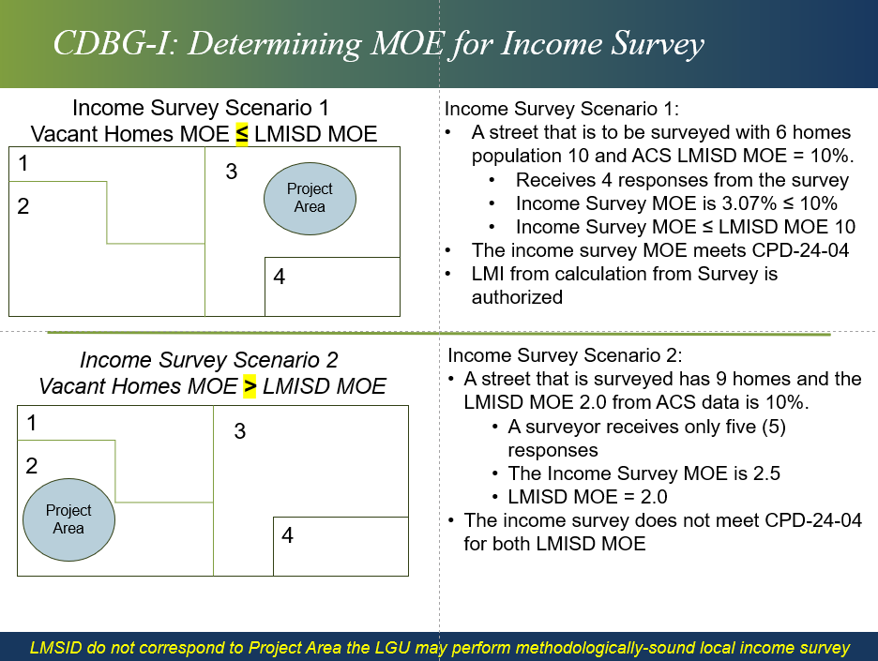
Figure 4: Income Survey and Margin of Error Scenario 1 and 2

Income Survey Summary Tabulation Spreadsheet
Once all the income surveys are complete, the data must be recorded the LMI Workbook (File Name: DEQ_DWI_LMI Workbook). If applicable, the PHA complex data from a PHA must be inserted into the LMI Workbook. The PHA and letter must be included in the LMI Documentation to support what is in the LMI Workbook, along with all other required documentation.
The Income Survey Summary, no less than 11 × 17 or a size that can be readable (no smaller than 11 font). Include LMI Information Worksheet Tab, Demographic and Section 3 Worksheet Tab, and Connections Survey Worksheet Tab. All surveys must be numbered to match the tabulation sheet. The residential addresses (or numbering system) shall be in the same order as the attached income surveys. An example can be found at the Division website under Additional Resources.

Required LMI Documentation for Funding Application
Both the electronic application (the official application) and the hardcopy application (required by HUD and DOC) must have the following documentation to be complete and eligible. The Division will not look for documentation in the hardcopy if it is missing from the electronic application. If the electronic application, which is the official application, is missing LMI documentation the application will be deemed incomplete and ineligible.

Required LMI Documentation Checklist:
Submit  With Application | Required Document
- Survey methodology – a narrative and support documentation- used to survey the project area. The survey methodology should include:
  - Narrative stating the survey type:
    - LMISD
    - Income Survey
      - Method(s) used,
      - Margin of error based on response rate.
  - A copy of online survey form, if applicable.
  - A copy of survey notifications, if applicable.
- Copies (not originals) of all surveys (both sides of form) must be included –completed (error-free – no markups without initials/dates), signed and dated (need survey forms for all responses, vacant, and non-responses). A survey that is only one-sided will not be accepted.
- For abandoned properties provide required documentation.
- The tabulation sheet (Income Survey Summary Tabulation Spreadsheet) should be in landscape layout (11x17) or a size that can be readable (no less than 11-point font). Unused columns can be hidden or deleted to make table readable.
  - All surveys must be numbered (either via address and/or a numbering system) to match the tabulation sheet. The residential addresses (or numbering system) shall be in the same order as the attached income surveys.
 | - LMI persons residing in PHA complexes are to be documented by the required documentation outlined in the Section “Public Housing (Public Housing Authority) Residential Units Within LMA.”
 | - If applicable, a copy of the most current ACS 2020 LMISD for the applicant.

Required Low Mod Area Benefit (Project Area Map with LMI data) Map Checklist
Each funding application must have a Low Mod Area Benefit (LMA) map that shows the following requirements:
Submit With Application | Required with LMI Map
 | - At a readable scale;
 | - With geographic coordinates;
 | - Project area boundaries clearly marked (i.e., bold line) - with the project area boundaries, waterbodies names (if applicable), and street/road names.
 | - If project area is a subarea of a town or county, street names must be clearly visible. Indicate the LMISD census tract-block group on map.
 | - All surveyed occupied residential units, vacant units, abandoned units, and non-responses must be marked (i.e., different colored dots/circles for LMI, above, vacant, non-responses) on the map to ensure all residences were accounted for.
 | - If there are direct beneficiaries (new connections), indicate those residences with either a different color or shape so it is clear where those are located within project area.

Public Housing (Public Housing Authority/PHA) Residential Units within LMA
If the project area includes a Public Housing Authority (PHA) residential complex (multi-family dwellings), the following must be included in the application for the PHA LMI information to be considered:
- The PHA Director/Manager must provide a list of each unit (address) and indicate the number of people, their income, as well as the gender, race, and whether there are any elderly or disabled residents or any female-headed households in each unit.
- A letter from the PHA Director/Manager must also be included, where they attest the provided data is true and accurate.

- The PHA data must be inserted into the Summary Tabulation Spreadsheet (Income Survey Summary).

- Must submit the PHA data and letter in the LMI Documentation (Tab 3) to support what is in the Summary Tabulation Spreadsheet.
Income Surveys will be required for individual, single-family dwellings (individual residences). HUD-provided data or PHA data (as mentioned above) is not acceptable for income surveys for individual residences. All individual residences must have a completed, signed, and dated income survey by the survey taker.

Definitions of CDBG Regularly Terms

Family
Pursuant to 24 CFR 5.403, family includes but not limited to the following, regardless of actual or perceived sexual orientation, gender identity, or marital status:

- A single person, who may be an elderly person, displaced person, nearly-elderly person, or any other single person;
- Unrelated individuals shall be considered as one-person families; or
- A group of persons residing together, and such group includes, but not limited to:
  - A family with or without children (the temporary absence of a child from the home due to placement in foster care shall not be considered in determining family composition and family size).
  - An elderly family—a family whose head (co-head), spouse, or sole member is a person who is at least 62 years of age. It may include two or more persons who are at least 62 years of age living with one or more live-in aides. (A live- in aide is a person who resides with one or more elderly persons or near- elderly persons, or persons with disabilities).
  - A near-elderly family—a family whose head (co-head), spouse, or sole member is a person who is at least 50 years of age but below the age of 62, living together; or one or more persons who are at least 50 years of age but below the age of 62 living with one or more live-in aides.
- Disabled family—a family whose head (including co-head), spouse, or sole member is a person with disabilities. It may include two or more persons with disabilities living together, or one or more persons with disabilities living with one or more live-in aides.
- A displaced family—a family in which each member, or whose sole member, is a person displaced by governmental action, or a person whose dwelling has been extensively damaged or destroyed because of a disaster declared or otherwise formally recognized pursuant to Federal disaster relief laws.
- The remaining member of a tenant family.
- A single person who is not an elderly or displaced person, or a person with disabilities, or the remaining member of a tenant family.

Household
Pursuant to 24 CFR 570.3, household means all persons who occupy a housing unit. A household may consist of persons living together or any other group of related or unrelated persons who share living arrangements, regardless of actual or perceived sexual orientation, gender identity, or marital status.

LMI (Low-Mod-Income) Person
An LMI person is defined as having an income less than or equal to 80 percent area median income.

Income
“Income” is a family’s total adjusted gross income; total adjusted gross income should be based off the previous year’s tax returns. Any individual that makes up an LMI classified family, will be considered an LMI individual. Annual income limits are available on the HUD website. If HUD has not published the applicable years income limits, then the primary applicant may use the previous year.

Income exclusions: Federal Register: Federally Mandated Exclusions From Income-Updated Listing

Seasonal Residents
Seasonal (or part-time) residents (e.g., migrant farmers who reside in manufactured homes) may not participate in an income survey if their benefit of a service or an activity is incidental. For example, the use of a library or senior center by seasonal residents would be considered an incidental benefit. Seasonal residents may participate in income surveys for CDBG-funded activities such as installation of sewer lines and sewage treatment plants, etc.

  - For CDBG-I type projects – seasonal residents information can be used for income surveys.
    - Exception: Direct Beneficiaries (New Connections) is ineligible.

The ACS defines residency in terms of “current residence” – a unit is defined as the current residence of a household if the household is living in the unit for at least two months upon receipt of the survey, even if the household lives somewhere else for most of the year. In contrast, the long form uses a “usual residence” rule, i.e., the place where a person lives and sleeps most of the time. The differences in the definition of residence have consequences for vacancy and homeownership estimates.

For seasonal homes, the seasonal residents must answer the survey, in the case of no response, the survey will be considered above income, and it cannot be count as a vacant property.
See HUD CPD-14-013 - Issued: September 23, 2014

