SPEARS – Opportunity Portal - Worker

QUICK
Guide



The HUD Section 3 Opportunity Portal is intended to help HUD grantees and Section 3 businesses meet their Section 3 obligations for employment and contracting. The site is to be used by either Section 3 Workers or Employers. Section 3 workers may use the site to Search for Jobs, post their profile/employment history for companies to search or post their business(es). Employers may use the site for posting opportunities or business(es) or search for Workers to fill positions. Authentication has been implemented using GSA’s Login.Gov service. Login.gov is an authentication service that offers the public secure and private online access to participating government programs, including the HUD Section 3 Opportunity Portal.

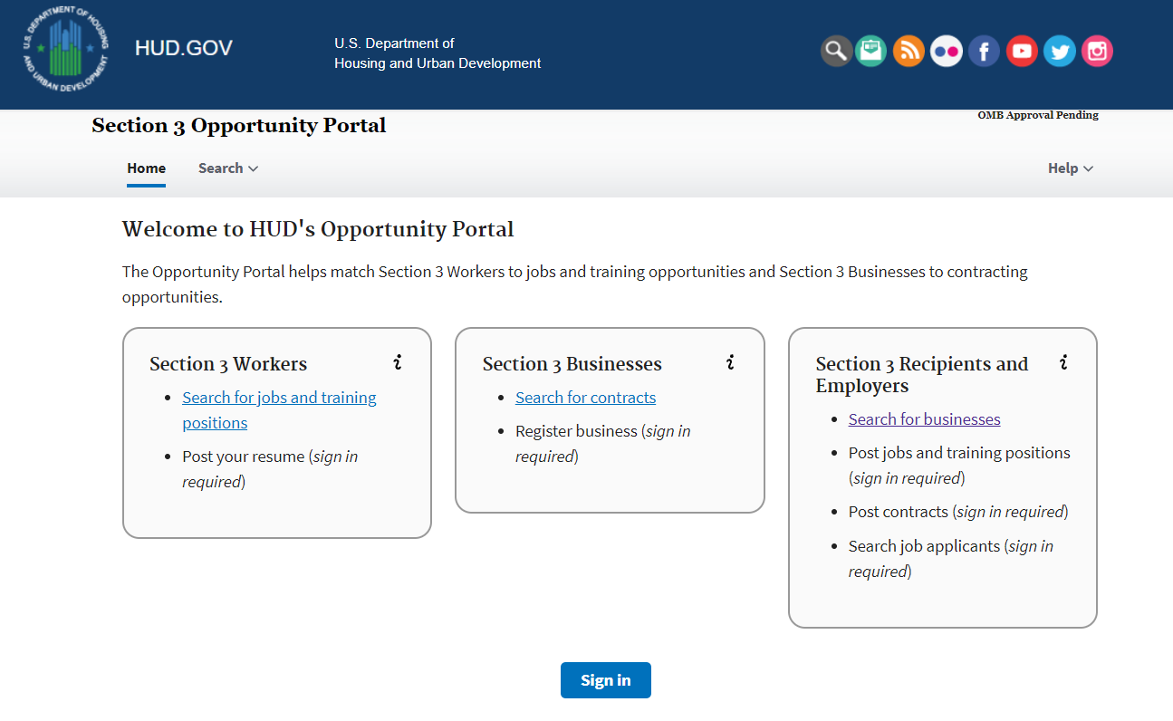

This document will guide the user through the creation of a Login.Gov account, logging into the Opportunity Portal application, and exercising the features that are available to both Section 3 Employers and Workers such as updating contact information, posting an employment profile, posting opportunities and searching for job/contract opportunities.

Create a Login.gov UserID
To access certain features in the Opportunity Portal such as creating a Worker profile so that businesses can search for you, posting Job and Contract opportunities, or search for Workers seeking employment, you must create a Login.gov account. If you only wish to search for open Job and Contract opportunities, you do not need a Login.gov account. To create an account:

- Open a web browser such as Chrome, Edge, Firefox or Safari.
- [Enter] https://hudapps.hud.gov/OpportunityPortal in the URL box.
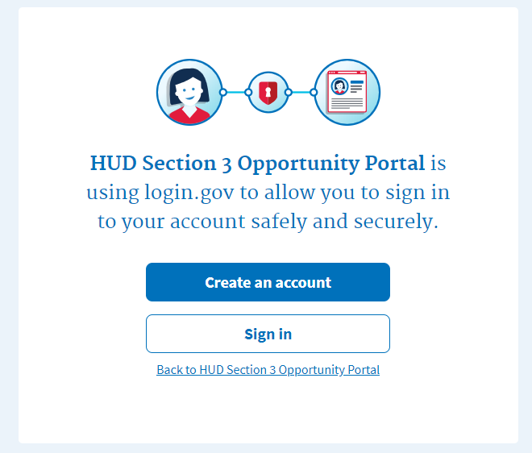
- [Click] the Create an account button. Note: if you already have an account, you can [Click] the Sign in button.
- Enter your email address in the Email address field (Note: this must be a valid email address that you can access at that time), then [Click] Submit.
- You can now close the tab or window you are currently working in.
- Go to your email account and look for a new email from no-reply@login.gov with the Subject: Confirm your email and open it.
- In the email, [Click] the Confirm your email address button. (Note: this will open in your default browser; if you wish to use a different browser, simply copy this URL and paste it into the browser you wish to use.)
- Create a new password. It must be at least 9 characters long and not be a commonly used password. Type the password into the Password field and [Click] Continue. (Note: you will not be able to move forward unless your password is “strong” enough).
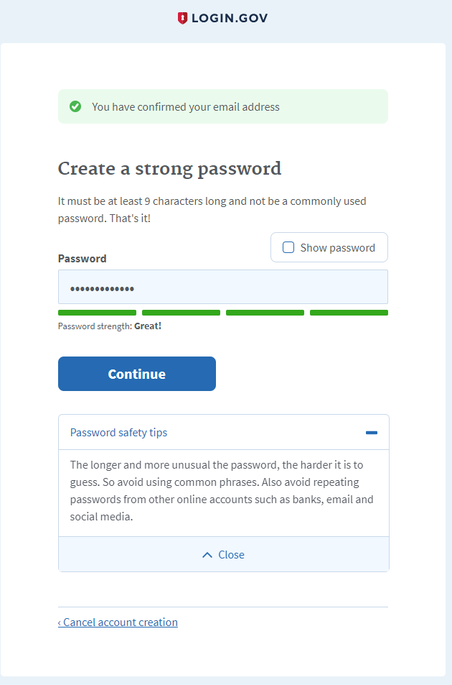

- Login.gov requires “two factor authentication”, meaning you need to provide an additional way to prove you are the owner of your account when logging in (this adds an additional layer of security to your account). Choose one of the 3 options presented (the simplest is usually Text Message/SMS if you have a cell phone; otherwise, the next simplest is to get a phone call). Then [Click] the Continue button.
- If you chose Text Message/SMS then enter your mobile phone number in the Mobile phone number field, then [Click] the Send code button.

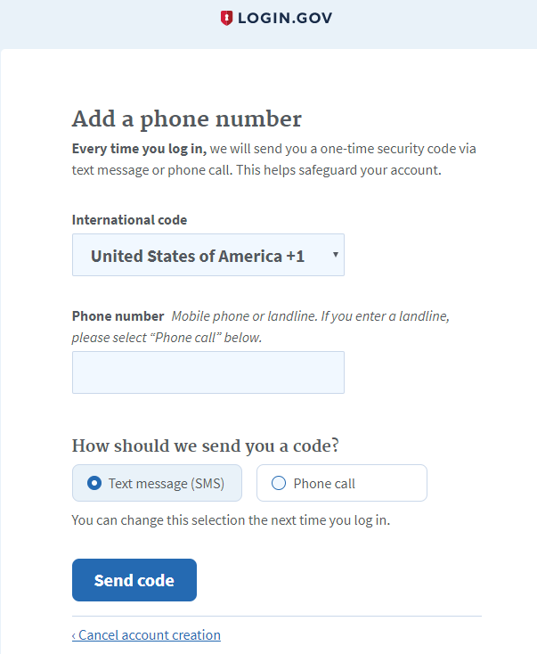

- If you chose Text Message/SMS then enter your security code that you received via text message/SMS in the One-time security code field, then [click] Submit. (Note: you must do this within 10 minutes of receiving the code, or you will need to generate a new one).
- Write down, print out, or take a screen shot of your personal key; you may need this to log in later to regain access to your account if you lose your phone, for example.
- [Click] Continue.

- Type the personal key that you just saved in the field that appears. You do not need to enter dashes, just the numbers and letters from your key.
- [Click] Agree and Continue.

Log in with Login.gov
To log in to the Section 3 Opportunity Portal, do the following.

- Once you have an account, you can go to https://hudapps.hud.gov/OpportunityPortal in your web browser, then [Click] the Sign in button.
- [Enter] your Email Address and Password that you used when signing up for Login.gov and [Click] Next.
- Follow the steps for multi-factor authentication.
- You will then be logged into the application and the Section 3 Opportunity Portal home page will appear.

Choose Worker Role
When you log in for the first time, you will need to select a role. The Worker Profile role allows you to post information that only approved employers can search for, such as your skills, interests, preferences, employment information and resume.
- On the Role page, [Select] “I want to participate as a Section 3 Worker by posting a resume with my employment history/experience, skills, and training for approved employers/contractors to review for possible employment.”, [Click] “I certify that I meet HUD’s Section 3 eligibility requirements”, then [Click] Save.
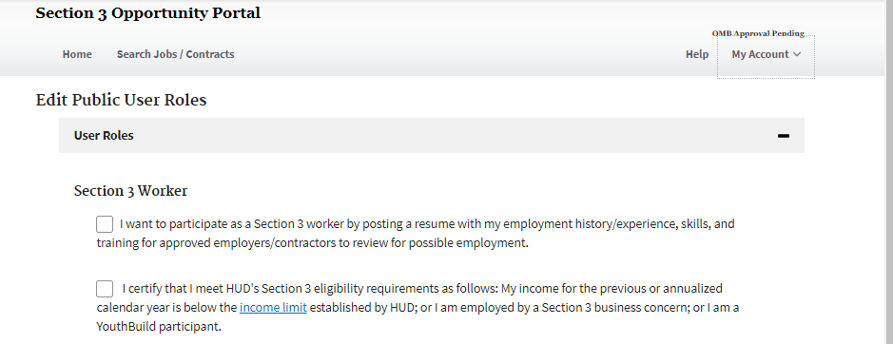

Edit Worker Profile
- [Click] My Section 3 Portal in the upper menu, then
[Click] My Worker Profile.
- [Scroll] to the Contact section and [Click] the Edit button.
- [Enter] data. You must enter data in all of the Required fields. [Click] Save.
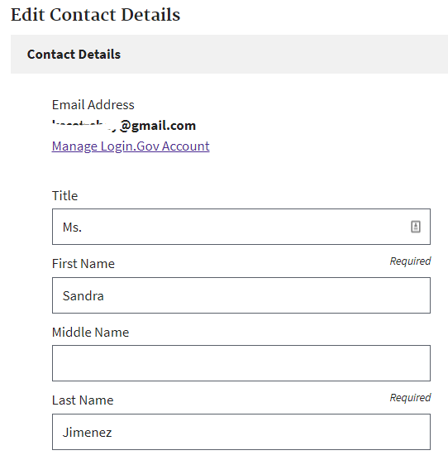
- [Scroll] down to the Profile Details section and [Click] the Edit button.
- [Enter] data into all of the relevant fields. [Click] Save.
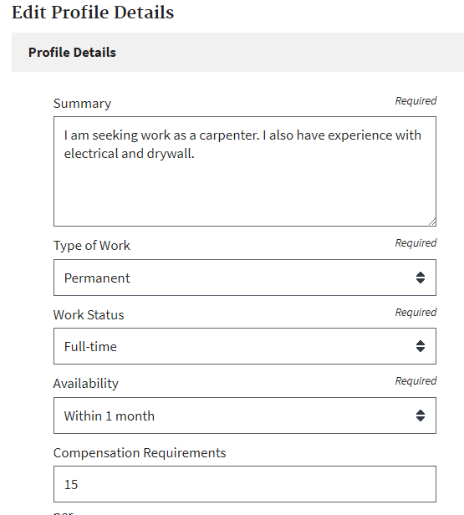
- [Scroll] down to the Employment History section and [Click] the Add Employment History button.
- [Enter] data into all of the fields. [Click] Save.
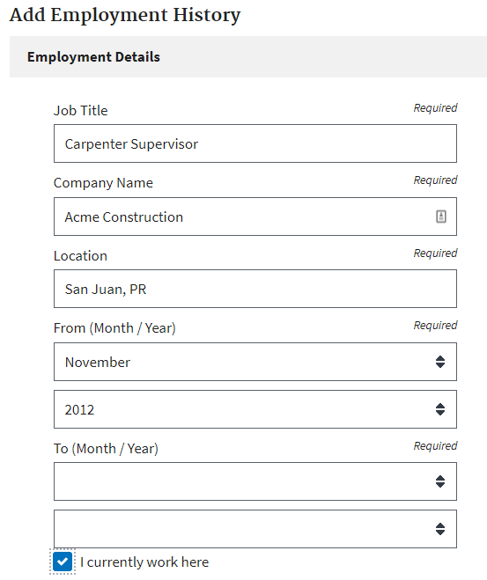
Employment History will be displayed with the most recent starting date at the top of the list.
- To edit employment history,
[Scroll] down to the Employment History section and [Click] the Edit button next to one of your entries.
[Update] data in the fields you want to change. [Click] Save.
- To delete an Employment History entry, [Scroll] to the Employment History section and [Click] the Delete button next to one of your entries.When prompted, [Click] OK to confirm.

- If you have a Document to add, [Scroll] down to the Documents section and [Click] the Add Document button.
- [Click] Browse… and choose a file to upload (PDF or .docx), then [Enter] data into all of the relevant fields. [Click] Upload.
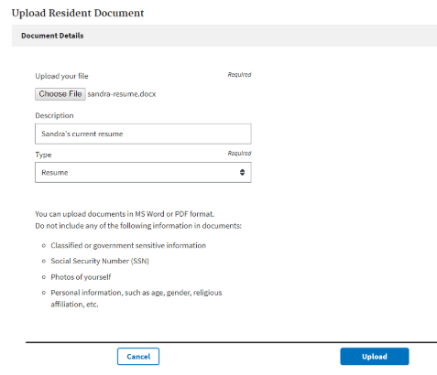
- NOTE: Each file upload is limited to 2MB in size, but unlimited in the number of files that may be uploaded.
- To edit a Document’s properties,
[Scroll] down to the Documents section and
[Click] the Edit button next to one of your documents.
[Update] data in the fields you want to change.
[Click] Save.
- To delete a Document,
[Scroll] down to the Documents section and
[Click] the Delete button next to one of your documents. When prompted, [Click] OK to confirm.

My Businesses
Any user may register their Section 3 self-certified business listing within the Section 3 Opportunity Portal. Any registered businesses are listed on the My Businesses page.
- [Click] My Section 3 Portal in the upper menu, then
[Click] My Businesses.
Along with self-registered businesses, the application will Claim any businesses that match with the user’s email address. Upon caiming, a checkmark will appear beside the business for the next 3 days. After claiming, the user may edit and re-post the business similar to any other entries.
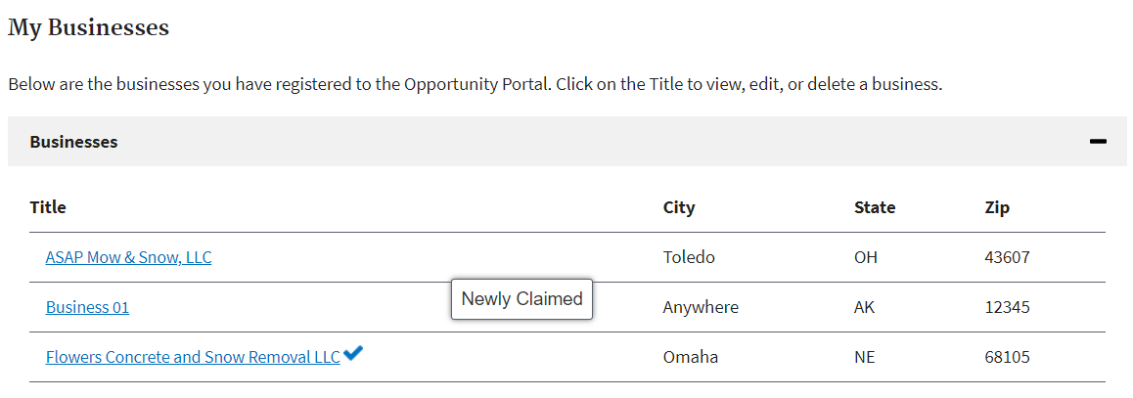

Add Business
- [Click] My Section 3 Portal in the upper menu, then
[Click] My Businesses.
- [Click] Add Business.

- Business Information.
- [Enter] Business Name, Business Street Address, City, State
- Enter the first 3 (or more) numbers of the ZIP code, then [Select] the ZIP code you desire. This will automatically update the City and State fields.

- Contact Information.
[Enter] Business Telephone Number, Business Point of Contact and Business Email.

- Business Details
[Enter] Business Details in the following fields.

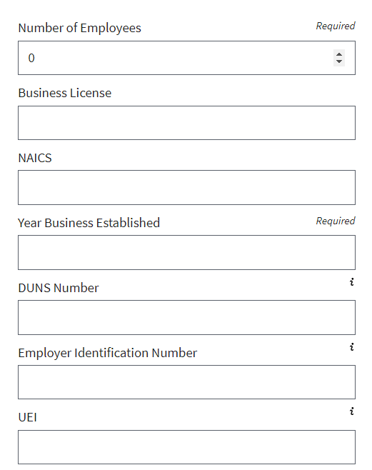
Optionally,
- [Enter] County and/or City Area(s) that the business is not willing to serve. Entries must be less than 200 characters.
- The Capabilities Narrative is a summary of a company's ability to perform. Narratives must be less than 4,000 characters.
- Small Business
[Check] if you identify as a small business.

- Business Designations
[Check] one or more checkboxes (optional) to select business designations.

Add a Business (cont.)
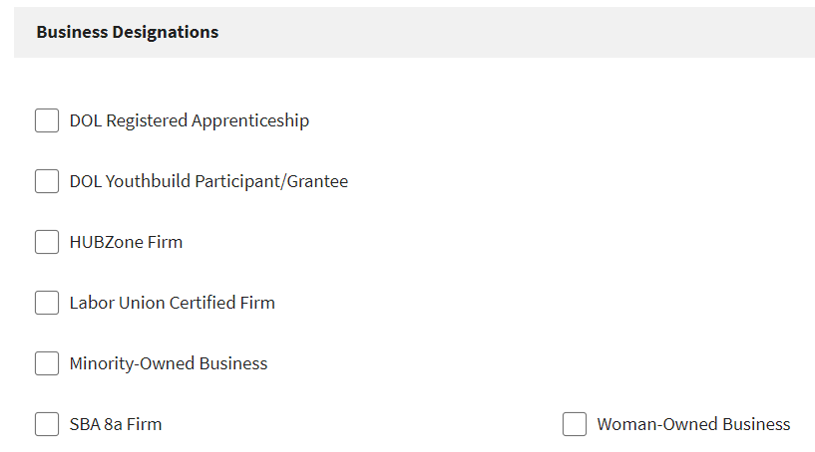
- Provided Services
The selection (one or more) of the following checkboxes is required.
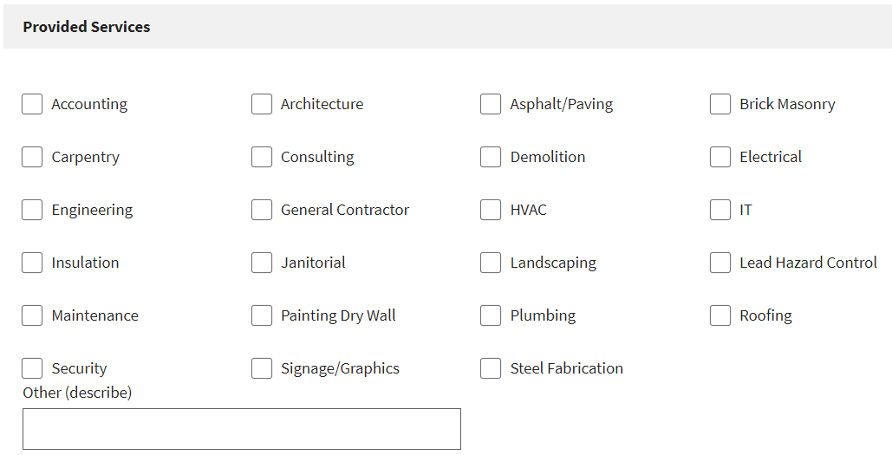

- Business Currently Hiring
[Select] the appropriate option for the business’ hiring status. (The default radio option is No).

- Section 3 Business Criteria
The selection (one or more) of the following checkboxes is required.
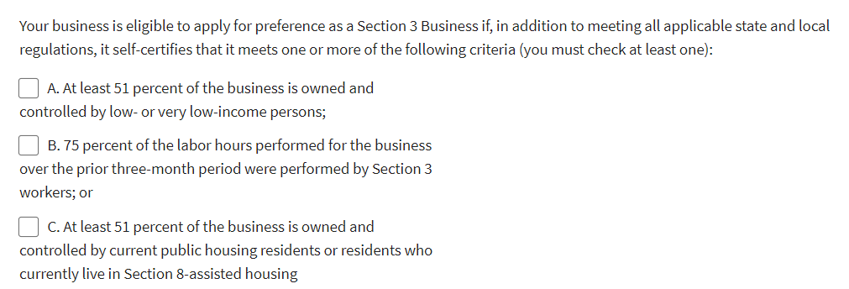

[Check] The above information is true/accurate
[Click] Submit

Edit a Business
- [Click] My Section 3 Portal in the upper menu, then
[Click] My Businesses.
- [Click] the Title of a business, from the pop-up menu,
[Click] Edit
- Revise the Business listing’s data as needed.
- [Check] The above information is true/accurate
- [Click] Submit

View a Business
- [Click] My Section 3 Portal in the upper menu, then
[Click] My Businesses.
- [Click] the Title of a business, from the pop-up menu,
[Click] View Public Post

Delete a Business
- [Click] My Section 3 Portal in the upper menu, then
[Click] My Businesses.
- [Click] the Title of a business, from the pop-up menu,
[Click] Delete
- In the pop-up dialog, [click] OK

Search for Section 3 Businesses
[Click] Search in the upper menu, then
[Click] Search Business
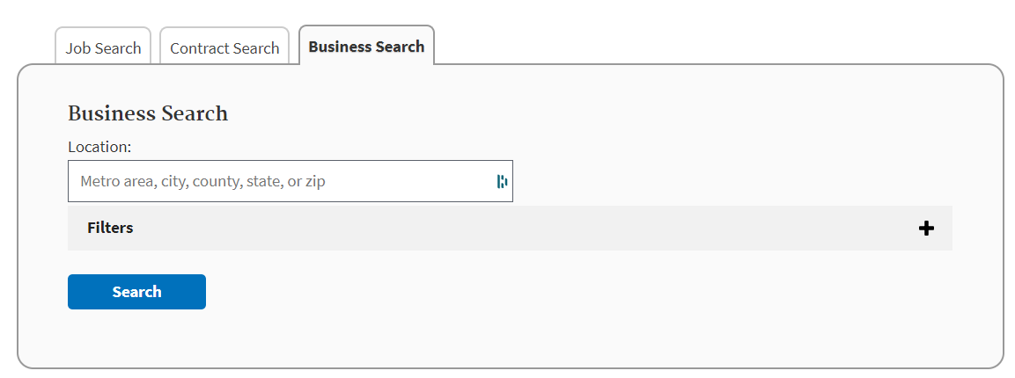

- Select Metropolitan Area.
- In the Location text box, start entering the name of a state, metro area, county or zip code, then select the Location for the Business from the auto loaded drop down list. Selection of a Location is required.
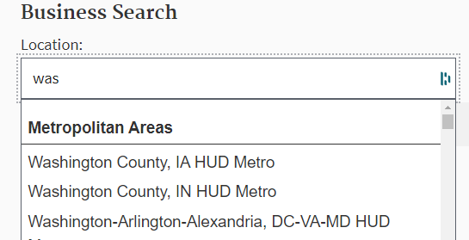

- Select Filters.
- [Click] the “+” on the Filters section
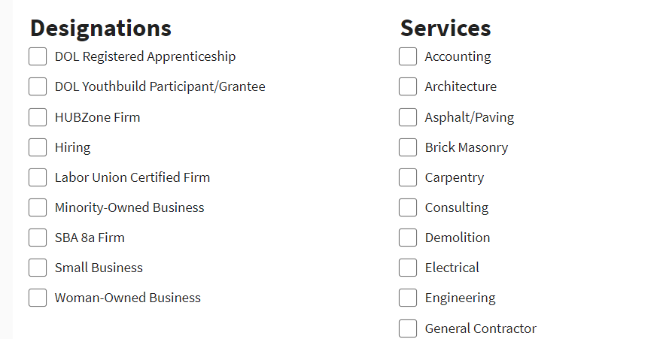
- [Check] on one or more Check Boxes
for Designations or Services to filter (optional)
Search Businesses (cont.)
- [Click] Search to view Search Results.
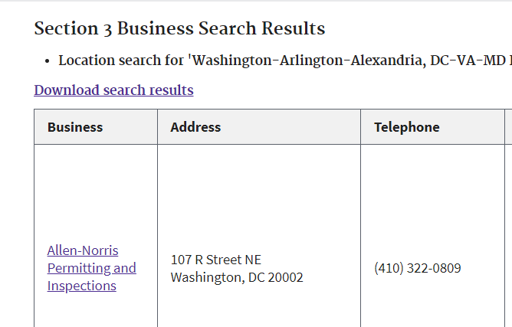

- Export Results to Excel.
- To export the results of the business search to Microsoft Excel, [Click] the Download search results link, which is just before the table.
- Depending on the browser, the file will either open in a viewer or can be downloaded and saved.
- When opening the file in MS Excel, it may open in a Protected View.
- If so, [Click] the Enable Editing option at the top of the screen.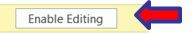
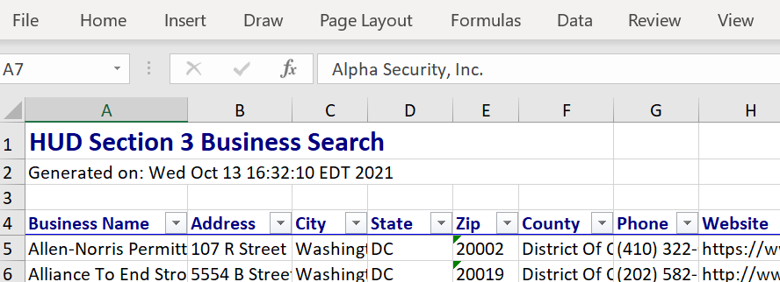

Search and View Job and Contract Opportunities
- [Click] Search Jobs/Contracts in the upper menu.
- [Choose] either the Job Search or Contract Search tab for your search.
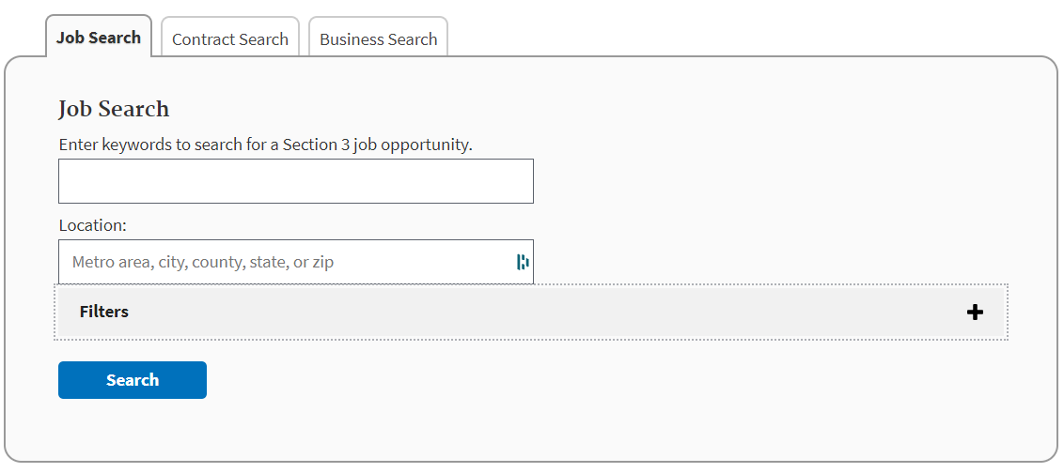
- To search for an opportunity, [Enter] one or more keywords and a location related to the type of job or contract you are seeking and [Click] Search. Note that you can limit the results by clicking the Filter panel and clicking any of the options.
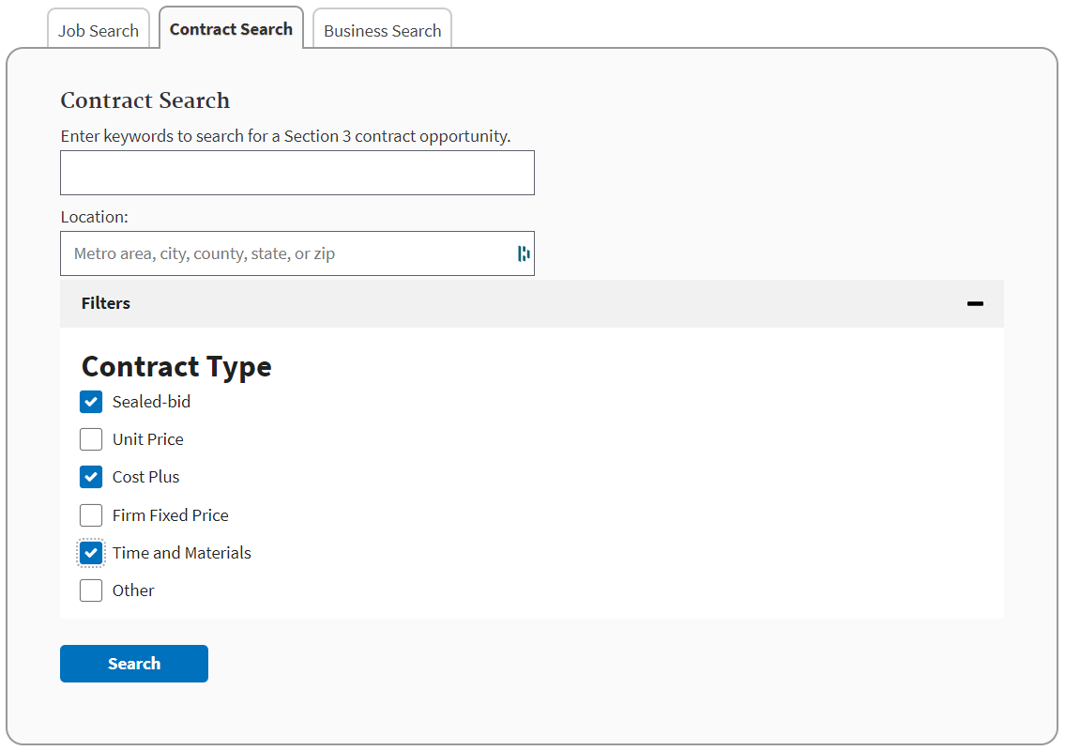
- [Click] a Job or Contract Title link from the search results to view the read-only view of the posting.
- Contact details are available in the posting, and some postings will have clickable URLs for more information.

