Study Plan for the Identification of Select Emerging Compounds in Falls Lake and its Surrounding Watershed

Purpose

The objective of this study is to provide the NC Division of Water Resources information on per- and polyfluoroalkyl substances (PFAS), 1,4-dioxane and bromide in Falls Lake and its surrounding watershed. Specifically, this includes water sampling, water testing and water analysis of samples taken from Falls Lake and connecting creeks and rivers to identify levels of these emerging compounds.

Study Plan

Design
In addition to the current monitoring study in place on Falls Lake as required by 15A NCAC 02B .0275, concentrations of select emerging compounds will be evaluated at five existing in-lake sites and five existing Ambient Monitoring System (AMS) sites. These stations will be sampled once per month. Sites are located within Falls Lake and its watershed to provide water quality data in areas of Falls Lake that receive inflow from surface waters with permitted municipal NPDES (National Pollution Discharge Elimination System) facilities that have discharges greater than 10 million gallons per day. This will provide information specific to these compounds in Falls Lake and its watershed areas, and their relation to the City of Raleigh’s water treatment plant intake.

Parameters
Sample collection will focus on 23 select PFAS including GenX, PFOA and PFOS, as well as 1,4-dioxane, and bromide water quality parameters. Sites and a detailed list of parameters to be evaluated in this study are shown in Table 1. In-lake chemical water quality samples will be collected from the surface (0.15 m) as grab samples. Depth-stratified physical parameters will be collected at the surface (0.15 m), in 1 m increments to a depth of 10 m, and every 5 m thereafter. Stream samples will be collected as grab samples from 0.15 m below surface as will physical water quality conditions. Water quality sample collections and field operations will follow ISU Standard Operating Procedures: Physical and Chemical Monitoring Version 2.1 (December 2013) and Ambient Lakes Quality Assurance Project Plan Version 2.0 (March 2014). Quality control documents can be found on the Division of Water Resources’ Intensive Survey Branch website at: https://deq.nc.gov/about/divisions/water-resources/water-resources-data/water-sciences-home-page/intensive-survey-branch. Bromide and 1,4-dioxane samples will be analyzed by DWR Water Sciences Section in Raleigh, and PFAS samples will be shipped to EPA’s Science and Ecosystem Support Division (SESD) in Athens, GA. Appropriate QA/QC samples will be collected during each sampling event including trip blanks, duplicates, MS/MSDs, and equipment blanks where necessary. All samples will be maintained under chain of custody from the time of collection to the time of analysis.

Assessment
Evaluation of water quality data collected during this study will focus on the compounds listed in Table 1 and their respective concentrations versus location in Falls Lake and its watershed. If additional data or changes to the study area are required, this study plan will be re-evaluated and updated accordingly. Sampling will begin in July 2018 and will continue through December 2018, allowing for sufficient data to be collected to begin evaluating levels of the target analytes.
Figure 1. Falls Lake emerging compound monitoring locations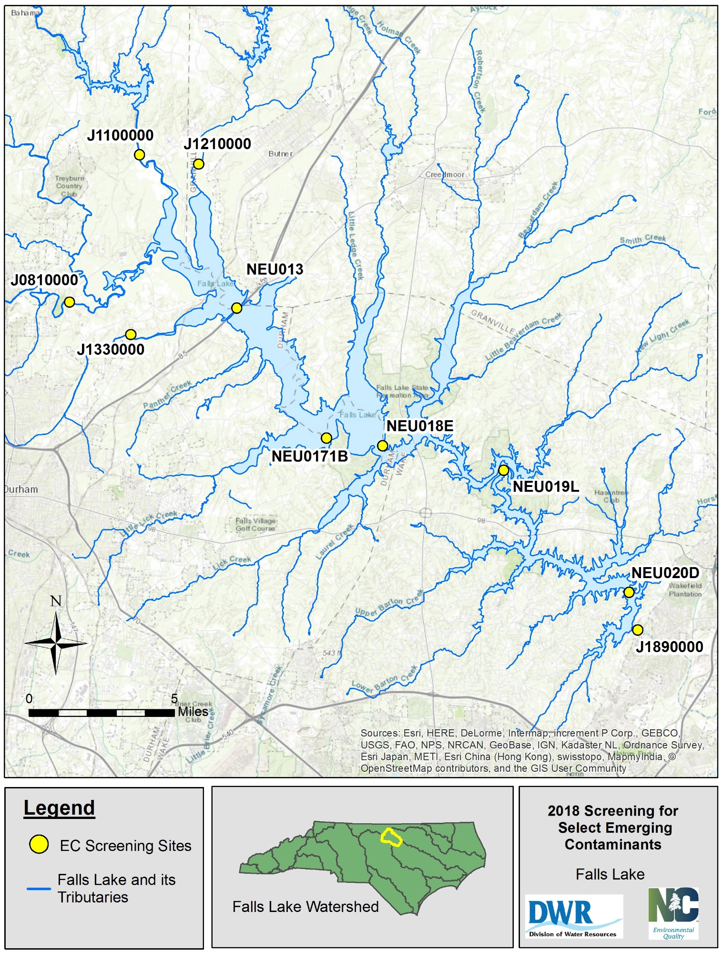

Table 1. Sites and parameters to be evaluated

Station | Station Description | Physical | Chemical | Parameters
NEU020D | FALLS LAKE AT MARKER #1 NEAR BAYLEAF NC | X | X | Physical:  Temperature (°C), pH (s.u.), Dissolved Oxygen (mg/L), Conductivity (µs/cm), Secchi Depth (m)  Chemical:  4:2FTS, 6:2FTS, 8:2FTS, FOSA, HFPO-DA, N-MeFOSAA, PFBA, PFBS, PFDA, PFDoA, PFDS, PFHpA, PFHpS, PFHxA, PFHxS, PFNA, PFNS, PFOA, PFOS, PFPeA, PFPeS, PFTrDA, PFUdA, 1,4-Dioxane, Bromide
NEU019L | FALLS LAKE AT CHANNEL MARKER #6 NEAR BAYLEAF NC | X | X
NEU018E | FALLS LAKE AT MOUTH OF LEDGE CREEK NR CREEDMOOR | x | x
NEU0171B | FALLS LAKE AT MOUTH OF LITTLE LICK CREEK | X | X
NEU013 | FALLS LAKE AT I-85 NEAR NORTHSIDE | X | X
J1100000 | FLAT RIV AT SR 1004 NR WILLARDSVILLE | X | X
J1210000 | KNAP OF REEDS CRK AT WWTP OUTFALL NR BUTNER | X | X
J0810000 | ENO RIV AT SR 1004 NR DURHAM | X | X
J1330000 | ELLERBE CRK AT SR 1636 NR DURHAM | X | X
J1890000 | NEUSE RIVER AT SR 2000 NR FALLS | X | X

