Study Plan for the Identification of Select Emerging Compounds in Jordan Lake, Haw River Arm Watershed and New Hope Creek Arm Watershed.

Purpose

The objective of this study is to provide the NC Division of Water Resources information on per- and polyfluoroalkyl substances (PFAS), as well as 1,4-dioxane and bromide in Jordan Lake and its surrounding watershed. Specifically, this includes water sampling, water testing and water analysis of samples taken from Jordan Lake and connecting creeks and rivers to identify levels of these emerging compounds.

Study Plan

Design
In addition to the current monitoring study in place on Jordan Lake required by section 3.(c) of S.L. 2009 - 216, five existing and one new in-lake monitoring stations will be sampled as part of this study. Additionally, six existing and one new Ambient Monitoring System (AMS) watershed site will be sampled (Figure 1). These stations will be sampled once per month. Sites are located within Jordan Lake and its watershed to provide water quality data in areas of Jordan Lake that receive inflow from surface waters with permitted municipal NPDES (National Pollution Discharge Elimination System) facilities that have discharges greater than 10 million gallons per day. This will provide information specific to these compounds in Jordan Lake and its watershed areas, and their relation to the Town of Cary’s water treatment plant intake.

Parameters
Sample collection will focus on PFAS, 1,4-dioxane, and bromide water quality parameters. Sites and parameters to be evaluated in this study are shown in Table 1. In-lake chemical water quality samples will be collected from the surface (0.15 m) as grab samples. Depth-stratified physical parameters will be collected at the surface (0.15 m), in 1 m increments to a depth of 10 m, and every 5 m thereafter. Stream samples will be collected as grab samples from 0.15 m below surface as will physical water quality conditions. Water quality sample collections and field operations will follow ISU Standard Operating Procedures: Physical and Chemical Monitoring Version 2.1 (December 2013) and Ambient Lakes Quality Assurance Project Plan Version 2.0 (March 2014). Quality control documents can be found on the Division of Water Resources’ Intensive Survey Branch website at: https://deq.nc.gov/about/divisions/water-resources/water-resources-data/water-sciences-home-page/intensive-survey-branch. Bromide and 1,4-dioxane samples will be analyzed by DWR Water Sciences Section in Raleigh, and PFAS samples will be shipped to EPA’s Science and Ecosystem Support Division (SESD) in Athens, GA. Appropriate QA/QC samples will be collected during each sampling event including trip blanks, duplicates, MS/MSDs, and equipment blanks where necessary. All samples will be maintained under chain of custody from the time of collection to the time of analysis.

Assessment
Evaluation of water quality data collected during this study will focus on the compounds listed in Table 1 and their respective concentrations versus location in Jordan Lake and its watershed. If additional data or changes to the study area are required, this study plan will be re-evaluated and updated accordingly. This study design may also be adopted to a wider scale for evaluation of entire watersheds within North Carolina. Sampling began in January 2018 and will continue, allowing for sufficient data to be collected to adequately evaluate levels of the target analytes.

Figure 1. Jordan Lake emerging compound monitoring locations

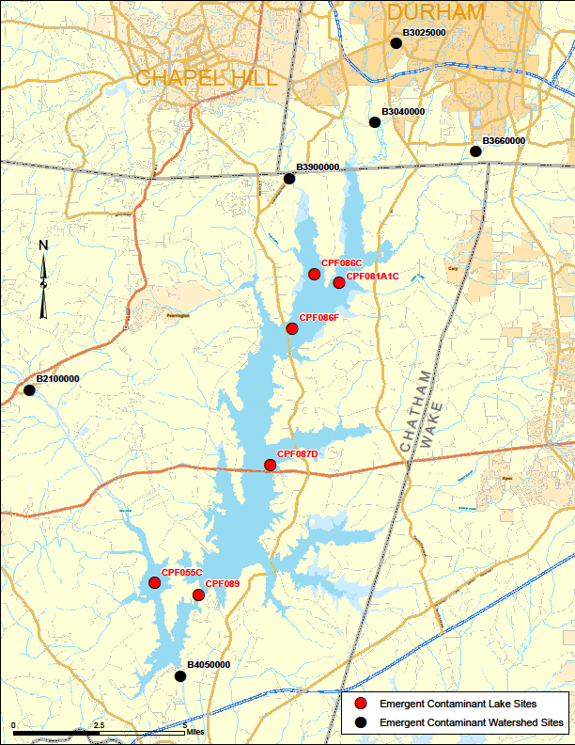
B3750000

Table 1. Sites and parameters to be evaluated

Station | Station Description | Physical | Chemical | Parameters
CPF086C | JORDAN LAKE AT MOUTH OF MORGAN CK NR FARRINGTON | X | X | Physical:  Temperature (°C), pH (s.u.), Dissolved Oxygen (mg/L), Conductivity (µs/cm), Secchi Depth (m)  Chemical:  4:2FTS, 6:2FTS, 8:2FTS, FOSA, HFPO-DA,  N-MeFOSAA, PFBA, PFBS, PFDA, PFDoA, PFDS, PFHpA, PFHpS, PFHxA, PFHxS, PFNA, PFNS, PFOA, PFOS, PFPeA, PFPeS, PFTrDA, PFUdA , 1,4-Dioxane, Bromide
CPF081A1C | JORDAN LAKE AT MOUTH OF NEW HOPE CREEK | X | X
CPF086F | JORDAN LAKE NEAR FARRINGTON NC | x | x
CPF087D | JORDAN LAKE AT MOUTH OF WHITE OAK CREEK NR SEAFORTH | X | X
CPF055C | JORDAN LAKE ABOVE STINKING CREEK NR PITTSBORO NC | X | X
CPF089 | JORDAN LAKE NEAR MERRY OAKS | X | X
B4050000 | HAW RIV BELOW JORDAN DAM NR MONCURE | X | X
B2100000 | HAW RIV AT SR 1713 NR BYNUM | X | X
B3900000 | MORGAN CRK AT SR 1726 NR FARRINGTON | X | X
B3040000 | NEW HOPE CRK AT SR 1107 NR BLANDS | X | X
B3660000 | NORTHEAST CRK AT SR 1100 NR NELSON | X | X
B3025000 | THIRD FORK CRK AT NC 54 NR DURHAM | X | X
B3750000 | PHILS CRK NR CAVANDER | X | X

