Mattamuskeet Drainage Association Watershed Restoration Plan

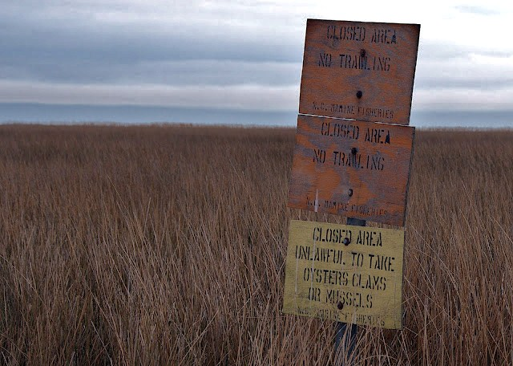

Funded by:
N.C. Division of Water Quality, Section 319 Grant

TABLE OF CONTENTS
TABLE OF CONTENTS i
ACRONYMS, ABBREVIATIONS and GLOSSARY ii
EXECUTIVE SUMMARY 1
INTRODUCTION 2
WATER QUALITY STANDARDS AND CLASSIFICATIONS 4
REASONS FOR COASTAL WATER QUALITY IMPAIRMENT AND NEED FOR IMPROVEMENTS 8
WATER QUALITY IMPAIRMENTS AND SHELLFISH CLOSURES OF PAMLICO SOUND 11
EXISTING MANAGEMENT STRATEGIES 22
GOALS, OBJECTIVES AND MANAGEMENT ACTIONS 25
APPENDIX A: ASSOCIATION LAND CLASSIFICATIONS AND SPECIFICATIONS 48
APPENDIX B: DWQ WATER QUALITY CLASSIFICATIONS 49
APPENDIX C: 303(d) LIST INTEGRATED REPORT CATEGORIES 51
APPENDIX D: NORTHERN WORKGROUP, OYSTER RESTORATION PLAN MAP 52
APPENDIX E: HISTORY OF CLOSURES FOR OTTER CREEK 53
APPENDIX F: CLOSURE PROCLAMATIONS FOR FIFTH AVENUE 55
APPENDIX G: Wetland RESTORATION SCHEMATIC (L1) 59
APPENDIX H: WETLAND RESTORATION SHOREBIRD PROJECT SCHEMATIC (MV0) 59
APPENDIX I: WETLAND RESTORATION PROJECT SCHEMATIC (MV0) 61
APPENDIX J: wetland restoration project ELEMENT DIAGRAMS, NCSU 62
APPENDIX K: DRAINMOD ANALYSIS DRAWING KEY AND DEFINITIONS 68
APPENDIX L: AREAS CHOSEN FOR GPR 70
APPENDIX M: SUMMARY TABLES OF DRAINMOD ANALYSES 71
APPENDIX N: QAPP WATER QUALITY MONITORING PROTOCOL 72

ACKNOWLEDGEMENTS
Ladd Bayliss, North Carolina Coastal Federation
Jan DeBlieu, North Carolina Coastal Federation
Erin Fleckenstein, North Carolina Coastal Federation
Todd Miller, North Carolina Coastal Federation
Christine Miller, North Carolina Coastal Federation
Dr. George (Chip) Chescheir, North Carolina State University
Dr. Mike Burchell, North Carolina State University
Kris Bass, North Carolina State University
Mac Gibbs, Hyde County Cooperative Extension Director
Wilson Daughtry, Alligator River Growers, Mattamuskeet Drainage Association Board Member
Jamin Simmons, Mattamuskeet Ventures, Mattamuskeet Drainage Association Board Member
Chris Peacock, Halderman Farm Management, Mattamuskeet Drainage Association Board Member
Bill Edwards, Natural Resources Conservation Service
Jonathan Hinkle, Natural Resources Conservation Service
Mike Bryant, U.S. Fish and Wildlife Service, Alligator River NWR
Dennis Stewart, U.S. Fish and Wildlife Service, Alligator River NWR
Scott Lanier, U.S. Fish and Wildlife Service, Alligator River NWR
Pete Campbell, U.S. Fish and Wildlife Service, Lake Mattamuskeet NWR
Deborah Pierce, U.S. Fish and Wildlife Service, Lake Mattamuskeet NWR
Tommy Hughes, North Carolina Wildlife Resources Commission
Dale Davis, North Carolina Wildlife Resources Commission
Kris Noble, Hyde County Office of Economic Development

Special thanks to:
N.C. Division of Water Quality, DENR
Hyde County Soil and Water Conservation District
Hyde County Office of Economic Development
Shellfish Sanitation Section, N.C. Division of Marine Fisheries, DENR
U.S. Fish and Wildlife Service

ACRONYMS, ABBREVIATIONS and GLOSSARY
ACOE – Army Corps of Engineers
APPROVED AREA - An area determined suitable for the harvest of shellfish for direct market purposes.
ARNWR – Alligator River National Wildlife Refuge
ASSOCIATION - Mattamuskeet Drainage Association, a large agricultural drainage district in eastern Hyde County comprised of 42,500 acres
BMP - Best Management Practice
CFU - Colony Forming Unit, used to measure fecal coliform concentrations.
CONDITIONALLY APPROVED CLOSED - An area subject to predictable intermittent pollution that may be used for harvesting shellfish for direct market purposes when management plan criteria are met generally during drought conditions.
CONDITIONALLY APPROVED OPEN - An area subject to predictable intermittent pollution that may be used for harvesting shellfish for direct market purposes when management plan criteria are met generally during low rainfall conditions.
CRP – Conservation Reserve Program
CWA - Clean Water Act
DEGRADED WATERS - General description of surface waters that have elevated pollution levels, including high bacteria levels, pathogens, sediment, low dissolved oxygen, and/or high nutrient levels. This is not a legal description of impairment (see impaired waters definition below).
DOT - N.C. Department of Transportation
DWQ - N.C. Division of Water Quality
EMC - N.C. Environmental Management Commission
EPA – U.S. Environmental Protection Agency
FECAL COLIFORM - Bacteria that originate in the intestines of warm-blooded animals. Bacteria of the coliform group which will produce gas from lactose in a multiple tube procedure liquid medium (EC or A-1) within 24 plus or minus two hours at 44.5 degrees C plus or minus 2 degrees C in a water bath.
FLOW - The volume of water, often measured in cubic feet per second (CFS), flowing in a stream or through a stormwater conveyance system.
GROWING WATERS - Waters that support or could support shellfish life.
HYDROLOGIC CYCLE - The cycle by which water evaporates from oceans and other bodies of water, accumulates as water vapor in clouds, and returns to oceans and other bodies of water as precipitation or groundwater. Also known as the water cycle.
HYDROGRAPH - A graph showing changes in the discharge of a surface water river, stream or creek over a period of time.
HYDROLOGY - The science dealing with the waters of the earth, their distribution on the surface and underground, and the cycle involving evaporation, precipitation, flow to the seas, etc.
ICWW – Intracoastal Waterway
IMPAIRED WATERS - For the purposes of this Plan, any saltwater classified for shellfish harvest (SA) that is not managed as an “Approved Area” by the Division of Environmental Health, or any saltwater classified for swimming (SB) where swimming advisories are being issued. These waters have been listed as impaired on the state’s 303(d) list for EPA.
LIDAR – “Light Detecting and Ranging,” a remote sensing technology that can measure properties of a target using light.
MAXIMUM EXTENT PRACTICABLE - According to EPA, available and capable of being done after taking into consideration cost, existing technology and logistics in light of overall project purpose.
NPDES - National Pollution Discharge Elimination System
NRCS – Natural Resources Conservation Service, a federal agency that administers Farm Bill programs one of which is the Wetland Reserve Program. WRP works with landowners on private lands to conserve natural resources
NSSP - National Shellfish Sanitation Program
PROHIBITED AREA - An area unsuitable for the harvesting of shellfish for direct market purposes.
SA - Saltwater classified by the EMC for shellfish harvesting. These are waters that should support aquatic life, both primary and secondary recreation (activities with frequent or prolonged skin contact), and shellfishing for market purposes.
SB - Saltwater classified by the EMC for swimming.
SC - Saltwater classified by the EMC for fish propagation and incidental swimming. The waters are safe for swimming but have a higher risk of pollution and human illness than SB waters.
SS - Shellfish Sanitation Section, N.C. Division of Marine Fisheries, N.C. DENR. In 2011 the N.C. General Assembly transferred the shellfish and recreational water quality functions of this agency from the N.C. Division of Environmental Health to the N.C. Division of Marine Fisheries.
TOTAL MAXIMUM DAILY LOAD - Section 303(d) of the Clean Water Act establishes the Total Maximum Daily Load (TMDL) program, a water quality-based approach to regulating waters that fail to meet water quality standards despite the use of pollution control requirements. A TMDL is a calculation of the maximum quantity of a given pollutant that may be added to a water body from all sources without exceeding the applicable water quality standard for that pollutant. States must establish TMDLs for all pollutants that prevent waters from attaining water quality goals. The TMDL helps regulators devise the limitation necessary to meet water quality standards by identifying and quantifying the individual sources contributing to a particular water quality problem.
STORMWATER - Water from rain that flows over the land surface, picking up pollutants that are on the ground.
303(d) LIST - Under section 303(d) of the Clean Water Act, states, territories, and authorized tribes are required to develop lists of impaired waters. These are waters that are too polluted or otherwise degraded to meet the water quality standards set by states, territories, or authorized tribes. The law requires that these jurisdictions establish priority rankings for waters on the lists and develop TMDLs for these waters. A Total Maximum Daily Load, or TMDL, is a calculation of the maximum amount of a pollutant that a water body can receive and still safely meet water quality standards. Category 5 impaired waters require the development of a TMDL.
WATERSHED - The topographic boundary within which water drains into a particular river, stream, wetland, or body of water.
WREP – (Wetland Reserve Enhancement Program) a voluntary program through the NRCS to protect, restore, enhance, and manage high priority wetlands and wildlife habitat. WREP funds can only be used on projects that meet WRP program requirements
WRP - (Wetlands Reserve Program) a voluntary program through the NRCS to preserve and protect wetlands on private property. An incentive program, landowners are compensated financially to restore previously drained farmland into wetlands habitat.

EXECUTIVE SUMMARY
In northern Hyde County, the waters of Otter Creek, Berry’s Bay, and a portion of the Pamlico Sound are listed as “impaired” by the U.S. Environmental Protection Agency (EPA).
These waters are adjacent to land managed by the Wildlife Resources Commission which is a part of the Gull Rock Game Lands Long Shoal Tract. The Mattamuskeet Drainage Association, a non-profit private association, operates a 42,500 acre land drainage operation west of the WRC land. The discharge of the drainage operations partially flow toward the Pamlico Sound and it is generally believed this discharge has contributed to the impairment of the described areas of the Pamlico Sound. With support from the N.C. Division of Water Quality (DWQ), the Mattamuskeet Drainage Association is working with the N.C. Coastal Federation and other key stakeholders to develop a comprehensive, voluntary watershed restoration plan in an effort to improve the quality of these waters and fisheries habitats.
Hydrologic modification in the landscape results in increased flow into these waters. This increased volume of surface water is assumed to be the primary cause for the impairment of shellfish growing waters of Otter Creek, Berry’s Bay, and a portion of the Pamlico Sound. Land alterations, initially for the purpose of forestry and later agriculture, through clearing, ditching and the use of pumps have facilitated the release of increased amounts of water into these downstream waters. This Plan aims to address water quality on a watershed-scale, by restoring or replicating historic hydrology to the maximum extend practical within the 42,500-acre association through the implementation of various projects that reduce the amount of water that is pumped toward Pamlico Sound to the east, as well as the Alligator River and Intracoastal Waterway to the west.
Historically, it is believed most of the waters on the eastern portion of the association flowed via subsurface and shallow surface runoff to the northwest, towards the Alligator River and Intracoastal Waterway, and lesser amounts eastward toward the Pamlico Sound. On the western side of the association, waters historically flowed toward the west and northwest. Since the creation of the association, a portion of this total drainage water was rerouted via pumps to the Pamlico Sound in the east. There are additional pumps on the western side of the association, used to direct water into the Intracoastal Waterway and Alligator River. The pumped runoff contains levels of naturally occurring bacteria that consistently exceeds the water quality standard for shellfish harvest. This water enters historic shellfishing waters of Otter Creek, Berry’s Bay, and the Pamlico Sound through the pump stations at Second and Fifth Avenues.
Since removing fecal coliform bacteria from runoff is impractical if not impossible, the association and its partners have developed this watershed restoration Plan that focuses on reducing the amount of pumped volume of water that transports bacteria into the Pamlico Sound, Otter Creek and Berry’s Bay. Restoring water quality in these areas will be a long-term, multi-decadal effort. Impaired shellfish growing waters are believed to be the by-product of previous land alteration practices that have occurred since the 1930’s. While this intense ditching and draining have increased property values and contributed to the economic growth of the immediate area, these activities have reduced the natural functional capacity of the landscape to infiltrate rainfall. Gradual improvements in water quality will occur as hydrologic restoration efforts are carried out within the association and pumped volumes into these impaired areas are decreased.

The association and partners wish to reduce stormwater runoff so that the shellfish growing waters classified for harvest (SA) may eventually reopen. Ultimately, this Plan aims to change the listing of the waters from “Prohibited Area” to “Approved Area.” Once this occurs, these shellfish growing waters will no longer be listed by EPA as “impaired.”

INTRODUCTION
This watershed restoration plan provides a long-term management framework for restoring the historic hydrology of an agricultural drainage association in northeast Hyde County (Figure 1), thereby reducing the amount of water that is currently released by pumping through canals into Otter Creek, Pamlico Sound, the Intracoastal Waterway, and the Alligator River (Figure 2). Some of these water bodies have experienced water quality impairments since the mid-1980’s. In the years and decades to come, the positive effects of this Plan will result in the gradual improvement of water quality. This positive trend in water quality will be demonstrated by both reducing the quantity of water pumped to Pamlico Sound and other receiving waters, and by measured water quality improvements through monitoring performed by Shellfish Sanitation as shown by an expansion of shellfish growing areas that are open to harvest.

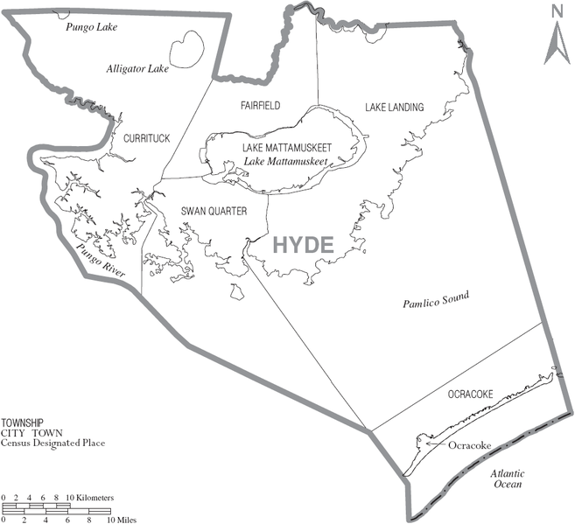
Figure 1. Map of Hyde County, N.C. General project area outlined.
The Plan identifies five objectives (listed below) to restore and protect water quality in compliance with water quality laws and regulations pursuant to the federal Clean Water Act of 1972. All of these strategies and actions are focused on restoring or replicating the natural hydrology of the overall Mattamuskeet Drainage Association where practical and reducing the flow of water directly into shellfish waters.
- Continue managing current projects.
- Promote efforts to reduce pumping volume to coastal waters.
- Determine how to meet project goals at current Shellfish Sanitation stations.
- Ensure compliance and maintenance of the Engelhard Wastewater Treatment Plant.
- Measure success and adapt plan based on results.

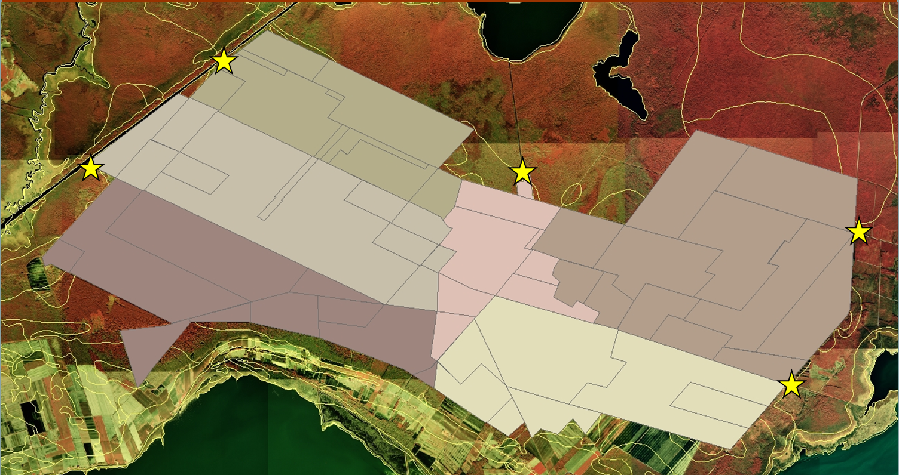
Figure 2. Pump locations within the Mattamuskeet Drainage Association in Hyde County shown by yellow stars. Different shaded areas indicate the modeled “sphere of influence” of the pumps. Map courtesy of NCSU.
Based upon infrared photography, supported by LIDAR imagery and GPS ground survey performed by N.C. State University, the presence of remnant sloughs within the association that extend into the adjacent refuge lands are apparent (Figure 3).
Water quality restoration will be achieved by using alternative water management strategies designed to achieve volume reduction and by other management strategies, such as land acquisition and enrollment in conservation easement programs that have beneficial effects on reducing overall direct discharge volumes. By focusing on reducing, slowing, and absorbing stormwater to reduce runoff directly into the Pamlico Sound and other receiving waters, the goal is to mimic the natural hydrology that existed prior to intense land alteration practices. This will be achieved by the cumulative effect of water reallocation, wetland restoration, and other techniques.

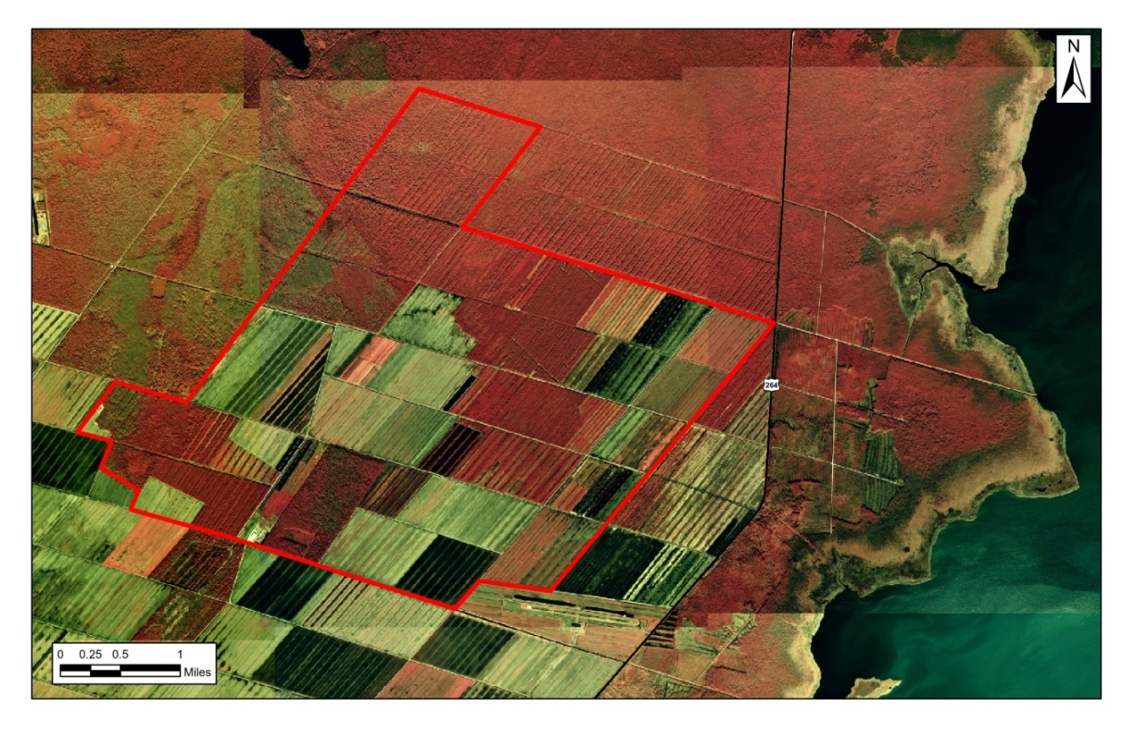
Figure 3. Infrared photograph of the eastern portion of the drainage association, outlined in red. Land with red color indicates lower elevation, this information coupled with LIDAR data and ground truth survey work indicate a historic slough flowing to the northwest.

WATER QUALITY STANDARDS AND CLASSIFICATIONS
The federal Clean Water Act in 1972 was enacted to establish uniform national standards to restore and maintain the chemical, physical, and biological integrity of our nation’s waters. It contains provisions that address the pollution of shellfish waters as well as other water quality issues.
To limit pollution, the Clean Water Act requires that “existing uses” of the waters be maintained. In other words, waters may not be polluted to the point that they no longer support their uses such as swimming, shellfishing, and fish propagation. A use is “existing” if it has been available since November 28, 1975 when the regulation was adopted by the EPA. Pollution disposal is not a protected use for waters.
The state water quality classification of a water body specifies which uses are to be protected. Saltwater classifications for North Carolina’s coastal areas are SA, SB, and SC. For example, the SA classification is for shellfish waters while SB classifications are for organized or frequently used swimming waters. Each classification also specifies the maximum concentrations of various pollutants that will be allowed. Every creek, river, stream, estuary, section of the ocean, or other segment of water in the state has been assigned a water quality classification and corresponding standards. Unnamed and unclassified freshwater tributaries to SA, SB, or SC waters have the same classification as their receiving waters. (See Appendix B for a complete listing of classifications.)
A basic use of all waters is the propagation and maintenance of aquatic life, including plants and animals. The anti-degradation regulation requires that existing uses be protected even if the uses or threatening pollutants are not specifically mentioned in the classification and standards. For example, if shellfish harvest is taking place in waters classified SB for swimming, any pollution that would close those waters to shellfish harvest violates the anti-degradation requirement because it eliminates the water’s use. For this reason, SB waters used for shellfish harvest should be reclassified as SA waters to be consistent with the federal Clean Water Act.
A water quality classification cannot be changed to eliminate an “existing use” that has existed at any time since November 28, 1975. For areas that have not had an “existing use” since 1975, a use attainability study must still show that pollution is irreversible, or the area is not suitable for the classified use, before an assigned water classification can be changed to eliminate a designated use.
Waters classified as SA are protected for market purpose shellfishing and have stringent bacteriological standards. Disease causing bacteria and viruses are concentrated in clams and oysters as they filter food from the water. Since shellfish can be eaten raw, the water must be free of disease-carrying pollutants. Therefore, in order to protect public health, sewage discharges into SA waters are prohibited.
The Shellfish Sanitation Branch of the Division of Marine Fisheries (DMF) is responsible for monitoring shellfishing waters. Waters that exceed the fecal coliform standard, or are adjacent to a known threat of pollution, are closed to shellfishing by the state. To protect existing shellfishing waters, sources of pollution that cause closure of waters must not be allowed. Shellfish growing areas classifications are explained in Table 1.
The saltwater classification SB designates waters used for organized or frequent swimming, skiing, and fish propagation. A SB classification requires that waste treatment plants have backup equipment to ensure that no untreated sewage flows into the waters. The backup provisions must include standby power and two parallel treatment units. Shellfish Sanitation monitors a type of bacteria called enterococci in waters frequently used for swimming. Like fecal coliform, enterococci are also found in the intestines of warm-blooded animals such as birds, dogs, raccoons and people. Enterococci will not make you sick; however, it is often associated with other bacteria and viruses that can cause water-borne illness. To comply with the shellfish harvest water quality levels set by the EPA and the state, water test results have to fall below a set average. Generally for shellfishing waters to remain open, the geometric mean of bacteria cannot exceed 14 MPN per 100 milliliters of water. The sampling protocol for Shellfish Sanitation is explained further in Objective Three.

N.C. Shellfish Sanitation Growing Area Classifications
Approved | These areas are always open to shellfish harvesting and close only after rare heavy rainfall events such as hurricanes. The medium fecal coliform Most Probably Number (MPN) or geometric mean MPN of water shall not exceed 14 per 100 milliliters, and the estimated 90th percentile shall not exceed an MPN of 43 per 100 milliliters for a five-tube decimal dilution test.
Conditionally Approved-Open Shellfish Areas | Sanitary Survey indicates an area can meet approved area criteria for a reasonable period of time, and the pollutant event is known and predictable and can be managed with a plan. These areas are open to harvest much of the year, but are immediately closed after certain sized rainfall events (refer to SS Shellfish Sanitation growing area management plans for specific closure strategies).
Conditionally Approved-Closed Shellfish Areas | Sanitary Survey indicates an area can meet approved area criteria during dry periods of time, and the pollutant event is known and predictable and can be managed with a plan. This growing area classification allows harvest when fecal coliform bacteria levels are lower than the state standard in areas that otherwise might be closed to harvesting. These areas are regularly monitored to determine if temporary openings are possible.
Prohibited Shellfish Harvest Areas | Sanitary Survey is not routinely conducted because previous sampling data did not meet criteria for Approval or Conditionally Approved. Area may also be closed as a matter of regulation due to the presence of point source discharges or high concentrations of boats with heads.
Table 1. N.C. DMF Growing Area Classifications.
The saltwater classification SC designates waters used for fish propagation and incidental swimming. The waters are safe for swimming but have a higher risk of pollution and human illness than do SB waters. Treated sewage may be discharged into SC waters if it will not impair the uses of the SC waters or any downstream SA or SB waters.
The N.C. Environmental Management Commission (EMC) determines water quality classifications and standards pursuant to the federal Clean Water Act. The classifications and standards are regulations and must have a public hearing to be changed. The state system for adopting and maintaining classifications and standards must comply with federal regulations, and EPA must approve every proposed change.

PHYSICAL DESCRIPTION OF THE WATERSHED
The Mattamuskeet Drainage Association is unusual in the sense that it is not a natural watershed. Most land in eastern North Carolina, and specifically the Albemarle-Pamlico Peninsula, is ditched and drained. This characteristic as well as a formal dike system and controlled water management make the Mattamuskeet Drainage Association a de facto watershed as it exists today. N.C. State University used DRAINMOD analysis to predict historic water flow on the lands. Their efforts indicate that in pre-development times, water moved north, east, and west across the peninsula by sheet flow through the peat soils of wetlands and bottomland forests (Figure 4).
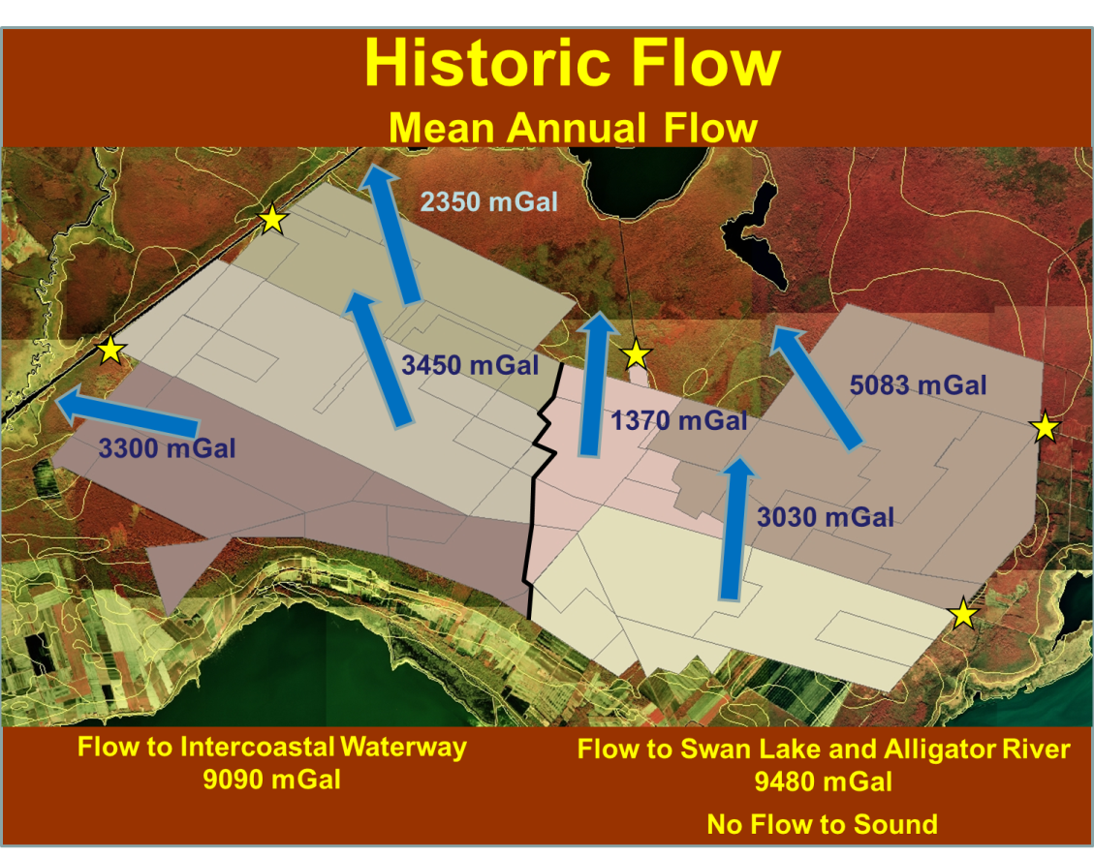
Figure 4. Historic theoretical average flow of water through the Mattamuskeet Drainage Association, as modeled by Dr. Chip Chescheir of NCSU using DRAINMOD, 2011. Figure courtesy of NCSU.

Today, the flow moves through canals and water control structures that regulate the water level of farm canals (Figure 5). All excess water is pumped off the association either to the east or west into the Pamlico Sound, the Intracoastal Waterway, or Alligator River. 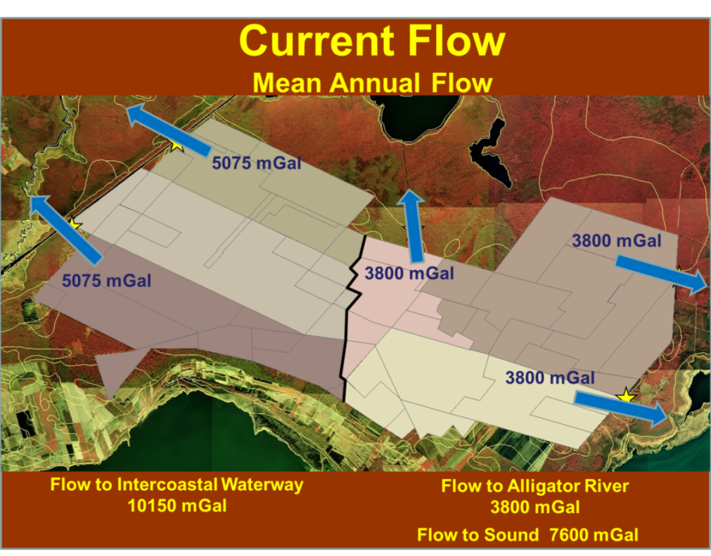
Figure 5. Current theoretical average flow of water within the Mattamuskeet Drainage Association as modeled by Dr. Chip Chescheir of NCSU using DRAINMOD and land us information provided by the association, 2011. Figure courtesy of NCSU.

Lunar tide influence within the association and canal system is minimal, as one way flap gates and pumps manage water at the perimeter of the association. When tides do influence the association, it is mainly in the form of strong wind tides during storm events causing sound or river water to overtop the association’s dikes. The elevation of the Albemarle-Pamlico peninsula is extremely low and the lack of gradient makes natural water movement very slow, except via wind or pumping.
The Mattamuskeet Drainage Association has well-defined boundaries, and the movement of water through it has been carefully watched for many decades. Because farmers within the district have placed over 20,000 acres of formerly ditched and drained land into the federal Wetlands Reserve Program (WRP), there is an opportunity to hold water on those lands where it can be filtered by soils and restore historic hydrology. By carefully designing an interconnected system of holding ponds, reservoirs, water management structures, enhanced wetlands, and restored natural sloughs, the hydrology of the area can be “re-plumbed” so it will more closely resemble predevelopment conditions. Fresh water that historically flowed naturally north through swamp forests and wetlands toward the Alligator River is now partially being redirected into the Pamlico Sound.

REASONS FOR COASTAL WATER QUALITY IMPAIRMENT AND NEED FOR IMPROVEMENTS
Water quality in coastal waters is generally impacted when the natural landscape is changed by drainage and vegetation removal (Figure 6). Altering the land cover changes the hydrology of a watershed. Lands that are cleared and drained can contribute to water quality impacts, including localized changes in surface water salinity after rainfall events in adjacent coastal waters, as well as an increase in turbidity and other nutrients such as phosphate, nitrate, and ammonia. In an unaltered landscape with a normal hydrologic regime, approximately 30 percent of rainwater that falls on the landscape is used by vegetation while much of the remaining water infiltrates into the ground where bacteria and other pollutants are removed by filtration as the water moves through the soil. During most normal weather conditions, very little surface runoff is produced; however, during wet periods (high rainfall periods in summer and fall, and normal rainfall in winter) surface runoff can occur. Surface runoff in natural wetlands is via slow moving overland flow through vegetation that can also remove bacteria and pollutants from the water. As watersheds become more altered, less water is used by vegetation, increasing the volume of water flowing from the land and improved drainage systems increases the rate at which it reaches coastal water bodies.

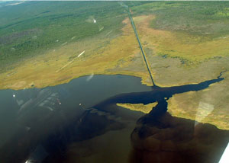
Figure 6. Aerial view of a freshwater plume resulting from runoff draining from an un-pumped canal in southern Hyde County after one half inch of rainfall. Photo courtesy of N.C. Coastal Federation.
In eastern North Carolina, where such land modifications have occurred, water entering the sounds can carry elevated levels of bacteria, sediment and nutrients. The drainage activities of the Mattamuskeet Association have become a focal point for water quality impairment due to increased volume of water flow from its operations.

LAND USE HISTORY OF THE MATTAMUSKEET DRAINAGE ASSOCIATION
In predevelopment times, the land now known as the Mattamuskeet Drainage Association was used predominantly for logging operations. In the 1930s and 1940s, the first canals were hand-dug to access small-scale logging operations, juniper and cypress trees were harvested for boat building and other needs. These canals were relatively small, usually between 1.25 and 1.5 yards wide, and were used for draining the land and to allow barges access for transport timber.
Additional canals were dug in the 1950s and 1960s when more efficient machinery became available (Figure 7). With a greater number of canals, timber harvest and transport increased and as clearing continuted, landowners began to contemplate agricultural opportunities on the land. Over time canals were widened and a pump system, to better manage the waters, was installed in the late 60’s. Large-scale farming within the association began in 1972. The association was formally formed in March of 1977.

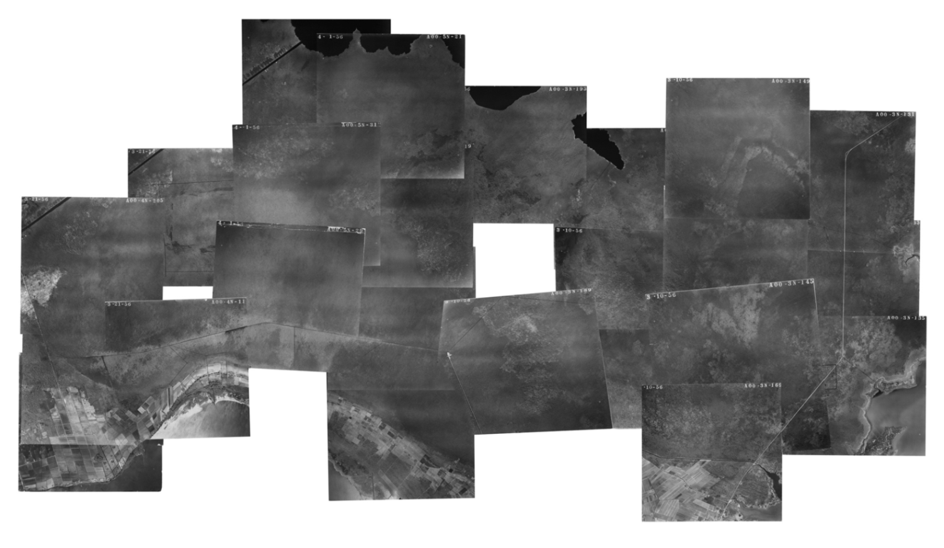
Figure 7. Aerial photographs from U.S. Forest Service pieced together by Ray Matthews, of Nags Head, showing land use patterns on the Mattamuskeet Drainage Association area in 1956. The land was still largely forested and had few canals and roads.
For the next decade, farming and improving the land for farming purposes became a large focus throughout the association (Figure 8). This focus was largely supported by the need to ramp up agricultural production by U.S. farmers. By 1984 two things halted continued land conversion in the immediate area. First, the U.S. Army Corps of Engineers began enforcing the Clean Water Act making it so that landowners were no longer allowed to convert wooded wetlands to agriculture. This affected much of the intact “pocosin” land within the association. Around the same time, landowners began realizing that the expense of converting the land was not always financially prudent, as commodity prices began a downward spiral. By this time much of the land (nearly 80 percent, or roughly 32,000 acres) within the association had been converted to agriculture, and as provided in the 1985 Farm Bill Swampbuster Provisions, it would be considered “Prior Converted” or “PC lands.” With arrival of the 1990's, the association ownership began growing, moving from a few owners to the more than 40 that exist today.
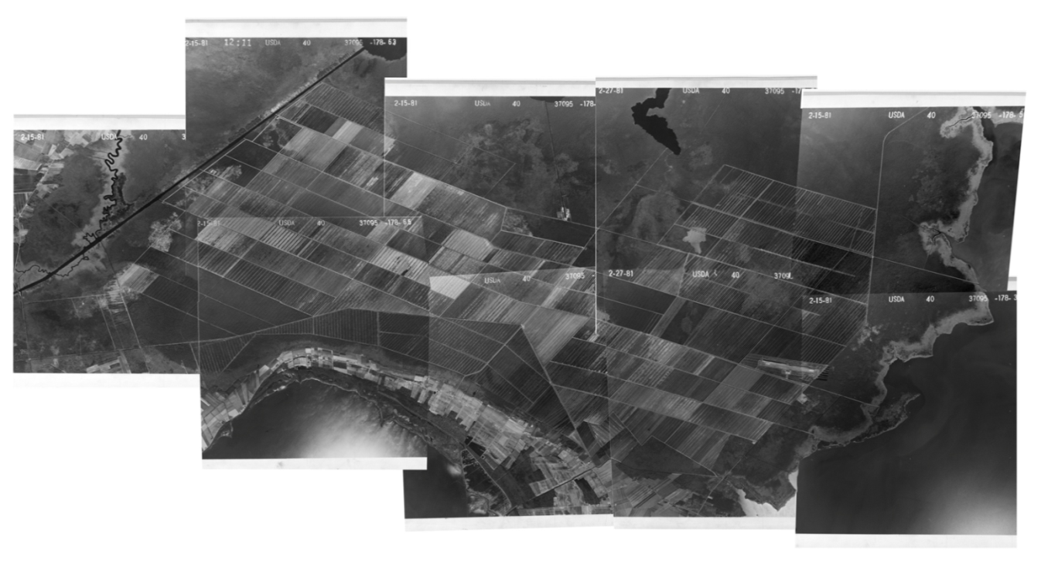
Figure 8. Aerial photograph courtesy of U.S. Forest Service pieced together by Ray Matthews of Nags Head, showing the Mattamuskeet Drainage Association area in 1981. Note the land use changes that occurred since the 1956 photographs were taken.
Pumping in the association has created an artificial diversion of water over the past several decades away from Swan Lake and the Alligator River since much of the historical water flow into these area from the south and east no longer flows in that direction. This pumping activity has contributed to soil subsidence and compaction in the undeveloped areas within the association boundaries and adjacent to it. The diversion of water flow also may have allowed adjacent freshwater systems (Swan Lake and Alligator River) to become more saline, or allowed saltwater to penetrate further into these freshwater habitats, due to the absence of freshwater from the association boundaries. Benefits to these habitats could be realized by the reintroduction of historic freshwater flows.

SHELLFISH CLOSURES OF PAMLICO SOUND
This Plan focuses on identifying projects throughout the association that will restore hydrology and reduce the associations’ need to pump water into surface waters surrounding its boundaries. Given the hydrologic connectivity of the association, what happens within its boundaries is felt throughout. The primary goal of the projects identified is to reduce and remove the water quality impairment at Otter Creek, Berry’s Bay and the Fifth Avenue Canal (Figure 9).

Figure 9. Shellfish Sanitation map of closed areas within growing area G-5. The sampling areas to be restored by this Plan are outlined in green.

The first shellfish closures occurred on March 12, 1985 at Otter Creek and Berry’s Bay and included 66.7 acres of water (Appendix D). According to Shellfish Sanitation sampling data, environmental conditions dictated closed waters between January 1983 and October 1984.

The first closure of the Fifth Avenue drainage canal occurred on October 9, 1987 up to the mouth of the canal, and included 15.5 acres. A later closure occurred on July 21, 1994 that expanded to include another 25.2 acres; bringing the total acreage of closed waters at Fifth avenue canal to 40.7 acres. The total acreage for closed waters adjacent to the drainage association is 105.4 acres; these areas remain closed today.

Water Quality Monitoring Efforts to Date
Several studies to understand the nature and extent of the water quality impairments have been conducted. The association has been a willing participant in all of these efforts. Various groups and universities have monitored the water quality in Otter Creek, Broad Creek, Fifth Avenue and within the association to better characterize these water bodies. What follows is a brief synopsis of these efforts and their various study conclusions.
It is important to note that these studies have been limited in their scope and time frame (most focusing on one year of data collection or less) that limits the ability to conclusively say that the pumping of the association has caused the water quality impairment in the sound. However, based on work in other watersheds (such as Bradley Creek in Wilmington, N.C.), it is believed that the land alterations and increased volume of water flowing to the sound contribute to the impairment. Therefore, management strategies proposed in this plan focus on reducing flow to the sound and restoring habitats and hydrology where possible.

Otter Creek Study
Following the closure of shellfishing waters adjacent to Otter Creek in March of 1985, the state launched an intensive study into the sources of fecal coliform contamination in Otter Creek in 1986 (Figure 10). By 1988, the N.C. Department of Natural Resources and Community Development and the Division of Environmental Management had completed this study on the declining water quality of Otter Creek entitled ”Fecal Coliforms in Otter Creek.”
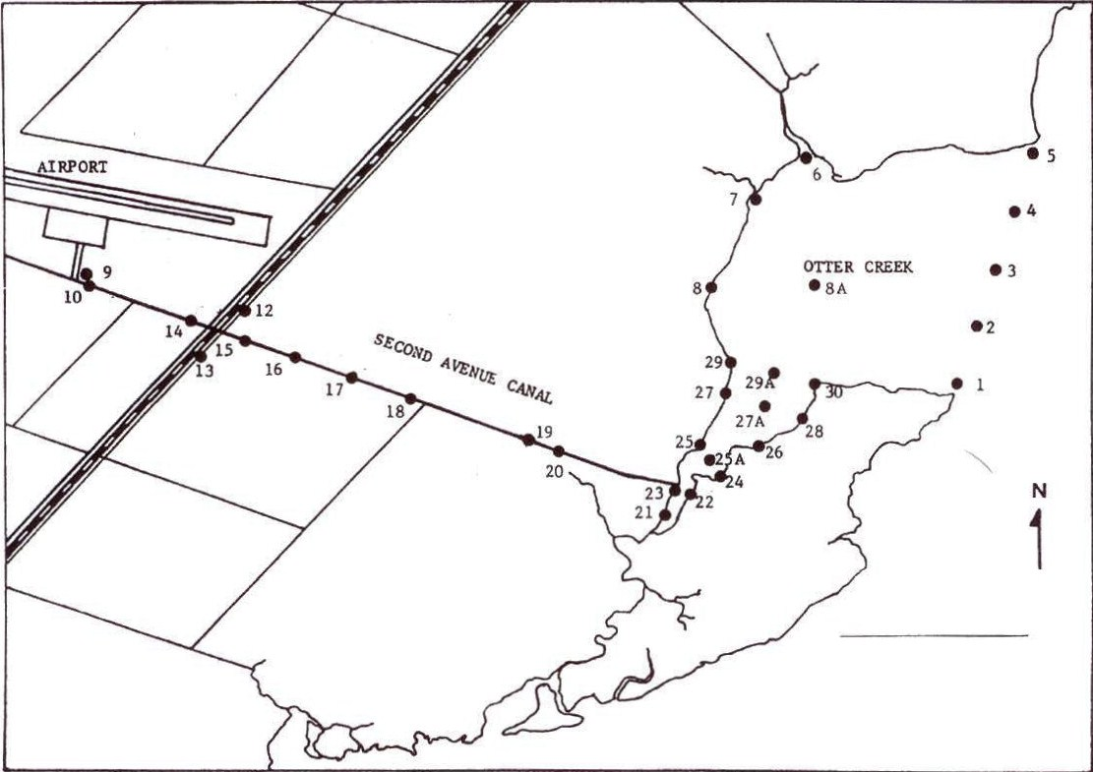
Figure 10. Sampling stations within the Otter Creek study area, 1988. Map courtesy of EMC.
Levels of fecal coliform bacteria fluctuated widely during the study and patterns were difficult to determine. According to Shellfish Sanitation, the study conducted from 1986-1987 did not consider dry weather conditions in the canal, or the notion that the fecal coliform could be coming from a natural source (i.e., wildlife). Additionally, sampling methods at that time were different than current methods employed by the state, and there were still differing opinions over the actual health risks from fecal coliform through non-point sources. Nevertheless, the following conclusions were produced:
- Fecal coliform levels in Otter Creek exceeded 14/100ml in 45-54 percent of the samples.
- Fecal coliform levels in Second Avenue canal could not account for elevated concentrations found in the creek during pump operation or wet weather. Water from the pumping station could not be verified as the source of fecal coliforms to Otter Creek. Overall fecal concentrations, however, were higher in the canal than in Otter Creek.
- Samples were not taken when the pump was on during dry weather. Therefore it was impossible to separate the causative effects of pumping from effects of wet weather drainage. Overall, fecal coliform concentrations were higher in wet than in dry weather and higher when the canal pump was on than when it was off (Similarly, it is important to note that the association generally doesn’t pump during dry weather conditions). However, the sampling event with the highest levels of fecal coliforms occurred following rainfall when the pump was not operating.
- Variations in fecal coliform levels were significantly correlated with fluctuations of other environmental parameters. Fecal coliform concentrations correlated negatively with salinity and positively with turbidity and ammonia-nitrogen.
- The tube and MF methods of fecal coliform analysis correlated positively with each other, but the strength of their relationship varied depending on how data were grouped. Correlation coefficients for these two parameters ranged from 0.376 to 0.730.
- Actual sources of fecal coliforms were difficult to confirm, but could have included bacteria of non-human origin, runoff, the natural creek feeding Otter Creek, and sediments re-suspended during storms, motorboat navigation, or pump operation.

Broad Creek Study
In 1984 a study was initiated to test salinities, fish and shellfish survival, and the impacts of freshwater flushing in Broad Creek (Figure 11).
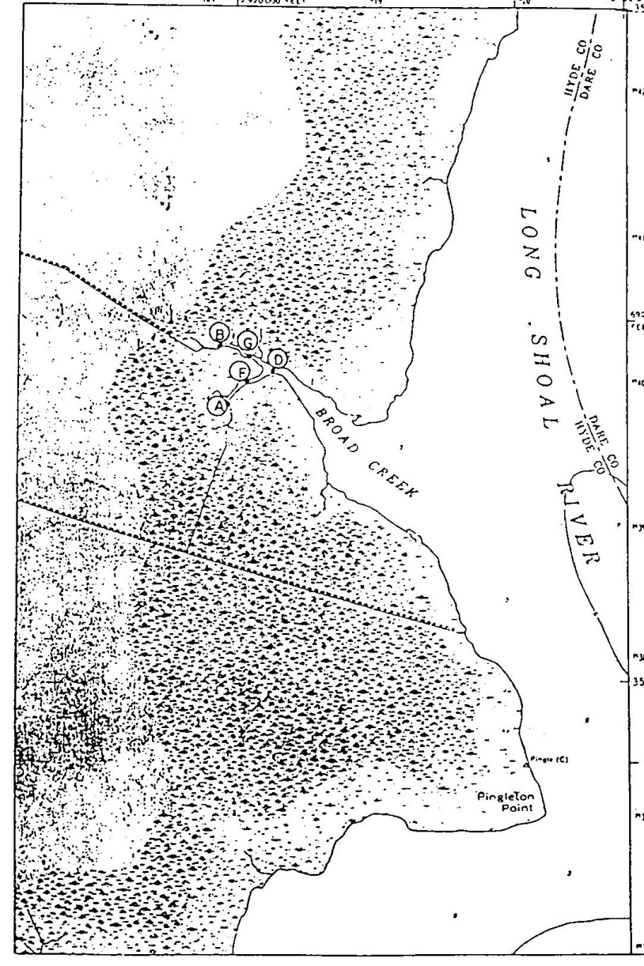
Fifth Avenue
Figure 11. Diagram of Broad Creek study area near Fifth Avenue drainage canal.
With field work occurring from 1986-1987, the Broad Creek study was conducted via the Governor’s Coastal Water Management Task Force. Tests occurred at five stations in the area adjacent to Fifth Avenue drainage canal. To create the freshwater flushing for the tests, a tractor pump drew water from the Fifth Avenue Canal to Broad Creek while the Association pump station was operating at Fifth Avenue. There were several conclusions produced from the study:
- Increased pumping merely strengthened the stratification in the creek and caused a slight increase in bottom salinity.
- Nearly all of the salinity variations in Broad Creek were reflective of wind-driven water level changes.
- Only organisms in the uppermost reaches of a canal were likely to be effected by a drop in salinity due to discharge of freshwater. The greatest risk depended on whether tidal oscillations occurred at the time of discharge.

Shellfish Sanitation Monitoring Efforts
The current protocol for Shellfish Sanitation’s water quality sampling operates on a three year data collection schedule. Within a certain growing area, each station is required to be sampled at least six times per year. This will produce at least thirty sampling days for each station. Generally, the rule for closure of SA waters is 10 percent, or at least three samples exceeding the water quality standard for fecal coliform. In the areas of Otter Creek, Fifth Avenue and Berry’s Bay, Shellfish Sanitation has been sampling since 1974. This sampling data is available through Shellfish Sanitation’s Sanitary Survey Reports.

N.C. Coastal Federation Monitoring Efforts
In addition to the Shellfish Sanitation data that has been collected, baseline water quality monitoring data was collected by the federation as part of this watershed restoration plan in 2011-2012. This data was used to understand the range of water quality within the association.
Grab samples were collected periodically from four to eight locations throughout the drainage district (Figure 13). Samples were collected monthly at the Fifth Avenue, Second Avenue and Barge Canal pump stations. At various times in the year, additional grab samples were collected at the association’s western pump stations and in canals within the association to better characterize the range of water quality in the association. (See Appendix N for DWQ approved QAPP.)
N.C. State University also collected grab samples from lands adjacent to the association in the Alligator River National Wildlife Refuge. These samples were collected as part of their efforts to understand nutrient loading ranges in the association and refuge and guided their modeling and prediction efforts for various projects under consideration.
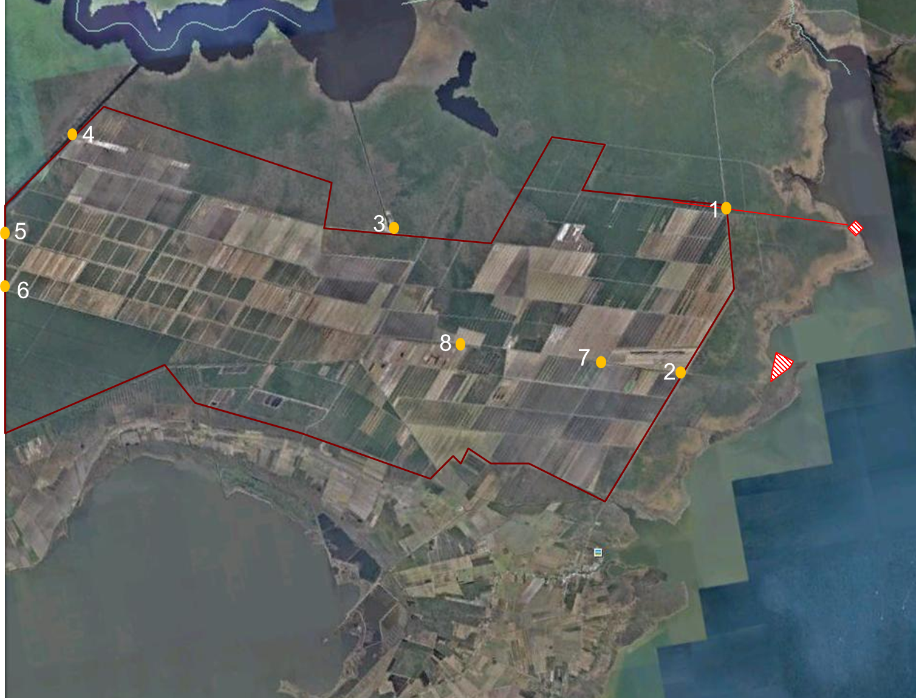
Figure 12. Federation water quality monitoring stations.

Results from the federation’s study indicate:
- High bacteria are present in the association’s waters. This is to be expected as the land within the association supports large populations of wildlife. In the year of sample collection, there was only one sample, collected in June of 2011 that the fecal coliform levels were below acceptable Shellfish Sanitation water quality standards for shellfish consumption.
- Highest levels were observed after Hurricane Irene when the association received approximately 9.94 inches of rainfall in 48 hours.
- Of the nutrients collected, nitrate samples were the nutrient of highest interest. There is not currently a state standard for nutrient samples. Samples collected ranged from 0.2-5.44 mg/L; averaging 0.45 mg/L. Most samples were less than 0.3 mg/L.
- Results from nitrate samples collected by N.C. State University on the adjacent refuge lands ranged from 0.0-0.11 mg/L. This indicates very low background nitrate levels on the refuge. There was concern that by employing one of the management strategies proposed in this plan of redirecting water to the refuge via hydrologic restoration efforts that eutrophication could be a possibility, but the researchers concluded that because there is such huge acreage of possible restored wetlands within the association, most nitrates will convert to nitrogen gas via de-nitrification and will not result in nutrient problems within the refuge or other nearby lands.
Nutrient levels were higher than naturally occurring wetlands, but restoring wetlands and adhering to a water management plan should improve water quality and minimize any possible eutrophication of adjacent properties.

RATIONALE AND DRAINMOD MODELING TO SUPPORT PLAN DEVELOPMENT
The various water-sampling efforts referenced in the previous section indicate high bacteria levels in the association’s waters and adjacent water bodies (Fifth Avenue, Otter Creek and Broad Creek). As mentioned, this is to be expected as the association and surrounding lands support extensive wildlife habitat, and one animal defecating at the right time in the right place can lead to high bacteria levels in the receiving waters. To improve water quality and remove the impairment at Fifth Avenue and Otter Creek, several strategies could be employed: removing the bacteria sources, treating the bacteria, or reducing water flow. These are discussed in more detail below. Reducing water flow was deemed by the plan stakeholders to be the most practical and desired method for reaching water quality standards in the sound.
- The first possible strategy that could be employed in reducing bacteria contamination to SA waters is to remove the bacteria sources. In the case of this watershed plan it is believed that bacteria sources causing the impairment are largely natural. While the Engelhard Waste Water Treatment plant is within the association’s boundary and it has had problems with its lagoon system, it is not thought to be the primary contributor to the water quality problems. The waters of Fifth and Second Avenue were closed to shellfish harvest long before the treatment plant was installed in the association. The Plan’s stakeholders do recommend that the plant be operated in compliance and that any problems be corrected post haste, but the majority of the stakeholders efforts were spent in developing a plan to deal with the natural sources of bacteria that were the original and still primary cause of the water quality impairments. To remove these natural sources would require a strategy that involves removing the birds, bear, deer and other wildlife from the association and surrounding lands. This is not feasible or practical, nor is it desirable.
- A second strategy for reducing bacteria contamination in to SA waters is to treat the flow. This would involve creating a treatment system that is capable of removing the bacteria. A treatment device that is capable of treating large volumes of water to achieve water quality standards for shellfish waters does not exist. If one did, it would be hugely expensive to design, operation and maintain. It would also be necessary to ensure that the discharge did not become re-contaminated once introduced back into the natural bacteria rich landscape. This, like the first option, was also deemed to not be a feasible long-term solution to improving water quality.
- A third option for reducing bacteria contamination is to reduce flow and volume of water reaching downstream into shellfish waters. This solution was deemed the most practical, and was further analyzed by N.C. State University and the watershed restoration plan stakeholders. What follows is the DRAINMOD analysis evaluation used to assess the feasibility of this strategy.
While the water quality impairment described in the previous section currently exists only on the eastern side of the project area, the project team and stakeholder group discussed that the plan would have the most impact if flow from the entire drainage association was considered. The waters of the association are well connected, meaning pumps used on one side of the association can pull water to the other side as well. With this in mind, the strategies and restoration projects identified focus on the main goal of reducing the amount of pumped volume that reaches all receiving waters including the Pamlico Sound, Otter Creek, Alligator River, and the Intracoastal Waterway. The Plan seeks to replicate historic water movement on the association’s land in pre-development times through water reallocation, redirection of flow, and wetland restoration.
The first step of this strategy is to place less desirable agricultural lands into conservation easements by enrolling them in farm bill programs that facilitate the restoration of wetland conditions. To date, nearly 20,000 acres of land within the association have been enrolled in such programs.
In addition to the easement programs and basic restoration that is performed as part of the farm bill programs, additional water quality benefits will be realized by routing water via historic flow patterns. This will be accomplished by installing pumps that will lift water into shallow impoundments which will overflow into restored wetlands and allow the water to return to its natural flow pattern through a wetland system. These methods aim to route water back on to the wetland landscape, and reduce the amount of pumped runoff entering the Pamlico Sound and other receiving waters. Additional benefits of the methods outlined in this Plan include reducing the amount of suspended solids, nutrients, and other quality concerns entering the sound and coastal waters.
Research has indicated that nutrient and sediment loads from pumped agricultural drainage can be substantially reduced within forested wetlands. Hydrology and water quality studies were conducted on two forested wetlands receiving pumped agricultural drainage, one in Dare County and one in Tyrrell County. Water surface elevations were measured and quality samples were collected on a network of stations across the wetlands during various pumping events over a two-year period. The information collected in the field study was used to develop and calibrate a hydrology and water quality model of the system that predicted the nutrient and sediment removal that would occur over a 20 year period of climatological record. Total nitrogen, total phosphorus, and sediment removal rates were greater than 79 percent on the Dare County site where the ratio of drained land area to wetland area was 5:1. Nutrient and sediment removal rates were lower (30 to 60 percent) on the Tyrrell county site where the ratio of drained land area to wetland area was 18:1.
We expect nutrient and sediment load reductions similar to or greater than those observed at the Dare County site since the ratio of drained land area to wetland area will be less than 2:1 and could be closer to 1:1. The previous field studies and the modeling studies showed that sediment and nutrient load reductions increased as the ratio of drained land area to wetland area decreased. For a ratio of 2.4:1, the predicted removal rates for total nitrogen, total phosphorus, and sediment was greater than 85 percent.

N.C. State University DRAINMOD Analysis
To adequately address the shellfish closures on the receiving waters of the eastern side of the association, a hydrological modeling study of the entire association was conducted by engineers at the Department of Biological and Agricultural Engineering at N.C. State University (NCSU). This modeling considers the water movement of the entire 42,500 acres with the main purpose of reducing the amount of total pumped volume that leaves the association in an effort to remove the impairment on the shellfishing waters of Otter Creek, Berry’s Bay and the Pamlico Sound near the Fifth Avenue Drainage Canal.
This study used the water balance model, DRAINMOD, which was specifically developed for the high water table hydrologic conditions such as those within the association. Input data used in the model include soil properties, crop parameters, drainage system parameters, and weather data. The model is capable of calculating hourly values for water table depth, surface runoff, subsurface drainage, lateral seepage, infiltration, and actual evapotranspiration over long periods of climatological data. The reliability of DRAINMOD has been tested for a wide range of soil, crop, and climatological conditions.
The steps in the modeling study were to:
- Create a geo-spatial database of soil, land-use, management and weather data needed for the hydrologic analysis.
- Perform DRAINMOD simulations of the land in its historic condition before it was drained and developed for forestry and agriculture.
- Perform DRAINMOD simulations of the land in its current condition with current land use and management practices.
- Use the DRAINMOD simulation results to develop and evaluate alternative watershed restoration projects.
DRAINMOD requires multiple user inputs related to drainage design (e.g., ditch spacing, depth, surface storage, outlet conditions/pumping rates, etc.), soils (e.g., saturated lateral hydraulic conductivity, infiltration parameters, etc.), crops (e.g., types, rooting depths, etc.) and local weather (e.g., precipitation, evapotranspiration, etc.). These inputs were obtained from existing soil maps and soil data, farm records, existing published values, or by direct field measurement.
Historic and current drainage patterns at the site were determined using historic and current aerial photography, current topography, G.I.S. mapping (soil maps, wetland areas, etc.) and through discussions with local farmers and cooperative extension agents. Historic maps were available at the County Extension Office. N.C. State University used an extensive aerial survey for the site, including digital images and topographic data that were recently conducted and supplied to the federation by GeoData Corporation. Soil maps were also used as indicators of drainage patterns.
Land and crop management practices were determined to simulate the current conditions on the land. Information about different land uses, crop types and planting and harvest dates were collected from the farmers. Also, rainfall records collected on site by the growers were gathered and used as input for the DRAINMOD model.
For simulating the historic conditions, the watershed was divided into individual fields according to the soil type, vegetation type, and historic drainage patterns determined from the database. Each individual field was simulated with DRAINMOD and the predicted outflows were routed through drainage ways to the historic watershed outlets. The vegetation for the historic simulations was assumed to be forested wetland vegetation with continuous deep rooting depths. The simulation results were expressed in terms of predicted outflow (surface and subsurface drainage), and evapotranspiration from individual fields, sub-watersheds, and the entire watershed.
Watersheds for the current conditions were divided into individual fields according to the soil type, land-use and management, and drainage patterns determined from the database. Each individual field was simulated with DRAINMOD and the predicted outflows were routed through the canal system to the pumped watershed outlet. Results from DRAINMOD simulations of the current conditions allowed us to estimate the amount of water that would be pumped from the current drainage district in response to variable weather conditions. For the recent history, the predicted outflows were compared to the pumping records, which served as a validation of the DRAINMOD model.
Simulation results from the validated DRAINMOD model were used to create and evaluate alternative watershed restoration project. The wetland area for each alternative project was delineated and the agricultural area (contributing area) that would contribute outflow to the wetland was estimated based on the size of the pumping station and the location of the wetland. For each alternative, the contributing area was divided into individual fields according to the soil type, land-use, and management. Each individual field was simulated with DRAINMOD and the predicted outflows were routed through the canal system to the pumping station for that project.
The wetland receiving the outflow from the contributing area was simulated using the Contributing Area routine in DRAINMOD. This routine adds outflow from the contributing area to the water balance of the wetland which increases the outflow from the wetland. The lateral seepage routine in DRAINMOD was also used when simulating the wetland, since some of the water pumped on to the wetland will seep back into the contributing area. Therefore, the water balance for the wetland area is:
P + CA = ET + SRO + DRN + LS
Where; P is precipitation, CA is the outflow from the contributing area that is pumped onto the wetland, ET is evapotranspiration form the wetland, SRO is surface runoff from the wetland, DRN is subsurface drainage from the wetland, and LS is lateral seepage from the wetland back into the contributing area. The SRO and DRN from the wetlands may be out of the watershed if the wetland is located on the boundary of the watershed. If the wetland is landlocked in the watershed, the SRO and DRN will eventually find its way back into the watershed. It should be noted that the SRO and DRN flowing from the wetland will have been treated by the wetland whether it flows out of the watershed or back into the watershed.

The different projects were compared in terms of:
Reduction in Pump Load - The percent reduction in the load at the perimeter pumps resulting from the project
Total Pumped Water Treated - The percent of the current total volume of water pumped by the perimeter pumps that is treated by the project. We estimate that at least 85% of the total nitrogen, total phosphorus, and total suspended solids would be removed as the pumped water moves through the project wetland.
Restoration of Historic Flow - The percent of the historic flow to Swan Lake that is restored by the project (only shown for projects draining to Swan Lake)
Pumped Total - The total volume of water that needs to be pumped for the project.
Pumped Total = CA + SRO + DRN + LS. If the wetland project is located on the watershed boundary and the outflow (SRO and DRN) are out of the watershed, then SRO and DRN are zero. Otherwise, SRO and DRN eventually flow back into the watershed and will need to be pumped again, so SRO and DRN are added to the Pumped Total. Lateral seepage, by definition, flows back into the watershed and is added to the Pumped Total regardless of the location of the wetland.
Net Cost of Operation - The pumping cost of the project relative to the pumping cost under current conditions, assuming pumping costs at $6.50 per million gallons
Net Cost = (Pumped Total – Pumped Current) x $6.50
If Net Cost is positive, the project cost is an added cost relative to the current pumping cost
If Net Cost is negative, the project cost is a cost savings relative to the current pumping cost.
Under natural historic conditions, it is believed some water from the drainage district flowed north to the Alligator River. As part of the DRAINMOD study, calculations were made to determine how much water could be restored to its original flow patterns without impacting the natural systems of the Alligator River National Wildlife Refuge, which lies immediately to the north.
Ten projects were identified and modeled to assess their impact on flow reduction to the sound. Most of the projects involved restoring wetlands and historic water flows. One proposed project, L5, was designed to recycle drainage water for crop irrigation. Project descriptions and modeling results are included in the Plan’s strategies and goals section.

EXISTING MANAGEMENT STRATEGIES
Past land use history in the association has focused more on removing water from the landscape as quickly as possible, and less on adjacent water quality preservation. However, the association ownership and management recognize the need to change water management techniques and have exhibited an unprecedented willingness to collaborate with various state, federal, environmental and research institutions in a commitment to protect and restore water quality. Recent efforts by association members focus on reducing the volume of pumped stormwater into the Pamlico Sound by restoring the historic northward flow of groundwater through wetlands restoration and stormwater reallocation into filtration areas. The association plans to continue these efforts and expand them to realize improved water quality in the sound.
The association was formed in 1977, where the impetus for formation was based upon improving drainage and providing adequate access to all properties. Of greatest importance to the landowners at the time was the assurance that the original 37,000 acres of land could be parceled out into smaller pieces to ensure greater success in selling. This formation of the association ensured a vast improvement for the local Hyde County economy through the following avenues: (1) an increased number of available jobs on now-suitable farmland, (2) Increased land value and tax base, (3) Enablement of public use facilities such as Hyde County Airport and Sanitary District, as well as (4) Recreational opportunities. Today, the association lands total 42,500 acres and is managed by a three person Board of Directors, who represents a total of 42 landowners.
New to the association in 2011 is a land use classification system, created for more equitable assignment of association assessment fees. The categories are as follows: commercial, agricultural, non-agricultural, blocked drainage, and undeveloped (Table 2).

Mattamuskeet Drainage Association
Land Use | Acreage | Percent of Total
Agricultural | 14,598.1 | 34.5
Non-agricultural | 13,729 | 32.4
Blocked Drainage | 7,561.7 | 17.9
Undeveloped | 6,271.1 | 14.8
Commercial | 156.7 | .3
Table 2. Land Use Categories for the Mattamuskeet Drainage Association. See Appendix A for details.
Understanding these current land uses in the association and working under the premise of identifying ways to remove the water quality impairment in the sound, a stakeholders group was created by the partnership of the federation, landowners, farm managers, scientists, and various state and federal officials. This group worked to identify bacterial and pollutant pathways through the drainage district, suggest potential BMPs and restoration projects, point out potential hazards, and rank proposed projects by their feasibility and contribution to improving water quality.
It is highly unusual for such restoration projects to have the enthusiastic support of local farmers. In this case, their willingness to collaborate comes from several factors: their desire to hold back some water for irrigation, improve water management capabilities, improve wildlife habitat for enjoyment and hunting purposes, and their hope to protect their fields from salt water intrusion. In addition, hydrologic restoration projects present farmers with an opportunity to improve their water management capabilities and to demonstrate their interest in preserving the lands and waters that they depend on for their livelihoods, while minimizing impacts to their nonfarm neighbors.
The Wetlands Reserve Program (WRP) offers a unique opportunity to realize many of the goals of this watershed restoration plan. The program purchases conservation easements on prior converted lands and restores them to basic wetland function. It was first used in the association in 1992. The WRP is a voluntary program established through USDA Natural Resources Conservation Service (NRCS) that offers landowners the opportunity to protect and restore wetlands on their property. NRCS’ main role is to provide technical and financial support to aid landowners in restoring wetlands on personal property. For every acre enrolled, the ultimate goal is to gain the greatest wetland function and value in addition to prime wildlife habitat.
Through a WRP permanent easement, the USDA pays 100 percent of the easement value, and thusly 100 percent of the restoration efforts. All present easements on the association are permanent. Under these easements, the landowner retains the following rights:
(1) control of access, (2) title and right to convey title, (3) quiet enjoyment, (4) undeveloped recreational uses, (5) subsurface resources, and (6) water rights.³
These first enrollments on the association in 1992 totaled 5,000 acres. By 2002, an additional approximate 7,000 acres were enrolled, followed by 8,000 more in 2012. Today, there are approximately 20,000 acres of prior converted land enrolled in the WRP program; nearly half the total acreage of the association (Figure 13).
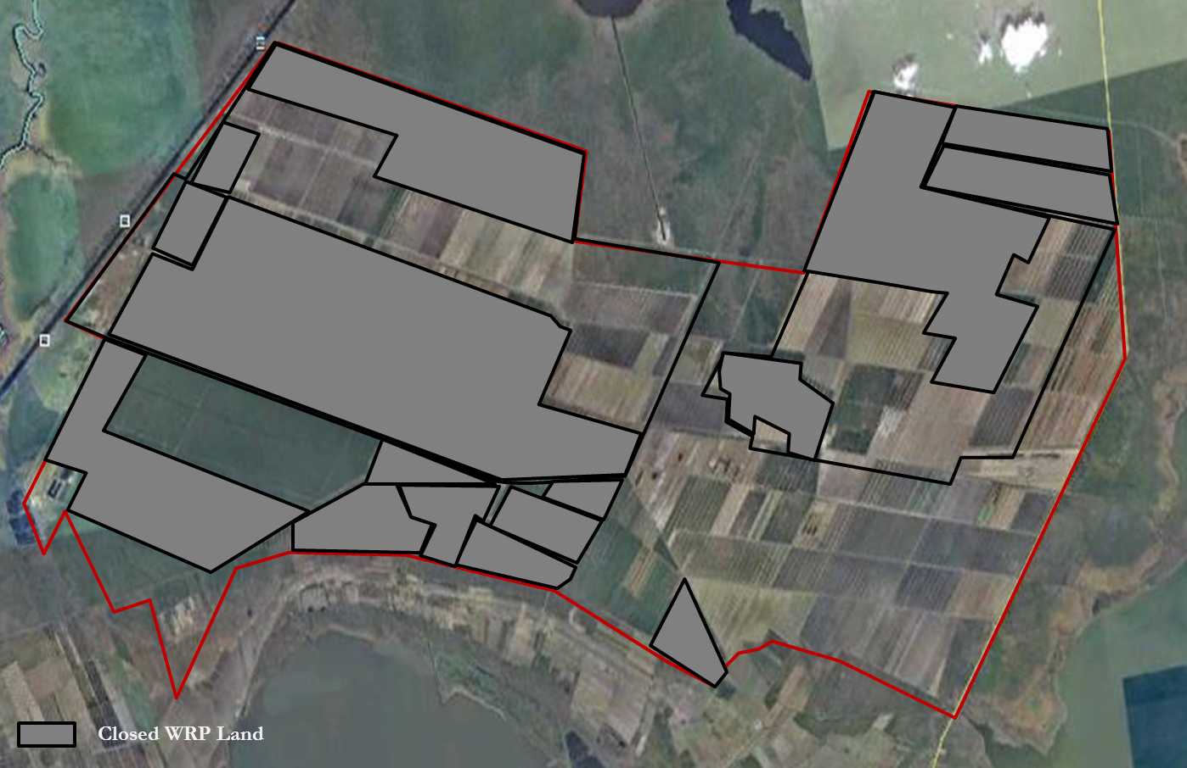
Figure 13. WRP lands within the Mattamuskeet Drainage Association.
These conservation easements and the desire to restore wetlands as part of the program plays heavily into the proposed strategies for realizing water quality improvements at Fifth Avenue and Otter Creek.

GOALS, OBJECTIVES AND MANAGEMENT ACTIONS
The primary goal of this Plan is to remove the water quality impairment in waters of Otter Creek, Berry’s Bay and Fifth Avenue. This will be achieved by the secondary goal of reducing the volume of water that is pumped directly into coastal water bodies by restoring or replicating the natural flows of groundwater where practicable. The restoration of these impaired waters will allow SA waters to be eventually reopened for shellfish harvest through the pursuance of these aforementioned primary and secondary goals.
The impaired waters that are the focus of this goal are waters classified as SA. The impaired waters include:
- Otter Creek: 54.5 total acres closed;
- Pamlico Sound: 40.7 total acres closed near the Fifth Avenue drainage canal; and
- Berry’s Bay: 10.2 acres closed south of Otter Creek.

This goal will be accomplished by working towards five objectives and twenty-one management actions identified below. Over time, reductions in the volume of stormwater that is redirected as a result of this Plan will result in measurable water quality improvements that will be realized by gradual increases in opportunities to harvest shellfish in these waters. The objectives and management actions of this Plan include:

Objective One: PROMOTE EFFORTS TO REDUCE PUMPING VOLUME TO COASTAL WATERS
Action 1-1: Identify, prioritize and implement restoration projects to achieve flow reduction from the Mattamuskeet Drainage Association.
Action 1-2: Facilitate project implementation and evaluate success.
Action 1-3: Acquire additional lands through fee-simple or place easements on land that could be incorporated into plans for flow reduction.
Action 1-4: Core dikes around restoration projects and drainage association perimeter to improve water management and reduce pumping need.
Action 1-5: Continue landowner education and participation to reduce water flow from association lands.
Action 1-6: Develop a water management plan for projects and the association that minimizes pumping to the Pamlico Sound to achieve Shellfish Sanitation’s water quality compliance. Set 5, 10 and 15 year goals for pump volume reduction.

Discussion of Approaches to Achieving Management Actions
The federation has worked with the association and other partners to identify and implement future projects, as well as rank current flow reduction projects within the association. As part of the plan’s primary effort to reduce the amount of pumped volume into coastal waters, the following projects, currently complete or proposed within the association, are listed and described below.

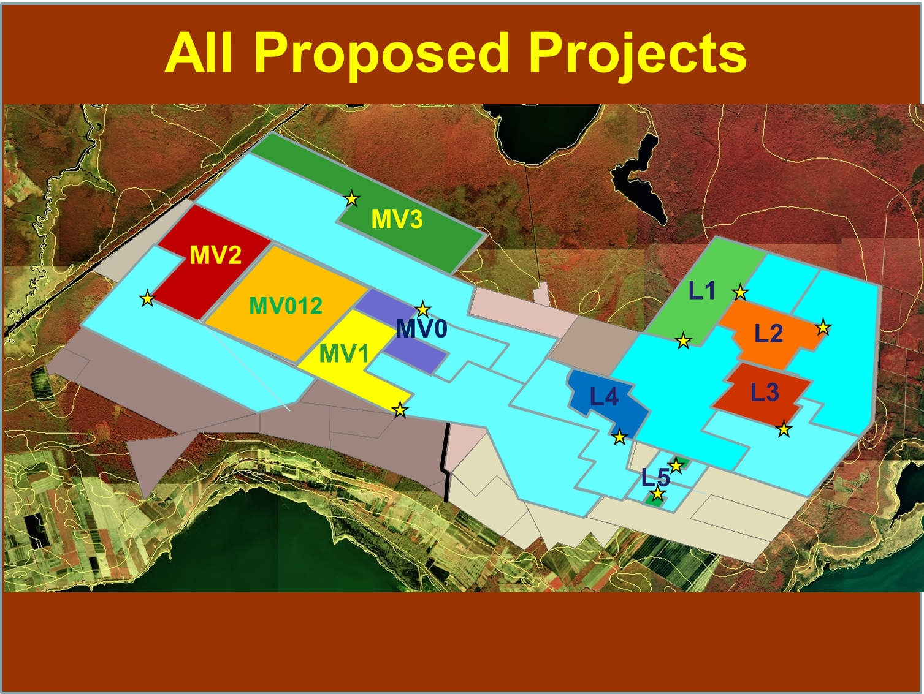
Figure 14. Proposed projects within the Mattamuskeet Drainage Association. NCSU.

Current and Future Projects
The design and predicted performance of each project is described below. The predicted performance of the projects was the results of the DRAINMOD modeling study. A summary table of the performance of each project is shown in Appendix M.

Wetland Restoration Project Phase 1 (L1)
This project will restore 1,400 acres of prior converted wetlands. The land has been enrolled in a permanent WRP easement and basic wetlands restoration will be completed. Additional water quality benefits and restoration of historic hydrologic flows will be realized through the implementation of enhancement activities funded by grants awarded to the federation from the N.C. Clean Water Management Trust Fund. This additional enhancement work involved installing four, 24 inch pumps at two pump station locations that will pump agricultural drainage water on to the wetland. The percentage of historic flow that will be restored to Swan Lake is expected to be 34.2 percent. Implementation of this project is expected to result in a 9.1 percent reduction in the volume of water pumped from the association. Nearly all of this reduction will be from the water currently pumped through the Second and Fifth Avenue Pump Stations to the sound. This wetland project would treat 7.6% of the total water currently pumped from the watershed.

This project is predicted to produce a $2,315 savings in operation costs per year. The cost of this project is estimated at $777,000, and the total predicted cost of the project over 20 years is $36,600 per year.

Wetland Restoration Project Phase 2 (L2)
This project aims to restore 950 acres of prior converted wetlands. The land is enrolled in a WRP easement, and basic wetland restoration will be performed on the land in the coming years. Additional water quality benefits and restoration of historic hydrologic flows may be realized through the implementation of enhancement activities funded by grants. Grant funds are not yet encumbered for this project and the landowner is not fully committed to this project. However, conceptual plans for this restoration have been drafted and involve installing a pump station to redirect agricultural runoff to a 150-acre impoundment reservoir. The water from the reservoir would overflow into restored sloughs or be available for fire suppression in nearby timberlands or subsurface irrigation on adjacent agricultural fields. The percent of historic flow that could be restored to Swan Lake through this project design is predicted to be 24.6 percent. This project could result in a 6.5 percent reduction in the total amount of water pumped from the association. Nearly all of this reduction will be from the water currently pumped through the Fifth Avenue Pump Station to the sound. This wetland project would treat 5.4 percent of the total water currently pumped from the watershed.

This project is predicted to produce an $803 savings in operation costs per year. The cost of this project is estimated at $388,000, and the total predicted cost of the project over 20 years is $18,600 per year.

Wetland Restoration Project Phase 3 (L3)
This project aims to restore 850 acres of prior converted wetlands. The land is enrolled in a WRP easement, and basic wetland restoration will be performed on the land in the coming years. Additional water quality benefits and restoration of historic hydrologic flows may be realized through the implementation of enhancement activities funded by grants. Grant funds are not yet encumbered for this project and the landowner is not fully committed to this project. However, conceptual plans for this restoration have been drafted and involve installing a pump station to redirect agricultural runoff to one or two reservoirs totaling 200 acres. The water from the reservoir(s) would overflow into restored sloughs or be available for fire suppression in nearby timberlands or subsurface irrigation on adjacent agricultural fields. The percentage of historic flow that could be restored to Swan Lake is estimated to be 17 percent. Implementation of this project could result in a 4.5 percent reduction in the volume of water pumped from the association. Nearly all of this reduction will be from the water currently pumped through the Second and Fifth Avenue Pump Stations to the sound. This wetland project could treat 5.4 percent of the total water currently pumped from the watershed.

This project is predicted to produce a $523 savings in operation costs per year. The cost of this project is estimated at $388,000, and the total predicted cost of the project over 20 years is $18,900 per year.

Wetland Restoration Project Combined Phase 123 (L123)
This section presents the effects of the combination of the L1, L2, and L3 project. The combined project will restore 3,200 acres of prior converted wetlands. Volume of water directed to this area was modeled to be approximately 3610 mGal per year. Implementation of this project is expected to result in a 20 percent reduction in the volume of water pumped from the MDD watershed. Nearly all of this reduction will be from the water currently pumped through the Second and Fifth Avenue Pump Stations. In terms of the volume of water currently pumped through the Second and Fifth Avenue Pump Stations, the volume of water pumped to the sound will be reduced by 55 percent. The percentage of historic flow restored to Swan Lake could be 75.3 percent. This wetland project would treat 16.7 percent of the total water currently pumped from the association.

This project is predicted to produce a $5,552 savings in operation costs per year. The cost of this project is estimated at $1,550,000, and the total operation cost over 20 years is $74,000.

Water Storage and Reuse Project 1 (L4)
This project aims to restore 600 acres of prior converted wetlands. This project involves enrolling the land in a permanent WRP conservation easement. Enrollment was completed in 2011. Basic wetlands restoration will be performed by NRCS in the coming years. Additional water quality benefits and restoration of historic flows may be realized by the implementation of enhancement activities funded by grants. Grant funds are not yet encumbered for this project and the landowner has made no commitment to the enhancement activities described herein. However, conceptual plans for this restoration have been discussed and involve installing a pump station to redirect agricultural runoff to the 600-acre area. Water could be directed into a flume canal running through the middle of the restoration area and could then flow laterally into the entire 600-acre block. Volume of water directed to this area has been modeled to be approximately 618 mGal per year. Implementation of this project could result in a 0.1 percent reduction in the volume of water pumped from the association. Most of this reduction could come from the water currently pumped through the Second Pump Station. This wetland project would treat 2.9 percent of the total water currently pumped from the watershed.

This project is predicted to produce a $3,750 increase in operation costs per year. The cost of this project is estimated at $260,000, and the total cost of the project over 20 years is $16,700 per year.

Water Storage and Reuse Project (L5)
This project involves storing water on two 60-acre tracts of land leased for farming. The land is currently actively farmed. The landowner may be willing to remove the acreage from crop production to realize water reuse capabilities. This project would build cored dikes to hold 4-5 feet of water in the 60 acre impoundment areas. The water would be lifted via a pump. Once lifted and stored the water would be available for reuse in adjacent agricultural fields for irrigation. The storage and water reuse is expected to result in a 0.2 percent reduction in the volume of water pumped from the association. Nearly all of this reduction will be from the water currently pumped through the Second Pump Station to the sound. This wetland project would treat 1.4 percent of the total water currently pumped from the watershed.

This project is predicted to produce a $793 increase in operation costs per year. The cost of this project is estimated at $360,000, and the total cost of the project over 20 years is $18,800 per year. If properly managed, this project will increase the crop yields on the irrigated lands by 5 to 8 percent. Profits from these yield increases will offset the annual cost of this project.

Wetland Ventures for Shorebirds Project (MV0)
This project involves redirecting water to approximately 600 acres of prior converted land, enrolled in the NRCS WRP program with basic restoration complete. Construction of enhancement features on this project was completed in 2010 and it will be operated under a management agreement between the landowner and the federation for a minimum of ten years. The project goals are to improve water quality and create migrating shorebird habitat. A grant through the Partners for Fish and Wildlife Program to the federation allowed for a 24-inch pump to be installed in the northern block, which directs water into a flume canal which is then diverted into eight management units. Water control structures and dikes are used to manage the water for quality improvements and to create needed foraging grounds for migrating shorebirds. Modeling results indicate that this project has resulted in a 0.4 percent reduction in the volume of water pumped from the watershed. This wetland project treats 1.8 percent of the total water currently pumped from the watershed.

As currently designed, without an eventual outlet from the association, this project is predicted to produce a $1,712 increase in operation costs per year. The construction cost of this project is estimated at $196,000, and the total cost of the project over 20 years is $11,500 per year. However, this project is one phase of a multi-phase implementation plan that involves constructing MV 1 and 2 in combination with this project and may result in improved water quality benefits as well as significant cost savings and reductions in the volume of water pumped from the watershed. See description below for project MV012 for how this project will work in concert with the other two phases currently planned.

Wetland Restoration Project Phase 1 (MV1) - This project aims to restore 1,350 acres of prior converted wetlands. This project involves enrolling the land in a permanent WRP easement and performing basic wetlands restoration. Additional water quality benefits and restoration of historic hydrologic flows will be realized through the implementation of enhancement activities funded by grants awarded to the federation from the CWMTF and APNEP. This additional enhancement work involves installing one 40” pumps at a location that will redirect water from the First Avenue canal into the project area. The pump will remove approximately 1 inch of runoff from 1,000 acres in 24 hours. The pump station will collect runoff waters from 2,000 acres of crop land by the existing canal drainage system and lift the water into blocks (cells) as shown on the project map. This is expected to result in a 0.5 percent reduction in the volume of water pumped from the watershed. Most of this reduction will be from the water currently pumped through the Second Avenue Pump Station to the sound and through the First Avenue Pump Station to the Intracoastal Waterway. This wetland project would treat 6.6 percent of the total water currently pumped from the watershed.

This project is predicted to produce an $8,250 increase in operation costs per year. The construction cost of this project is estimated at $360,000, and the total cost of the project over 20 years is $26,300 per year. However, as explained in the shorebird project description, this project is one phase of a multi-phase implementation plan that involves constructing MV0 and MV2 in combination with this project and will result improved water quality benefits as well as significant cost savings and reductions in the volume of water pumped from the watershed. See description below for project MV012 for how this project will work in concert with the other two phases currently planned.

Wetland Restoration Project Phase 2 (MV2) - This project will restore 1,500 acres of prior converted wetlands in 6 blocks of land. This land has been enrolled in a permanent WRP easement and has basic WRP wetland restoration completed on four of the blocks of land. Basic restoration will be completed on the remaining two blocks. Additional water quality benefits and restoration of historic hydrologic flows will be realized through the implementation of enhancement activities funded by grants awarded to the federation or landowner. Currently funding does not exist for these additional enhancement activities. The enhancement work proposed will involve installing one 30” pump station that will redirect water from the adjacent 1,750 acres of crop land. This is expected to result in a 0.3 percent reduction in the volume of water pumped from the watershed. Most of this reduction will be from the water currently pumped through the Second Avenue Pump Station to the sound and through the First and Fourth Avenue Pump Stations to the Intracoastal Waterway. This wetland project would treat 5.7 percent of the total water currently pumped from the watershed.

This project is predicted to produce a $7,254 increase in operation costs per year. The construction cost of this project is estimated at $388,000, and the total cost of this project over 20 years is $26,700 per year. However, as explained in the shorebird and MV1 project descriptions, this project is one phase of a multi-phase implementation plan that involves constructing MV0 and MV1 in combination with this project and will result improved water quality benefits as well as cost savings and reductions in the volume of water pumped from the watershed. See description below for project MV012 for how this project will work in concert with the other two phases currently planned.

Wetland Restoration Project Combined Phase 012 (MV012) - This project combines the three above phases and adds the 2,560 acres between MV1 and MV2 to make a total wetland area of 6,000 acres. This entire project would require a connection or discharge outside of the drainage association watershed in order to be truly effective, and have the pumped volume reduction benefit. The total combined reduction in the volume of water pumped from the association’s pump stations would be 18.7 percent. Most of this reduction will be from the water currently pumped through the Second Avenue Pump Station to the sound and through the First and Fourth Avenue Pump Stations to the Intracoastal Waterway. This wetland project would treat 13.7 percent of the total water currently pumped from the watershed.

This project is predicted to produce a $9,323 savings in operation costs per year. The cost of this project is estimated at $1,550,000, and the total cost over 20 years is $68,400 per year.

Wetland Restoration Project Phase 3 (MV3) - This project will restore 2,100 acres of prior converted wetlands in 5 blocks of land. This land has been enrolled in a permanent WRP easement and basic WRP wetland restoration is currently being designed. Additional water quality benefits and restoration of historic hydrologic flows will be realized through the implementation of enhancement activities funded by grants awarded to the federation or landowner. Currently funding does not exist for these additional enhancement activities. The enhancement work proposed will involve installing one 30-inch pump station that will redirect water from the adjacent 1,750 acres of crop land. This is expected to result in a 12 percent reduction in the volume of water pumped from the association’s pump stations. Most of this reduction will be from the water currently pumped through the Fourth Avenue Pump Stations to the Intracoastal Waterway. This wetland project would treat 9.7 percent of the total water currently pumped from the watershed.

This project is predicted to produce a $3,633 savings in operation costs per year. The cost of this project is estimated at $955,000, and the total cost over 20 years is $44,200 per year.

SUMMARY OF PERFORMANCE PREDICTIONS OF THE PROJECTS
The performances of the projects were different depending on restored wetland size, volume of water pumped onto the wetland, and location of the wetland project in the watershed. All of the projects had significant water quality benefits, since the pumped agricultural drainage water was allowed to flow through a wetland. Based on past studies and the low ratios (less than 2:1) of contributing area to wetland area, we estimate that over 85 percent of the total nitrogen, total phosphorus, and total suspended solids will be removed from the agricultural drainage water. The main differences in water quality benefits provided by each project depended of the amount of water pumped on to the wetland.

Differences in the performances of the projects were greater when compared in terms of the reductions in volumes of water pumped from the watershed and the operational costs. The main factor affecting these performance criteria was the location of the project relative to the watershed boundary. This location determined whether or not the outlet for the runoff from the wetland was outside of the watershed. Projects located on the watershed boundary (L1, L2, L3, L123, MV3, and MV012) showed the greatest reductions in the pump load at the existing perimeter pumps, since runoff flowed out of the watershed. These projects also showed reduced operational costs since the wetland area was removed from the watershed and outflow from that area no longer needed to be pumped by the perimeter pumps.

The individual landlocked projects (L4, L5, MV0, MV1, and MV2) showed much lower reductions in pump loads and higher operational costs. This was due to the fact that much of the water pumped onto the wetland eventually flowed back into the watershed as runoff or seepage since there was no other outlet for the excess water. The added operational costs came from the need to pump this excess water a second time to remove it from the watershed. There were some small reductions in pump loads which were due to the increase in evapotranspiration that would occur on the wetlands receiving pumped drainage water.

An example of the impact of project location can be seen in the advantages gained by combining MV0, MV1, and MV2 with the 2,560 acres of wetland between MV1 and MV2 to make the MV012 project. This combination of project would allow an outlet to be created from the wetland projects to the Intracoastal Waterway. This outlet would route the runoff from the wetland out of the watershed and effectively remove the landlocked status of MV0, MV1, and MV2. The resulting project, MV012, would greatly reduce the pump load on the perimeter pumps and reduce operational costs. It is possible that this project could receive more agricultural drainage water from the area draining to the Second Avenue Pump Station and further reduce the amount of water being pumped into the sound.

As a continued task of the Plan, additional funding will be sought to implement and model the effects of future projects. To accomplish this work, the continuation of stakeholder group meetings and a continued relationship with long-term partners is paramount.

To establish official ranking criteria for projects, partners chose three main factors to classify project success: water quality, habitat diversity, and funding availability. L1, L123, MV012, and MV3 ranked highest using these criteria. As explained above, the combination of individual projects (i.e., L123, MV012) enhances project success. Funding is secured for portions of the highest ranking projects.

As an additional effort to reduce pumped volume, the stakeholders encourage that land deemed less suitable for agricultural use consider enrollment in WRP. There are already several projects proposed on lands enrolled in the WRP program (Figure 15). While land may be suitable for agricultural use and simultaneously appealing for restoration efforts, partners realize the business interests of the association and the importance of livelihood preservation. However, should landowners desire to enroll their lands in WRP, the federation and other project partners will write letters of support to endorse particularly important land acquisition into the WRP program. Particularly if these letters would enhance the progress of outlined restoration practices within the association and facilitate a property’s acceptance into the WRP program. Acceptance into the WRP program allows restoration efforts within the association to continue, as well as enhancing the overall goal of a reduction in pumped volume to the Pamlico Sound.

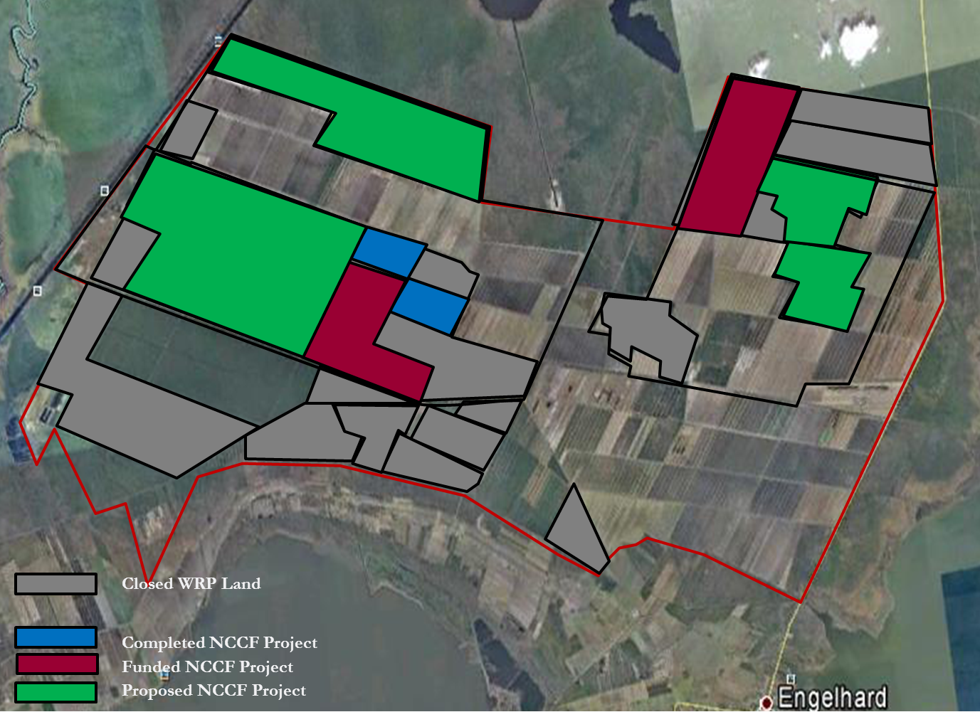

Figure 15. Proposed projects on WRP lands within the Mattamuskeet Drainage Association.
In addition to WRP enrollment, the federation and association will explore fee simple acquisitions. Under these plans, land can be donated while the landowner receives tax benefits from the donation. In other circumstances both a purchase and donation can occur, where land can be sold below market value, while the landowner donates a portion of the property’s value to the buyer. It may be possible for the federation to contribute funds for easement purchase on lands especially crucial to restoration project success.

For those lands already enrolled in the WRP program, the use of Wetland Reserve Enhancement Program (WREP) funds should be considered to expedite the restoration. The federation is currently managing a project for the Natural Resources Conservation Service (NRCS) where by lands in easement are designed for restoration by outside contractors. Typically NRCS handles most wetland restoration design on WRP projects. However, because of a bottleneck effect that NRCS was experiencing where they had more WRP enrollments than engineers available on staff to complete the restoration designs, a WREP grant was secured allowing the federation to coordinate NRCS’s design efforts under their guidance and tutelage. Through stakeholder meetings and participation in both WRP and WREP, the potential for long-term agency partners is possible to create a stable funding mechanism.

Given the connectivity of the drainage association despite property lines and differing restoration project plans and boundaries, the possibility of coring dikes around restoration projects will prove to be essential to project efficacy. Through sub-surface seepage and dike overflow, the compartmentalization of project areas is difficult in such an area. Additionally, the cost of coring the entire association’s perimeter is highly prohibitive; therefore, encouraging detection of areas with particularly bad seepage rates is paramount.
One method for coring dike surrounding parts of the association and individual projects is by using a compacted mineral core in an earthen dike which will reduce the high permeability that exists in the native organic soils. It is possible that the association could perform these capital improvements through their annual fee. To determine which areas exhibit the highest permeability, the use of ground-penetrating radar is known to be effective. NRCS has agreed to donate personnel in 2013 to aid in this data collection.
In addition to an earthen baffle, another option for coring is the installation of a liner material. Given the high costs of coring and the high mileage perimeter of the association, cost savings may be accomplished by using this technique as opposed to constructing an earthen dike.
To pinpoint problematic seepage areas along the association’s perimeter, the stakeholders group has recommended that Eight Street and areas around the Second and Fifth Avenue pump stations be scanned first, followed by other areas in the association outlined in Appendix L. Additionally, the area near the barge canal is very susceptible to flooding following long periods of north wind (Figure 16) and would benefit from a raised dike along this stretch to prevent overtopping and therefore decreasing the volume of water that the association has to manage.

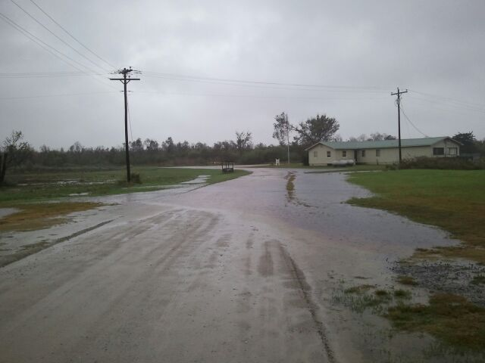
Figure 16. Flooding near the Barge Canal following heavy north winds.
In addition to acquiring parcels of land solely for restoration efforts, there are ways to better use land not already under easement (yet potentially planned for restoration) due to a variety of different land uses within the association. This Plan seeks to educate landowners practicing different land uses on water management strategies that could reduce reliance on perimeter pumps. This will thereby reduce pumped volume to the Pamlico Sound. Each land use practice has a unique potential to aid in the reduction of this drainage.
As an example, many properties are managed for waterfowl hunting and impoundments. As a waterfowl impoundment, certain blocks of land will be flooded during the season, which is typically late fall to early January. Water control structures retain water for this period of time. However, once the waterfowl season ends, flashboard risers are typically removed. Some, but not all, landowners pull the boards all at once, adding a large surplus of water to the association’s drainage system. To reduce pumped volume, this water can be released slower by pulling one or two boards at a time and allowing the water to be better assimilated into the association’s system. This slow release would ultimately reduce the amount and rate at which runoff is pumped into the Pamlico Sound.
For land uses that are mainly agricultural, there is the opportunity to use vegetative filter strips along in-field drainage ditches. The Conservation Reserve Program (CRP) and the Conservation Reserve Enhancement Program (CREP) in North Carolina are a source to employ this method. The CREP program in N.C. was created to improve the water quality of the Albemarle-Pamlico estuary. Installing filter strips is a listed CRP/CREP practice. The use of this method helps to reduce the amount of nutrients and bacteria that are flushed into association canals and Pamlico Sound.
The possibilities of better agricultural water management should be explored further among the Association’s members, the federation would be a willing partner in this process. As part of this Plan, fact sheets and public outreach materials will be created to educate Association landowners on water management alternatives that could provide significant water quality benefits and cost savings.
Much like the plans that will be created for individual restoration projects, this Plan aims to create an association water management plan that continually addresses the overall goal to reduce the volume of runoff that leaves the Association boundaries. As part of the association’s water management plan, there will be five, ten and fifteen year goals for pump reduction. Much like the individual project water management plans this association-wide water management plan will be evaluated annually at stakeholder group meetings. This larger scale water management plan will aim to monitor and document the flow reductions that occur as a result of the combined project implementation. The Association, and select project partners, will evaluate the efficacy of the watershed management plan.
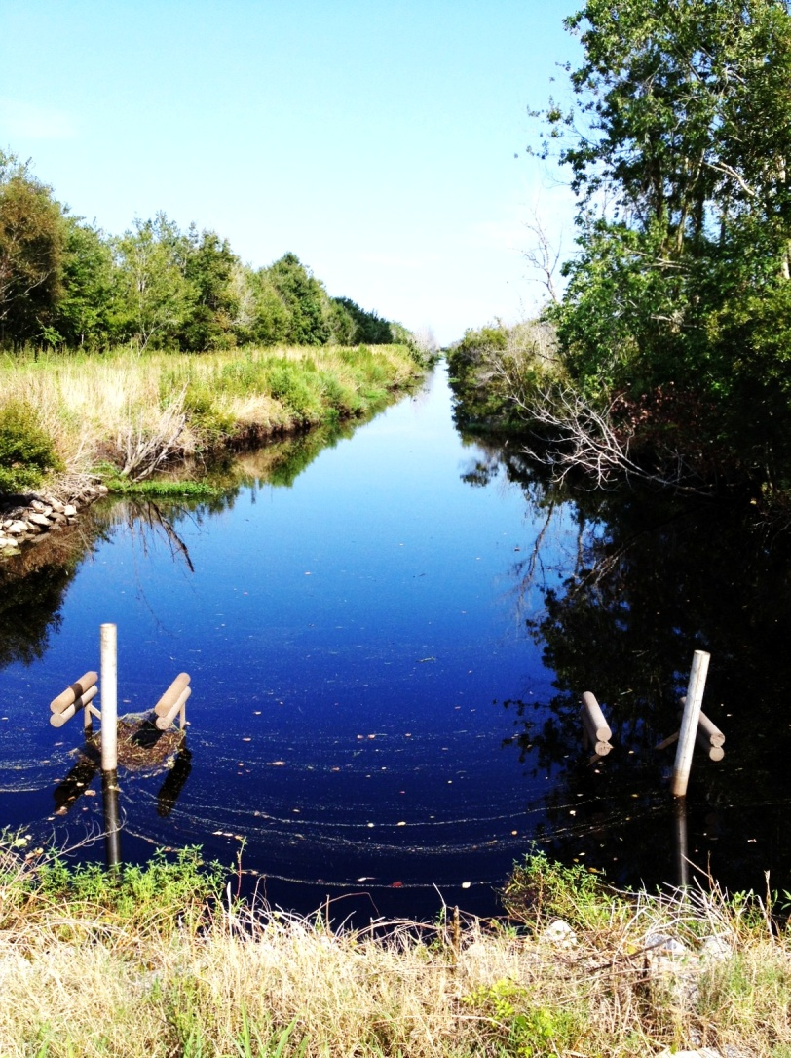
Figure 17. Pumps off at Fifth Avenue drainage canal.

Objective Two: CONTINUE MANAGING CURRENT PROJECTS
Action 2-1: Continue management of the “Wetland Ventures for Shorebirds” Project. Continue implementing and assessing efficacy of the water management plan.

Action 2-2: Continue to monitor and maintain water control structure, project pumps and dikes, including those not collectively maintained by the association.

Action 2-3: Maintain stakeholder group meetings to establish a framework to discuss quality control, project improvements, challenges, and successes.

Action 2-4: Continue Shellfish Sanitation’s water quality testing at Otter Creek, Berry’s Bay, and Fifth Avenue Pump Canal.

Action 2-5: Continue to support the association’s goals and objectives to meet water quality standards.

Discussion of Approaches to Achieving Management Actions
This Plan reaffirms the need for existing projects that are helping to address water quality impairments near the Mattamuskeet Drainage Association. These existing and proposed future projects will serve to prevent additional increases in stormwater runoff volume from flowing to the sound.
Currently, a 600-acre water quality and impoundment project has been constructed in the association. This project is referred to as the “shorebird project” or “wetland ventures for shorebirds”. It has a water management plan that was developed by USFWS that aims to create foraging habitat for migrating shorebirds and to improve water quality by redirecting otherwise discharged runoff into the project area. This Plan encourages the continued management of the shorebird project. The federation, USFWS and the landowner have an established 10-year agreement to manage the project that includes annual project review and adaptation meetings, where an open forum on project efficacy and management can be discussed.
For the true benefits of this Plan to be realized, the association’s Board of Directors will ensure the continued maintenance of perimeter pumps, project pumps and dikes (Figure 13). The board of directors and association as a whole will need to remain a viable and legal entity to ensure the Plan’s success. The association collects dues based on land use assessments. These dues are used to maintain access and association infrastructure. With the proposed projects aiming to reduce the need for the large perimeter pumps, the hope is that the association will move to adopt the individual project pumps. The framework for this is already in place, but keeping the association solvent and relevant is a priority to making sure the projects operate smoothly into the future. Often, to facilitate the wetting or drawing down of fields, association members will install temporary “tractor pumps.” These mobile pump systems act to address immediate water allocation needs as a result of environmental conditions, and could occasionally be necessary for project needs.
Monitoring of the current projects will help to ensure intended project success, while simultaneously keeping an open forum for communication between project coordinators and landowners within the association.
To gauge plan success, water quality testing should continue. The federation will seek additional grant funding to implement a water quality sampling program that illustrates progress of the project. The Shellfish Sanitation’s sampling stations at Otter Creek, Fifth Avenue Pump Canal and Berry’s Bay should be maintained and sampled. The sampling results from these stations will be used to continue to improve the water management plan.

Objective Three: DETERMINE HOW TO MEET WATER QUALITY CLASSIFICATION GOALS AT CURRENT SHELLFISH SANITATION SAMPLING STATIONS

Action 3-1: Work with Shellfish Sanitation to establish monitoring stations within the closed waters of Otter Creek and Fifth Avenue Pump Canal.

Action 3-2: Determine the amount of association drainage that may be pumped to the Pamlico Sound and still achieve Shellfish Sanitation water quality compliance. Set 5, 10 and 150-year goals for pump reduction.

Action 3-3: Evaluate if additional Shellfish Sanitation sampling is necessary to gauge the success of federation projects.

Action 3-4: Re-designate the manmade canals of Second Avenue and Fifth Avenue to SB or SC to reduce obligation for correcting water quality and restoring waters to SA condition.

Discussion of Approaches to Achieving Management Actions
N.C.’s Shellfish Sanitation Program is directed by the National Shellfish Sanitation Program’s Guide for the Control of Molluscan Shellfish Model Ordinance. Under this ordinance, sanitary surveys are conducted in order to manage shellfish waters for harvest. A sanitary survey includes a shoreline survey to identify sources of pollution, as well as hydrographic, meteorological and bacteriological surveys. These surveys are conducted in all “potential shellfish growing areas in coastal North Carolina.” Based upon compilations of these sanitary surveys, a written report is submitted every three years for each shellfish growing area. Harvest management of the growing area is determined by the results of this report.
Currently, the waters of Otter Creek, Berry’s Bay and the Pamlico Sound near the Fifth Avenue Pump Canal are sampled under these same protocols. For these waters to be approved for shellfishing, the following standards must be met:
…a bacteriological standard over the survey period of a median or geometric mean of not more than 14 MPN/100ml and a 90th percentile not to exceed 43 MPN/100ml.
By implementing projects that reduce the amount of runoff that enters shellfish waters, the bacterial content of these shellfish growing waters should be reduced.
Over the course of this project, the federation will work with Shellfish Sanitation and the Association to periodically monitor stations further within closure lines. With the implementation of future restoration projects within the Association, the closure lines of Berry’s Bay, Otter Creek, and the Pamlico Sound near the Fifth Avenue pump canal will likely recede with the projected reduction of pumped volume entering the sound.
This plan seeks to set 5, 10, and 15-year goals for pump reduction parameters. These goals will be monitored and evaluated by holding continued stakeholder group meetings.
While continued involvement with all partners is essential to carry out this plan, the partnership between the Association, Shellfish Sanitation and the federation will provide a mechanism for reopening shellfish waters. This will take the form of a Memorandum of Understanding (MOU). This MOU will provide a procedure for the Association to report when pumps are operated so that shellfish waters can be opened and closed accordingly.

Based upon initial conversations with Shellfish Sanitation, this MOU would temporally close shellfish harvest waters for up to 21-days following any weather event warranting pumping into the Pamlico Sound. The parameters of this 21-day closure period must be further discussed with the Association and Shellfish Sanitation. These guidelines will include rainfall amounts that justify closures, as well as the establishment of a communication system between the Association and the state. Continued contact between Shellfish Sanitation and the Association concerning pumping schedules is essential to the success of this plan. This will occur through continued stakeholder meetings, in addition to communication surrounding the closure of adjacent shellfish waters due to abnormal weather conditions. The use of mobile device messaging as the primary notification outlet for pump operation has been discussed with Association board members. The MOU would ensure direct communication between Shellfish Sanitation and the Association.

Shellfish Sanitation currently samples Otter Creek, Berry’s Bay and the Pamlico Sound near Fifth Avenue pump canal. To gauge the success of the proposed projects, Shellfish Sanitation samples should continue to be collected in the same manner and location. Should the waters of Otter Creek and Fifth Avenue experience improved water quality, the sampling stations should continue to be moved towards the headwaters until water quality impairments are encountered.

Given the natural bacterial numbers resulting from runoff, sedimentation, and wildlife waste, it is unrealistic to believe the canal waters of Second and Fifth Avenues will ever be open for shellfish harvest. Furthermore, these manmade canals do not have habitat that is suitable to grow shellfish resources. They are designated SA waters merely because the receiving waters (mouth of Otter Creek and Fifth Avenue) are classified SA. Although flow will be reduced under the current project plans, the existence of natural bacteria in these headwaters will not disappear. Discussions with Shellfish Sanitation and DWQ should be conducted to consider reclassifying the canals of Second and Fifth Avenue to either SB or SC. This reclassification would eliminate any need to restore the canal waters to SA condition.

A Use Attainability Analysis (UAA) will have to be conducted to reclassify this water. The federation will aid Hyde County in drafting a letter to petition the Environmental Management Commission (EMC) and DWQ to begin work on the study should all parties agree that reclassifying these canals is a good idea.

Objective Four: ENSURE COMPLIANCE AND MAINTENANCE OF ENGELHARD WASTEWATER TREATMENT SYSTEM
Action 4-1: Work with Hyde County, DWQ and the Engelhard Sanitary District to facilitate system compliance and continued maintenance.
Action 4-2: Repair and upgrade system.
Action 4-3: Explore alternative wastewater treatment facility designs or strategies.

Discussion of Approaches to Achieving Management Actions
A wastewater treatment plant was built within the Mattamuskeet Drainage Association in mid-2002 to service Engelhard. This facility is located on 302 acres of land included within the Association. The system consists of a 64,000 GPD, nine-acre facultative treatment and storage lagoon, as well as a pump station facilitating spray irrigation. The system current serves 310 customers in Hyde County.
This system has been issued several Notices of Violations (NOV) from DWQ in Washington, NC. The reason for these violation notices is for the persistently leaking lagoon liner. Currently, DWQ is taking grab samples in the Second Avenue Canal to determine if wastewater is entering the association’s canals. Prior to completion of the site, the Engelhard Sanitary District was notified by the Division of Water Quality to fix bubbling underneath the liner of the treatment pond (Figure 18). These problems have persisted and have required the treatment plant to be placed on moratorium by DWQ. Under the conditions of this moratorium, no additional sewer hookups may be added to the system until the current problems are corrected.
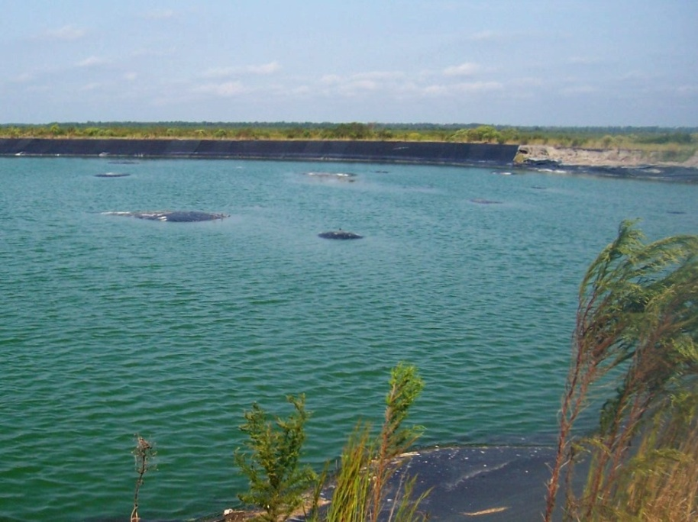
Figure 18. Liner “bubbling” at Engelhard Wastewater Treatment Plan on the Mattamuskeet Drainage Association, 2004, DWQ.

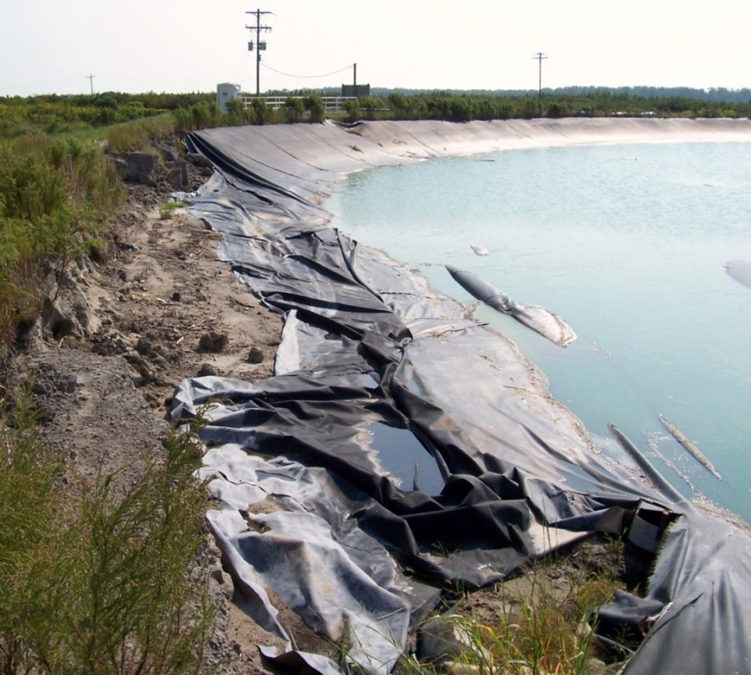
Figure 19. Liner receding at Engelhard Wastewater Treatment Plant on the Mattamuskeet Drainage Association, 2004, DWQ.
Currently, the Engelhard Sanitary District (ESD) has partnered with Hyde County to address the issues of the failing wastewater treatment system. Funding has been obtained to add 44 additional hookups to the EWTP, given repairs to the current system are made. Hyde County, the EDS and DWQ are entering into a Special Order of Consent (SOC). This SOC will ensure the county of Hyde and the Engelhard Sanitary District adhere to strict deadlines for EWTP repairs. Violation costs will be negotiable given all deadlines are met.
While the contributions of bacteria to the closed waters adjacent to the Association are presumed to be natural, the repair of the EWTP system is imperative. Should failure of the system occur in an area in such close proximity to sensitive shellfishing waters, the outcome could be catastrophic. It is important to note that project partners do not assume or hypothesize that bacteria present in the waters adjacent to the Association is a product of the Engelhard wastewater system. Given the high water table of the area, it is imperative that an alternative to individual, onsite septic systems be obtained. The answer lies in the repair and continued maintenance of the EWTP.
As part of this plan, the Association will work with Hyde County, DWQ and the federation to further ensure maintenance and compliance of the Engelhard wastewater system in the years to come.
Creation and submittal of a request for proposals to repair the plant is currently underway by the Hyde County Office of Economic Development. Given the unique soil and ecosystem characteristics of the Albemarle-Pamlico Peninsula, this plan seeks to explore alternative methods to the conventional wastewater treatment plant. Unsuitable design and an incompatibility with the environmental conditions of Hyde County proved to be detrimental to the operations of the current wastewater treatment system.

Objective Five: MEASURE SUCCESS AND ADAPT PLAN BASED UPON RESULTS
Action 5-1: Work with Shellfish Sanitation to closely monitor water quality in the impaired waters to determine if plan is having its intended water quality benefits.
Action 5-2: Conduct an annual and five year assessment on the success of the Plan, taking into account the amount of Pamlico Sound pumping volume reduction achieved, the cost of measures installed, and any trends in water quality impairments observed. Implement an ecosystem-scale study.
Action 5-3: Facilitate framework that will sustain yearly stakeholder discussions.

Discussion of Approach to Achieving Objectives
Progress made in achieving water quality improvements will be measured. This Plan will be adapted as necessary based upon this monitoring. The key interim indicators of plan success include: (1) no increase in the acreage of shellfish harvest closures in target watersheds; and (2) more frequent opportunities to temporarily open waters for shellfish harvest as a result of improving water quality. This will be measured through Shellfish Sanitation’s water quality monitoring efforts.
Factors such as water quality regulations and the success or failure of management actions can influence the relevance and effectiveness of this plan. It is important to evaluate and adapt management objectives and actions based upon observed results. On-going water quality monitoring of the impaired waters by a third party is also essential to determine if shellfish harvest can be restored.

All techniques and practices employed by the Association’s landowners as part of this plan will be quantified. As new techniques and designs are identified, they will be added to the flow reduction measures toolbox. The federation will be responsible for reporting progress towards the targeted conditions. The tool will also prove to be an effective reference guide for evaluating long term plans and establishing goals for annual watershed improvement plans.

This plan will be evaluated periodically (at least every five years) and adapted to reflect experiences gained in carrying out management actions, new technology and techniques, and the results of water quality monitoring.

To further document benefits and shortcomings of such a large-scale project, it is important for an ecosystem-scale study to be conducted. Grant funding will be obtained as part of future assessment efforts to document the benefits and other possible unintended consequences to the surrounding ecosystem. This will ensure a continued involvement with current project partners and agencies. Ecosystem-wide benefits will be assessed with volume reduction goals.

1. Promote efforts to reduce pumping volume to coastal waters

Action |  | Description | Timeline |  |  | Partners |  |  | Strategy
1-1 |  | Identify, prioritize and implement restoration projects to achieve flow reduction from the Association. | On-going |  |  | Coastal Federation, N.C. Soil and Water Conservation District, NRCS |  |  | Continue conversations with landowners. Seek funding for implementation and modeling of project benefits. Establish long-term agency partners for modeling and implementation.
1-2 |  | Facilitate project implementation and evaluate success. | On-going |  |  | Coastal Federation, Shellfish Sanitation, NRCS, USFWS, NCSU |  |  | Continue involvement in stakeholder group meetings. Evaluate individual projects. Seek funding for monitoring/evaluation.
1-3 |  | Acquire additional lands through fee-simple or place easements on land that could be incorporated into plans for flow reduction. | On-going |  |  | Coastal Federation, NRCS, N.C. Soil and Water Conservation District |  |  | Enroll non-productive lands in established easement programs: WRP, CRP, CREP etc. Seek funding and/or bargain sales. Perform enhancement to achieve maximum flow reduction. Establish long-term agency partners to create funding mechanism.
1-4 |  | Core dikes around restoration projects and drainage association perimeter to improve water management and reduce pumping need. | On-going |  |  | Coastal Federation, NRCS, NCSU |  |  | Perform analysis of dikes in vulnerable areas. Seek grant funding and/or assess the association's ability to perform capital improvements.
1-5 |  | Continue landowner education and participation to reduce water flow from association lands. | On-going |  |  | Coastal Federation, NCSU |  |  | Explore opportunities that exist at annual stakeholder meetings. Create fact sheets explaining projects.
1-6 |  | Develop water management plan for projects and association that minimizes pumping to Pamlico Sound to achieve Shellfish Sanitation water quality compliance. Set 5, 10, and 15 year goals for pump reduction. | On-going |  |  | Coastal Federation, NCSU, USFWS |  |  | Monitor and document flow reductions to the sound realized through project implementation. Evaluate water management plan annually.
2. Continue managing current projects

Action |  | Description |  |  | Timeline |  | Partners |  | Strategy
2-1 |  | Continue management of the shorebird project. Continue implementing and assessing efficacy of the water management plan. |  |  | On-going |  | Landowners |  | Continue a ten-year agreement with landowners including annual review and adaptation meeting.
2-2 |  | Continue to monitor and maintain water control structures, project pumps, perimeter pumps and dikes including monitor those not collectively maintained by the MDA. |  |  | On-going |  | Coastal Federation, landowners |  | MDA president/board performs maintenance review as needed.
2-3 |  | Maintain open dialogue between the landowner and NCCF to facilitate communications regarding habitat benefit. Establish a framework to better discuss quality control, project improvements, challenges, and successes. |  |  | On-going |  | Shellfish Sanitation, Coastal Federation |  | Maintain current communication with SS and MDA. Maintain stakeholder group meetings.
2-4 |  | Continue Shellfish Sanitation water quality testing at Otter Creek, Berry's Bay, and Fifth Avenue Pump Canal. |  |  | On-going |  | Shellfish Sanitation, Coastal Federation, NCSU |  | Maintain SS water quality sampling stations.
2-5 |  | Continue to support MDA's goals and objectives to meet water quality standards. |  |  | On-going |  | Coastal Federation, NRCS, USFWS, Shellfish Sanitation |  | Continue involvement in stakeholder group meetings. Facilitate tri- or bi-annual stakeholder meetings.
3. Determine how to meet project goals at current Shellfish Sanitation monitoring stations

Action | Description |  |  | Timeline |  |  |  | Partners | Strategy
3-1 | Work with Shellfish Sanitation to establish additional monitoring stations within the closed waters of Otter Creek and 5th Avenue Pump Canal. |  |  | Year 1 - establish preliminary monitoring |  |  |  | Shellfish Sanitation, Coastal Federation | Conduct a Use Attainability Assessment (UAA).
3-2 | Determine the amount of association drainage that may be pumped to the Pamlico Sound and still achieve SS water quality compliance. Set 5, 10 and 15 year goals for pump reduction. |  |  | On-going |  |  |  | Shellfish Sanitation, Coastal Federation, NCSU | Use the modeling expertise of NCSU. Establish management plan between MDA and SS.
3-3 | Evaluate if additional Shellfish Sanitation sampling is necessary to gauge the success of Coastal Federation projects. |  |  | Year 2 - based upon preliminary monitoring |  |  |  | Shellfish Sanitation, Coastal Federation | Evaluate the need and location of a new SS sampling station.
3-4 | Re-designate man-made canals of 2nd Avenue and 5th Avenue to SB or SC to reduce obligation for correcting water quality and restoring waters to SA condition. |  |  | On-going |  |  |  | Shellfish Sanitation, Coastal Federation, Hyde County | Aid Hyde County in drafting letter to petition the EMC and DWQ to conduct a Use Attainability Assessment (UAA).
4. Ensure compliance and maintenance of the Engelhard Wastewater Treatment System

Action | Description |  |  | Timeline |  |  |  | Partners | Strategy
4-1 | Work with Hyde County, Engelhard Sanitary District, and DWQ to facilitate system compliance and continued maintenance. |  |  | On-going |  |  |  | Hyde County Office of Economic Development, Engelhard Sanitary District, Coastal Federation | Support efforts to get SOC with DWQ and an RFP for engineer's services.
4-2 | Repair and upgrade plant. |  |  | On-going |  |  |  | Hyde County Office of Economic Development, Engelhard Sanitary District, Coastal Federation | Compose letters of support to seek funding.
4-3 | Explore alternative wastewater treatment plant designs or strategies. |  |  | On-going |  |  |  | Hyde County Office of Economic Development, Engelhard Sanitary District, Coastal Federation | Encourage stakeholder involvement in redesign.
5. Measure success and adapt plan based on results

Action | Description |  |  | Timeline |  |  |  | Partners | Strategy
5-1 | Work with Shellfish Sanitation to closely monitor water quality in the impaired waters to determine if the plan is having its intended water quality benefits. |  |  | On-going |  |  |  | Shellfish Sanitation, Coastal Federation | Support monitoring efforts.
5-2 | Conduct an annual and five year assessment on the success of the plan, taking into account the amount of Pamlico Sound pumping volume reduction achieved the cost of measures installed, and any trends in water quality impairments observed. Implement an ecosystem-scale study. |  |  | Year 1 and Year 5 |  |  |  | Shellfish Sanitation, Coastal Federation, USFWS, NCSU | Assess success against proposed volume reduction goals. Evaluate improvements from water quality samples collected. Obtain grant funding for ecological scale study.
5-3 | Facilitate framework that will sustain yearly stakeholder discussions. |  |  | On-going |  |  |  | Coastal Federation | Facilitate tri- or bi-annual stakeholder meetings.
Table 3. Summary of Plan’s objectives and actions.

Use of Plan
This Plan will serve as the Association and partner’s watershed restoration blueprint for Otter Creek, Berry’s Bay and the waters adjacent Fifth Avenue Pump Canal. It:

- Documents and explains the causes of water quality impairments near this de facto watershed, and why reducing the pumping volume of stormwater is key to removing those impairments.

- Identifies which management measures are successful in reducing the amount of stormwater transported to the Pamlico Sound based upon individual project efficacy and other factors that influence their effectiveness.

- Provides incremental mileposts for measuring the success of the plan, with yearly opportunities to adjust the implementation strategy based upon measured results.

- Establishes a mechanism of using historic and future water quality monitoring to determine compliance with water quality standards.

The plan includes the nine key elements recommended as being integral to a watershed plan by EPA (Table 4).
EPA’s 9-Key Elements

- An information/education component to enhance public understanding of the project.
- A monitoring component to evaluate the effectiveness of the implementation efforts over time measured against the criteria (used to determine whether loading reductions are achieved).
- An identification of the causes (stressors) and sources or groups that need to be controlled to achieve pollutant load reductions estimated in the watershed.
- An estimate of the pollutant load reductions expected for the management measures.
- A description of the Nonpoint Source pollution (NPS) management measures that will need to be implemented to achieve load reductions as well as to achieve other watershed goals identified in the watershed based plan.
- A set of criteria that can be used to determine whether loading reductions are being achieved over time and substantial progress is being made towards attaining water quality standards.
- An estimate of the amount of technical and financial assistance needed, associated costs and/or sources, and authorities that will be relied upon, to implement the plan.
- A schedule for implementing the NPS management measures identified in this plan that is reasonably expeditious.
- A description of interim, measureable milestones for determining whether NPS management measures or other control actions that are being implemented.
Table 4. EPA’s 9-key elements of a watershed restoration plan.

In addition, this plan addresses the six required elements that EPA states must be included in a watershed restoration plan for it to serve in lieu of a TMDL. Specifically, surface waters do not have to be included on the Section 303(d) list if other pollution control requirements (e.g., best management practices) required by local, State, or Federal authority are stringent enough to result in achieving applicable water quality standards within a reasonable period of time. A complete watershed plan can provide the alternative management measures that exceed TMDL requirements (Table 5).

Six Elements for TMDL Exemption
- Identification of segment and statement of problems causing the impairment.
- Description of pollution controls and how they will achieve water quality standards.
- An estimate or projection of the time when water quality standards will be met.
- Schedule for implementing pollution controls.
- Monitoring plan to track effectiveness of pollution controls.
- Commitment to revise pollution controls, as necessary.
Table 5. Six required elements of a watershed restoration plan to serve in lieu of a TMDL.

The association will use this plan as a voluntary effort to restore water quality. It recognizes that the plan provides the basis for a TMDL if one should be needed in the future.

APPENDIX A: ASSOCIATION LAND CLASSIFICATIONS AND SPECIFICATIONS

- Commercial – This classification would apply to land that meets any of the following:
  - Acreage of land that has been approved for residential or commercial uses.
  - Acreage that has been paved or had gravel or other non-original soil types placed upon it.
  - Land that has been elevated above natural elevations for the purpose of improved drainage.
  - Commercial acreage would be assessed at a rate 8.0 times higher than undeveloped.
- Agricultural – This classification would apply to land that meets any of the following:
  - Acreage containing regularly spaced ditches and used for production of annual crops.
  - Acreage enrolled in CRP or other conservation practices that considers the acreage to be planted but is not subject to long term easements of 30 years or more.
  - Acreage used for waterfowl impoundments that are periodically flooded and drained.
  - Agricultural acreage would be assessed at a rate 4.0 times higher than undeveloped.
- Non-Agricultural - This classification would apply to land that meets any of the following:
  - Acreage containing regularly spaced ditches open to drainage, but not meeting the Agricultural classification or Blocked Drainage classification.
  - Forested plantations or natural woodland with regularly spaced ditches.
  - Acreage enrolled in long term conservation programs required easement of 30 years that prevent using the land for agricultural crop production or other non-conservation uses where ditches are left open to drain.
  - Non-agricultural acreage would be assessed at a rate 3.0 times higher than undeveloped.
- Blocked Drainage - This classification would apply to land that meets any of the following:
  - Acreage containing regularly spaced ditches where the flow from such acreage has been effectively reduced by functioning water control structures, elevated culverts, or other means such as core diking, designed to maintain the water level within these acreages within 1.5 feet of top of the land and enables the land to be flooded. This acreage would receive non priority drainage and would be allowed to flood without relief during heavy rainfall events. Control mechanism and water levels in these areas would be closely monitored by the operations manager of the Association to ensure compliance with this category.
  - Blocked Drainage acreage would be assessed at a rate 2.0 times higher than undeveloped.
- Undeveloped – Land not having regularly spaced ditches where drainage is provided only by perimeter canals and not meeting the requirements of any of the other classifications.
  - Undeveloped acreage would be assessed at the base rate.

APPENDIX B: DWQ WATER QUALITY CLASSIFICATIONS
Division of Water Quality Tidal Saltwater Classification System Primary Classifications
Class | Best Uses
SC | Saltwater Class C. Aquatic life propagation and maintenance of biological integrity (including fishing, fish, and functioning primary nursery areas (PNA’s)), wildlife, secondary recreation (including recreational fishing, boating, and water related activities involving minimal skin contact), and any other usage except primary recreation or shellfishing for market purposes.
SB | Saltwater Class B. Primary recreation (including swimming on a frequent or organized basis) and any other usage specified for SC waters.
SA | Saltwater Class A. Shellfishing for market purposes and any other usage specified for SB or SC waters. All SA waters are also High Quality Waters (HQW).

Division of Water Quality Surface Freshwater Classification System Primary Classifications
Class | Best Uses
C | Waters protected for secondary recreation, fishing, wildlife, fish and aquatic life propagation and survival, agriculture and other uses suitable for Class C. There are no restrictions on watershed development of types of use.
B | Waters used for primary recreation and other uses suitable for Class C. There are no restrictions on development of types of discharges
WS-I | Waters used as sources of water supply for drinking, culinary, or food processing purposes for those users desiring maximum protection for their water supplies. WS-I waters are within natural and undeveloped watersheds in public ownership with no point source discharges. All WS-I waters are HQW by definition.
WS-II | Waters used as sources of potable water supply where a WS-I classification is not feasible. WS-II waters are generally predominantly in undeveloped watersheds, and only general permits for discharges are allowed. All WS-II waters are also HQW.
WS-III | Waters used as sources of potable water supply where more protective WS-I and WS-II classifications are not feasible. WS-III waters are typically in low to moderately developed watershed; general discharge permits only are allowed near the water supply intake whereas domestic and non-process industrial discharges are allowed in the rest of the water supply watershed.
WS-IV | Water used as sources of potable water supply where a WS-I, WS-II, or WS-III classification is not feasible. WS-IV waters are generally in moderately to highly developed watersheds or Protected Areas, and involve no categorical restrictions on discharge.
WS-V | Water protected as water supplies which are generally upstream and draining to Class WS-IV waters or waters used by industry to supply their employees with drinking water or as waters formerly used for water supply. Unlike other WS classifications, WS-V has no categorical restrictions on watershed development or wastewater discharges, and local governments are not required to adopt watershed protection ordinances.

Division of Water Quality Supplemental Classifications
Class | Best Uses
HQW | High Quality Waters. Waters which are rated excellent based on biological and physical/chemical characteristics through Division monitoring or special studies, native and special native trout waters (and tributaries) designated by the Wildlife Resources Commission, primary nursery areas (PNA’s) designated by the Marine Fisheries Commission, and other functional nursery areas designed by the Marine Fisheries Commission.
NSW | Nutrient Sensitive Waters. Waters that experience or are subject to excessive growths of microscopic or macroscopic vegetation. Excessive growths are growths which the Commission determines impair the use of the water for its best usage as determined by the classification applied to such waters.
ORW | Outstanding Resource Waters. Unique and special surface waters of the state that are of exceptional state or national recreational or ecological significance that require special protection to maintain existing uses.
Sw | Swamp Waters. Water which are topographically located so as to generally have very low velocities and other characteristics different from adjacent streams draining to steeper topography.
Tr | Trout Waters. Waters which have conditions that shall sustain and allow for trout propagation and survival of stocked trout on a year-round basis.

Classifications of other Divisions
Class | Best Uses
Division of Coastal Management (DCM)
AEC | Estuarine Areas of Environmental Concern. Coastal water and land areas of significant economic and biological values to the state.
Division of Marine Fisheries (DMF)
PNA | Primary Nursery Areas. Growing areas where populations of juvenile finfish and shellfish of economic importance occur. PNA’s are also HQW.
Division of Environmental Health (SS)
Approved | Suitable growing area for harvesting shellfish for direct marketing to the public.
Conditionally approved | Growing areas subject to predictable intermittent pollution but suitable for harvesting shellfish for marketing when Management Plan conditions are met.
Restricted | Growing area suitable for shellfish harvesting by permit only. Shellfish must be purified by approved process.
Prohibited | Area unsuitable for harvesting shellfish for direct marketing due to presence of high fecal coliform, point source discharge, or marine, or no current sanitary survey.

APPENDIX C: 303(d) LIST INTEGRATED REPORT CATEGORIES

APPENDIX D: NORTHERN WORKGROUP, OYSTER RESTORATION PLAN MAP

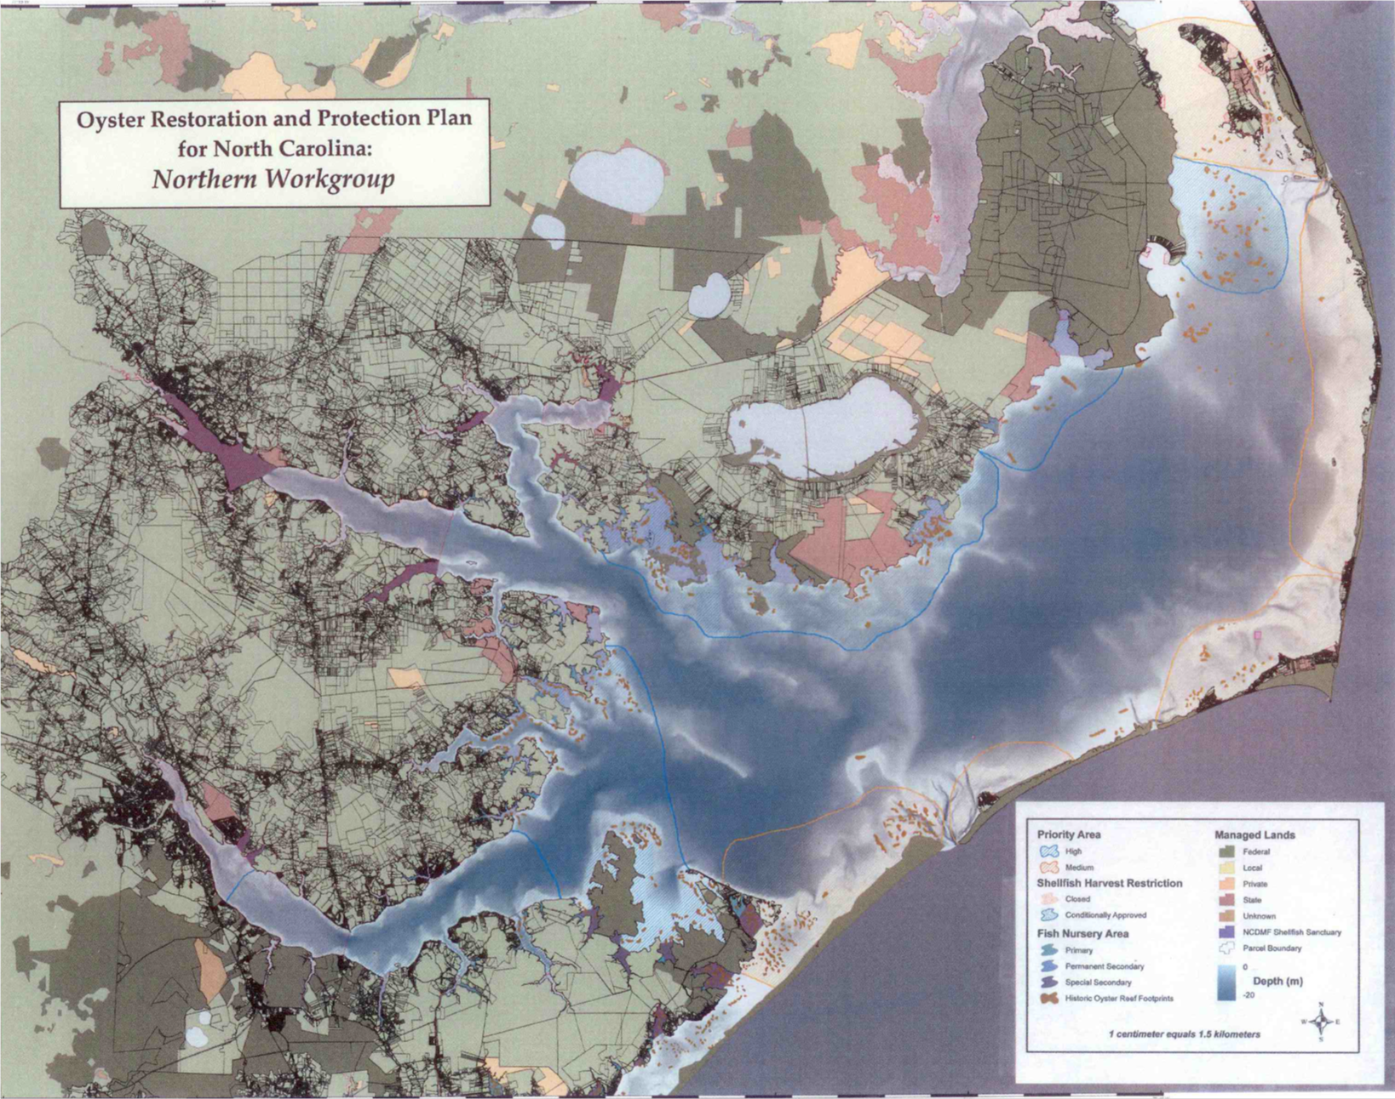

(Brown areas in coastal waters represent historic oyster habitat)

APPENDIX E: HISTORY OF CLOSURES FOR OTTER CREEK
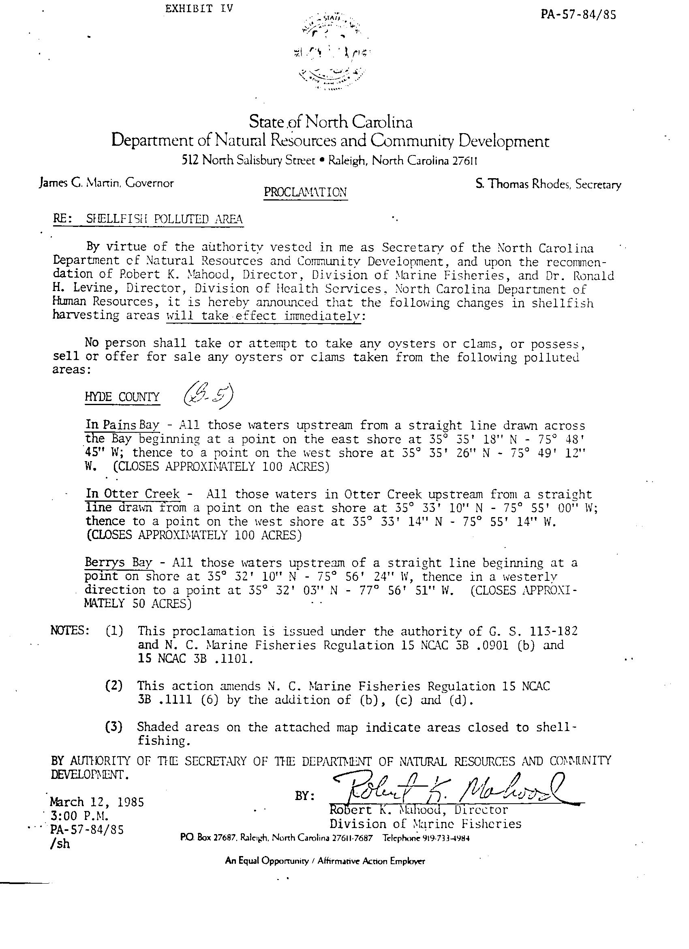

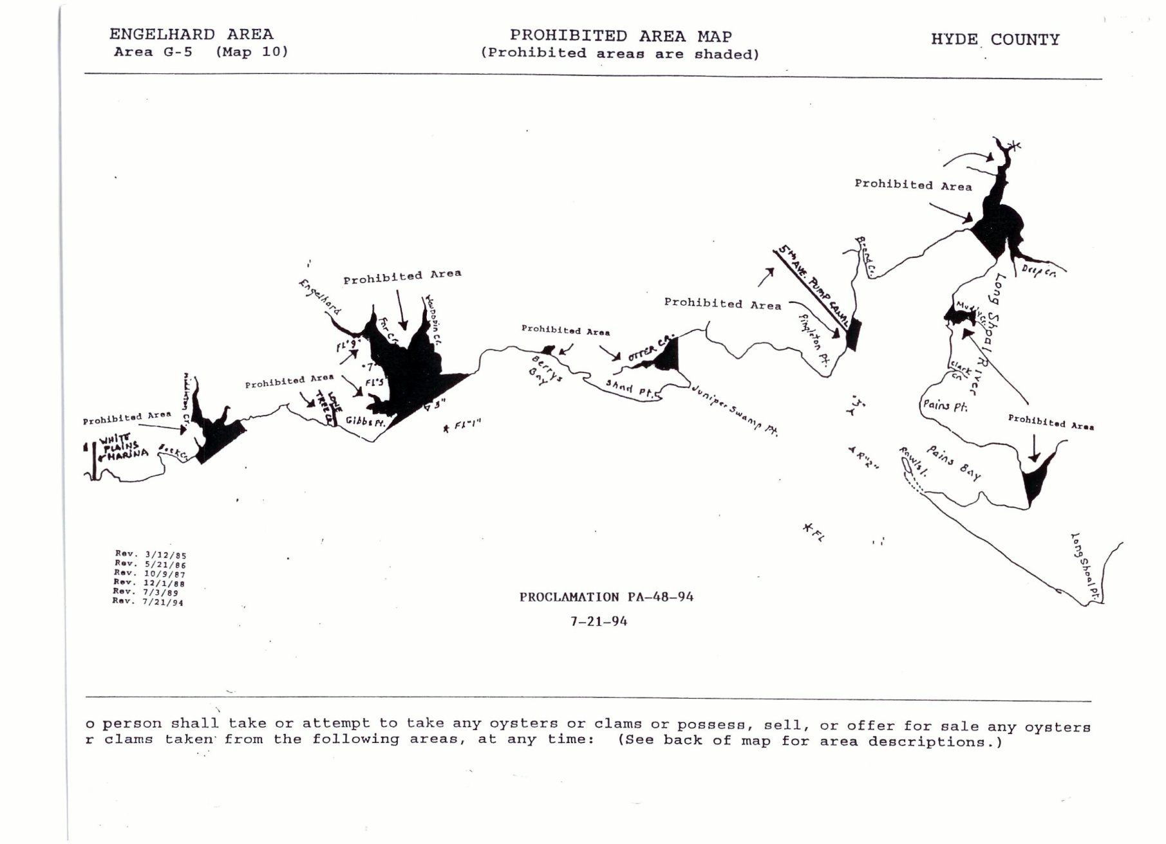

APPENDIX F: CLOSURE PROCLAMATIONS FOR FIFTH AVENUE
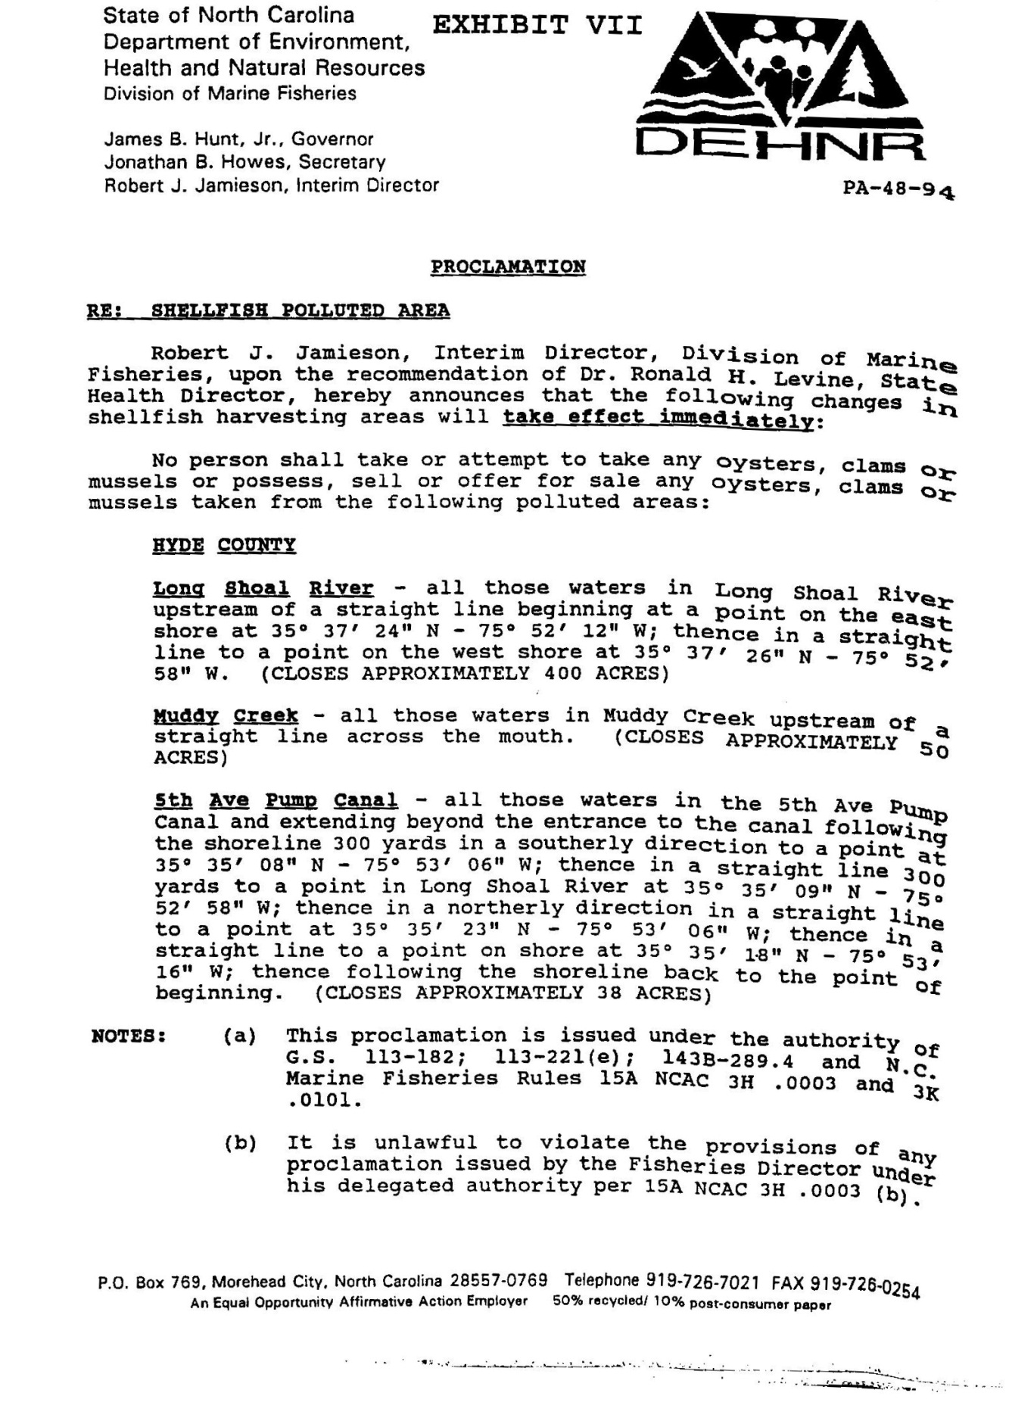
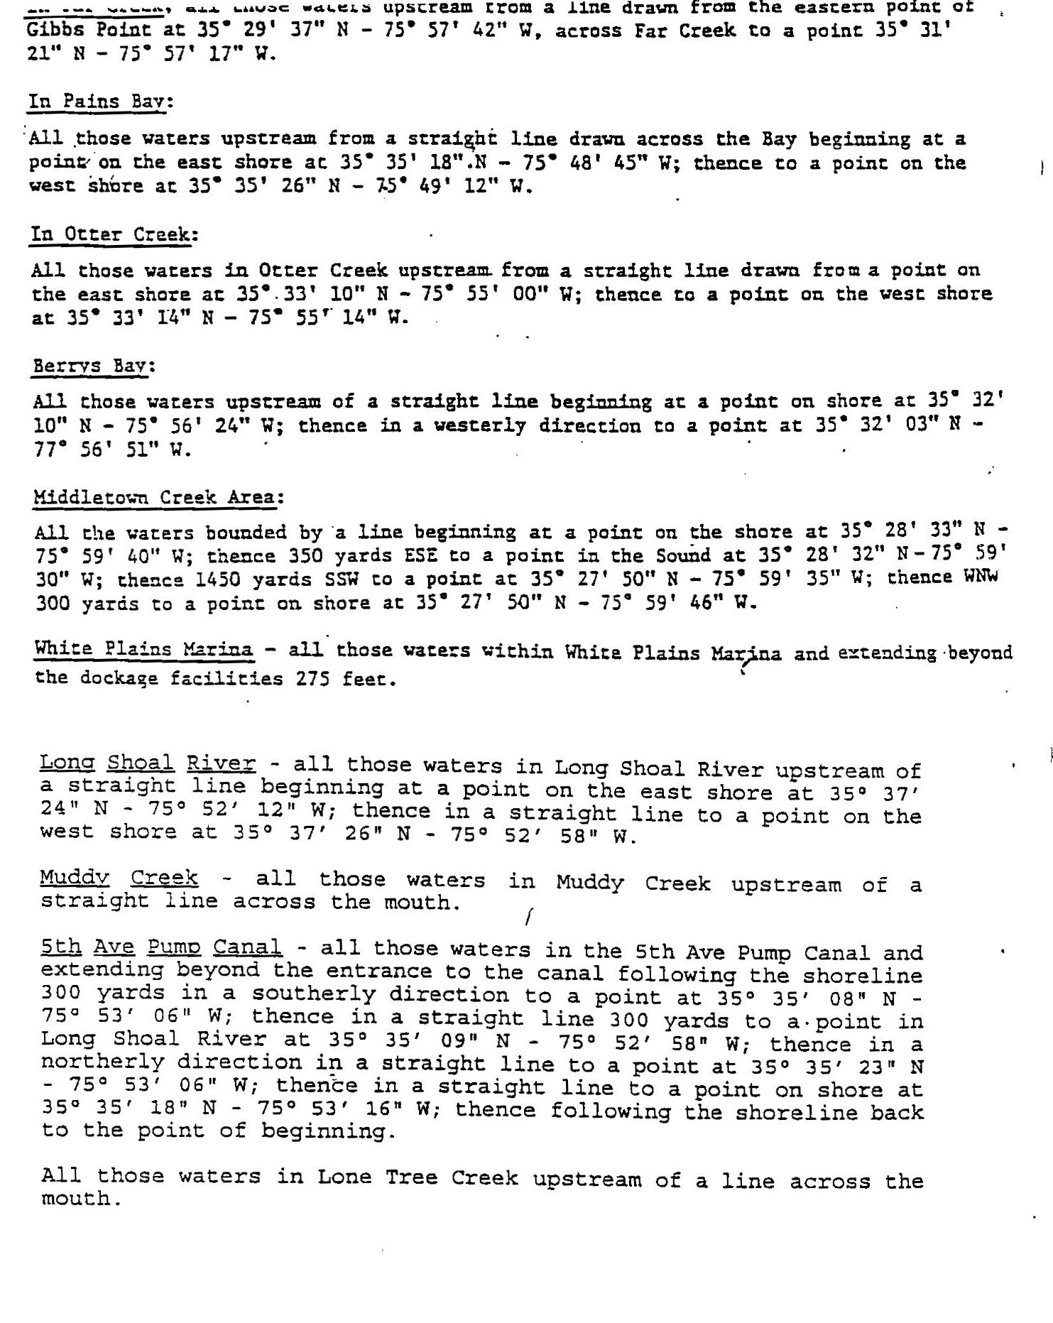

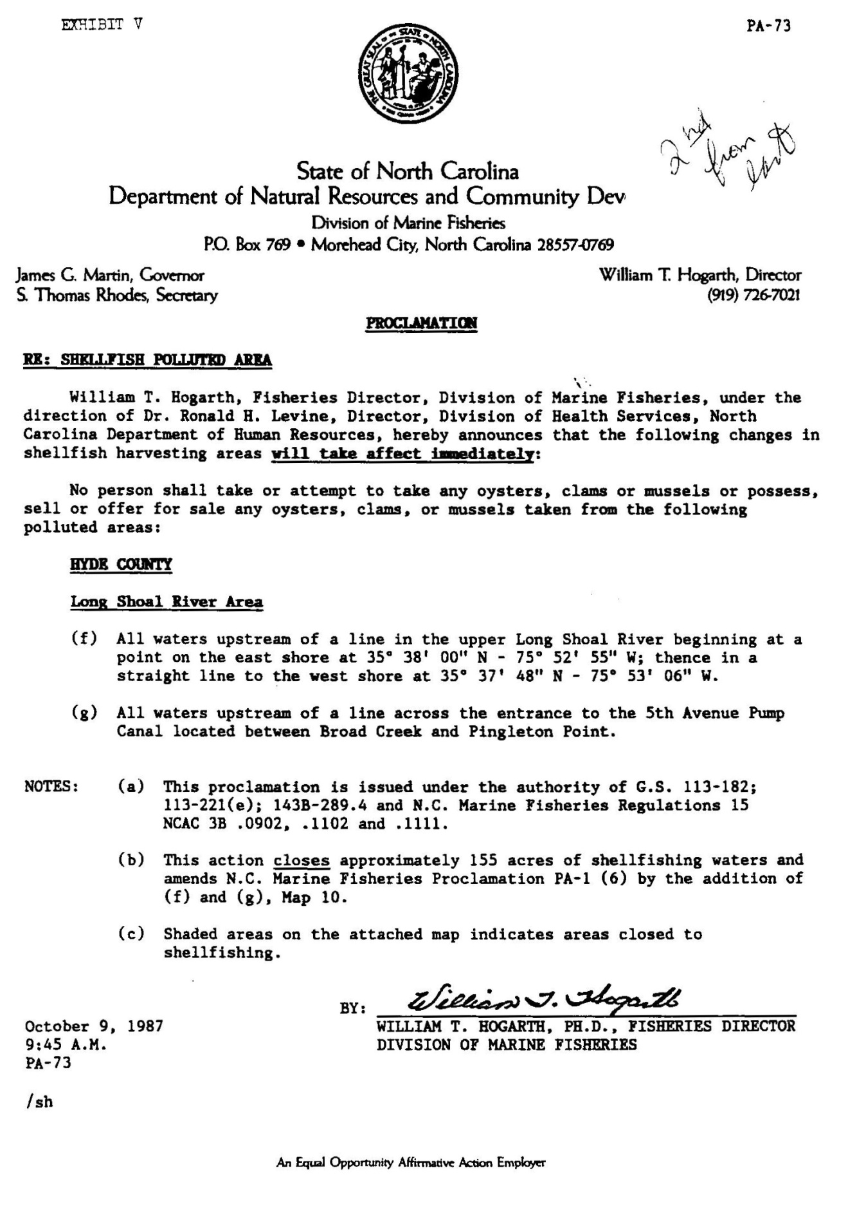

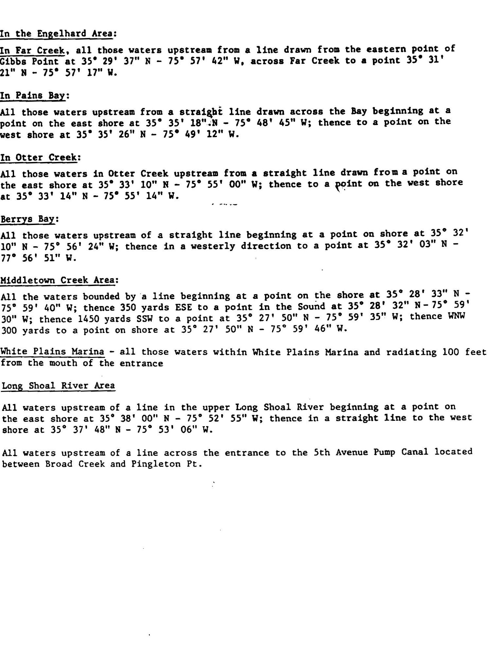

APPENDIX G: WETLAND RESTORATION PROJECT PHASE

1 SCHEMATIC (L1)

APPENDIX H: WETLAND RESTORATION SHOREBIRD PROJECT SCHEMATIC (MV0)

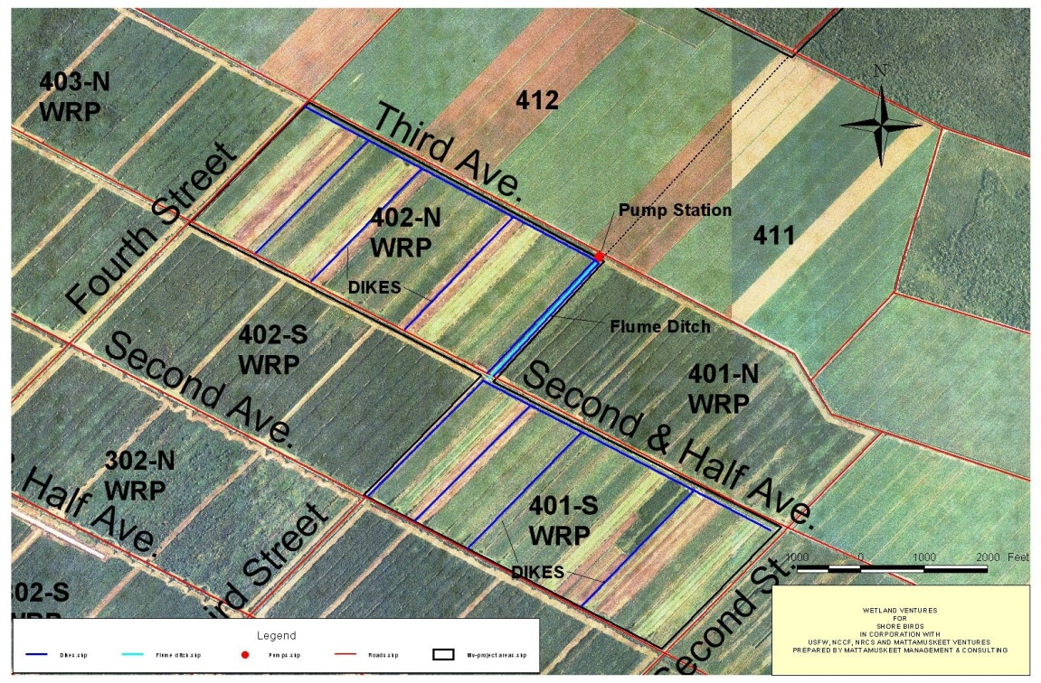

APPENDIX I: WETLAND RESTORATION PROJECT (MV0)
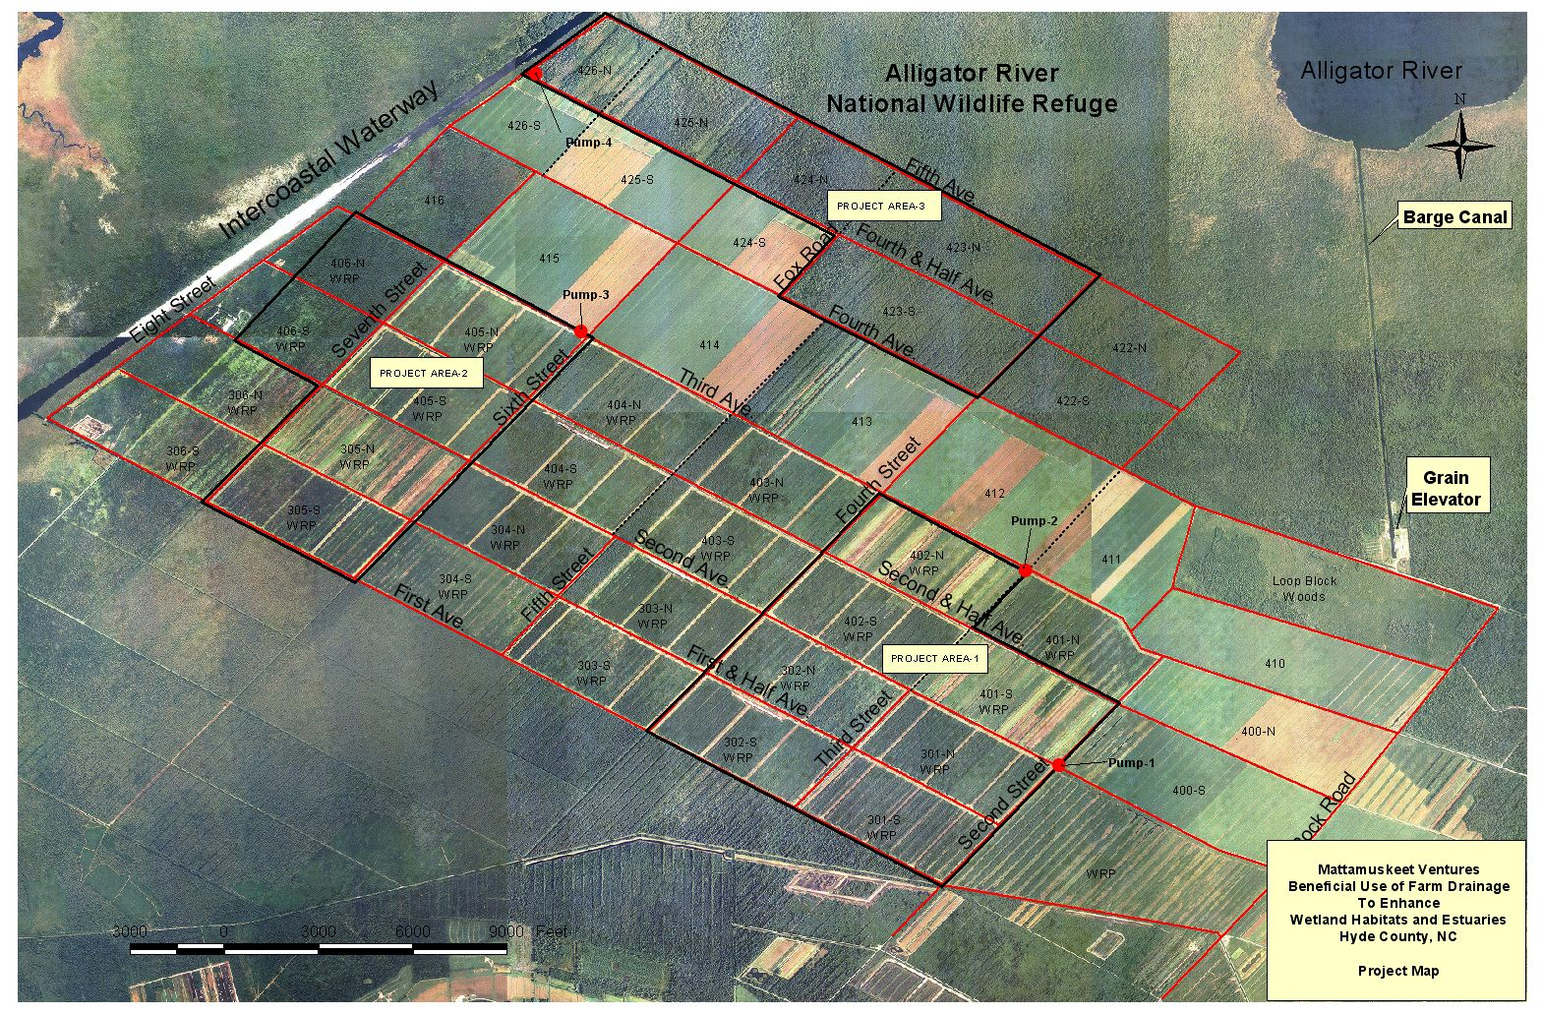

APPENDIX J: PROJECT ELEMENT DIAGRAMS, NCSU

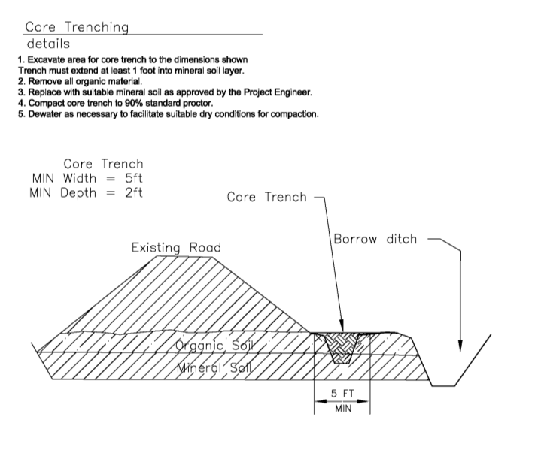

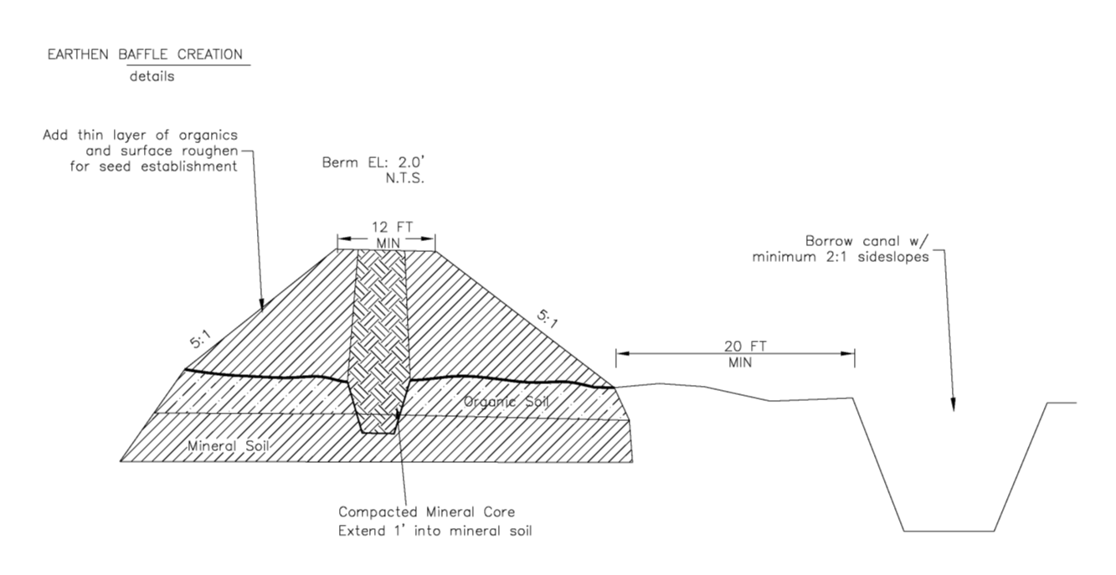

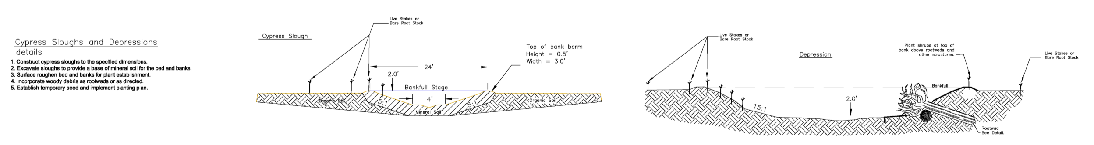

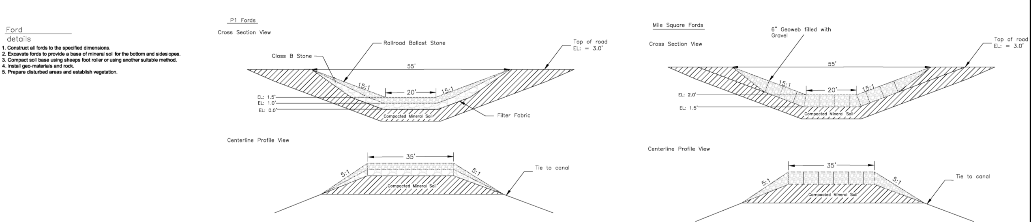

APPENDIX K: DRAINMOD ANALYSIS DRAWING KEY AND DEFINITIONS
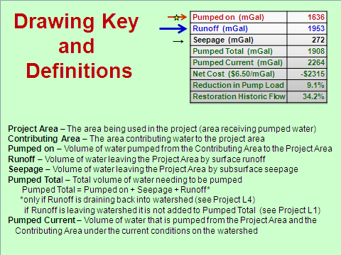

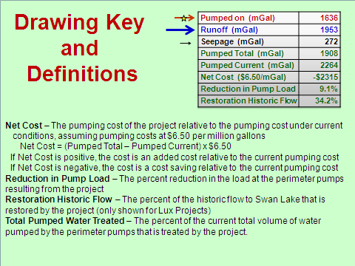

APPENDIX L: AREAS CHOSEN FOR GPR
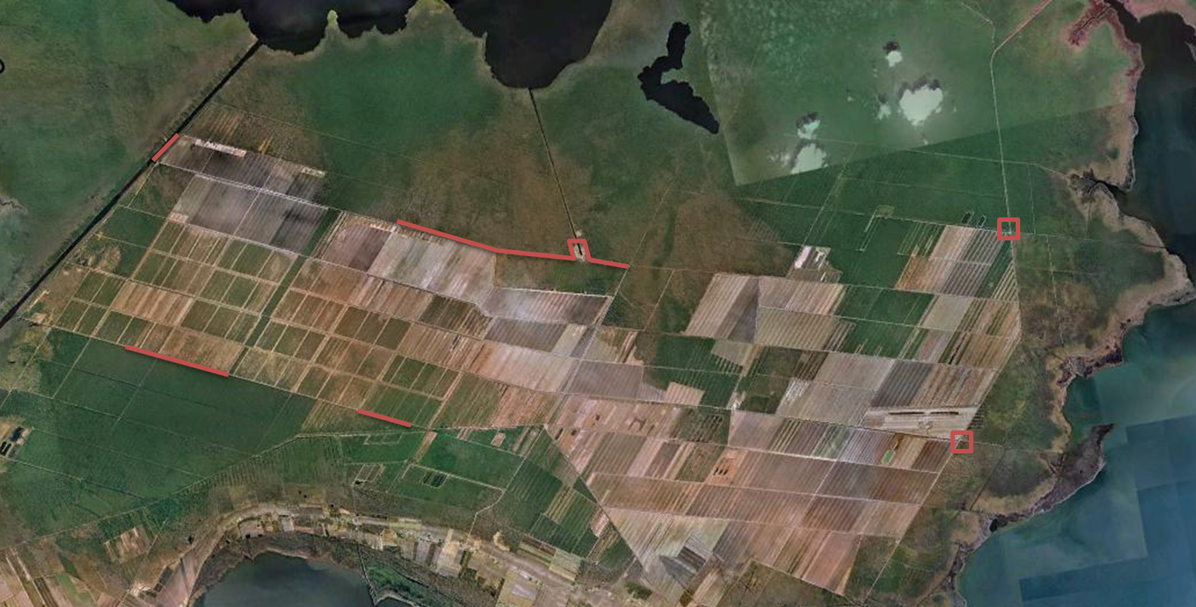

APPENDIX M: SUMMARY TABLES OF DRAINMOD ANALYSES
*Below tables represent calculated amounts of theoretical/modeled pumped volume. Projects subject to change dependent upon funding, land ownership, and stakeholder input.

 | L1 | L2 | L3 | L4 | L5 | L123
Pumped on (mGal) | 1636 | 1172 | 826 | 618 | 300 | 3610
Runoff (mGal) | 1953 | 1406 | 972 | 702 | 186 | 4306
Seepage (mGal) | 272 | 196 | 126 | 179 | 16 | 593
Pumped Total (mGal) | 1908 | 1368 | 952 | 1529 | 518 | 4203
Pumped Current (mGal) | 2264 | 1643 | 1150 | 956 | 392 | 5057
Net Cost ($6.50/mGal) | -$2315 | -$1787 | -$1289 | $3530 | $793 | -$5552
Reduction in Pump Load (percent) | 9.1 | 6.5 | 4.5 | 0.1 | 0.2 | 20.0
Total Flow Treated (percent) | 7.6 | 5.4 | 3.8 | 2.9 | 1.4 | 16.7
Restoration Historic Flow (percent | 34.2 | 24.6 | 17.0 |  |  | 75.3

 | MV0 | MV1 | MV2 | MV012 | MV3
Pumped on (mGal) | 379 | 1420 | 1219 | 2960 | 2081
Runoff (mGal) | 403 | 1515 | 1504 | 4033 | 2580
Seepage (mGal) | 160 | 312 | 406 | 1486 | 417
Pumped Total (mGal) | 1021 | 3352 | 3129 | 4446 | 2498
Pumped Current (mGal) | 678 | 1978 | 2013 | 5880 | 3057
Net Cost ($6.50/mGal) | $1712 | $8250 | $7254 | -$9323 | -$3633
Reduction in Pump Load (percent | 0.4 | 0.5 | 0.3 | 18.7 | 12.0
Total Flow Treated (percent) | 1.8 | 6.6 | 5.7 | 13.7 | 9.7

APPENDIX N: QAPP WATER QUALITY MONITORING PROTOCOL

A7. Quality Objectives and Criteria Identify performance/measurement criteria for all information to be collected; and acceptance criteria, including project action limits and laboratory detection limits, and range of anticipated concentrations of each parameter of interest (includes field and lab, if applicable)

Water quality samples will be drawn from six stations within the drainage district. Samples will be primarily collected by NCCF staff, following the protocol spelled out in the EPA booklets Volunteer Estuary Monitoring: A Methods Manual and Volunteer Stream Monitoring. Occasionally samples will be collected by volunteers trained by NCCF staff, including farm personnel. Lab sample analysis by Envirochem Laboratory will follow NCDWQ-approved QA/QC procedures.

Data Precision, Accuracy, Measurement Range
Express the degree to which sample results are repeatable. State decision error limits, if applicable. Note: Projects which are based on authoritative rather than statistical sampling designs will not have quantitative decision error limits.

Data Precision: Agreement among the collected water samples will be determined through replicate samples. At least three replicate samples (two completely separate sample bottles collected at the same site) will be taken from each site during the course of the year (our target is one every three months for one year), both to be analyzed by EnviroChem Laboratory. Additionally, at least three split samples will be taken from each site during the course of the year (target one every three months for one year), all to be analyzed by EnviroChem Laboratory. Variation among these duplicate samples must meet confidence limits used by EnviroChem Laboratory. Note that a range of precision is not available for any bacterial parameters, including fecal coliform and enterococci. Precision for salinity, temperature will adhere to the specific instrument DQOs. Replicate measurements will also be taken for each physical/chemical parameter. Precision for all parameters must meet the objectives set in Table 1. If a parameter measure fails to meet precision, an additional replicate measure should be taken. The value in error will be discarded and an average will be taken of the two more closely related values to meet precision objectives.

Accuracy: The fecal coliform samples cannot be compared to any standard or “true value.” EnviroChem Laboratory DQOs could determine sample accuracy through positive control samples or negative control samples. The YSI Model 85 is to be calibrated and maintained according to standard operating procedures (SOPs) for the instrument. Accuracy ranges for the YSI Model 85 multi-parameter probe are listed in Table 2.

Table 2: Data Quality Objectives for Collected Fecal Coliform Samples and Physical/Chemical Parameters
Parameter | FECAL COLIFORM | ENTERO-CCOCUS | TKN | TP | TSS | NO3-N | SALINITY | TEMP
Method | Grab sample | Grab sample | Grab sample | Grab sample | Grab sample | Grab sample | Hydrometer | Hydrometer
Range | No. of colony-forming units (CFU) | No. of colony-forming units (CFU) | 0.5 to 15 mg/L | 0.04 to 2 ml/L | 1 to 4000 mg/L | 0.02 to 15 mg/L | 1.000 - 1.060 specific gravity | 0 - 40 °C or 30 - 105 °F
Detection Limit | 1 CFU | 1 CFU | 0.5 mg/L | 0.04 mg/L | 1-2 ppm | 0.02 mg/L | 0.001 | 1 °C
Precision | Not available | Not available | ± 10% | ± 10% | ± 10% | ± 10% | 0.002 ± 10% | 1 °C ± 10%
Accuracy | Not available | Not available | ± 20% | ± 20% | Not available | ± 20% | 0.001 | 1 °C
Calibration Method | Standard reference materials | Standard reference materials | 5 Stan-dard curve | 5  Stan-dard curve | Standard reference materials | 5 Stan-dard curve | Standard instrument procedures | Standard instrument procedures

TKN analysis method – EPA 351.2
TP analysis method – Standard Methods 4500 PF
NO3-N analysis method – EPA 353.3 2

Accuracy for TKN, NO#-N and TP determined by Lab and Matric Spike Duplicates

*Fecal Coliform and Enterococcus:
container – sterilized plastic bottles
minimum sample size – 275 ml each
preservation – cooled to < 4 deg. Celsius
maximum holding time – 6 hours

Data Quality Objectives for YSI Model 85
Parameter | SALINITY | TEMPERATURE | DISSOLVED OXYGEN
Range | 0 to 80 ppt | -5 to + 95 deg. C | 0 to 200% , 0 to 20mg/l
Detection Limit | 0.1 ppt | 0.1 deg. C | 0.1% , 0.01 mg/l
Accuracy | + 2% or + 0.1 ppt | + 0.1 deg. C | + 2% , + 0.3 mg/l
Data Representativeness
Express the degree to which the data accurately represents the population or the environmental condition at the sampling location (i.e. explain how well the monitoring characterizes the physical conditions).

Grab samples will be collected once monthly from six sampling stations. Because data will not be continually collected, sample representativeness will be somewhat subject to variability in weather and environmental conditions at the sites. However, at the time each sample is taken, data will also be recorded about weather conditions and any unusual environmental circumstances. Coupled with the frequency of sampling, this will give us adequate confidence in the accuracy with which the samples represent environmental conditions within the drainage district.

The extent to which sampling results mirror actual environmental conditions within the drainage district has been carefully considered during our choice of sampling sites. Because the drainage district pumps agricultural stormwater into the impaired waters, it is appropriate to collect water quality samples from the six pump stations within the drainage district. The sampling stations at the Second and Fifth avenue pump stations will be used throughout the entire year of monitoring. However, once sampling begins, we may discover that we would collect better data if we relocate the four western sampling stations or replace them with more frequent samples taken from the Second and Fifth avenue canals.
Data Comparability

Express the degree of confidence that one data set can be compared to another at the sample location or to a sample taken at another location. Grab samples will be collected primarily by NCCF staff, although volunteers may occasionally collect them. In all cases, samples will be taken using the protocol outlined in the EPA publications Volunteer Estuary Monitoring: A Methods Manual and Volunteer Stream Monitoring for fecal coliform and indicator bacteria sample collection using sterilized, plastic bottles and all physical/chemical parameters.

The protocols found in Appendix VI will mirror the EPA standard protocols for volunteers but may be modified to fit the scope of the project under the guidance of technical advisors and stakeholder group members. The fecal coliform samples collected are also to be analyzed at Envirochem Laboratory in Manteo, N.C., a DWQ-certified lab using standard methods and quality control procedures.

Table 3 -- Data Completeness

Measure of the amount of valid data needed to develop conclusions (i.e., estimate how many measurements are needed to meet each monitoring objective(s))

Parameter | No. Valid Samples Anticipated | Minimum No. Valid Samples needed | Monitoring Objective
Fecal coliform and Enterococci | 12 per station | 12 per station, Second and Fifth Avenue pumps; 6 per other stations | Bacteria concentration
TSS | 12 per station | Same as above | Sediment concentration
TN | 12 per station | Same as above | Nutrient concentration
TP | 12 per station | Same as above | Nutrient concentration
NO3-N | 12 per station | Same as above | Nutrient concentration

Completeness will be measured by the total number of samples collected and analyzed against the goals outlined in the project design. Because of the rural conditions of the drainage district and the unreliable conditions of farm roads, it is recognized that samples may not be able to be taken on some scheduled sampling days. When one site cannot be sampled during a rain event due to risky conditions, that site may be left out of the data record. If more than two sites cannot be sampled, another sampling day will be added to the schedule for that month. The project aims for 90% completeness.

Table 6--Sample Design Logistics - Sample numbers and frequency. Also include monitoring of covariates such as rainfall and discharge. State if parameter is for informational purposes only and not critical.

Type of Sample/ Parameter  (i.e. storm/grab, water/sediment, etc.) | Number of Samples | Sampling Frequency and Period
Grab stormwater sample | Six each sampling day, plus QC checks | Twice monthly for one year
Salinity | Six each sampling day | Twice monthly for one year
Dissolved oxygen | Six each sampling day | Twice monthly for one year
Temperature | Six each sampling day | Twice monthly for one year
Rainfall and discharge |  | Recorded daily by drainage district

Table 7--Identify Sampling Equipment, Collection Methods and SOPs
Parameter | Sampling Equipment | Sampling Method
FECAL COLIFORM INDICATOR BACTERIAL | STERILE WATER BOTTLES | GRAB SAMPLES
TSS, TN, TP, NO3-N | STERILE WATER BOTTLES | GRAB SAMPLES
TEMPERATURE, SALINITY, DISSOLVED OXYGEN | ysi 85 | IMMERSION

i North Carolina Department of Environment and Natural Resources, Division of Water Quality Water Quality Section-Planning Branch, North Carolina Water Quality Assessment and Impaired Waters List February 2003 (02IRMT04Ff), (Raleigh, N.C., 2003) 10.

ii North Carolina Department of Environment and Natural Resources, Division of Water Quality, A Guide to Surface Freshwater Classifications in North Carolina, Water Quality Planning Branch, (Raleigh, N.C., 2001).

iii North Carolina Department of Environment and Natural Resources, Division of Water Quality Water Quality Section-Planning Branch, North Carolina Water Quality Assessment and Impaired Waters List February 2003 (02IRMT04Ff), (Raleigh, N.C., 2003) 10.

iv North Carolina Department of Environment and Natural Resources, Division of Water Quality, A Guide to North Carolina’s Tidal Saltwater Classifications, (Raleigh, N.C., 2001).

Kirby-Smith, William., and Richard Barber. 1979. The Water Quality Ramifications in Estuaries of Converting Forest to Intensive Agriculture. Beaufort, NC: Water Resources Research Institute.
P. Fowler, personal communication, April 3, 2012.
N.C. Division of Environmental Management, Water Quality Section. 1988. Fecal Coliforms in Otter Creek. Raleigh, NC. Print.
Overton, Margery F., Fisher, John S., and John M. Miller, et al. 1988. Freshwater Inflow and Broad Creek Estuary, North Carolina. North Carolina State University, Raleigh, N.C.
Chescheir, G.M., J.W. Gilliam, R.W. Skaggs, and R.G. Broadhead. 1992. Evaluation of wetland buffer areas for treatment of pumped agricultural drainage water. TRANSACTIONS of the ASAE 35(1):175-182.
Chescheir, G.M., J.W. Gilliam, R.W. Skaggs, and R.G. Broadhead. 1991. Nutrient and sediment removal in wetlands receiving pumped agricultural drainage water. Wetlands 11(1):87-103.

