Atmospheric Deposition of Nutrients to High Rock Watershed

Basics
The vast majority of surfaces in the watershed are land and associated structures, and in terms of nutrient management and accounting, atmospheric deposition to these various land forms is accounted for through regulation of the associated source types. Thus, receiving waters throughout the watershed are the only deposition surface not accounted for in establishing overall strategy reduction needs (deposition to the surface of High Rock Lake itself is accounted for in the lake model and the resulting reductions needs estimated by the model). High Rock watershed model results, shown below, reveal that atmospheric nitrogen deposition to water surfaces in the watershed contributes less than 1% of all N loading delivered to the lake. There is no meaningful phosphorus component to atmospheric deposition, and this is reflected in the phosphorus loading results.

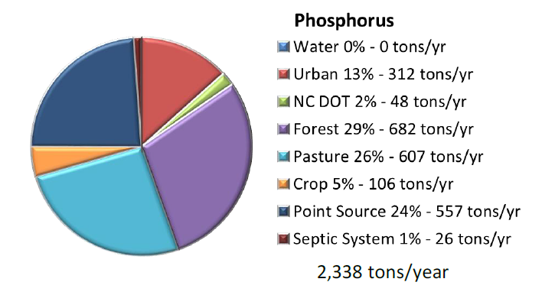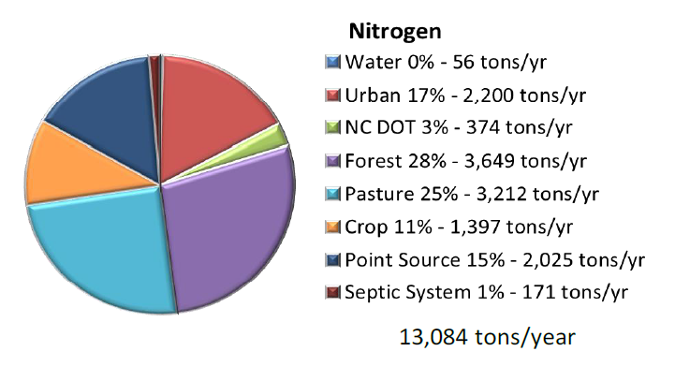

DWR NPS Staff Recommendation on Redistributing Atmospheric Nitrogen Loads
Given the model findings described above, we consider the question of whether to redistribute atmospheric loading to be insignificant for purposes of establishing overall reduction goals. For simplicity, we would propose not to redistribute it based also on the following additional factors:
- Total atmospheric nitrogen deposition in the area has been reduced by 20% since the 2006 baseline (see below).
- Continued reductions in atmospheric nitrogen deposition can be expected, attributable to stationary source and vehicle emission air quality regulations.

Trends in Atmospheric Deposition
The chart below shows wet and dry atmospheric deposition in Candor, NC (Site CND125) which is about 30 miles south of High Rock Lake. The source of this data is the EPA: https://www3.epa.gov/castnet/site_pages/charts/CND125_totn.png
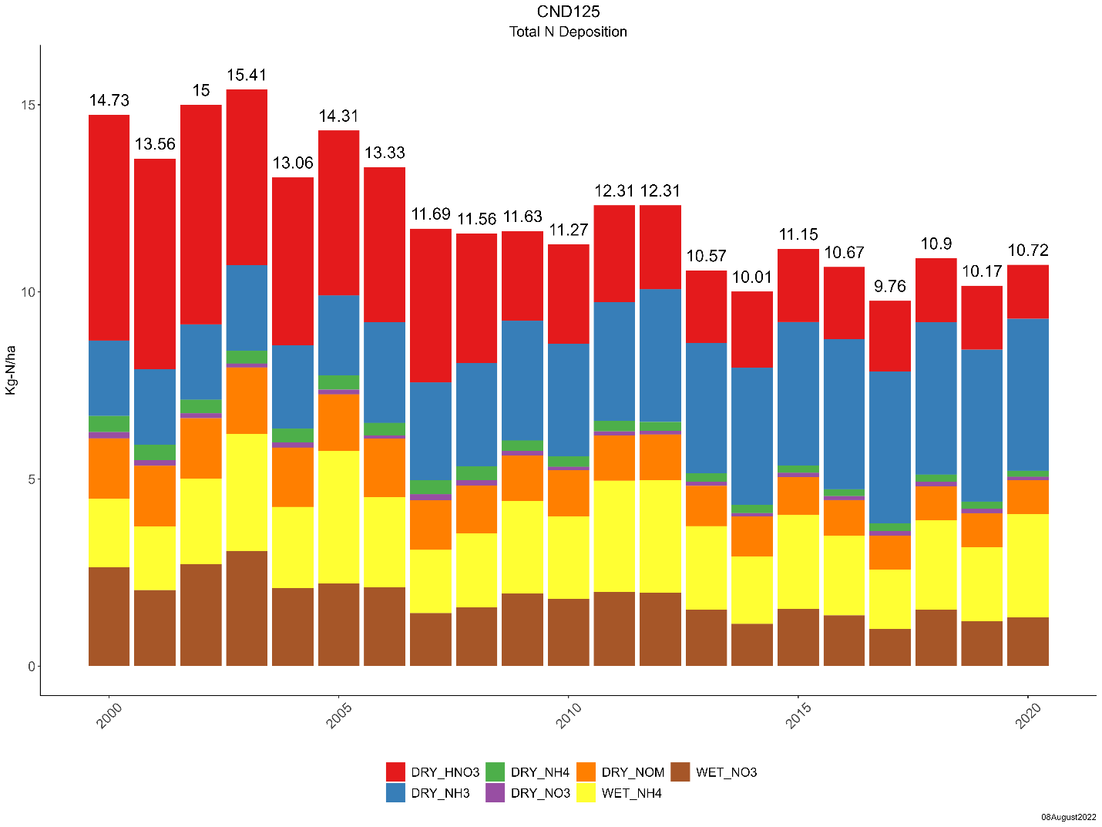
Based on recent monitoring data, significant declines in dry nitric acid deposition appear to be a result of increasingly stringent air quality and vehicle emissions regulations from the 1990s and 2000s. The only atmospheric nitrogen source which has increased since 2000 is dry ammonia, which can be attributed largely to animal agriculture. The increase is steady, but it is not enough to overcome the overall decrease in total deposition from all sources. Current atmospheric nitrogen deposition (~10.72 Kg-N/ha) is approximately 20% lower than atmospheric nitrogen deposition during the 2006 baseline year (~13.33 Kg-N/ha).
Additionally, atmospheric nitrogen deposition sources were calculated for each drainage catchment in Tetra Tech’s 2012 HSPF watershed model. These sources were characterized as described below:
Direct atmospheric deposition onto streams is a minimal fraction of the total N load because the stream surface area is small relative to the watershed as a whole. Atmospheric deposition onto pervious and impervious land surfaces is more important, but its contribution is difficult to tabulate in the model. This is because the model adds atmospheric load to the total store on the land surface that may either be washed off or removed (by volatilization, plant uptake, street sweeping, or incorporation into the medium). The atmospheric contribution is thus embedded within the nonpoint source categories. (Tetra Tech, 2012)

