W. Kerr Scott Reservoir Watershed

Basics
The nutrient loads that are delivered both to and from W. Kerr Scott Reservoir make a relatively small but significant contribution to the Yadkin River nutrient loads, and therefore to High Rock Lake. The High Rock Lake Steering Committee has been tasked with determining whether Nutrient Management Strategy regulations should apply to the area upstream of the dam, and to recommend if adjustments should be made to any regulatory mandates in that subwatershed.

Excerpt from HRL Steering Committee Charge Document:

Steering Committee Charge
DWR asks the Steering Committee to provide written recommendations on the following:
Task D: Determine whether to include the subwatershed above W. Kerr Scott Reservoir in management mandates, and any appropriate modifications to regulatory mandates for that subwatershed.
With regard to modeling characterizing watershed nutrient loading to Kerr Scott Reservoir, DWR does not currently have modeled loading estimates of the various nutrient sources above the reservoir. Instead, in the High Rock watershed model, a simplified approach was taken using a single loading value for the water leaving the dam (see below).
To characterize nutrient sources in the Kerr Scott watershed and changes to those sources since the baseline, the information below was assembled. Based on this information, it appears that upstream land uses may be experiencing changes contributing to a deterioration of water quality in W. Kerr Scott Reservoir.

DWR NPS Staff Recommendation
NPS staff supports inclusion of the area upstream of the W. Kerr Scott Reservoir dam in the High Rock Lake Nutrient Management Strategy. This recommendation is based on the following factors:
- The reservoir has recently transitioned from mesotrophic to eutrophic.
- The reservoir is currently violating the state’s water quality criteria for chlorophyll-a and pH, and so requires a management plan.
- Fish communities have so far responded favorably to the increase in productivity, but there is a risk that unmanaged loading will result in unpredictable future impacts.
- The area upstream of the reservoir is 81% forested, and if included in the High Rock strategy would be subject to the forest harvest provisions of the riparian buffer rule, benefiting both W. Kerr Scott Reservoir and High Rock Lake.
- The great bulk of other nutrient source activity in the watershed is agricultural, so inclusion of the watershed under an agriculture rule would extend the focus of potential agricultural management improvements to deserving activities in the watershed, benefiting both W. Kerr Scott Reservoir and High Rock Lake.
- The area was excluded from modeling due to insufficient data, not due to limited biological influence.

W. Kerr Scott Reservoir in High Rock Watershed Model
Starting in 2008 DWR contracted with Tetra Tech to compile a Hydrologic Simulation Program – FORTRAN (HSPF) model to characterize land uses and nutrient sources in the area that drains to High Rock Lake. At the time that baseline data was collected, insufficient monitoring information was available to develop a detailed characterization of the area upstream of the W. Kerr Scott Reservoir dam. Tetra Tech provided this explanation in their final report:
This project did not include development of a separate lake model for W. Kerr Scott Reservoir, which substantially alters the amount and composition of nutrient and solids loads originating upstream. Therefore, the outflow from this reservoir is treated as a boundary condition for the High Rock Lake watershed model. The U.S. Army Corps of Engineers (USACE) – Wilmington district provided the daily average flow record for outflow fromW. Kerr Scott Reservoir, which was used as a headwater assignment in the High Rock Lake watershed model application. Due to its size, and the lack of frequent water quality monitoring, the water quality of outflow from this reservoir is treated as approximately constant in time. (Tetra Tech, 2012)

Characterization of the Watershed to W. Kerr Scott Reservoir

Excerpts from the 2022 Yadkin Pee Dee Basin Plan
Pages 3-49 through 3-50: “Twenty-two of the Yadkin-Pee Dee basin lakes were evaluated in both reports and had the same results: 16 eutrophic lakes, three hypereutrophic lakes, and three mesotrophic lakes. Lake Rockingham was evaluated only in 2011 and had eutrophic conditions and Water Lake was evaluated only in 2016 and had mesotrophic conditions. Lake Tillery and Falls Lake on the mainstem changed from mesotrophic in 2011 to eutrophic in 2016. Fourteen of the 26 lakes evaluated since 2007 in the Yadkin-Pee Dee River basin are on the 2018 303(d) list including all or portions of every lake along the mainstem of the Yadkin-Pee Dee River; W Kerr Scott, High Rock, Tuckertown, Badin, Falls, Tillery, and Blewett Falls. There were ten lakes listed for chlorophyll-a in 2018 (all or partially) which include five of the mainstem lakes; Kerr Scott Reservoir in the upper part of the basin and four of the chain lakes in the lower part of the basin, High Rock Lake, Tuckertown Reservoir, Badin and Blewett Falls. Kerr Scott Reservoir and Blewett Falls, the most upper and lower of the lakes were newly listed in 2018 along with Lake Concord in the Rocky River watershed (Figure 3.3.3-1). The three hypereutrophic lakes, Lake Lee, Lake Monroe, and Lake Stewart, also located in the Rocky River watershed, and Thom-A-Lex in the Yadkin River watershed are impaired for chlorophyll-a. The Rocky River watershed lakes also comparatively had the highest mean and median concentrations of chlorophyll-a in the basin in both 2011 and 2016 (Table 3.3.3-1). Figure 3.3.3-2 reflects the most recent available (2019) Lakes Trophic data for all lakes in the Yadkin-Pee Dee River Basins, five lakes were evaluated outside the 2007-2016 time-period and Kerr Scott Reservoir was changed from mesotrophic to eutrophic with 2018 monitoring results.”
Page 7-2: “Less than 10% of the 942 miles of monitored streams are exceeding criteria; however, over three quarters of the 1,157 acres of monitored lakes and reservoirs are exceeding criteria due to the W. Kerr Scott Reservoir being added to the 303(d) list in 2018 for chlorophyll-a, pH, and temperature (Table 7.1-1). The reservoir is the first of the Yadkin River’s chain of lakes and is the only major impoundment located in this HUC8 watershed.”
Pages 7-84 & 7-85: “W. Kerr Scott Reservoir is the upper most reservoir on the Yadkin River and is located to the west of the towns of Wilkesboro and North Wilkesboro. The lake was constructed in 1962 by the US Army Corps of Engineers (USACOE) for the primary purpose of flood control. The lake is also used for recreation and to augment low flows for the purpose of maintaining a downstream water supply for Winston-Salem and ecological integrity. W. Kerr Scott Reservoir was sampled for water quality in 2009, 2011, 2012, 2013, 2016, and 2018 at three stations. The reservoir is classified as trout waters and was impaired for chlorophyll-a, temperature, and pH in 2018. The most recent 2016 Lakes Report, which included sampling events in 2012, 2013, and 2016, found pH ranged from 6.8 to 9.3 with seven exceedances of the 9.0 s.u. standard, temperature ranged from 20.7 °C to 30 °C with nine exceedances of the 29oC (84.2 °F) standard, and chlorophyll-a ranged from 6.5 to 24.0 with 14 exceedances of the 15 mg/L standard. Based on the calculated NCTSI scores, W. Kerr Scott Reservoir has had varied productivity in past years from moderate (mesotrophic in 2009, 2013 and 2016) to high (eutrophic in 2012 and 2018). 2009 was the first year the lake was rated as mesotrophic, and 2012 was the first time the lake was determined to be eutrophic (NC DWR 2016; NC DWR 2012). A 2018 study conducted by the NC Wildlife Resource Commission (WRC) found there has been a dramatic increase in the bass population in the last decade that may be related to changing biological productivity at W. Kerr Scott Reservoir. Bass populations had been in the low to moderate range and are typically associated with oligotrophic and mesotrophic lakes, but 2011 and 2016 surveys have indicated a steady increase in bass numbers (pers. comm. Kin Hodges February 18, 2021). The introduction of a new species, the Alabama bass (Micropterus henshalli), has also been concerning as this invasive species has already hybridized with the similar native spotted bass (Micropterus punctulatus) population. Under the right conditions, this species can wreak havoc, not only through hybridization, but also through competition with the three native bass species: smallmouth (Micropterus dolomieu), largemouth (Micropterus salmoides), and spotted (Micropterus punctulatus) (Hubbard, J 2020). Mild blooms were found at W. Kerr Scott Reservoir in 2011 and 2012 during routine sampling, but no potential HAB species were identified (Figure 7.5.3-1). An episodic blue-green algal bloom was reported in the upper end of the lake near the Warrior Creek arm on February 7, 2019. Water quality samples provided by the USACOE showed the dominant species was a potential HAB species (Aphanizomenon spp.). Minimal visual evidence of the bloom was available when DWR staff investigated the next day (NC DWR, 2019). Aphanizomenon spp., like other cyanobacteria, is more commonly dominant during the warmer months, but studies have shown it can bloom during the winter as well. Aphanizomenon spp. has been found to produce toxins, including microcystin. While DWR has never detected microcystin in W. Kerr Scott Reservoir, the toxin was detected in 2002 (Touchette et al., 2009). W. Kerr Scott Reservoir appears to be shifting from a historically oligotrophic/mesotrophic system to a eutrophic system. This shift may be representative of normal changes in a large reservoir over time but could also be accelerated due to land use changes in the watershed and warming climate. There are no impaired streams above W. Kerr Scott Reservoir in the watershed and currently most benthos and fish community ratings in tributaries draining to this reservoir are rated Good or Excellent. Observed changes in the trophic status toward eutrophication warrants continued monitoring by DWR staff.”
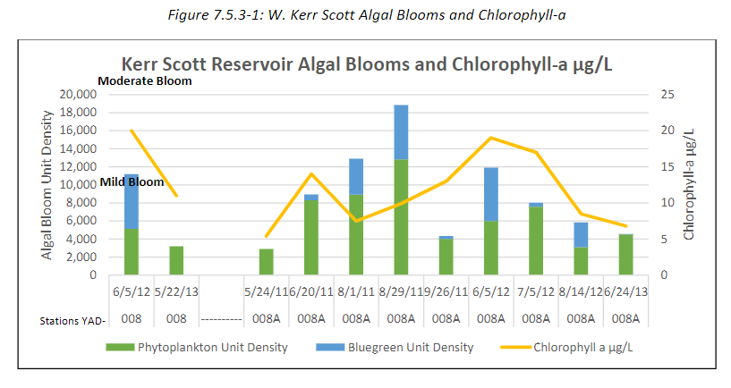
Page 7-95: “W. Kerr Scott reservoir, a trout classified waterbody, was added to the 303(d) list for the first time in 2018 for chlorophyll-a, pH, and temperature. A study conducted by the NC Wildlife Resource Commission (WRC) found that the bass population has dramatically changed over the past 10 years which may be related to changes in biological productivity in the lake. There have been recent algal blooms in the Warrior Creek arm with potential HABs occurring. W. Kerr Scott Reservoir appears to be shifting from a historically oligotrophic/mesotrophic system to a eutrophic system. When resources allow, a watershed assessment of the Warrior Creek Arm and other streams draining to the lake should be done to help identify the nutrient source.”

Permitted Point and Nonpoint Source Facilities
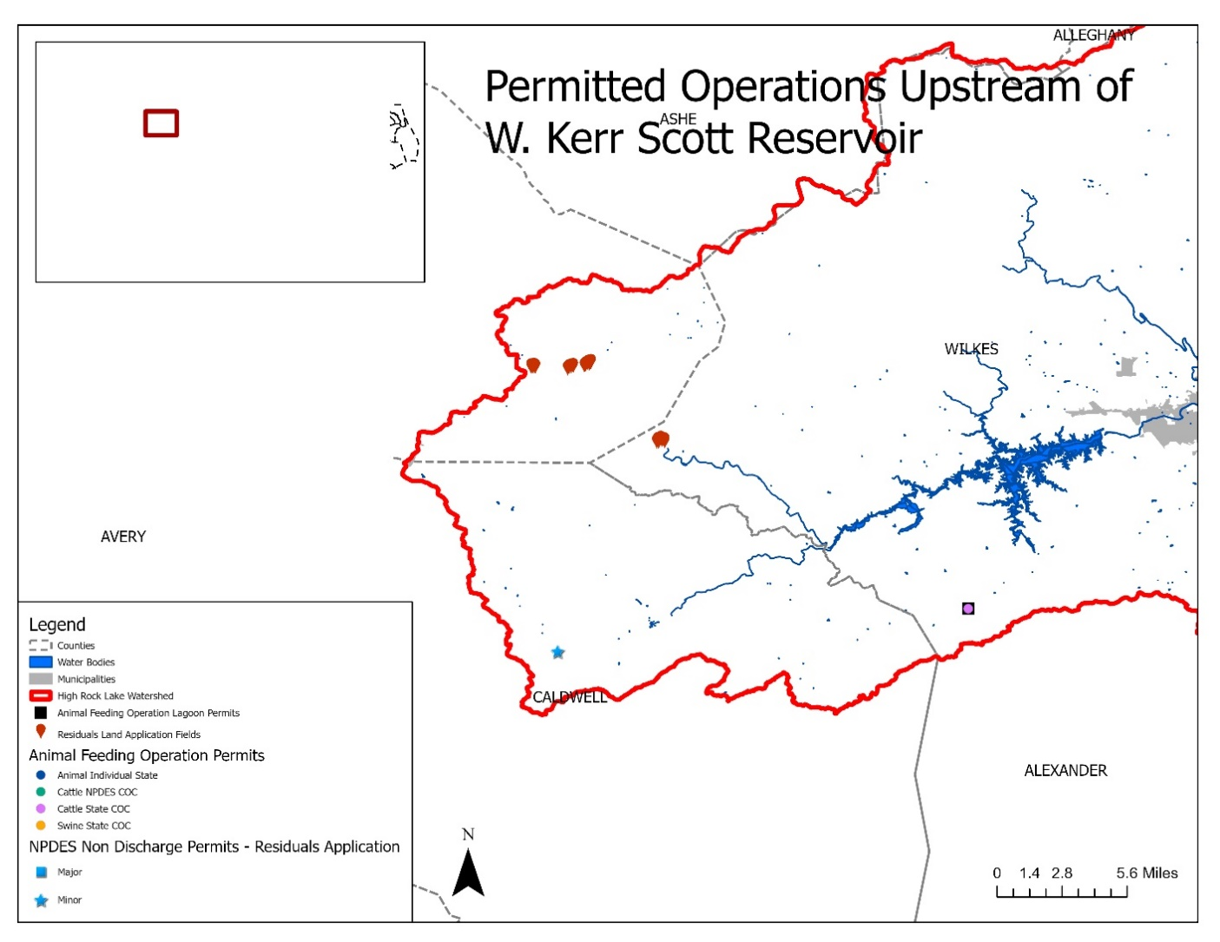

Monitoring Data – Fecal Coliform

2018 Impairments
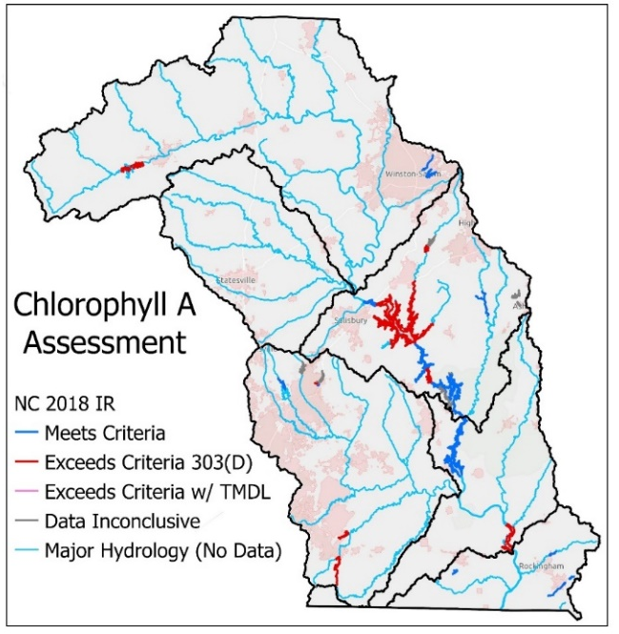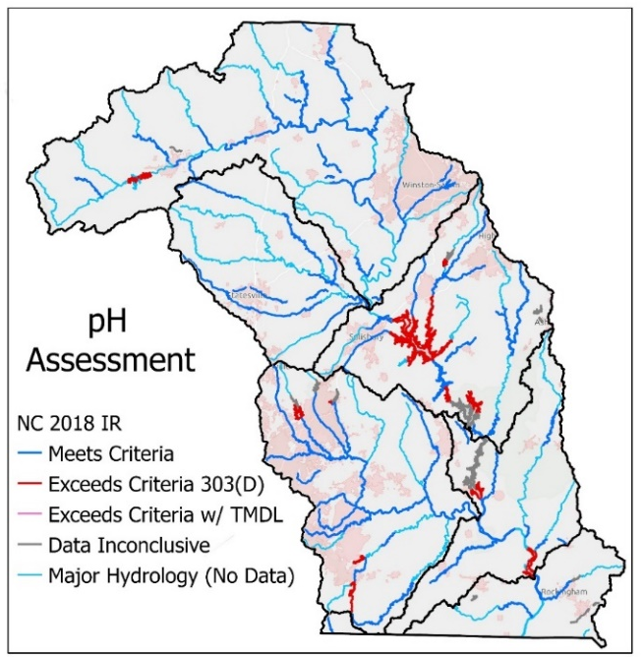
W. Kerr Scott Reservoir remained on the 303(d) list of impaired water bodies through the 2022 Integrated Report, which is the most recent published list. When nutrients and sunlight are sufficiently present, higher water temperatures lead to more algal growth. During the day, algae absorb carbon dioxide from the water for cell growth, raising pH. It appears that the exceedance of the State’s pH water quality criteria is an indicator of ongoing eutrophic conditions in the reservoir.

Excerpts from the 2022 Yadkin Lakes Assessment Report
Kerr Scott Reservoir was monitored monthly from May through September by DWR field staff. Secchi depths ranged from one to 1.0 to 2.0 meters and surface dissolved oxygen values ranged from 7.8 to 9.7 mg/L (Appendix A). Surface pH measurements ranged from 7.2 to 9.0 s.u. and surface conductivity in the reservoir ranged from 35 to 43 µmhos/cm.
Total phosphorus ranged from <0.02 to 0.03 mg/L. NH3 values were consistently below the DWR laboratory detection level of <0.02 mg/L while NO2+NO3 ranged from <0.02 to 0.08 mg/L. Chlorophyll a in Kerr Scott reservoir ranged from 10 to 21 µg/L. Turbidity ranged from 1.9 to 4.4 NTUs.
Based on the calculated NCTSI score, W. Kerr Scott Reservoir was determined to exhibit very low biological productivity or oligotrophic conditions in May. Issues with nutrient and chlorophyll a analysis by the DWR Chemistry Laboratory prevented the NCTSI scores for this lake from June through September to be calculated, and the overall trophic state of this reservoir in 2021 could not be accurately determined. Historically, this reservoir has ranged from oligotrophic (low biological productivity) to eutrophic (elevated biological productivity) since monitoring began by DWR staff in 1981.

2016 NLCD Land Cover
NLCD2001 | Cells | % | Acres
Open Water | 6,507 | 1% | 1,447
Developed | 61,041 | 6% | 13,574
Barren | 329 | 0% | 73
Forest | 855,966 | 81% | 190,352
Shrub | 31,837 | 3% | 7,080
Herbaceous | 7,260 | 1% | 1,614
Pasture | 83,131 | 8% | 18,487
Crops | 2,643 | 0% | 588
Wetlands | 1,851 | 0% | 412
Kerr Scott | 1,050,565 | 100% | 233,627

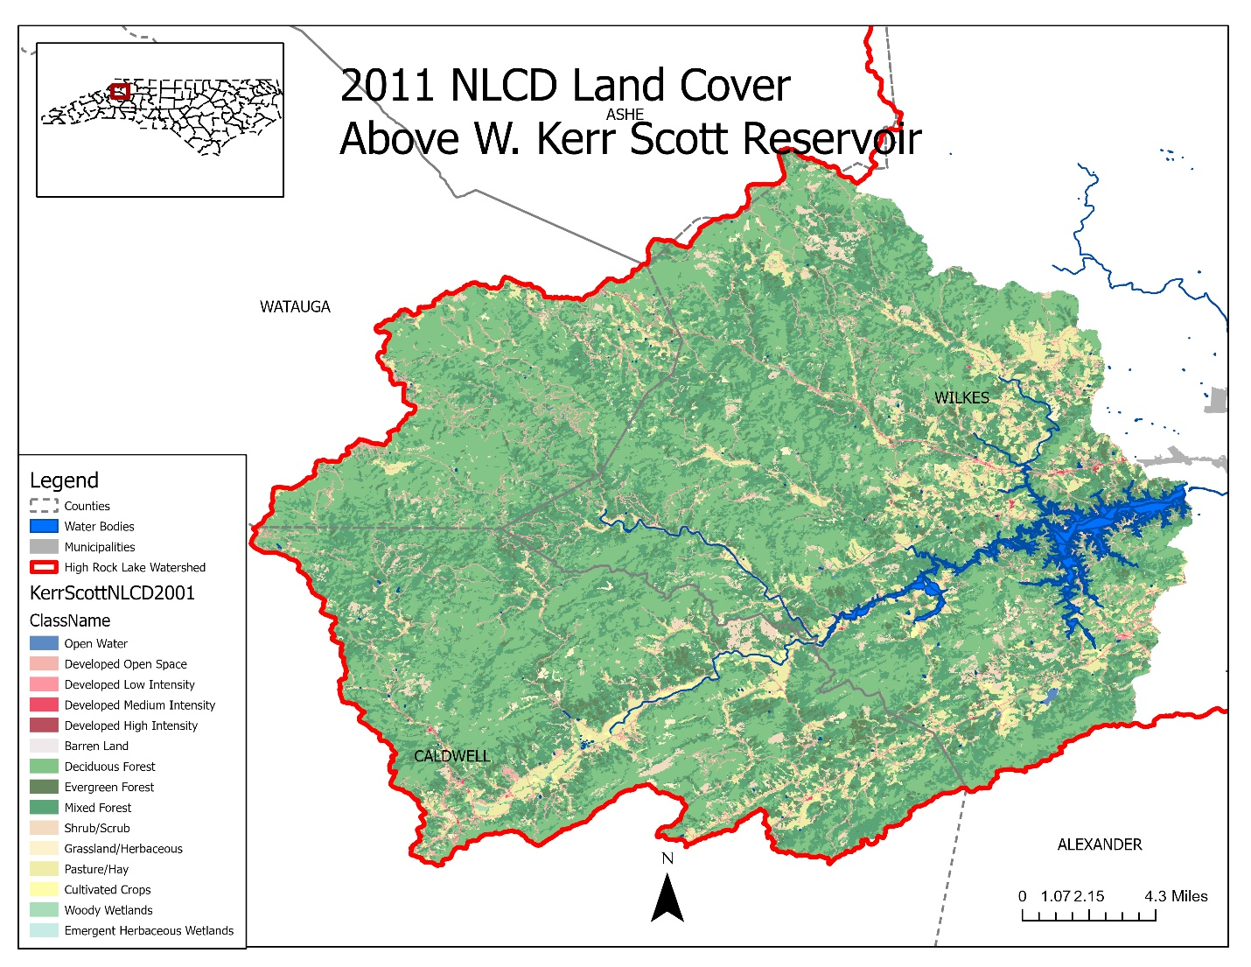

Population Growth
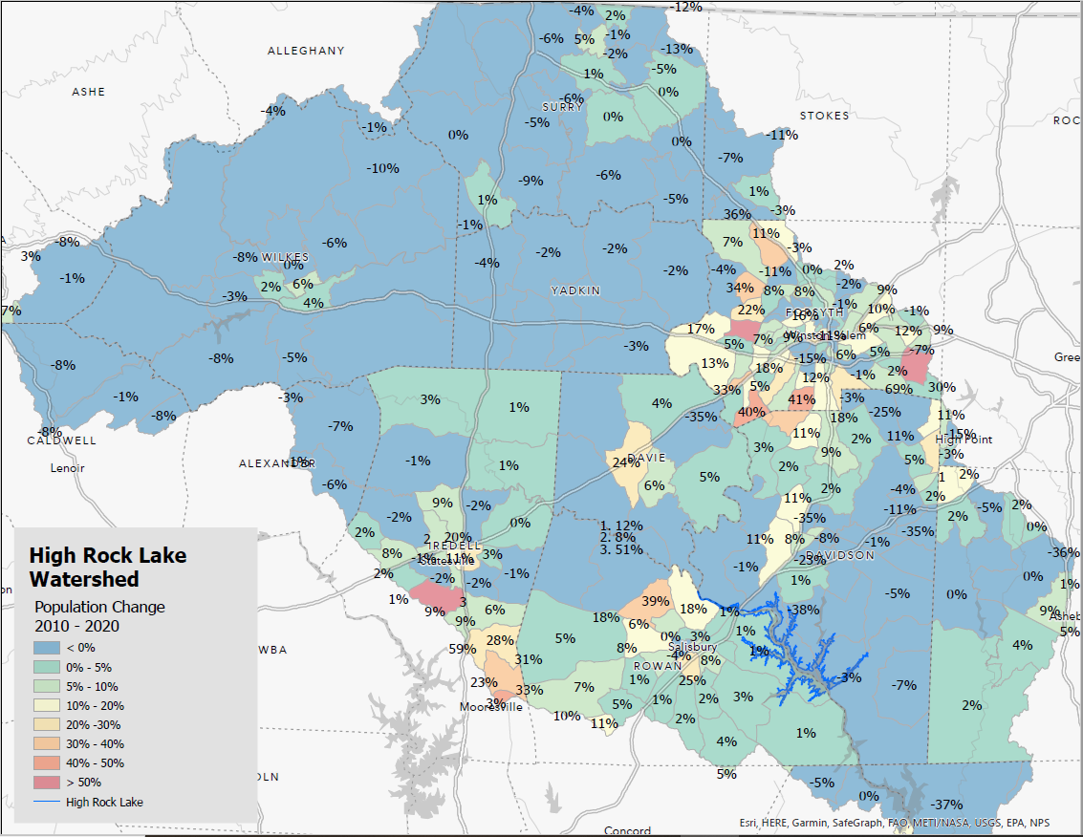
Note that population changes from 2010 through 2020 are negative with the exception of the 19 square mile census block which includes all of Blowing Rock. The 2020 population of that census block was 2,835, and only about a quarter of the census block lies in the High Rock Lake Watershed.

