Meeting Notes: Nutrient Scientific Advisory Board
December 2, 2022, 9:30 a.m. – 12:00 p.m.
Virtual Meeting – Teams

Attendees

Members and Alternates (X = present)
Representation | Member (affiliation) |  | Alternate (affiliation)
Local Government | Drew Blake (Chatham Co) |  | Rachael Thorn
 | Josh Johnson (Multiple LG’s)
 | Eric Kulz (Cary) | X | Charles Brown
 | David Phlegar (Greensboro) | X | Kristine Williams
 | Allison Weakley (CH) | X
 | Sandra Wilbur (Durham) | X | JV Loperfido
Professional or Academic | Michael Burchell (NCSU) |  | Deanna Osmund
Professional Engineer | Sally Hoyt (UNC) | X | Bill Hunt | X
NC DOT Representative | Andy McDaniel | X | Brian Jacobson
Conservation Organization | Peter Raabe (American Rivers) |  | Grady McCallie | X
Advisors
Falls Lake Watershed* | Forrest Westall UNRBA | X | Haywood Phthisic
Local Government | Bob Patterson Burlington

Guests – see Appendix
AGENDA
9:30 Members & Alternates Roll Call
Approve October Meeting Summary
9:45 - 10:30 SNAP Overview (Trish D’Arconte, DWR)
10:40 - 11:30 SNAP 4.2 Deep Dive (Trish D’Arconte)
- Review of significant changes from Version 4.1 (current version)
- New SNAP features and behaviors
11:30 SNAP Q&A (All)
11:45 Members/Alternates/DWR Updates-Comments

Neuse and Tar-Pamlico LG staff (and relevant contractors) also invited to this meeting to learn about new SNAP tool. Not making any decisions today.
Review: Per charter, direct participation limited to NSAB Board members. Guests can comment in chat. Members can ask the Board to allow guests to comment real-time. Feel free to ask clarification questions throughout, other questions and comments at end of each segment.
The October meeting summary was approved.
Trish D’Arconte: SNAP tool is up on website for your review/comment: https://deq.nc.gov/about/divisions/water-resources/water-planning/nonpoint-source-planning . Expect it to be released Feb 2023, along with SCM credit document.
Part I: - The Basics
Review of NC nutrient calculators & methods
There are 4 rules that use nutrient calculators. The nutrient rules specify that there will be a tool/calculator. All nutrient calculators were created for new development (not redevelopment) at a site-specific scale. Calculator tools developed for accounting of pounds of nutrients leaving a site on average every year. Tools change as science develops, so if you compare different tools to each other, you’ll get different results. The Tar-Pam tool is the ancestor of all of them.
We work with the international BMP database to keep up with new data and methods.
SNAP 4.2 is fundamentally similar to the Jordan-Falls tool.
Basic SNAP 4.2 Walkthrough
Flow chart on first page – use it depending on what your use case is for the SNAP tool. Regulatory or non, etc.
Built-Upon Area Worksheet was a request of local governments. Let Trish know whether it meets your needs!
Project Area and Offsite Land Cover Characteristics sheet is the first one you have to enter data into.
Unfortunately, if you cut and paste, it can permanently damage the spreadsheet and you may have to redownload it. Excel allows disabling BOTH cut and paste and copy and paste, or enabling both. Staff want you to be able to copy and paste data between land cover and SCM characteristics sheets, so you just have to be careful not to cut and paste by accident.
You will need to tell your developers what they need to achieve and why
Barney Blackburn - Is a professional engineer required to complete the SNAP tool?
Trish – No, it is not
Sally Hoyt – Anyone can use the SNAP tool, but a local government may require that the calculations packet has to be submitted by a PE, right?
Trish – We did not want to make this something that required engineering certification in order to use
Release and training schedule
Trish will send out timeline info
Part II: Deep Dive - What’s new in SNAP tool and why
Review of significant changes from Version 4.1 (current version)
The biggest change is that we had to remove macros, to address bugs when you download Excel spreadsheets with macros. It doesn’t let you just accept the macros and their security risk. You now need to close the file and open up the properties and enable macros. We thought that would pose an issue for developers, local governments and DWR so we removed macros. But that required us to remove a lot of features. Ie, anything that was a button is now just a url in a cell which works fine.
You will need to tell developers what their targets and buy-down thresholds are. That’s why the Project Info sheet includes a lot of the info that developers will need.
New SNAP features and behaviors
How-To SNAP page says what data you need to collect BEFORE even using the tool.
Encourages user to check in with regulator on what is required.
New SNAP is more user-friendly across different nutrient strategies. We realize that there is a lot of variability in how you all implement stormwater nutrient rules so this should help.
If using runoff volume match, still collect and input info, since we want to know to keep track of N and P from leaving development from these watersheds. It just won’t be a judge of whether meeting rules.
Flow chart guides the user through an iterative process.
SNAP Q&A
Michael Irwin: Implications of state law concerning impervious area present prior to baseline dates.
Part of the redesign of the tool was to address that there is existing BUA that doesn’t drain to SCMs. You don’t have to track this runoff. “Onsite” is the BUA that counts as new – ie, since your new nutrient rules go into effect (it resets.)
There are certain things we’re not able to model easily, like an existing onsite SCM. If you have these, contact us so we can come up with a generalized approach to modeling this.
Annette Lucas - I understand the desire to track the nutrients but it seems like a development meets runoff volume match, it it considered to meet the nutrient rule requirements.
Trish: We want to know what local govts are doing runoff volume match, but there is also an expectation that you’re going to come up with overall changes in nutrient export. This will help us make better rules – we’ll know the sizes of things, the types of SCMs that people are using. The objective was to reduce the effort you all will have to do in your annual reporting.
Annette – I’m wondering where it’s supported in the rules to do this. We want to encourage people to do runoff volume match, to reduce nutrients.
Trish: This tool is just for accounting of pre and post-conditions. [add from recording if I missed anything]
Rich: I’m curious to hear from the development community if they are challenged with runoff volume match calculations – nutrient calculations may be least of their worries.
[missed something here]
Trish: Can now track nutrient contributions from offsite run-on and existing BUA
We hope that changes help streamline reporting, and reduce the need for you to run the tool twice.
Changes related to macros:
Import/export function in old tool was macro-dependent. But you still have the CSV tab, which constantly updates to what is in the whole workbook. This means that you can still export that sheet as a .csv to import to another database. But you may not need to export it. All fields now have a named range, which should let you just refer to the field name when referring to the field via another database.
Other changes:
Lots of flyover popups instructing you on what to enter in cells.
Modified to be black and white for colorblind users.
On project info page, the cells related to nutrient management strategy are in black, and others are in gray.
Sally Hoyt – Are all of these cells in black used by the SNAP tool? Or just related to regs?
Trish: The latter – for all of us to track what’s going on. Not critical for getting numbers out of the tool.
BUA worksheet is optional; doesn’t affect results; based on LG feedback/need. Welcomes feedback.
Nutrient Export Summary page checks for all potential errors and shows them at top of sheet.
Katie Balaze – How many SCM drainage areas are included?
Trish – 6 catchments, and within each you can have 3 SCMs in series. If you route each catchment to each other, you could have a maximum of 18 SCMs in series, or you could have the catchments in parallel.
Danica Heflin - Please email us an unlocked copy of the "How To" -- can't copy/paste the links.
Trish will change this so you can copy them.
Ashley Rodgers – What if a site has more than 6 catchments?
Trish – How common is this for you? You may be able to bundle them.
Ashley – It doesn’t happen frequently, but we have one under review now. It has a lot more than 6.
Michael Erwin – Two projects – one has 12 SCMs, the other 13. Luckily they were all the same types, so they could combine them by type.
Trish – Yes, as long as they are all 100% or the same % sized, you can combine the same type of SCM. If you have more than 6 types of SCMs on a site, let’s talk. It’s hard to add catchments without structural modification of spreadsheet, which has the potential for errors
Trish - If you have a custom SCM, you need to enter the hydrologic values for it.
Nutrient Export Summary sheet – At bottom, retained catchment summary for N P and TSS
Michael Irwin- Rainwater harvesting: Area of SCM or area of land use irrigated?
Trish – I’ll check Sarah’s instructions – I think that’s one that is zero.
Bill Hunt - Thinks it’s a zero.
Trish – The land use that you’re discharging to isn’t really included because rain that falls on the treatment area isn’t going into the SCM.
Note also we have new Rainwater Harvesting N, P event mean concentrations (EMCs) as well as for other SCMs.
Note Storm Filter has dummy variables in it now, will be updated with real data and included in the tool release.
Nutrient offset sheet doesn’t link to any other sheets – you have to enter all data
Trish would like to know if you have issues importing CSV tab into any database.
Trish – You all made a lot of good suggestions we might want to incorporate into future changes. Would love to have a user’s group for the future to provide feedback to use in future updates. Here are some of the changes we haven’t made yet but could consider:
- Still collecting data that could perhaps let tool use curve number methods
- There was interest in more info on how local requirements work with the tool – not included since local
- If you have a common plan of development governing development spanning years/decades and how to model better – ask Trish
- If you’re retrofitting an SCM, you have to run the tool twice.
- Online options for this? We’d have to explore IT support, funding, who would host it and where, and see whether we could generalize local government options enough that it would work.
- Right now we have a SNAP listserv, but it hasn’t been well-used and doesn’t function as a user group
Michael Irwin – What do you do with rainwater harvesting for toilet flushing?
Trish – this is covered in instructions for using rainwater harvesting tool to get hydrologic outputs. Should all be considered ET&I.
Ashley Rodgers - Will the draft user guide for the new tool also be available while we are testing/commenting?
Trish – Sorry, no – so many changes to incorporate into it still/after public comment
Sally Hoyt – Even if it weren’t led by DEQ, where would people go if they wanted to interact with other users and crowdsource their questions/actions? Reddit, some engineering forum, ?? – seeking ideas from folks on the call today.
Also - Can we make comments on what needs to be added from last user guide?
Bill Hunt – FYI- NCSU is fixing a bug associated with the RWH Model - it struggles when running hourly data. Daily data is no problem. But I think we'll have it fixed by end Jan.
David Revoir - Please include the 4-page "Tool Definitions Cheat Sheet" in the new user guide. It is very helpful.
Trish – I’ll check if I pulled that from the manual – it should be in there if organized differently.
David – Having them all in one concise place is very helpful.
Trish will update links on SNAP How-To page.
Bill Hunt will fix broken links to NCSU pages next week.
Michael Irwin – Can we get professional development credits for this?
Trish will have the finally updated version uploaded later this afternoon, but wait for an email from Trish!
Forrest – DEMLR is offering monthly seminars and worked with the PE Board to issue credits. It would be beneficial.
Trish – would probably want this for planners and landscape architect board.
Several folks say talk to Julie Coco or Michelle Evans about this
Members /Alternates / DWR/ Updates-Comments
Eric Kulz – Town of Cary: Doesn’t use tool – Lisa Booze does.
Lisa – When do we anticipate effluents for Storm Filter going in and are we confident in those numbers?
Trish – Still have to review their data and meet with them. There will also be a 30-day comment period for their SCM. Our plan is to get them done by end of February at latest. Plan to release with SNAP and help doc.
David Phlegar – Greensboro: No comments, good job!
Allison Weakley – Chapel Hill: For Jordan Lake annual reporting, I use the SNAP tool every year for retrofit opportunities. I’m a biologist, not an engineer, and I’m able to use it. I have Ernest who is an engineer review it before submittal too.
Ernest – Excellent job!
Sandi Wilbur – Durham: Tried to download the video from the first half of the meeting, and you might need to save the file or share it somehow so that outside people can download it.
Trish – Yes – I can ask our web guy about this
Sally Hoyt, Raleigh – Another question: Are you open to feedback about training should happen?
Rich and Trish – Yes, the sooner the better! Need to finalize ASAP
Sally Hoyt – what is your initial thought?
Trish – Specific training for local govts about all the info you need to enter, error messages, and submitting for annual reports. It’ll depend on how many examples people want to go through. Probably a 3-hour online training so that we can record and share out. Would be for LGs not developers.
Would do a separate one for development communities – what would be the best format? Had previously done an all-day welcome to SNAP with NCSU, also covering their Rainwater Harvester and HyperTool. Not sure if that’s the best option.
Bill Hunt – We’re happy to help! Also, we have an event in March – Southern Stormwater Summit – stay tuned. Big training, will include sustainability and resilience, get bigger picture, talk about stormwater and flooding and impacts to communities.
Andy McDaniel – Thanks!
Grady McCallie – Thanks!
Forrest Westall – Training is important – will probably reach out to you to coordinate a workshop in Falls Lake watershed. Want to make sure all consultants and LGs can use it well.
UNRBA is beginning recommendations due end of 2023. Models are being finalized. Working with Collaboratory on a symposium in March or April.
Joey Hester – High Rock Nutrient Strategy Stakeholder process underway – started a productive conversation. Have started convening Technical Advisory Groups (TAGs) by sector – Stormwater, wastewater, agriculture and riparian buffer. Trying to diversify and make sure everyone’s involved. Home builders, COGs, etc. Next Steering Committee meeting late Feb; will draft the charge for the TAGs – what they’re asking for. There are hard questions to answer, but it’s a great conversation so far, and we’re trying to take as many lessons learned as possible to move forward.
Rich – Dr Bowen’s Jordan Lake Model refinements still underway – hope to have it finished by spring or summer. Unfortunately state hiring has been very slow – we still haven’t been able to post Patrick’s position.
Danica Heflin – Great overview and intro – I didn’t use the 4.1 version but am taking notes for Grace Messinger

Appendix
List of All Meeting Participants
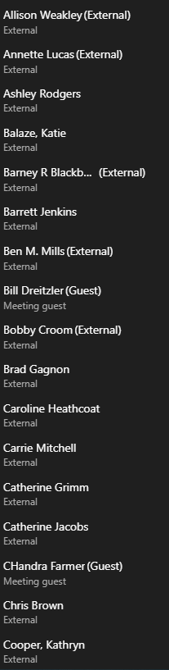 | 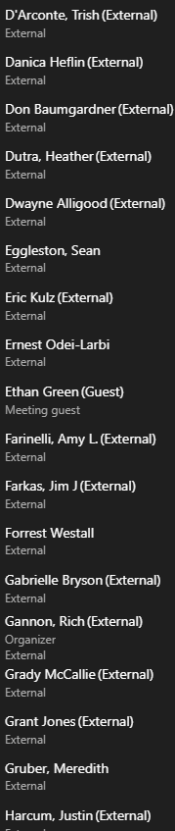 | 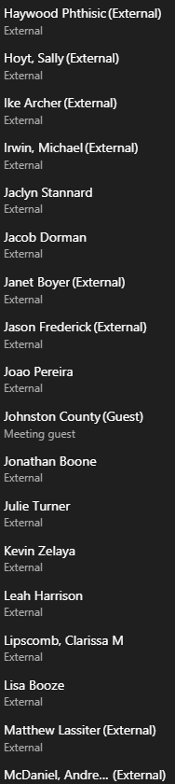 | 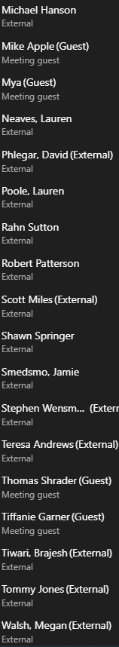 | 