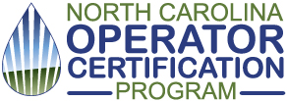

Wilbur E. Long Jr. Operator of the Year Award
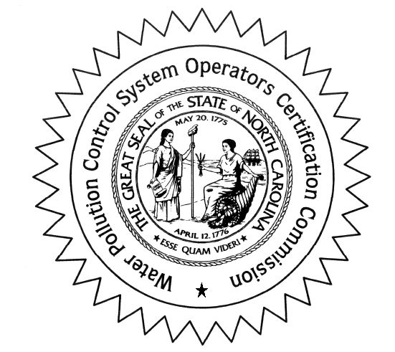
Nomination Form
Directions:
- Due June 1
- Expand text boxes to as many pages as needed.
- Email completed form to Jeffrey.Talbott@deq.nc.gov

Purpose:
The award is open to all active waste operators with certification in one or more of the following: animal waste, biological wastewater, collections, physical/chemical, land application, subsurface, and surface irrigation.
The Wilbur E. Long Jr. Operator of the Year award recognizes active certified water pollution control system operators in NC who:
- exhibit outstanding knowledge and innovation in the continuing operation of a water pollution control or animal system; or
- contribute time and effort toward the training, education, and professionalism of water pollution control or animal systems; or
- have devised, discovered, or invented devices or techniques which enhance the science of system operation.
Date:

Nominee
Name:
Operator certifications held:
Facility(s) where nominee works:
Professional Organization the nominee is active with.

Employer
Company name:
Contact name:
Contact phone:
Contact email:

Accomplishments of the Nominee

Nominator
Name:
Phone:
Email:

The Operator Certification Program will contact the DEQ Regional Office to ask about the nominee. We suggest you contact staff at the Regional Office to discuss the nominee. https://www.deq.nc.gov/about/contact/regional-offices
The award nomination period closes June 1 each year. Nominations will be vetted and presented to the WPCSOCC for an award decision.
The nominator can include supplemental information and attachments if they choose.
Where applicable, the award will be presented at the NC One Water Conference (November), the NC Rural Water Conference (May), or a NC Cooperative Extension event.

